03_DataWranglingIII

Mariana Higashi Sakamoto

27/11/2021

## Including Plots

You can also embed plots, for example:



Note that the echo = FALSE parameter was added to the code chunk to prevent printing of the R code that generated the plot.

You can format texts:

* *italic*: * at the beginning and end of sentence
* **bold**: addind ** at the beginning and end of sentence
* To create bullet points just do: * at the beginning of the sentence
* Title 1
* Title 2
  + Subtitle 2
* To do that give a tab

To write something at the bottom use ~ at the beginnig and end of element H2O

To write something at the top use ^ at the beginnig and end of element a2+b2 = c2

You can use LaTex format to write equations For example: $a=b^{2}$ to write in the same line

$$a=\sqrt{b}+c^{2}$$

$$a=(b×c)+(\frac{d}{e})$$

$$α_{1}=β_{1}+β_{2}^{3}$$

Introducing chunks: thats where we are going to code

array <- c(1:5)  
array

## [1] 1 2 3 4 5

Now lets import packages and a dataset

library(readxl)  
library(tidyverse)  
library(knitr)  
dados <- read_excel("./02_DataWrangling/(1.2) Dataset Aula Data Wrangling.xls")  
head(dados)

## # A tibble: 6 x 6  
## Estudante `Tempo para che~ `Distância perc~ `Quantidade de ~ `Período do dia`  
## <chr> <dbl> <dbl> <dbl> <chr>   
## 1 Gabriela 15 8 0 Manhã   
## 2 Dalila 20 6 1 Manhã   
## 3 Gustavo 20 15 0 Manhã   
## 4 Letícia 40 20 1 Tarde   
## 5 Luiz Ovíd~ 50 25 2 Tarde   
## 6 Leonor 25 11 1 Manhã   
## # ... with 1 more variable: Perfil ao volante <chr>

Create a table

dados_1 <- dados %>%rename(time = `Tempo para chegar à escola (minutos)` ,   
 distance = `Distância percorrida até a escola (quilômetros)`)   
  
dados_1 %>%   
 summarise(ave_time = mean(time),  
 ave_dist = mean(distance)) %>% kable()

|  |  |
| --- | --- |
| ave_time | ave_dist |
| 30 | 17 |

Create a graph

dados_1 %>% ggplot() + geom_point(aes(x=distance, y= time))

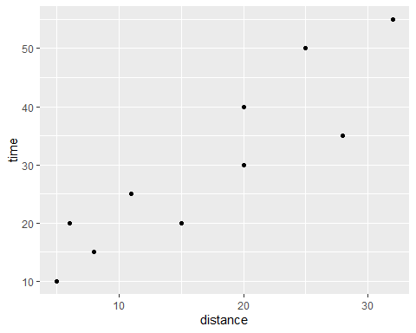

To be able to export as a pdf install: if tinytex:::is_tinytex() # tinytex::install_tinytex()