Problem set #4 (20p)

You may use the aipython code to solve these problems.

1. (6p) Exercise 6.1 from the book.

2. (7p) Exercise 6.3 from the book.

3. (7p) Exercise 6.4 from the book.

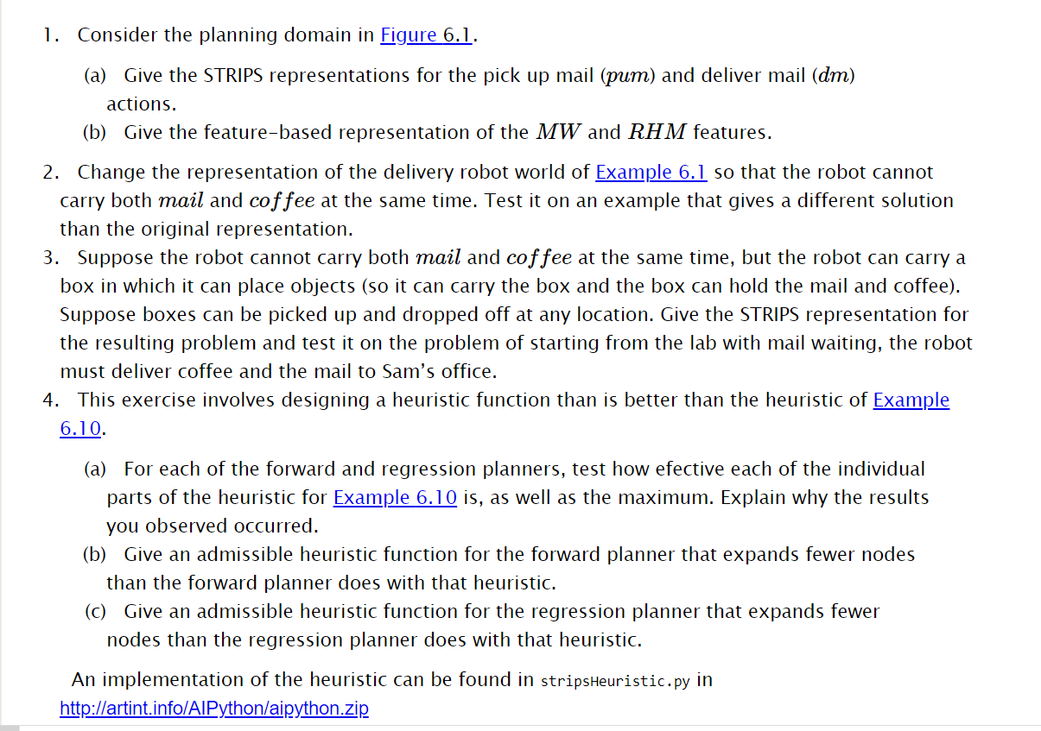

1a.

STRIPS representation of the action pick up mail, PUM:

Preconditions: Loc = mr and RHC = $!rhm$

Effects: RHM = rhm

STRIPS representation of the action deliver mail, DM:

preconditions Loc = off and RHM = rhm

effects RHC =!rhm and MW = !mw

1b.

When is mw true?

MW1=mw when MW0=mw and PUM0=!PUM

When is rhm true?

RHM1 = rhm when RHM0 = rhm and DM0 = !dm

RHM1 = rhm when PUM0 = pum

2.

RLoc

*– Rob’s location*

BW

*– box is waiting*

RHB

*– Rob has box*

***Actions***

Mc

*– move clockwise*

*Precondition:{rloc=off }*

*Effect:{ rloc=lab}*

*Or*

*Precondition:{rloc=lab}*

*Effect:{ rloc=mr}*

*or*

*Precondition:{rloc=mr }*

*Effect:{ rloc=cs}*

*Or*

*Precondition:{rloc=cs }*

*Effect:{ rloc=off}*

Mcc

*– move counterclockwise*

*Precondition:{rloc=off }*

*Effect:{ rloc=cs}*

*Or*

*Precondition:{rloc=cs}*

*Effect:{ rloc=mr}*

*or*

*Precondition:{rloc=mr }*

*Effect:{ rloc=lab}*

*Or*

*Precondition:{rloc=lab }*

*Effect:{ rloc=off}*

Pub

*– pickup box*

*Precondition:{bw,¬rhb }*

*Effect:{ ¬bw ,rhb}*

Db

*– deliver box*

*Precondition:{rhb }*

*Effect:{ ¬rhb }*

3a.

***** FORWARD NO HEURISTIC

15 paths have been expanded and 9 paths remain in the frontier

{'RLoc': 'lab', 'MW': True, 'SWC': True, 'RHC': False, 'RHM': False}

--mc_lab--> {'RLoc': 'mr', 'MW': True, 'SWC': True, 'RHC': False, 'RHM': False}

--mc_mr--> {'RLoc': 'cs', 'MW': True, 'SWC': True, 'RHC': False, 'RHM': False}

--puc--> {'RHC': True, 'RLoc': 'cs', 'MW': True, 'SWC': True, 'RHM': False}

--mc_cs--> {'RLoc': 'off', 'RHC': True, 'MW': True, 'SWC': True, 'RHM': False}

--dc--> {'RHC': False, 'SWC': False, 'RLoc': 'off', 'MW': True, 'RHM': False}

***** FORWARD WITH HEURISTIC h1

15 paths have been expanded and 9 paths remain in the frontier

{'RLoc': 'lab', 'MW': True, 'SWC': True, 'RHC': False, 'RHM': False}

--mc_lab--> {'RLoc': 'mr', 'MW': True, 'SWC': True, 'RHC': False, 'RHM': False}

--mc_mr--> {'RLoc': 'cs', 'MW': True, 'SWC': True, 'RHC': False, 'RHM': False}

--puc--> {'RHC': True, 'RLoc': 'cs', 'MW': True, 'SWC': True, 'RHM': False}

--mc_cs--> {'RLoc': 'off', 'RHC': True, 'MW': True, 'SWC': True, 'RHM': False}

--dc--> {'RHC': False, 'SWC': False, 'RLoc': 'off', 'MW': True, 'RHM': False}

***** FORWARD WITH HEURISTICs h1 and h2

9 paths have been expanded and 8 paths remain in the frontier

{'RLoc': 'lab', 'MW': True, 'SWC': True, 'RHC': False, 'RHM': False}

--mcc_lab--> {'RLoc': 'off', 'MW': True, 'SWC': True, 'RHC': False, 'RHM': False}

--mcc_off--> {'RLoc': 'cs', 'MW': True, 'SWC': True, 'RHC': False, 'RHM': False}

--puc--> {'RHC': True, 'RLoc': 'cs', 'MW': True, 'SWC': True, 'RHM': False}

--mc_cs--> {'RLoc': 'off', 'RHC': True, 'MW': True, 'SWC': True, 'RHM': False}

--dc--> {'RHC': False, 'SWC': False, 'RLoc': 'off', 'MW': True, 'RHM': False}

***** REGRESSION NO HEURISTIC

9 paths have been expanded and 3 paths remain in the frontier

{'SWC': False}

--dc--> {'RLoc': 'off', 'RHC': True}

--mc_cs--> {'RLoc': 'cs', 'RHC': True}

--puc--> {'RLoc': 'cs', 'RHC': False}

--mc_mr--> {'RLoc': 'mr', 'RHC': False}

--mc_lab--> {'RLoc': 'lab', 'RHC': False}

***** REGRESSION WITH HEURISTICs h1 and h2

8 paths have been expanded and 4 paths remain in the frontier

{'SWC': False}

--dc--> {'RLoc': 'off', 'RHC': True}

--mc_cs--> {'RLoc': 'cs', 'RHC': True}

--puc--> {'RLoc': 'cs', 'RHC': False}

--mcc_off--> {'RLoc': 'off', 'RHC': False}

--mcc_lab--> {'RLoc': 'lab', 'RHC': False}

Adding the first heuristic did not decrease the paths expanded for forward planning. This is because the second heuristic was need to decrease the paths. This first heuristic made all the cost equal which ended up with the nodes being explored in the same order. For regression h1 decreased the nodes remaining in the frontier but did not decrease the amount of paths expanded. H2 decreased the paths expanded.

3b. You should add a heuristic to check the distance from mail room and add this to the existing h2 heuristic in case the goal is delivering mail and not delivering coffee. This would check the distance to the mail room plus getting mail and delivering it, if mail waiting is true.

3c. You should add a heuristic to check the distance from mail room and add this to the existing h2 heuristic in case the goal is delivering mail and not delivering coffee. This would check the distance to the mail room plus getting mail and delivering it, if mail waiting is true.