Marisa Mills

Problem set #1 (20p)

1. (5p) Uncomment and run examples in agentTop.py Create the environment on slide 13 of lect2.pdf and run the example. Save and upload the figure.

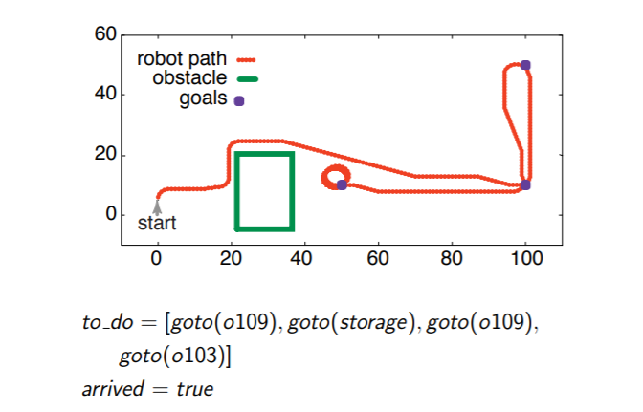

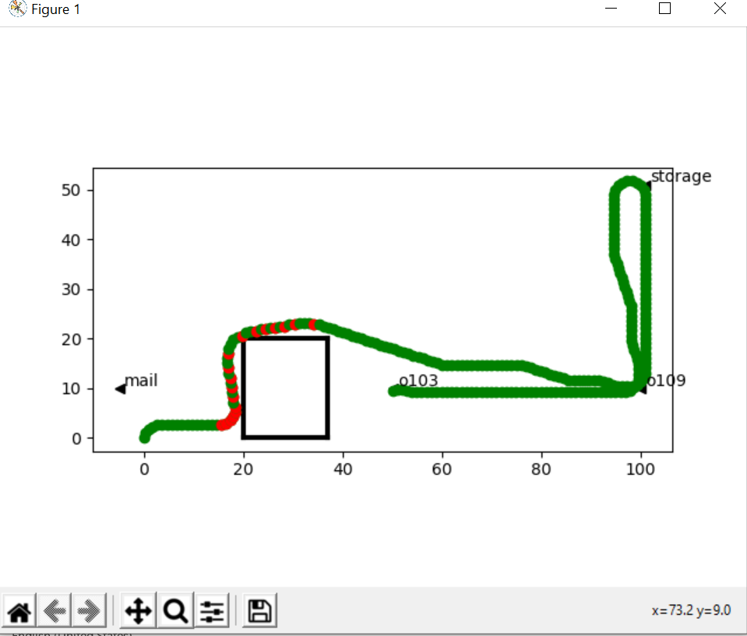

1. (5p) Exercise 2.9 from the book.

Suppose you have a new job and must build a controller for an intelligent robot. You tell your bosses that you just have to implement a command function and a state transition function. They are very skeptical. Why these functions? Why only these? Explain why a controller requires a command function and a state transition function, but not other functions. Use proper English. Be concise.

It is important to first understand what a command function and a state transition function are. A belief state simply has all the necessary information about an agent’s history to be used for current and future commands. An agent always has access to its belief state and its current percepts. A state transition function defines the new belief state given the current belief state and a percept. A command function defines a command given the current belief state and precept. If used correctly, you do not need access to the whole history of an agent. Instead, the belief state can be updated using the state transition function and command can be given using the command function.

2. (10p) (a) Explain why we use hierarchical (layered) controllers.

We use hierarchical controllers because they allow us to see the separate our controller into layers. The high order layers view the layers below as a virtual body from which it receives percepts and sends commands. The lower layers are much simpler and run faster. They can hide details that are nonessential to the higher layers.

(b) What does it mean that the higher layers run at a different time scale than lower layers?

The higher layers are generally given much more relaxed time constraints as compared to the lower level layers. The lower layers are designed to run quickly and deliver a simple view of the world to the higher layers. The lower layers provide the relevant information for the high layers to be open to introspection and reasoning.

(c) Give the intuition behind the notion of a transduction? Why do we define causal transductions?

A transduction is a function that maps from percept traces into command traces. A causal transduction maps the agent’s history at a time(t) into its action at time(t). Even though a causal transduction cannot be directly implemented because we lack the whole history of an agent, we define a causal transduction as the most general form of a controller.

(d) Why does an agent have a state?

A causal transduction cannot be directly implemented because we lack the whole history of an agent. Instead we use belief states and current percepts to create the belief state transition function and command function. An agent’s belief state contains all the relevant information the agent has remembered from the previous times. An agent has access only to the history recorded in its belief state. The belief state is used to create current and future commands.