CS 480 001 Due: Sep. 9, 2020 at 11:59pm

Fall 2020

Dr. Duric

Project #1 (30p)

Q4. (20p) Consider the "robot trap" in Figure 2.11.

1. (10p) This question is to explore why it is so tricky for a robot to get to location. Explain what the current robot does. Suppose one was to implement a robot that follows the wall using the "right-hand rule": the robot turns left when it hits an obstacle and keeps following a wall, with the wall always on its right. Is there a simple characterization of the situations in which the robot should keep following this rule or head towards the target?

The current robot heads straight toward the target makes a left, then turns around and begins to head back toward the target. This is what causes the robot to make an unrecoverable collision. 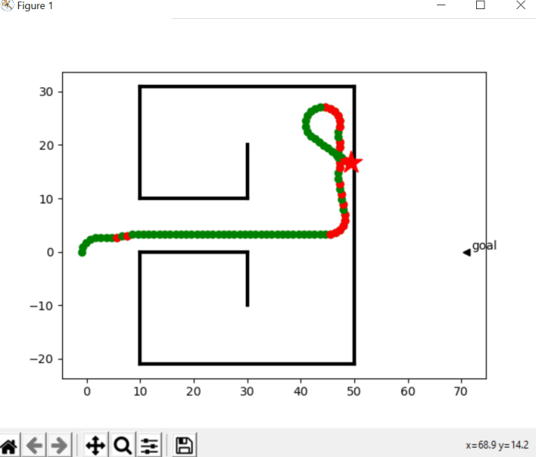

It makes sense for the robot to follow the righthand rule when trapped. Trapped means the times the walls surround the robot and chance of collision is high. If the robot becomes trapped it is reasonable for the robot to count the number of right and left turns to escape the maze and reach his target.

1. (10p) An intuition of how to escape such a trap is that, when the robot hits a wall, it follows the wall until the number of right turns equals the number of left turns. Show how this can be implemented, explaining the belief state, and the functions of the layer.

This can be implemented by using a hierarchical controller. The top layer maintains a belief state consisting of the goal location that the robot needs to visit. The top layers view the layers below as a virtual body from which it receives percepts and sends commands. The top layer receives the middle layer and the middle layer receives the environment layer. The lower layers hide details that are nonessential to the higher layers. The environment layer handles the robot body and whisker, as well as plotting obstacles. The middle layer handles the steering and decides if the goal was reached. The top layer has control and dictates the goal locations, plots movement, and obstacle coordinates.

Q5. (10p) If the current target location were to be moved, the middle layer of Example 2.5 travels to the original position of that target and does not try to go to the new position. Change the controller so that the robot can adapt to targets moving.

In example in the attached code.