Marisa Mills Project 2 output

* python runPacman.py -l tinyMaze -a SearchAgent

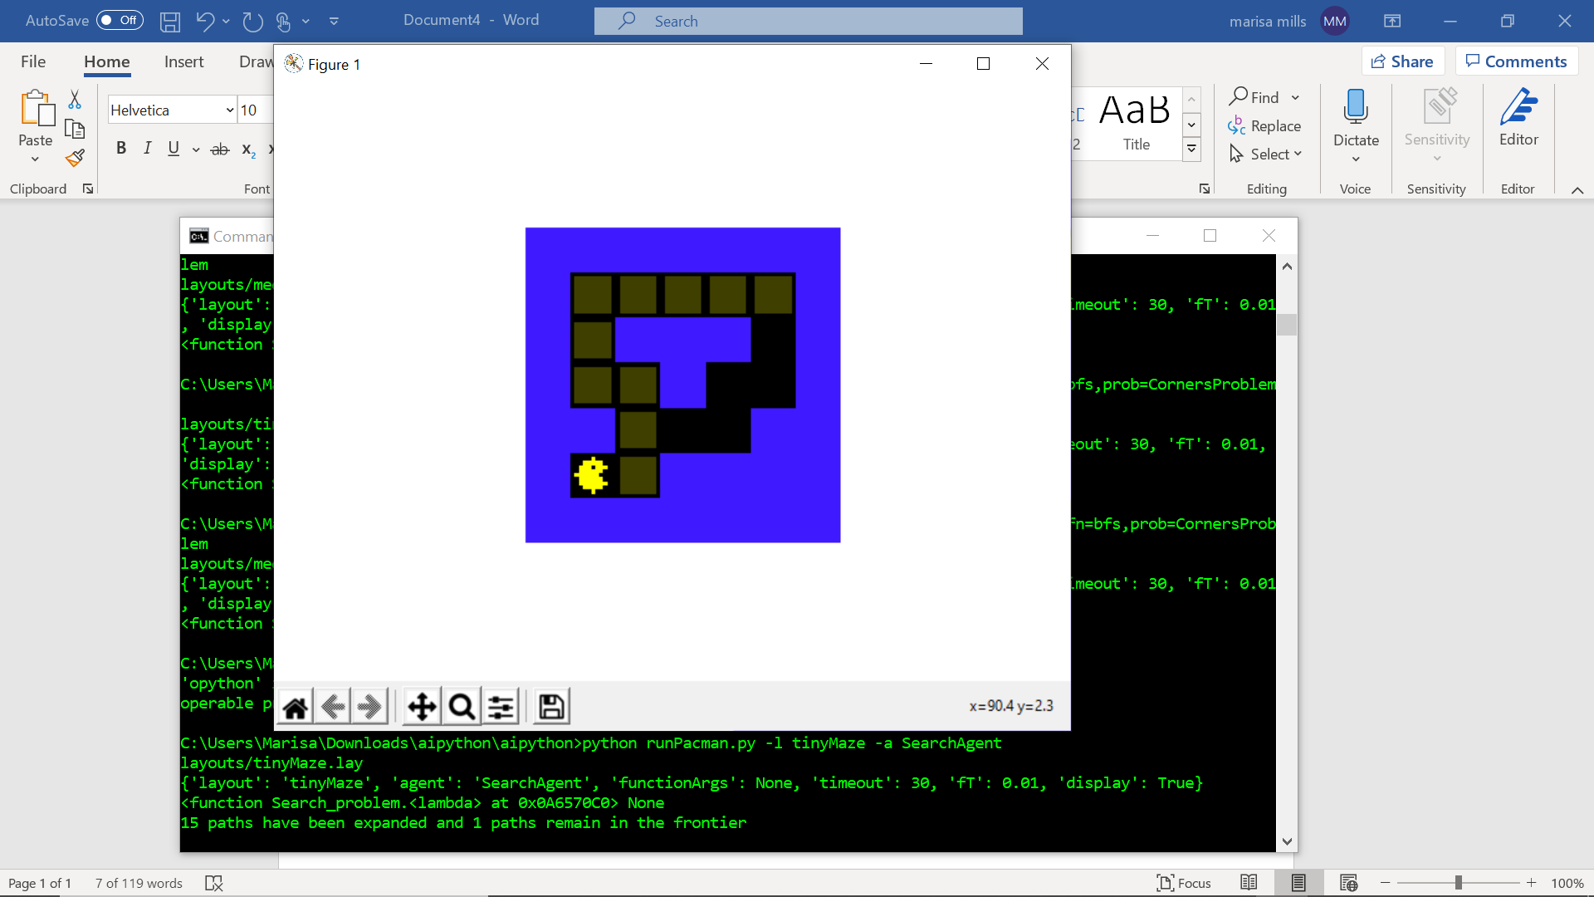

* python runPacman.py -l mediumMaze -a SearchAgent

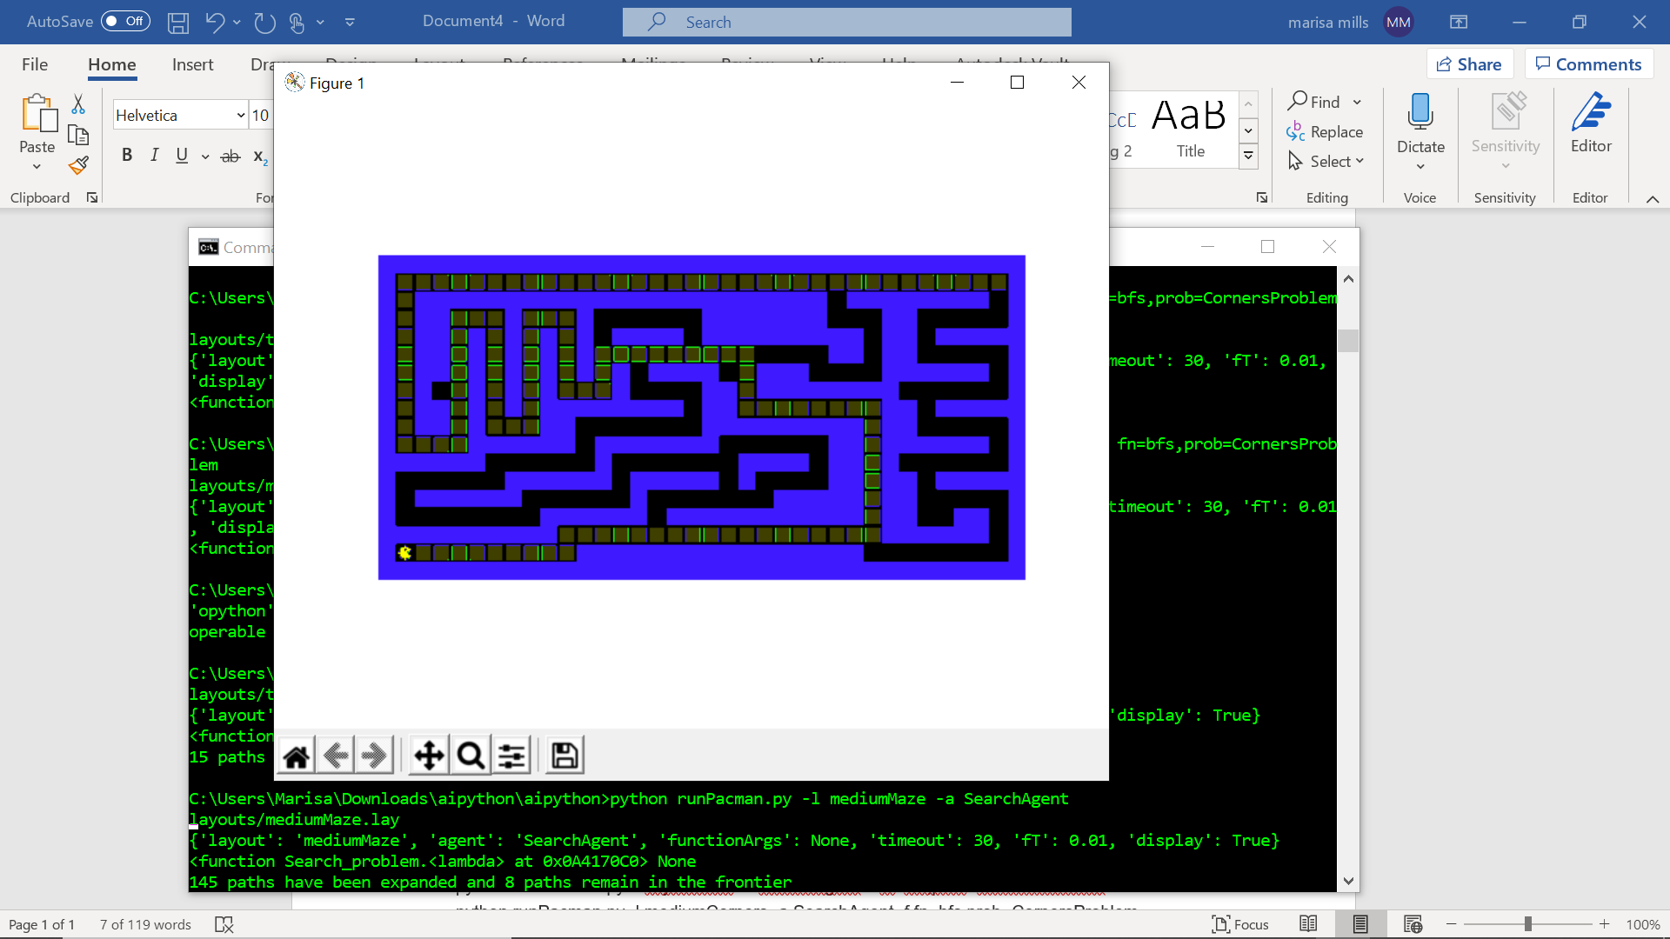

* python runPacman.py -l bigMaze -a SearchAgent

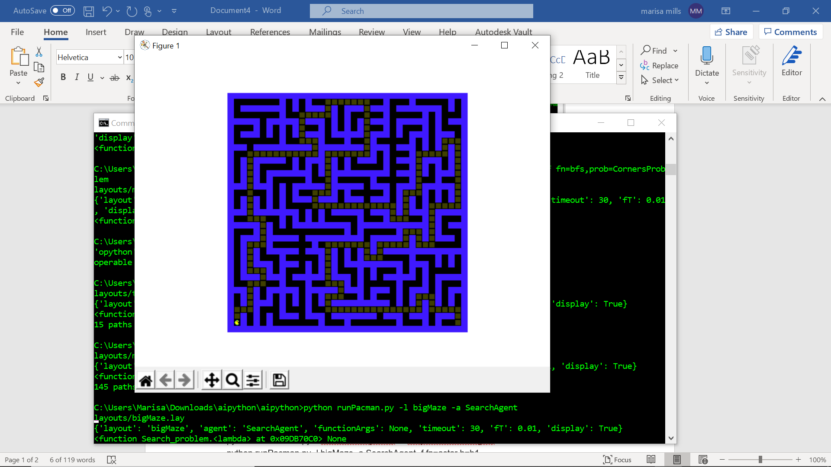

* python runPacman.py -l mediumMaze -a SearchAgent -f fn=bfs

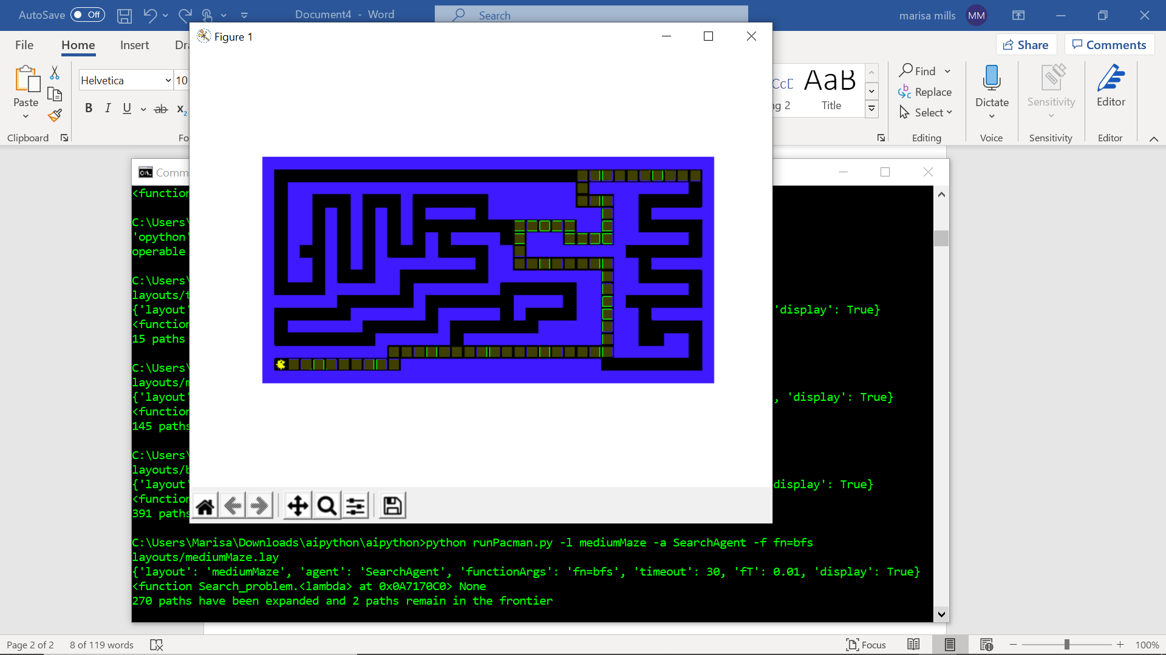

* python runPacman.py -l bigMaze -a SearchAgent -f fn=bfs

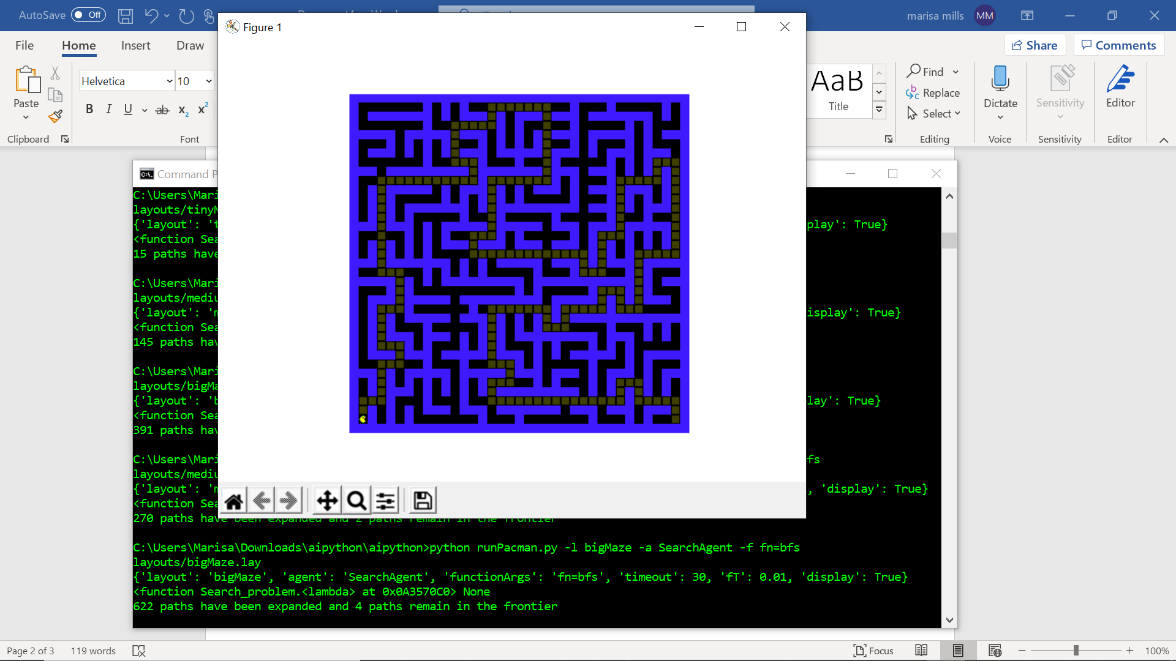

* python runPacman.py -l mediumMaze -a SearchAgent -f fn=ucs

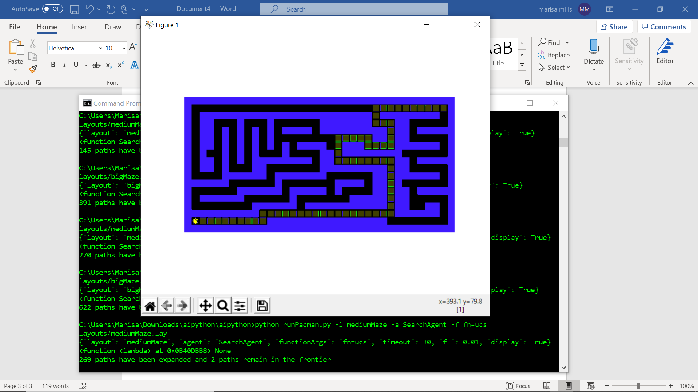

* python runPacman.py -l mediumDottedMaze -a StayEastSearchAgent

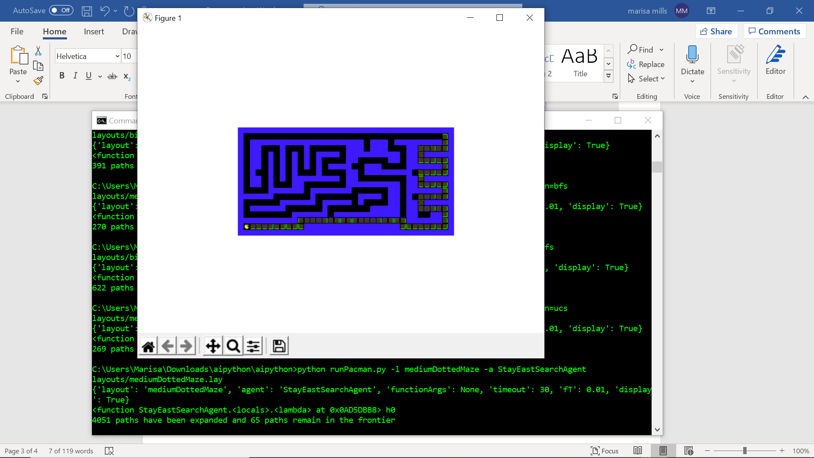

* python runPacman.py -l mediumScaryMaze -a StayWestSearchAgent

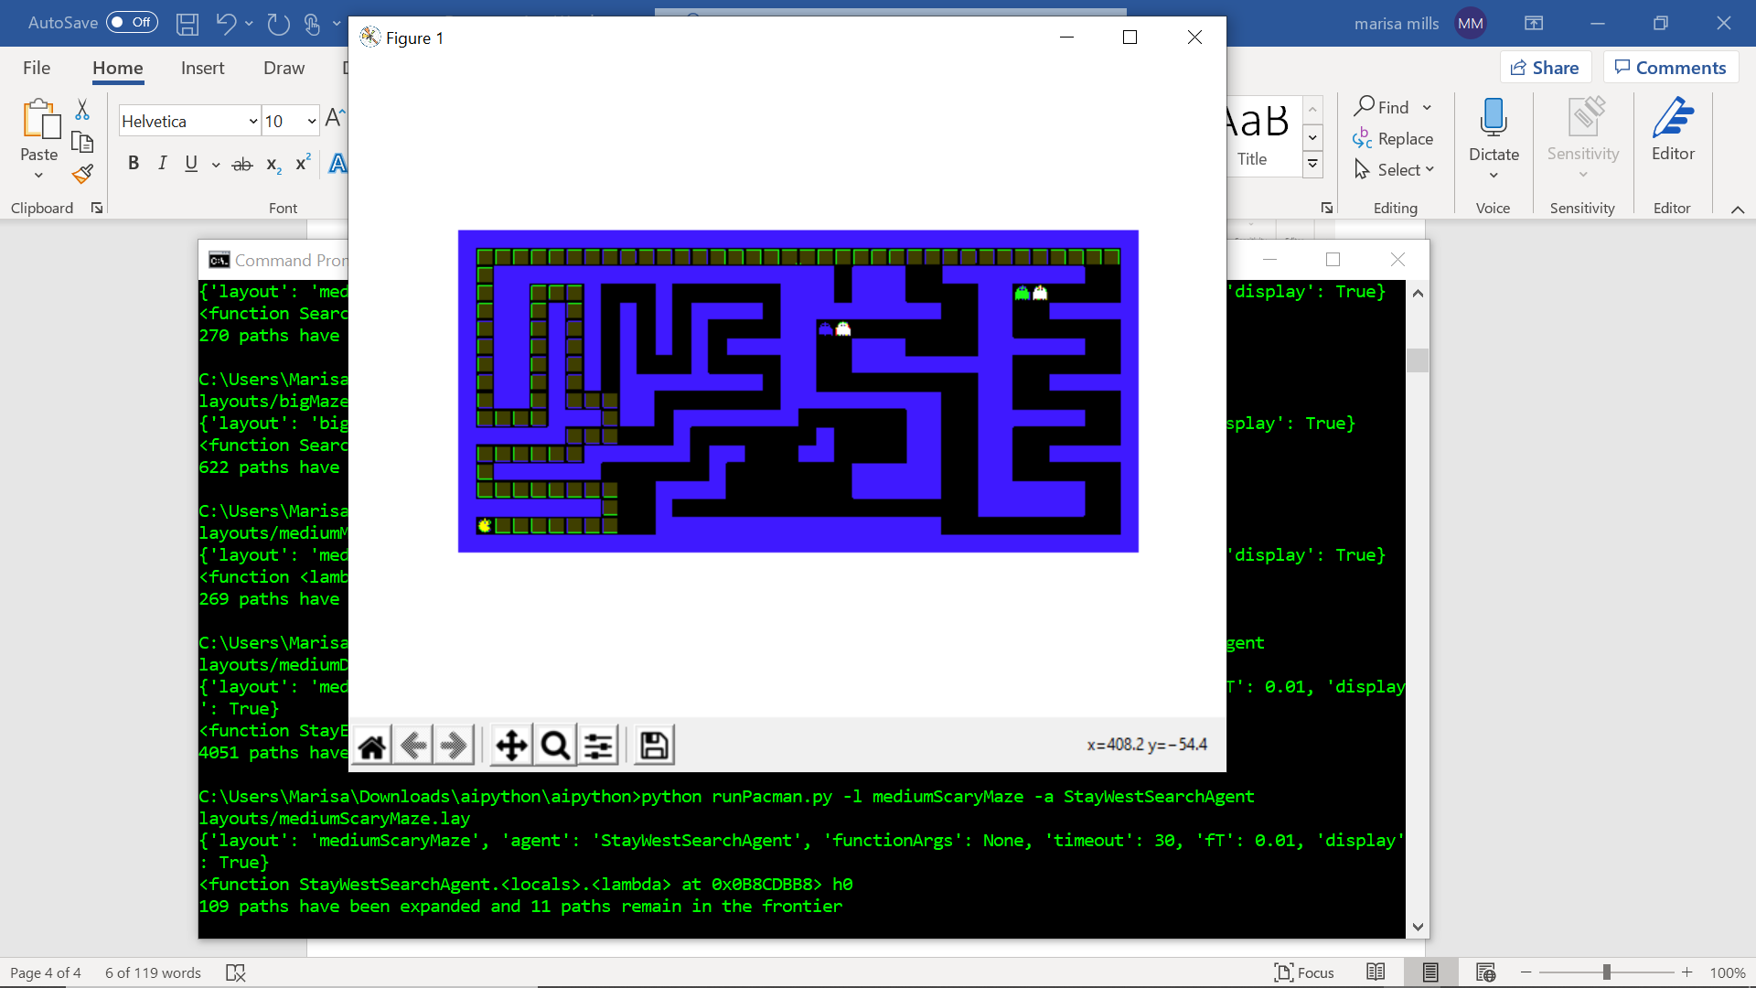

* python runPacman.py -l bigMaze -a SearchAgent -f fn=astar,h=h1

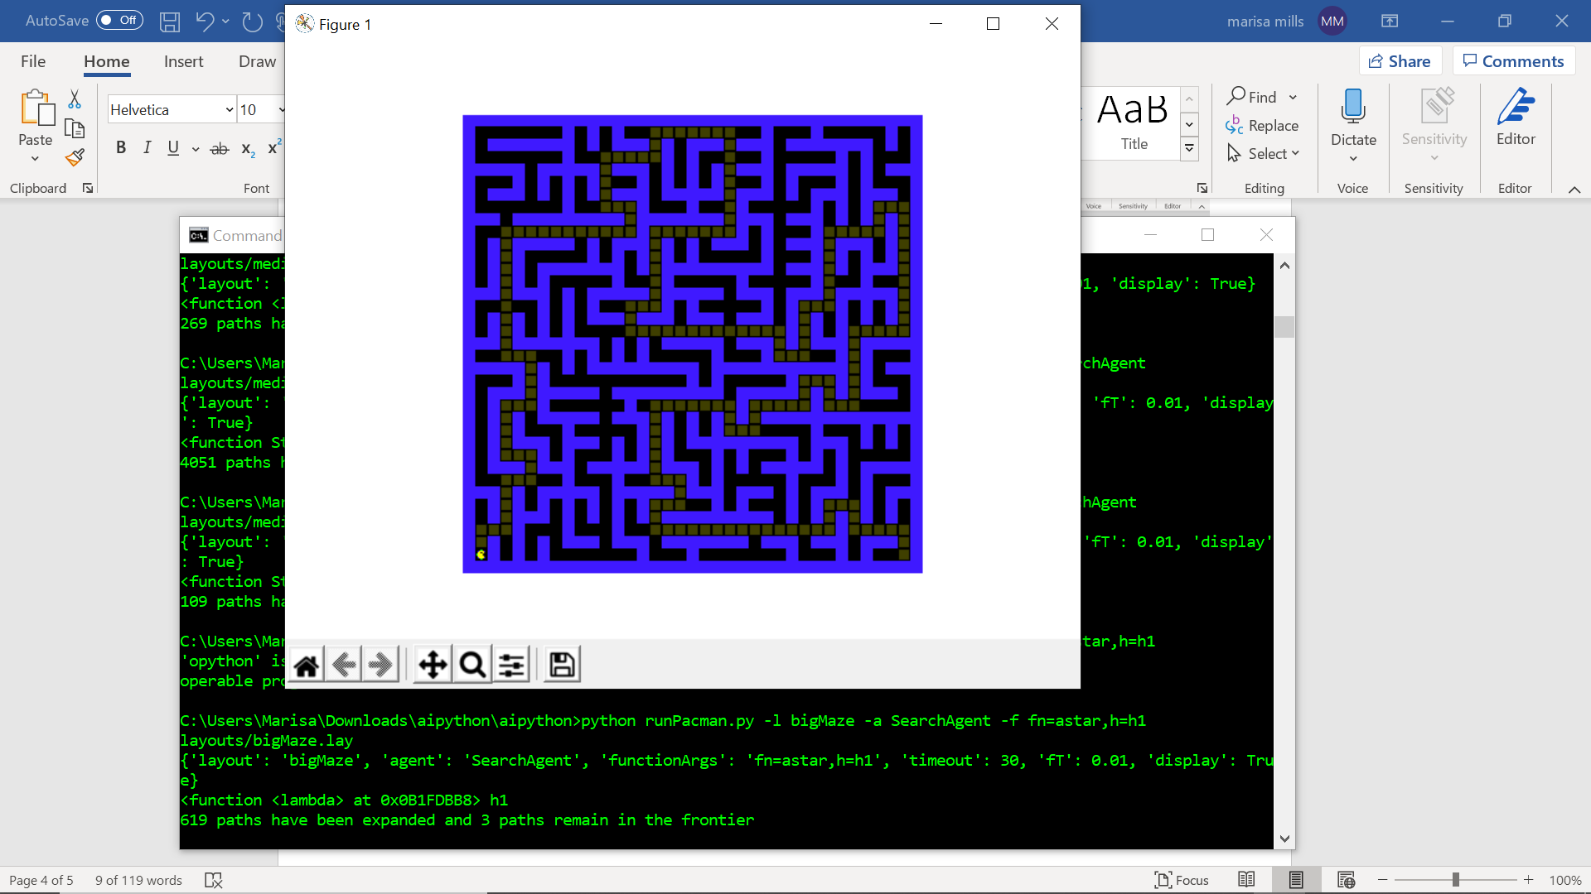

* python runPacman.py -l bigMaze -a SearchAgent -f fn=astar,h=h2

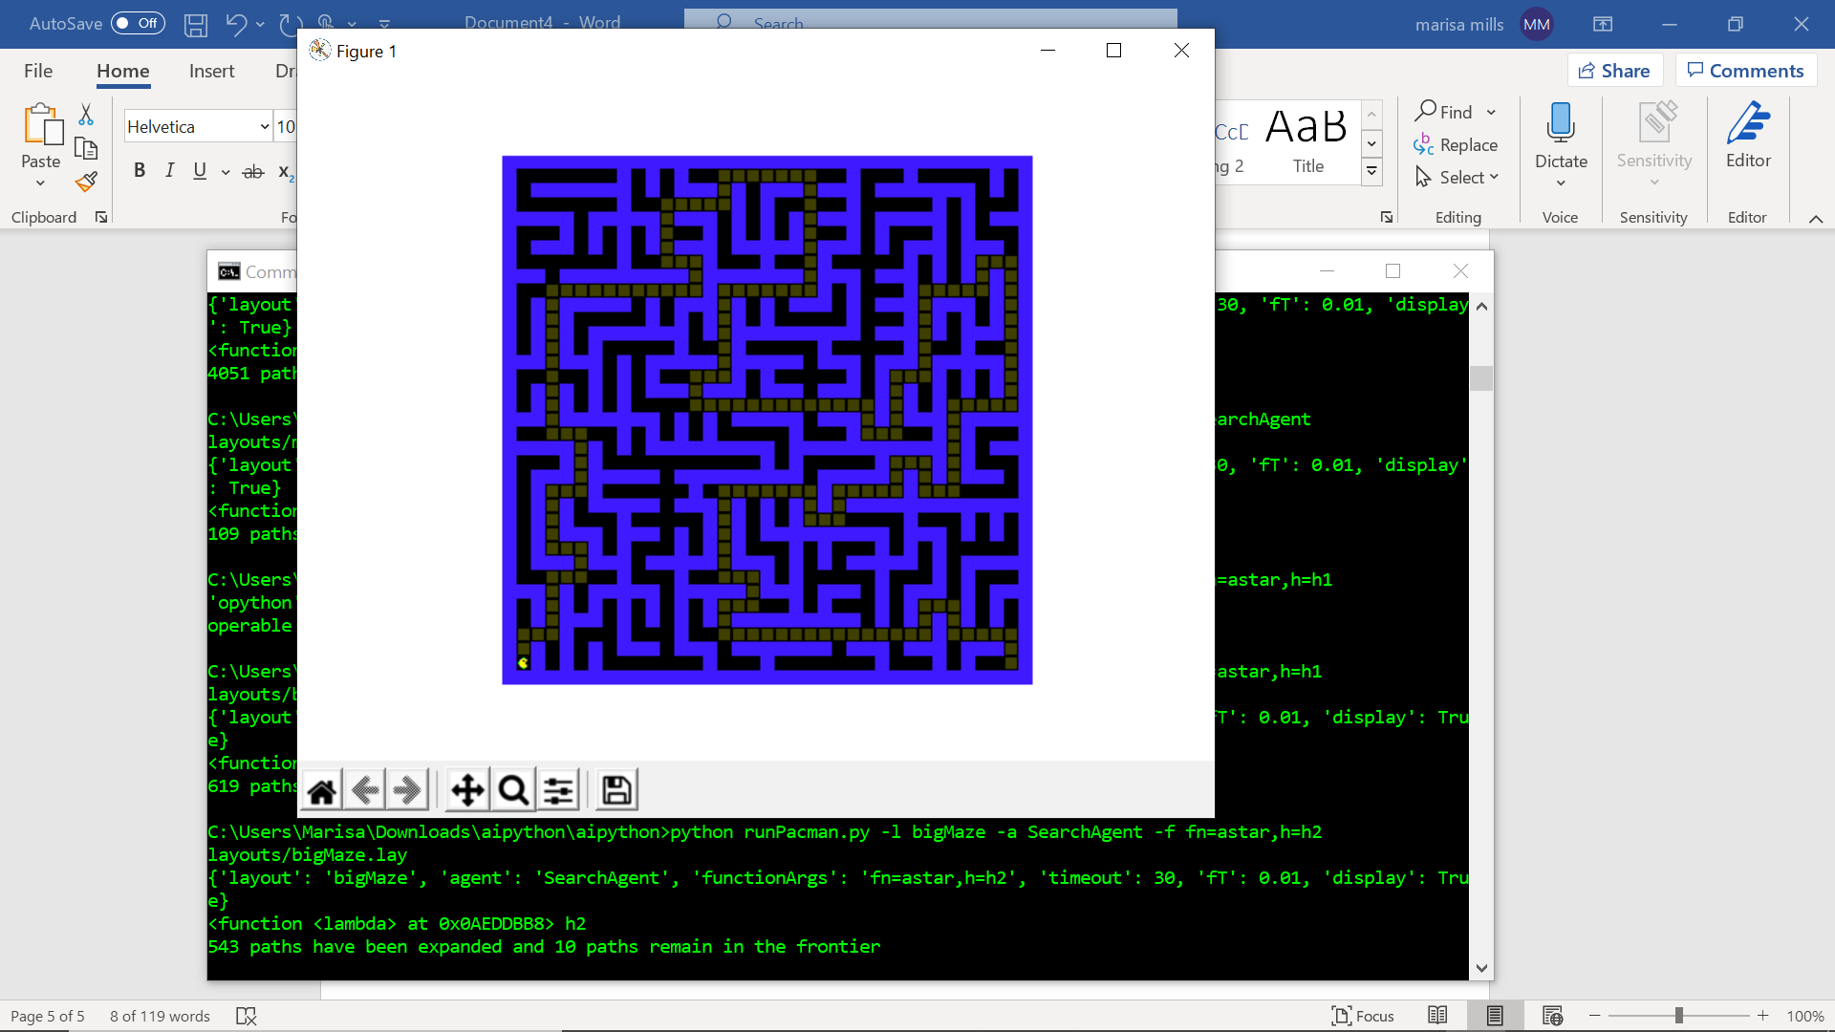

* python runPacman.py -l tinyCorners -a SearchAgent -f fn=bfs,prob=CornersProblem

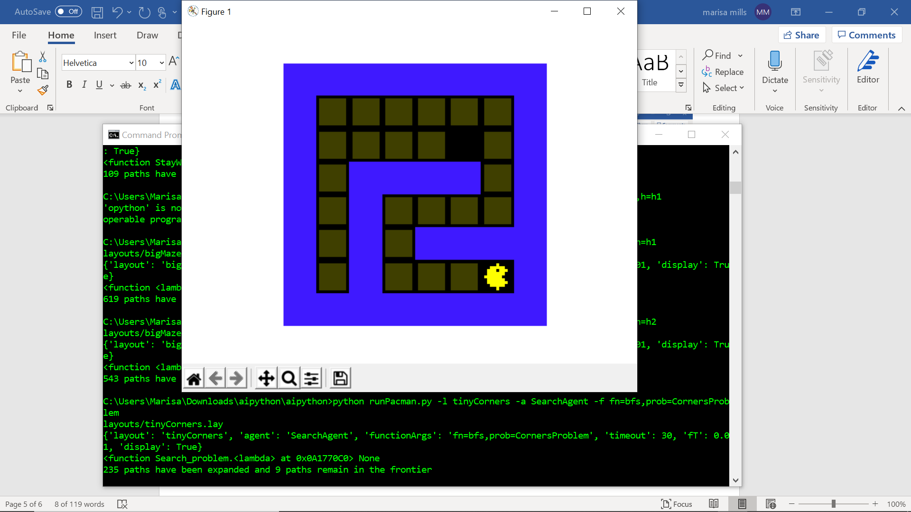

* python runPacman.py -l mediumCorners -a SearchAgent -f fn=bfs,prob=CornersProblem

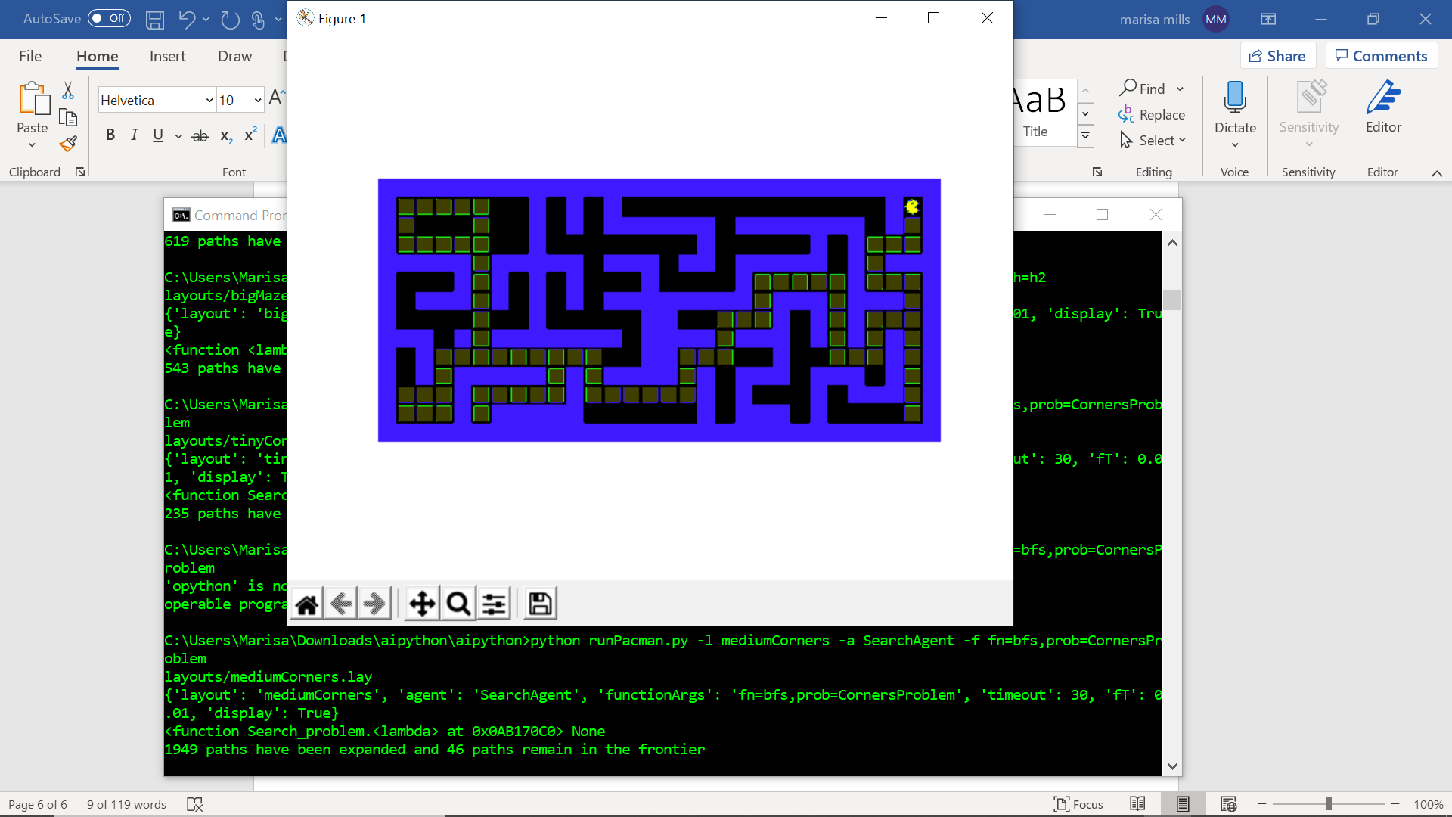

* python runPacman.py -l mediumCorners -a AStarCornersAgent

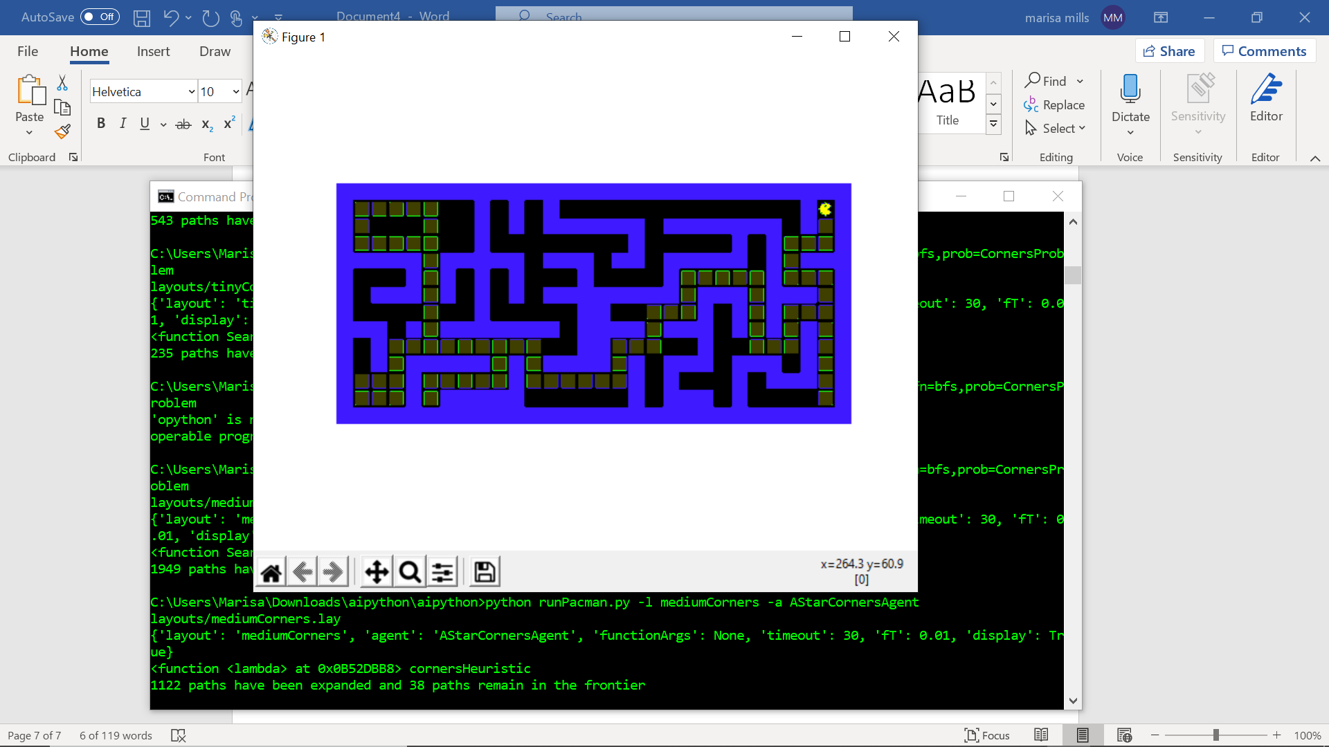

* python runPacman.py -l trickySearch -a AStarFoodSearchAgent

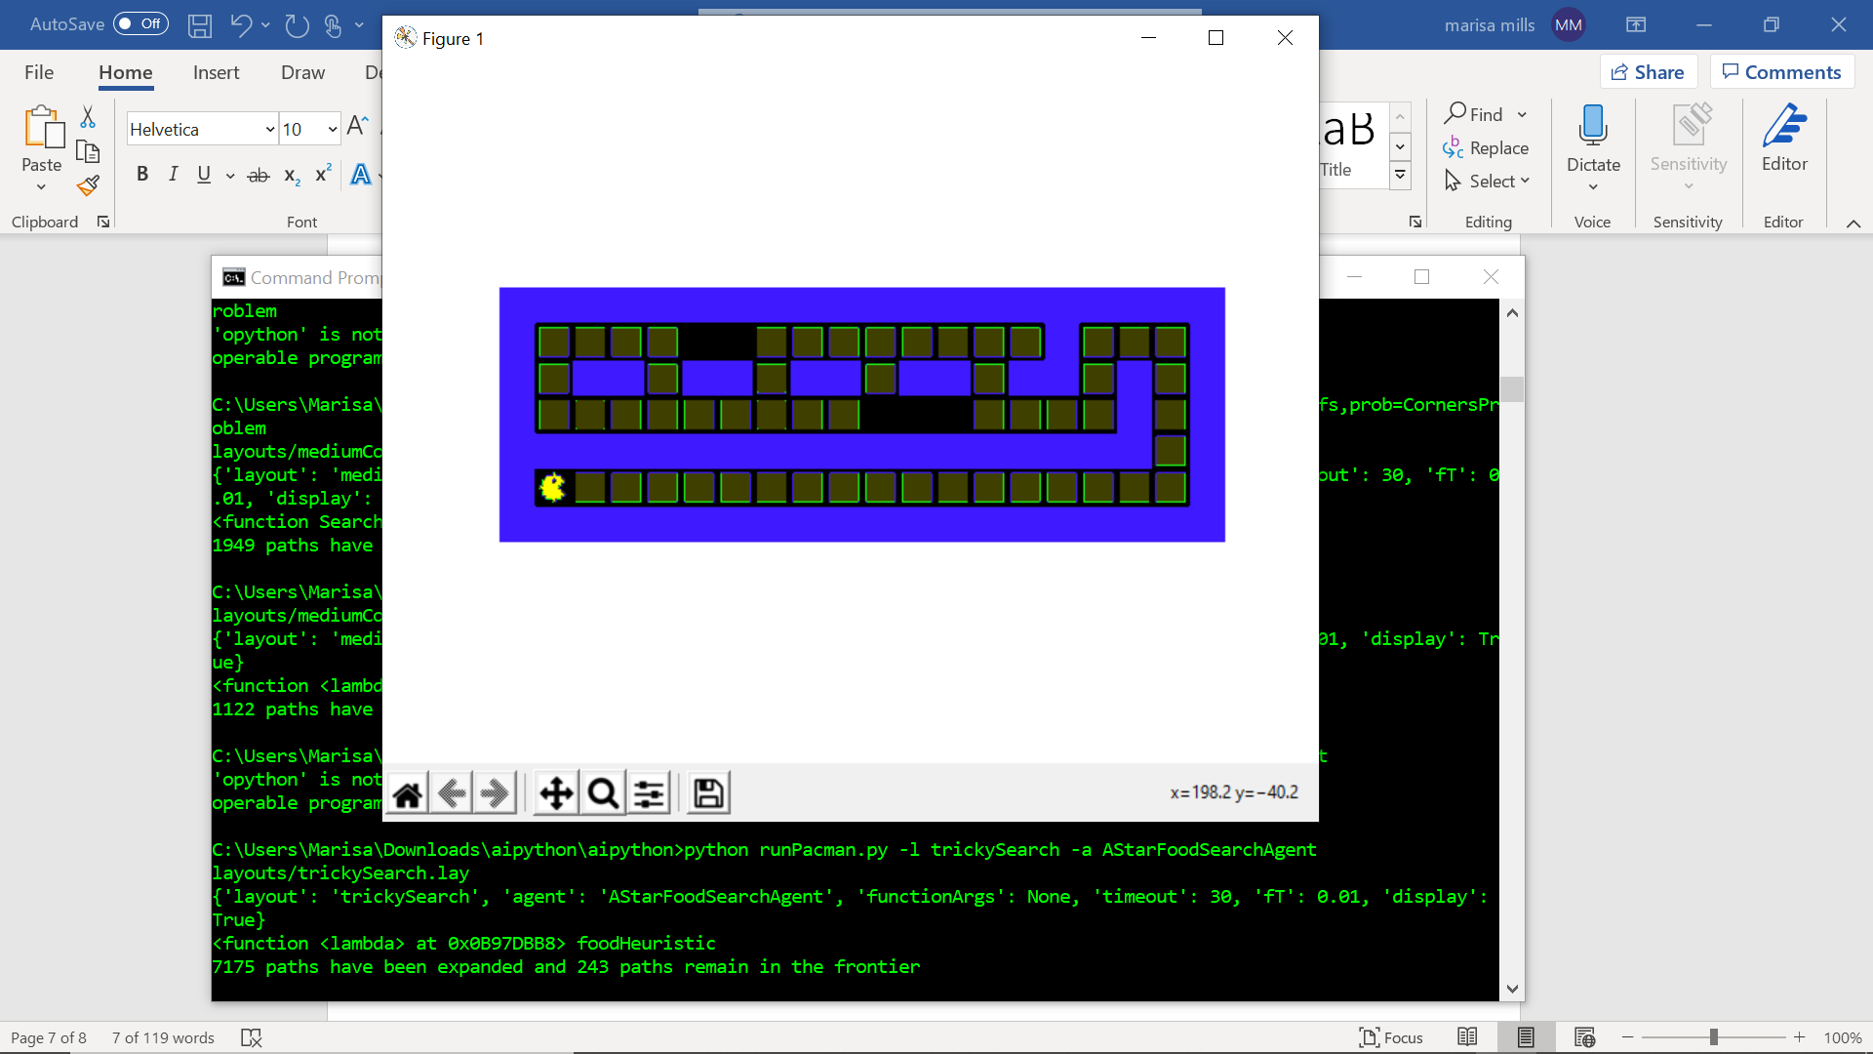

* python runPacman.py -l bigSearch -a ClosestDotSearchAgent

