**Installation guide**

1. Download the python installer (e.g *python-3.6.4.exe*) from <https://www.python.org/downloads/>.
2. Double click the *python-3.6.4.exe downloaded.*
3. Check the *Add Python 3.6 to PATH* and click *Install Now*

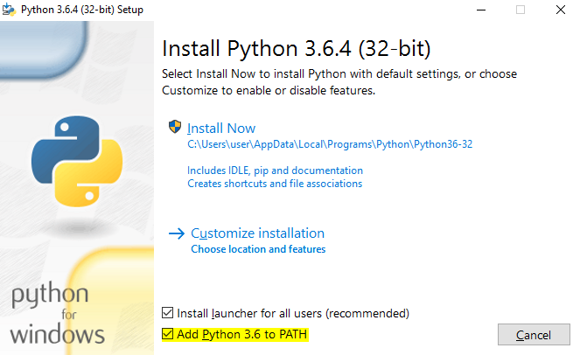

1. Click *Yes*
2. Wait until the installation is completed and click *Close*

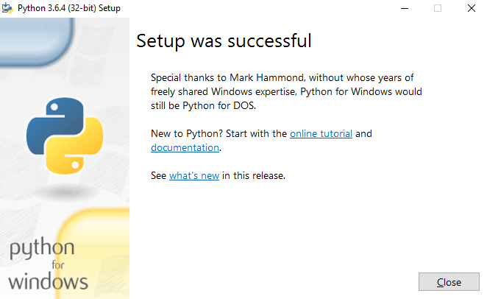

**Check the python installed**

1. To check if python installation is successful, open *Command Prompt*

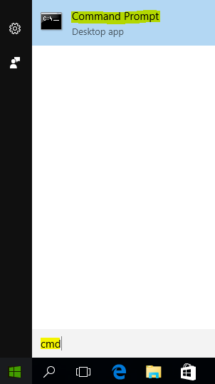

1. Type *python* and press *Enter*

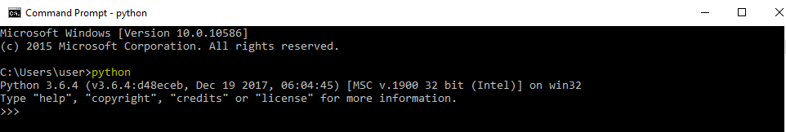

1. Then python version is displayed (e.g. *Python 3.6.4 …*)

**Install virtualenv**

1. Open *Command Prompt*
2. Type *pip install virtualenvwrapper-win* and press *Enter*
3. Type *mkvirtualenv python364_env* and press *Enter (Note: You can change the python364_env whatever you want.)*
4. The *python364_env* is now activated. (*You may refer here for more info about virtualenv https://github.com/davidmarble/virtualenvwrapper-win/.*)

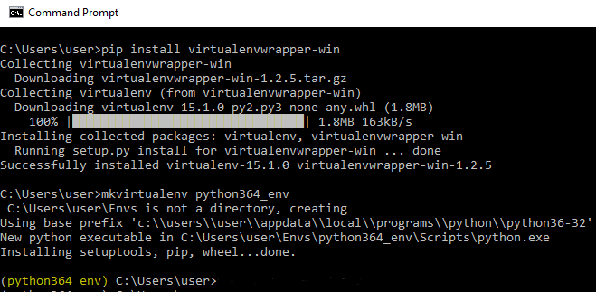

**Install the dependencies**

1. Open the *Command Prompt*
2. Activate the *python364_env* by typing *workon python364_env*
3. Go to the folder of the test scripts by typing *cd [path of the test scripts]* (*e.g cd Desktop\hyundai*)
4. Install the dependecies listed in requirements.txt by typing *pip install -r requirements.txt*

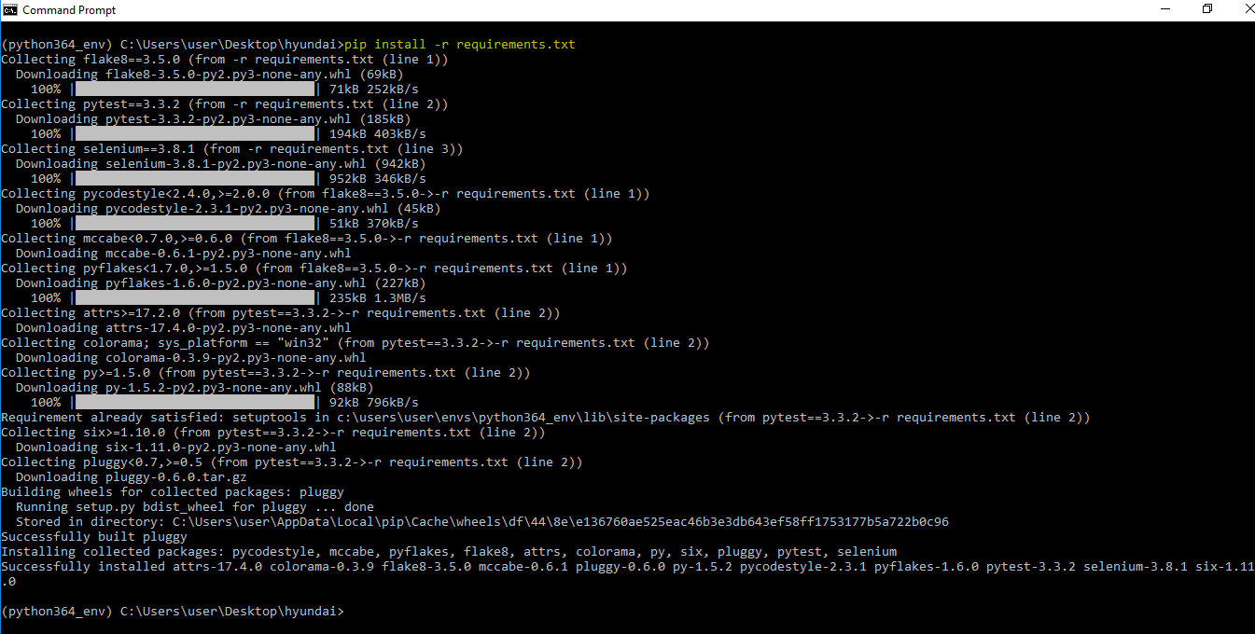

**Install Chromedriver**

1. Download the chromedriver.exe from <https://sites.google.com/a/chromium.org/chromedriver/downloads> or <https://chromedriver.storage.googleapis.com/index.html?path=2.35/>
2. Unzip the downloaded *chromedriver_win32.zip*
3. Copy the *chromedriver.exe* to *[python-path]/Scripts(e.g. C:\Users\user\AppData\Local\Programs\Python\Python36-32\Scripts)*