
CDU IT CODE FAIR 2026
DATA INNOVATION CHALLENGE | REMOTE CONNECTIVITY

Community Connectivity Atlas
Mapping and Prioritizing Connectivity Gaps in Remote Northern Territory Communities
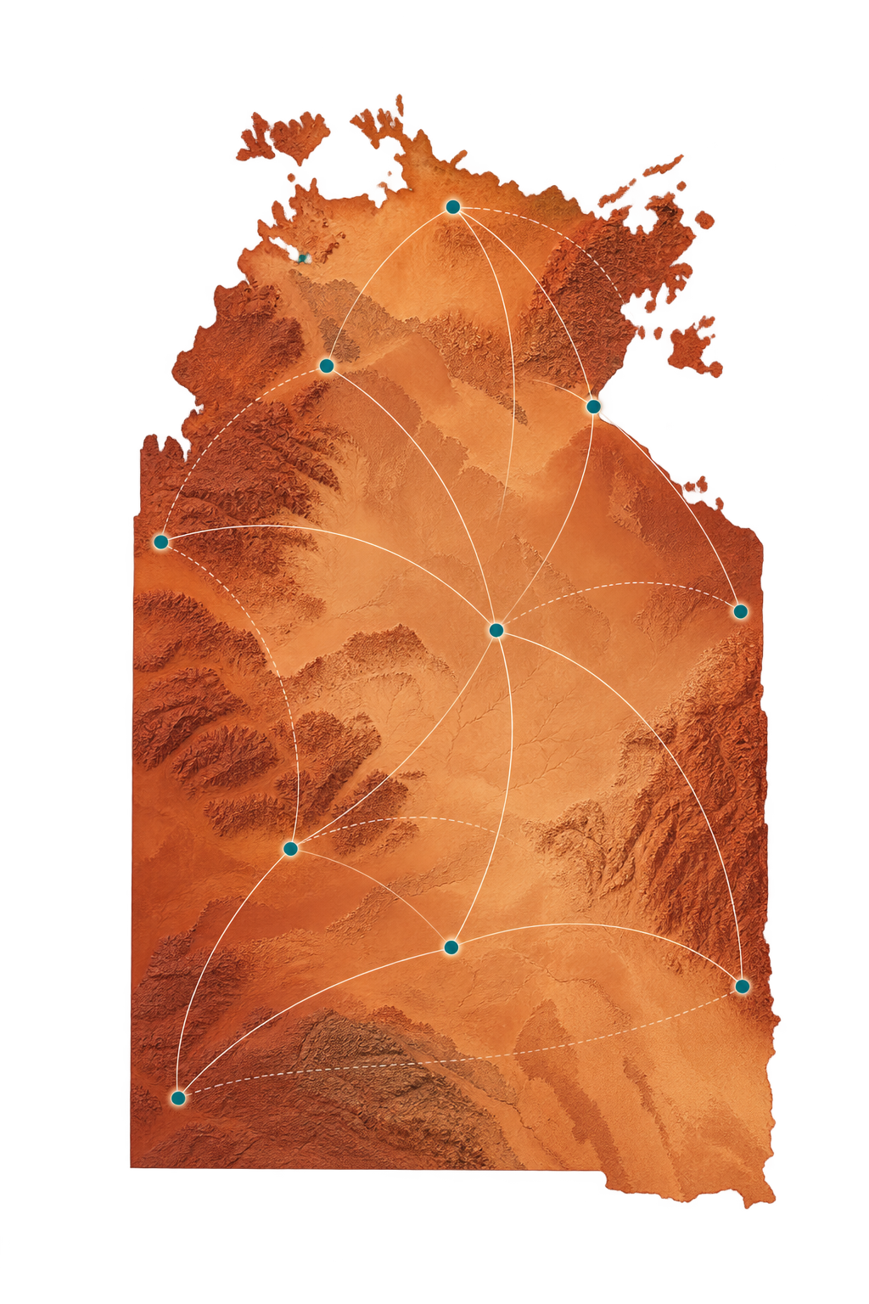

TEAM 019 | DARWIN CAMPUS | 30 SEPTEMBER 2026
TEAM MEMBER | PROJECT ROLE
Ngoc Loi Vong | Priority Analysis
Hoang Phuong Linh Le | Connectivity Data Analysis
Duong Trung Hieu | Mapping & Spatial Analysis
Maris Nguyen (Luong Thuy Dieu Nguyen) | Visualization

Table of Contents
List of Figures 3
List of Tables 4
Summary 5
1 Introduction 5
1.1 Problem and purpose 5
1.2 Scope and unit of analysis 5
2 Data and methodology 6
2.1 Sources and integration 6
2.2 Indicators and selection 6
2.3 Entropy weighting and ranking 7
2.4 Atlas implementation and checks 7
3 Findings 8
3.1 Coverage and data availability 8
3.2 Model weights and shortlists 8
3.3 Geographic and product interpretation 9
4 Discussion and limitations 9
5 Recommendations 10
References 11
Appendix Reproducibility 11
Scoring specification 12
AI usage declaration 13
Appendix Notebook figures 13
Appendix Interface and contextual screenshots 19

List of Figures
Figure A1 Candidate indicator correlation matrix 13
Figure A2 Entropy weights in the 792-site connectivity ranking 14
Figure A3 Ten highest-scoring sites in the connectivity ranking 14
Figure A4 Entropy weights in the 468-site population ranking 15
Figure A5 Ten highest-scoring sites in the population subset 16
Figure A6 Geographic distribution of connectivity priority 17
Figure A Connectivity and population ranking on the map 18
Figure A8 Community Connectivity Atlas overview 19
Figure A9 Australian Government connectivity mapping tool 20

List of Tables
Table 1 Analytical samples and indicators 7
Table 2 Outdoor mobile footprint by site type 8
Table 3 Entropy weighting results 8

Summary
Connectivity planning for Northern Territory (NT) communities requires evidence that can be inspected at the community level. This project brings together 792 BushTel site records with mapped mobile and terrestrial NBN coverage, infrastructure distances and available population. It produces a transparent priority analysis and a web atlas for exploring the underlying evidence. The 792 records include community types such as family outstations; they should not be described as 792 fully profiled remote communities.
In the analysed dataset, 442 of 792 sites (55.8%) have no mapped outdoor mobile coverage from any included network, while 350 (44.2%) are mapped as covered. Population is available for 468 sites and missing for 324 (40.9%). We therefore calculate a connectivity ranking across all 792 sites and a separate connectivity plus population ranking among the 468 with population data. Entropy weighting derives weights from the variation in each indicator. In the first ranking, the largest weights are the mobile gap (38.81%), mobile site distance (31.97%), and Wi-Fi distance (26.56%). In the second, population accounts for 49.83% of the separately recalculated weights.
The atlas lets users filter, inspect, shortlist and export site records. Its screening lenses provide an accessible way to explore the evidence. The EWM rankings support investigation, while final service and investment decisions require coverage checks, engineering review and engagement with Traditional Owners and residents.

1 Introduction

1.1 Problem and purpose
Remote connectivity affects access to telehealth, learning, employment, government services, and emergency communication. Public evidence is spread across community registers, infrastructure records, and coverage layers. The project asks which NT locations warrant closer investigation on the available mapped evidence, how the evidence can be compared transparently, and how potential population impact changes the shortlist. Its output is a screening tool for planners and community stakeholders, not a prediction of signal strength or a guarantee that premises can order service.
The practical problem is evidence and decision sequence. A mapped footprint, an infrastructure point and a community register each describe a different object, and none by itself shows whether residents experience reliable, affordable service. Combining them at a common site identifier allows an analyst to find apparent gaps, inspect the supporting fields and specify what still needs verification. The project therefore separates three questions: where mapped connectivity needs to appear high, where more people might be affected, and whether a technically and socially appropriate response is feasible. The first two are addressed by the rankings; the third requires information beyond this dataset.

1.2 Scope and unit of analysis
The analytical unit is a BushTel site record identified by community_id. The integrated dataset has 792 unique IDs and 31 source variables. These records include several site types, especially Family Outstations, and do not represent 792 distinct remote communities. Point coordinates represent sites rather than settlement boundaries.
This unit of choice matters when interpreting every percentage and map. Multiple named site records may relate to the same broader settlement or service area; conversely, an Indigenous Location statistical area need not align with one BushTel point. ABS 2021 Census DataPacks provide Indigenous Location tables, but joining a geographic population count to a point requires a documented match and a check of geography and reference year [9]. A site-level count should not be converted into the proportion of NT residents covered without a valid population denominator and a defensible link between sites and households. The 792-row sample is an operational inventory for screening, not a census of distinct communities.

2 Data and methodology

2.1 Sources and integration
BushTel provides site identity, type, coordinates and available population. The dataset documentation identifies 2021 ABS Census DataPacks for population and demographic context and an Australian Government spatial portal item for Indigenous Location geography [7]. The integrated table also holds mapped outdoor mobile coverage, terrestrial NBN flags and distances to recorded mobile and Wi-Fi infrastructure. Distance to a site is contextual evidence and does not establish usable coverage.
Integration should retain the original source fields alongside each derived indicator. A coverage flag represents the supplied spatial intersection or classification at a recorded coordinate, while a distance is calculated to a mapped point. The source date, coordinate precision, coverage technology, data license and meaning of a missing flag should be traceable. The report uses the executed notebook and accompanying project documentation as evidence for the calculations [4,7]. Where a field was derived upstream and its full spatial join procedure is not reproduced in the supplied material, the result is reported as an input to this analysis rather than as independently validated coverage.
Population matching deserves separate scrutiny. BushTel and ABS geography use different units and can differ in spelling, site boundaries and observation year. The available population_final field should be interpreted as a recorded or matched value for the 468 sites in the second model, not necessarily a current resident count at a household level. Retaining the 324 missing values makes the uncertainty measurable and avoids treating “unknown” as zero. Future updates should record the match method, source year, and whether a value belongs to the precise site, a nearby named locality, or a wider statistical area [9].
Population_final is available for 468 site records and missing for 324. The analysis retains unknown values rather than estimating them. The notebook reports no duplicate complete records or community IDs, and the four inputs to the full-sample ranking have no missing values.

2.2 Indicators and selection
The notebook recodes a missing mapped outdoor mobile footprint to mobile_need = 1 and a mapped footprint to 0. nbn_need = 0 if either fixed line or fixed wireless is marked “Yes”, otherwise 1. The continuous indicators are distance to the nearest recorded mobile site and distance to Wi-Fi infrastructure, in kilometers; greater distance is coded as greater screening need. Candidate features were checked for completeness, variance, and correlation. Overall mobile need and 4G need correlate at 1.00 in this sample, so including both would double count the same pattern. A general tower distance was also excluded to avoid overlapping infrastructure proximity. The 5G specific flag was excluded from the general access score. Population is reserved for the second ranking because of missingness and its distinct impact meaning.
The four selected full-sample indicators represent two types of evidence. Mobile and NBN need are binary absence flags in the supplied mapping, whereas mobile-site and Wi-Fi distances are continuous measures of separation from recorded infrastructure. Their directions are aligned before aggregation, so a larger normalized value always raises the score. This design does not equate distance with service quality. A distant tower can still provide service, and a nearby asset may be inaccessible or lack capacity. The Wi-Fi field is especially a proximity cue: the table does not show public access terms, operating status or whether the site is suitable for a household connection.

2.3 Entropy weighting and ranking
For each ranking, the notebook normalizes each indicator to the observed 0–1 range, computes the share of each community in the indicator total, estimates Shannon entropy, and normalizes entropy divergence to weights summing to one. Priority score is the weighted sum of the normalized indicators; higher scores indicate higher relative mapped need or impact within that ranking. The two models recalculate normalization and weights on different subsets, so their scores and rank positions are not directly comparable. Entropy weights express variation in this particular sample, not ethical importance, causal effects or the cost effectiveness of interventions. NBN gains a small weight because the binary gap varies little in these records.
The normalization is fitted to the observed minimum and maximum in each model. As a result, the numeric score is relative to the sites included and can change when a new extreme value, source revision or missing-data decision changes the sample. Entropy weighting then gives a larger weight to an indicator whose normalized values are more dispersed across the included records. It does not ask whether a gap is urgent, whether a population figure is precise, or whether an intervention would work. The equations and zero-share convention are set out in the reproducibility appendix; Table 1 identifies the differing samples and indicator sets.
Two independent outputs are necessary because a complete-case population analysis would remove 324 sites from the primary need screen. Ranking 1 uses four connectivity-related inputs for all 792 records. Ranking 2 adds population and refits all weights for the 468 records with a value. A site can rise in Ranking 2 because of population even if its connectivity flags look comparatively favorable. The atlas should show the model's name and included sample wherever it displays a rank; a difference between the lists is an analytical result, not an error to be averaged away.
Ranking | Records | Indicators
Connectivity need | 792 | Mobile gap; terrestrial NBN gap; mobile site distance; Wi-Fi distance
Connectivity and population | 468 | The same four indicators plus available population
Table 1 Distinct analytical samples and indicators. Source: executed EWM notebook.
The analytical workflow integrates BushTel site records and coordinates with mapped mobile and terrestrial NBN indicators and infrastructure distances. It produces a site-level dataset, two independently fitted entropy-weighted rankings, and an atlas for exploring the results.

2.4 Atlas implementation and checks
The ConnectNT prototype provides a point map, accessible table, search and filters, evidence cards, a shortlist of comparison and exports. Its Need, Impact, Delivery context, Resilience and Combined lenses are product screening views [8]. The Combined score uses proposed weights of 50% connectivity need, 20% population impact, 15% infrastructure proximity and 15% historical cyclone exposure, with missing components excluded and the remaining weights renormalized. These assumed weights differ from the data-derived EWM weights in the notebook and should not be read as the same ranking.

3 Findings

3.1 Coverage and data availability
Mapped outdoor mobile coverage is “Yes” at 350 of 792 sites (44.2%) and “No” at 442 (55.8%). The comparable 4G counts are 349 and 443; 5G is mapped at only 53 sites in this table. Fixed line NBN is flagged at 30 sites and fixed wireless at one. These are counts of site rows in the integrated table, not population coverage rates or verified household serviceability. Median nearest mobile site distance is 19.20 km; median recorded Wi-Fi distance is 84.80 km. For the population subset, median recorded population is 14.5, indicating a skewed distribution with a maximum of 3,362. The missing population rate is 40.91%.
The small fixed-line and fixed-wireless counts are particularly easy to misread. They report those two terrestrial flags in this integrated table, rather than all possible nbn technologies or all fixed broadband arrangements. The nbn rollout map also distinguishes fixed wireless and satellite pathways and uses location-specific service information [3]. Similarly, the 5G count is a technology-specific mapped footprint, not the number of sites with no usable mobile access. These qualifications should travel with the headline percentages in presentations and dashboard labels.
Site type | Sites | Mapped mobile Yes | Share mapped
Family Outstation | 630 | 210 | 33.3%
Other site types combined | 162 | 140 | 86.4%
All types | 792 | 350 | 44.2%
Table 2 Outdoor any-network mobile footprint by BushTel site type. Source: supplied CSV, mobile_outdoor_coverage_any_network. Counts are site records, not households or people.
The Family Outstation subset has a median 26.26 km to the nearest recorded mobile site, compared with 19.20 km for all sites. This descriptive difference does not establish the quality of service at either group. Outstations are also more numerous in this dataset, so the count distribution is strongly affected by the composition of the BushTel extract.
Table 2 makes the composition effect explicit: 630 of the 792 records are Family Outstations, and 210 of those 630 have mapped outdoor any-network mobile coverage. The 33.3% mapped share is lower than the 44.2% share across all records, but neither percentage estimates a resident-level digital inclusion rate. A comparison of medians also hides variation within each site type. For planning, the next useful check is a site-by-site review of the high-scoring outstations, including whether coordinates, name and occupancy information are current.
The mapped any-network mobile share is 44.2% (350/792) across all site records and 33.3% (210/630) for Family Outstations. These denominators describe BushTel records, not people or households.

3.2 Model weights and shortlists
Indicator | Connectivity need | With population
Unmapped outdoor mobile | 38.81% | 22.14%
Unmapped terrestrial NBN | 2.66% | 0.55%
Nearest mobile site distance | 31.97% | 15.46%
Nearest Wi-Fi distance | 26.56% | 12.03%
Population | — | 49.83%
Table 3 EWM weights from the executed notebook; each column sums to approximately 100%.
The four-indicator weight plot is reproduced as Appendix Figure A2.
The top ten connectivity needs records, in order, are WALYTJATJATA, MURUN MURULA, KURKUTJARA, JIWARANPA, UKATJUPU, WANGALINJI, MAMADI, DUCK PONDS, MIRRIDI and BATTON HILL. All ten have “No” for mapped outdoor mobile and both terrestrial NBN types in the notebook. These names identify candidates for verification, not a final investment list. The population model instead ranks NHULUNBUY, MANINGRIDA, BATTON HILL, WOGYALA, ORRTIPA-THURRA, GALIWINKU, MUNGALAWURRU, NITJPURRU, ACACIA LARRAKIA and MURRANJI in its top ten. Large population can lift a location even when mobile coverage is mapped: NHULUNBUY leads with population 3,362 and mapped mobile and terrestrial NBN. This demonstrates why “population impact” must be interpreted separately from the “connectivity gap”.
Table 3 shows how the two fits answer different questions. In Ranking 1, mobile need receives 38.81%, distance to the nearest recorded mobile site 31.97%, Wi-Fi distance 26.56%, and the terrestrial NBN flag for the small remaining share. These weights arise from the observed distribution and sum to approximately 100%; they are not policy targets. In Ranking 2, the population receives 49.83% of the refitted total. The contrast between a remote site with several mapped gaps and a larger population center is therefore expected. It calls for separate “need” and “potential reach” discussions before a shared shortlist is approved.
The ten leading site records in Ranking 1 are displayed in Appendix Figure A3. The notebook image title uses “Communities”; each bar represents one BushTel site record.

3.3 Geographic and product interpretation
The notebook plots site coordinates by relative score and scales population-subset markers by population. These point maps help locate candidates for investigation; they do not model terrain, signal propagation, roads or settlement boundaries. The atlas makes the underlying evidence easier to inspect, subject to a final check that its data and calculations match this report.

4 Discussion and limitations
A coverage map is a modelled provider's footprint; it cannot establish indoor service, signal quality, affordability, network capacity or availability at a specific premise. A tower or Wi-Fi site can be geographically near but unusable because of terrain, spectrum, capacity, access restrictions, power or backhaul. “No mapped terrestrial NBN” also excludes satellite and other options; it must not be phrased as no internet. The NBN rollout map is designed for location checks, and service eligibility requires a provider check [3].
This caution is supported by the ACCC, which discontinued its own mobile coverage analysis in the 2025 Mobile Infrastructure Report because modelling assumptions were insufficiently transparent and maps were difficult to compare [10]. The project can still use the supplied flags as consistent screening inputs but should avoid treating a binary intersection as observed performance. A field check could combine provider address checks, device tests at relevant buildings and routes, and resident reports at different times. Disagreements should be retained as evidence to investigate rather than forced into a single Yes/No value.
Population missingness is substantial and potentially uneven across site types. Restricting Ranking 2 to observed records changes both the sample and entropy weights. Its population weight of 49.83% can amplify larger towns irrespective of connectivity gaps. The observed near equality of 4G and any mobile coverage is specific to the supplied table. A future refresh could change correlations and weights, so model versions and extraction dates need to be recorded. There is no ground truth on actual connectivity failures, deployment costs or realized benefits, and no formal sensitivity test in the supplied notebook. Consequently, the project cannot quantify improvement in service or rank cost effectiveness.
Missingness can also bias the second model if sites without population are systematically smaller, newer or less documented. The observed subset is not a random sample merely because it has 468 rows. An appropriate sensitivity report would compare the distributions of site type, coverage status and infrastructure distance between sites with and without population, then state how the 468-site results change under defensible alternatives. No such output is claimed here. If a model is refreshed, both ranks and weights must be recalculated and the prior version archived so a change in shortlist can be traced to data or method.
The dashboard makes site evidence and uncertainty easier to inspect. The product documentation describes offline-capable static delivery after the first browser load [8], while the interface includes a skip link and results table. These features do not establish field usability or accessibility without testing.
Community names, location and population may have cultural and governance implications. Publish only approved public fields, avoid presenting a small outstation as a deficit label, and seek locally appropriate review with Traditional Owners and community representatives. Community priorities, language, cultural authority, consent, and data sovereignty should guide any transition from screening to fieldwork. A provider or government agency should validate its own infrastructure information before action.
The National Indigenous Australians Agency framework links governance of Indigenous data to self-determination and stronger partnership with Aboriginal and Torres Strait Islander communities [11]. In this project that principle has concrete implications: discuss intended users and access controls; verify naming and location display with relevant representatives; allow corrections and contextual explanations; and avoid publishing sensitive details simply because coordinates exist in a public extract. A candidate community should be able to challenge the evidence and shape the question being investigated. Such engagement is a prerequisite for investment decisions, not a validation box after the ranking is complete.

5 Recommendations
The rankings are most useful as an ordered investigation queue. A technical review should record the original site identifier, source versions, evidence status and reason for including or excluding each candidate. It should not collapse a family outstation into a major community with a similar name. Where an administrative or named settlement aggregation is needed, define it separately and obtain local validation. A short sensitivity exercise could vary the Wi-Fi distance indicator, remove population from the second model and compare overlap among top-ranked sites; report the actual output only after running it.
First, use the connectivity ranking to identify candidates for joint evidence review, then check each candidate against current operator maps, nbn serviceability, field measurements, and local knowledge. Record whether an apparent gap reflects no mapped coverage, uncertain data, poor experienced service or a mix. Second, treat the population ranking as a separate impact view; never drop the 324 sites with unknown population from the need screen. Flag uncertainty on every shortlist and document change in priority when plausible weights or thresholds are varied.
Third, commission a feasibility stage for shortlisted locations covering terrain, network options including satellite, power, backhaul, capital and operating costs, maintenance and emergency resilience. Engage Traditional Owners and residents before choosing an intervention. Fourth, maintain a versioned source register with source owner, date, license, definitions and validation status for BushTel, NBN, Wi-Fi and mobile layers. Reconcile atlas lens calculations against the Python results or label them clearly as different models. These steps turn the atlas into a traceable screening workflow while preserving community choice.
Test atlas search, keyboard access and offline loading under low bandwidth. Require reviewers to reproduce a shortlist and inspect the source and uncertainty for every indicator.

References
[1] Northern Territory Government. BushTel Remote Communities of the NT. https://bushtel.nt.gov.au/ (accessed 29 September 2026).
[2] Australian Competition and Consumer Commission. Mobile Infrastructure Report and data release. https://www.accc.gov.au/by-industry/telecommunications-and-internet/mobile-services-regulation/mobile-infrastructure-report (accessed 29 September 2026).
[3] nbn. nbn rollout map. https://www.nbnco.com.au/learn/rollout-map (accessed 29 September 2026).
[4] Project team. Remote_Connectivity_EWM.ipynb, supplied executed analysis notebook, September 2026.
[5] Project team. Community Connectivity Atlas prototype. https://community-connectivity-atlas.duongtrghieu.chatgpt.site/ (accessed 29 September 2026).
[6] Australian Government Department of Infrastructure, Transport, Regional Development, Communications, Sport and the Arts. First Nations Digital Inclusion, including the First Nations Connectivity Mapping Tool. https://www.infrastructure.gov.au/media-communications/first-nations-digital-inclusion (accessed 29 September 2026).
[7] Project team. Dataset README, supplied README (1)(1).md, September 2026.
[8] Project team. ConnectNT Investment Lens product vision, supplied PRODUCT_VISION.md, September 2026.
[9] Australian Bureau of Statistics. 2021 Census DataPacks, Indigenous Locations. https://www.abs.gov.au/census/find-census-data/datapacks (accessed 29 September 2026).
[10] Australian Competition and Consumer Commission. Mobile Infrastructure Report 2025, November 2025. https://www.accc.gov.au/system/files/Mobile%20Infrastructure%20Report%202025.pdf (accessed 29 September 2026).
[11] National Indigenous Australians Agency. Framework for Governance of Indigenous Data. https://www.niaa.gov.au/resource-centre/framework-governance-indigenous-data (accessed 29 September 2026).

Appendix Reproducibility
The Python notebook documents indicator selection, two ranking models, weights and plots. Its input filename is remote_community_connectivity_data.csv. Reproduction requires the corresponding input table and source data definitions.

Scoring specification
For each ranking, the Entropy Weight Method calculates the following quantities independently. Let xᵢⱼ be the value of indicator j at site i, n the number of eligible sites, and zᵢⱼ its normalised value.
1 Normalization
$$z_{ij}=\frac{x_{ij}-\min_{i}x_{ij}}{\max_{i}x_{ij}-\min_{i}x_{ij}}$$
Normalize each nonconstant indicator to the range 0–1. Larger values represent greater mapped need or, for population, greater potential impact.
2 Indicator shares
$$p_{ij}=\frac{z_{ij}}{\sum_{k=1}^{n}{z_{kj}}}$$
Calculate each site’s share of the total normalized value for indicator j.
3 Entropy
$$e_{j}=-\frac{1}{lnn}\sum_{i=1}^{n}{p_{ij}}ln\left(p_{ij}\right)$$
Calculate Shannon entropy, using the convention 0 ln(0) = 0.
4 Entropy weights
$$w_{j}=\frac{1-e_{j}}{\sum_{k=1}^{m}{\left(1-e_{k}\right)}}$$
Convert entropy divergence into indicator weights. The weights within each ranking sum to one.
5 Priority score
$$S_{i}=\sum_{j=1}^{m}{w_{j}}z_{ij}$$
Sum the weighted indicators to obtain the relative priority score for site i. Higher scores indicate higher relative mapped need or impact within that ranking.
Constant indicators are excluded before weighting. The 792-site and 468-site models separately recalculate the minimum, maximum and weights; their scores are therefore not directly comparable. The notebook contains an executable implementation.

AI usage declaration
OpenAI Codex assisted with editing the language, structure, equations, and Word formatting of this report. The analytical results and project materials were supplied by the team. The team is responsible for checking the final text, figures, data sources, and submission requirements.

Appendix Notebook figures
The following figures reproduce seven notebook screenshots. Their labels describe relative screening results for BushTel site records. The source is Remote_Connectivity_EWM.ipynb.
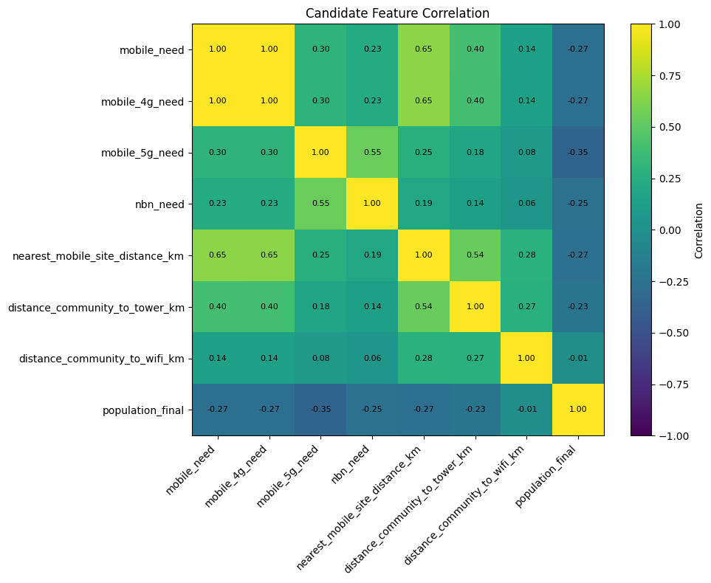
Figure A1 Candidate indicator correlation matrix. The observed correlation between overall mobile need and 4G need is 1.00.
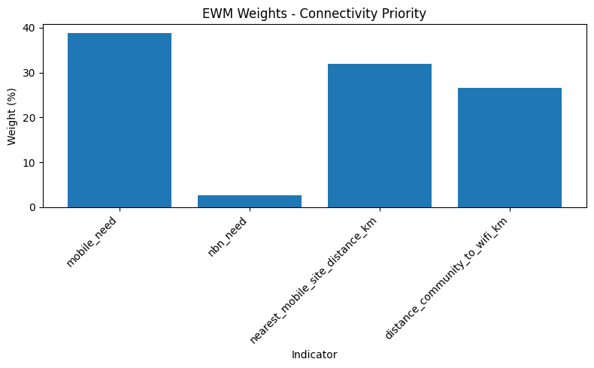
Figure A2 Entropy weights in the 792-site connectivity ranking.
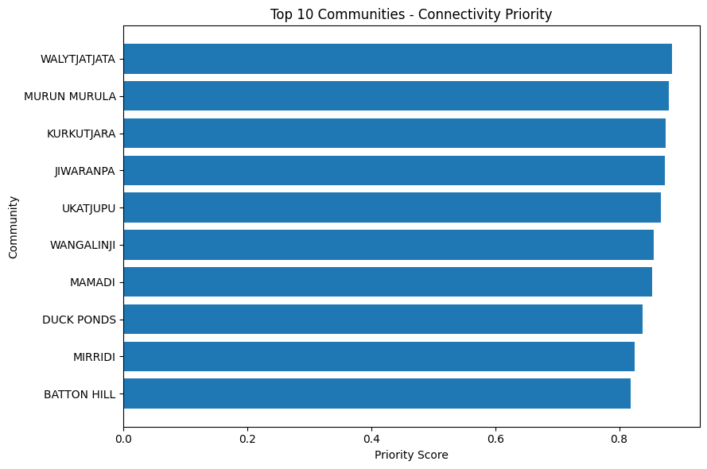
Figure A3 Ten highest-scoring BushTel sites in the connectivity ranking. The original plot title uses “Communities”.
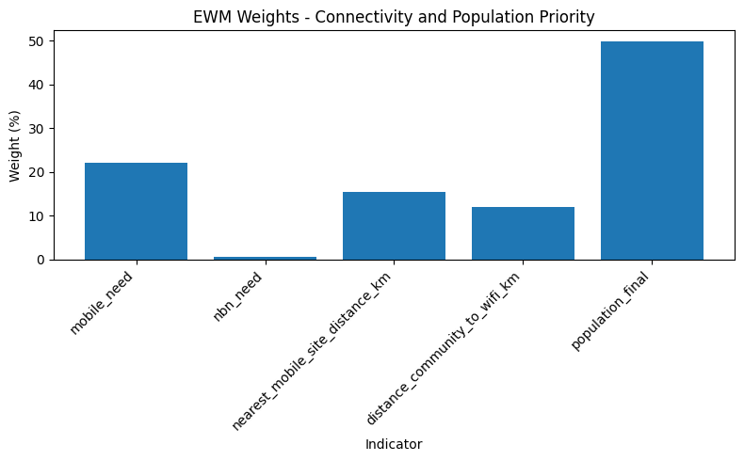
Figure A4 Entropy weights in the 468-site connectivity and population ranking.

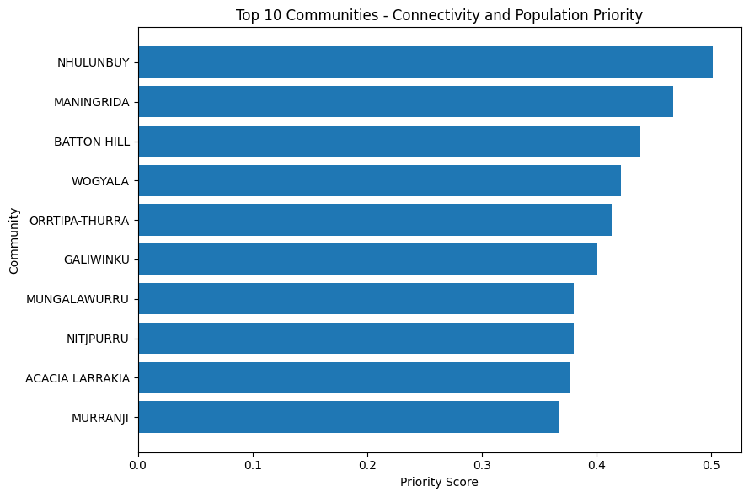
Figure A5 Ten highest-scoring site records in the population subset. Scores use weights fitted separately from Ranking 1.
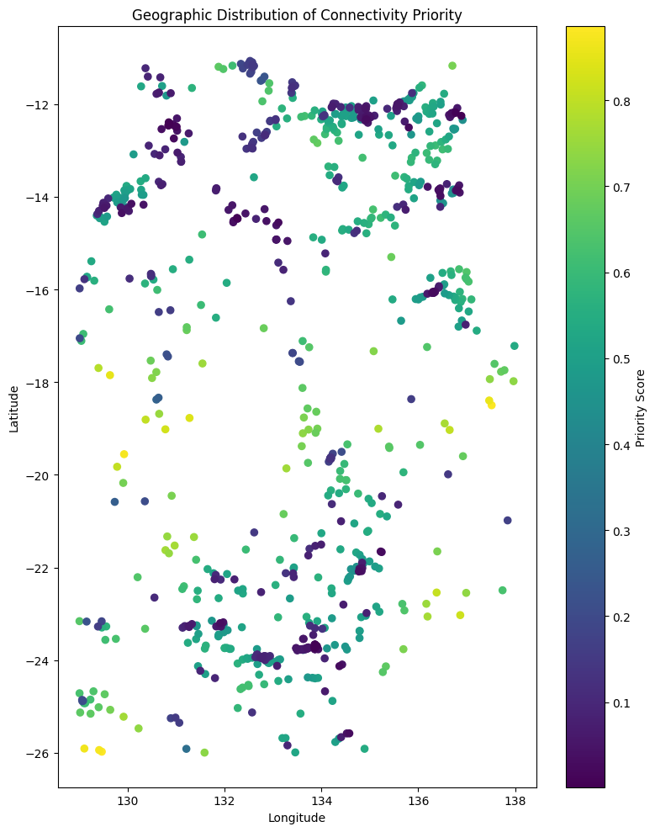
Figure A6 Geographic point distribution of connectivity priority; longitude and latitude are plotted directly.

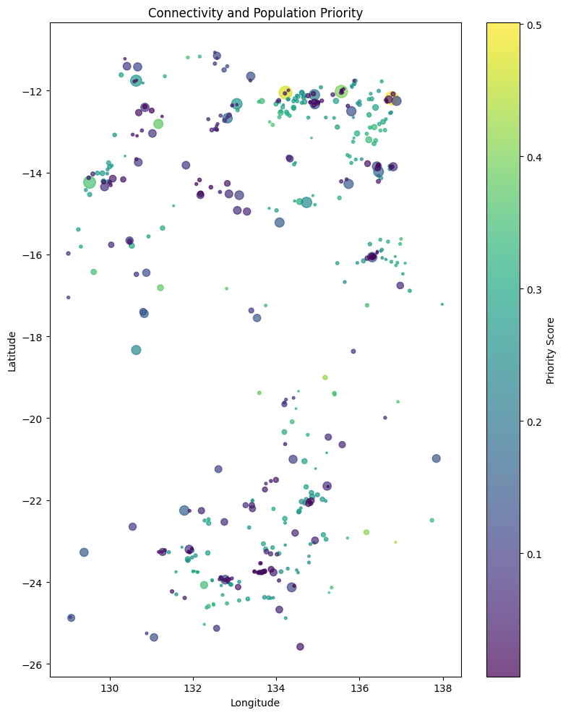
Figure A7 Connectivity and population ranking shown by point colour and population-scaled marker size.

Appendix Interface and contextual screenshots
Figure A8 shows the atlas overview. Figure A9 shows the Australian Government mapping tool as external context, not a project output [6].
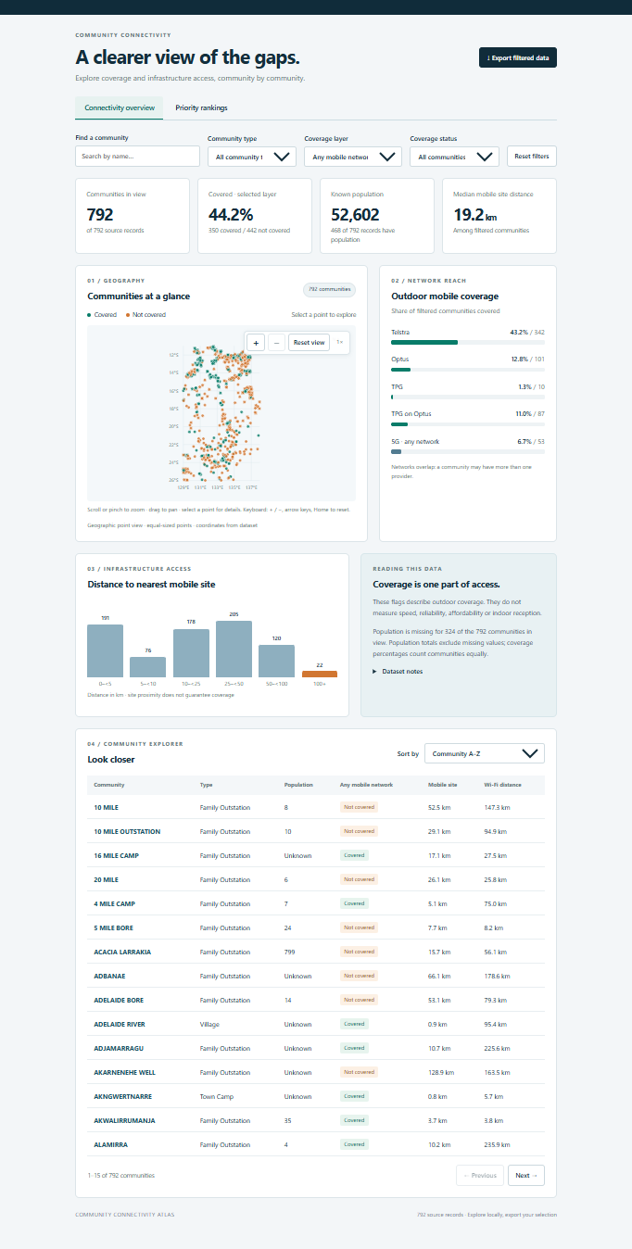
Figure A8 Supplied atlas overview, showing 792 BushTel site records and 350 with mapped any-network coverage. Its interface label “communities” should be interpreted as site records for this analysis.

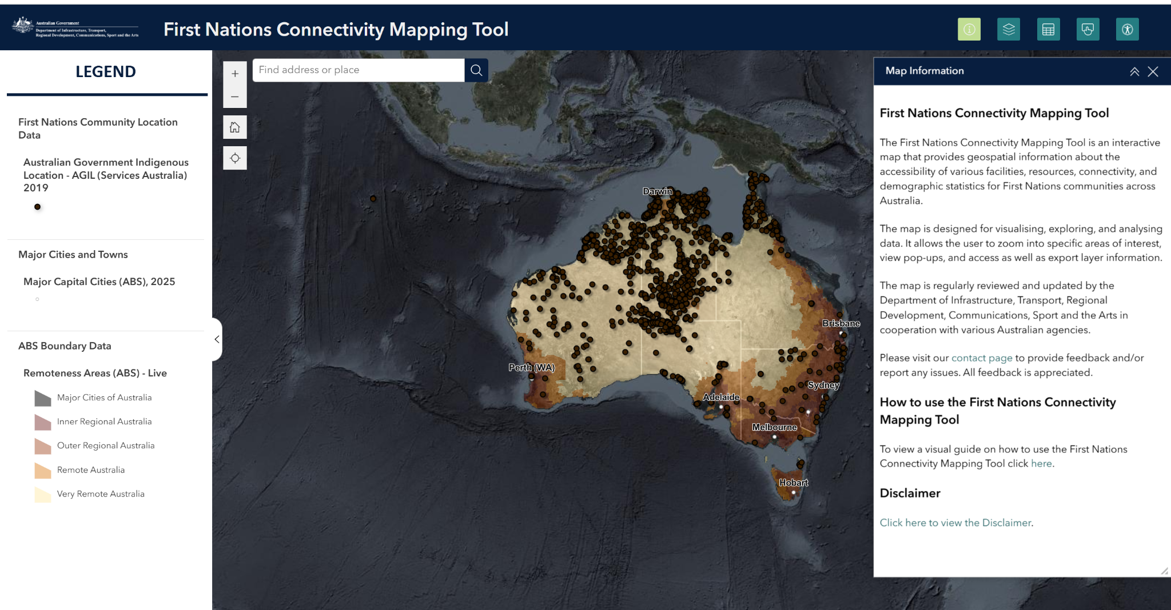
Figure A9 Australian Government First Nations Connectivity Mapping Tool, included as external context. Source: Department of Infrastructure [6].

