**Updated Document 3 - Architectural Design (UML Diagrams)**

Group 3: Amanda Schlais, Marissa Manata, Adam Grunwald, and Zander Franks

**UML Diagram**

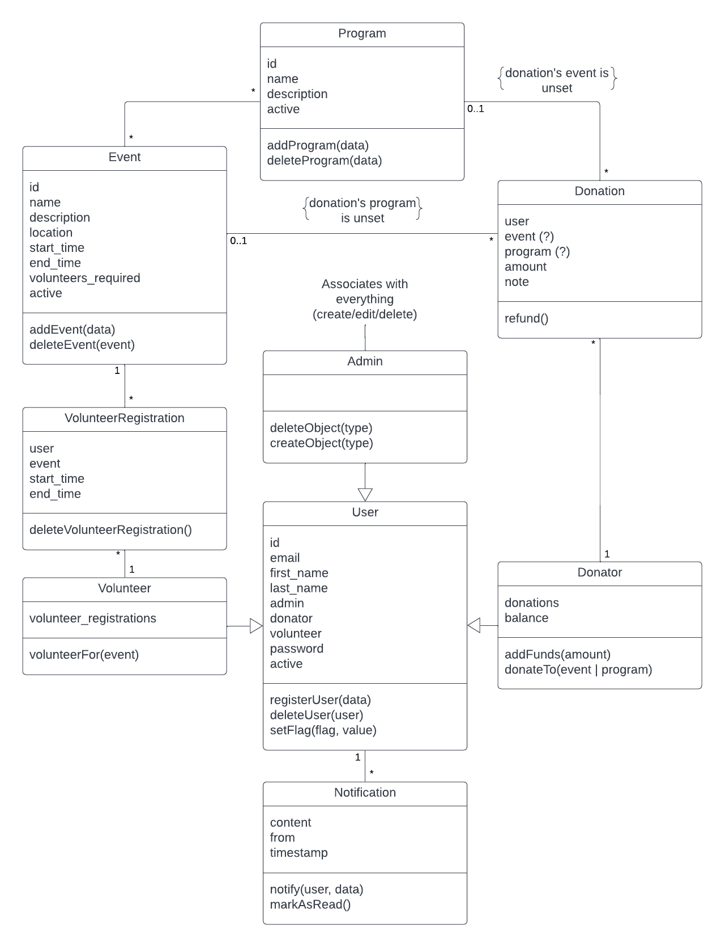

**ER Diagram**

