**Hasenpfeffer-Rabbit-Stew**

A savory stew made by marinating and braising rabbit in spices and vinegar.

Ingredients:

One large rabbit, dressed, and cut into pieces

½ cup flour

½ teaspoon garlic powder

½ teaspoon onion powder

¼ cup olive oil

1 teaspoon salt

½ teaspoon pepper

½ teaspoon allspice or cloves

1 medium-sized onion

5 cloves garlic, peeled and sliced

2 bay leaves

½ cup vinegar

1 can tomato puree

Directions:

Combine garlic powder, onion powder, and flour.

Roll pieces of meat in flour mixture, and fry in the oil until golden brown.

Place the fried meat in a Dutch oven with the sliced onion, garlic, allspice, bay leaves, salt, pepper, vinegar, and tomato puree.

Bake at 350 for 1 to 1.5 hours.

Photos

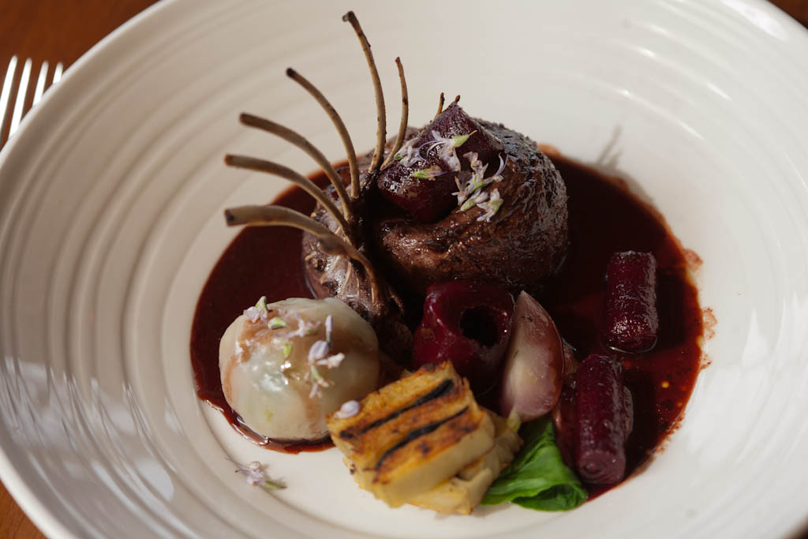





[](https://www.maxpixel.net/Restaurant-Dining-Tables-Terrace-Dining-Room-1626983)