Hi Class,

I’m excited to work with you all this week on data management. I just want you to do one quick thing for me before class. Please check to see if you have what you need on your laptop to run RMarkdown within RStudio.

1. Open up RStudio
2. Navigate to File > New File > R Markdown…
3. This should open up a dialog box called “New R Markdown”. Here you can give your new document a title and select an output format. For the time being, don’t worry about the options and just hit ‘OK’.
4. If everything is working correctly from the get-go, you will then see a new script-like page open up that looks something like this…

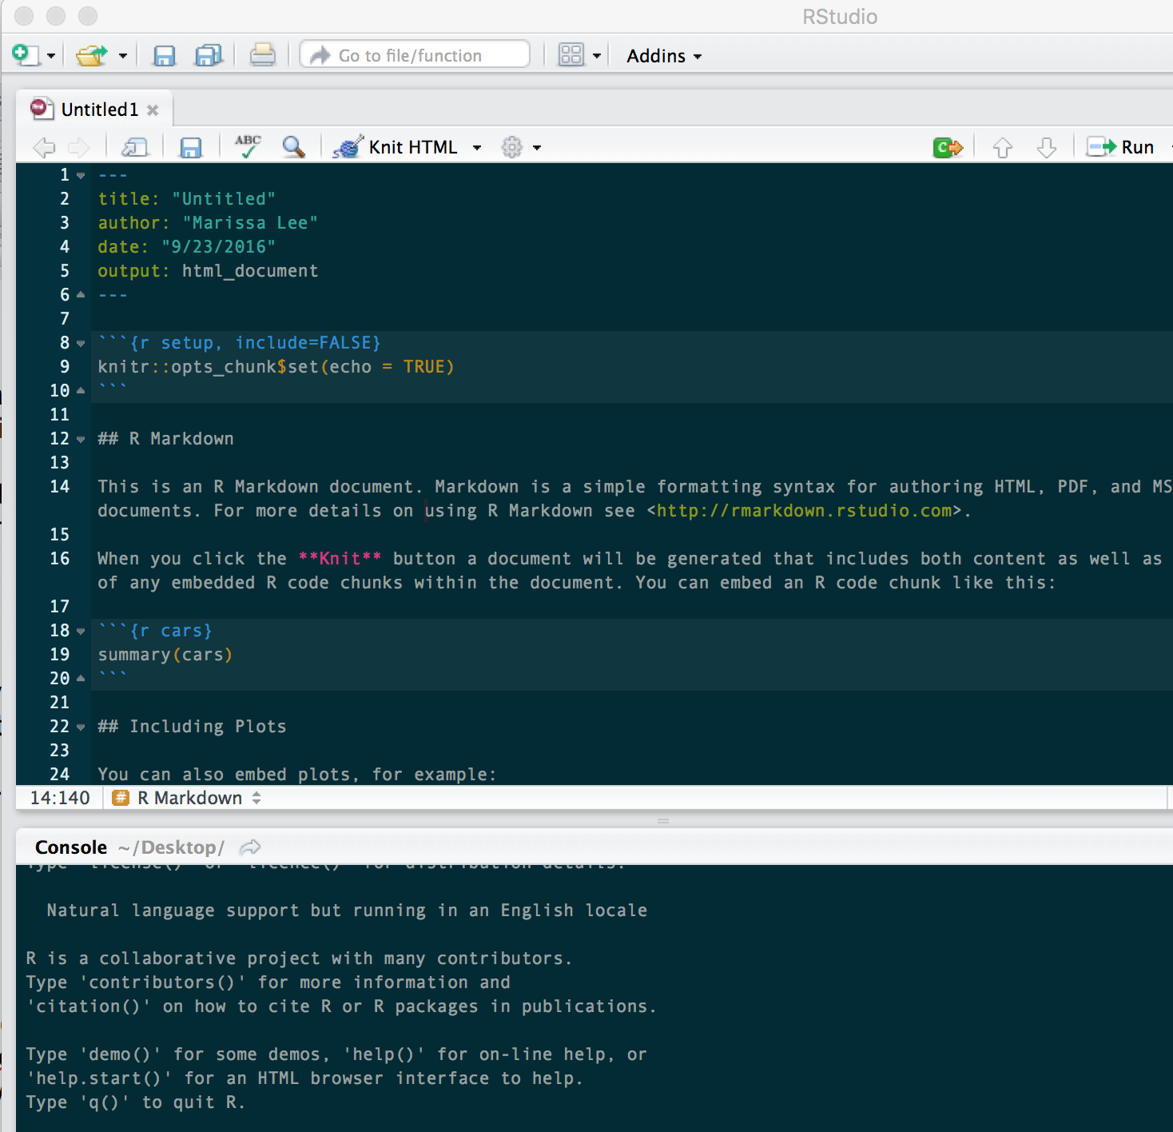

1. If that didn’t happen for you …You probably need to install additional software to make R Markdown happy. RStudio may provide some informative instructions – go ahead and follow those. If you don’t get good instructions or are just plain confused, just let me know at the beginning of class and we will troubleshoot together.