# Game Design Document (GDD)**:** School Daydream

## *Courtesy of Myself (2020)*

## Game Identity / Mantra

## Play the daydream of a tired student who has dosed off in the middle of class, fighting off their worst nightmare: school! Run across sheets of homework and avoid school dangers and nightmares in this 2D Platformer world of a student’s imagination! Be careful, though – you would hate to get woken up by the teacher!

Single player, side scrolling, platformer, cute, imagination

## Design Pillars

*

Player Color Palette

## 

Game Color Palette

## Main character is a school student daydreaming during class

* 2D horizontal and vertical move set
* Two stages of gameplay – Main game daydream and boss level reality

(Player) Sleeping Student in Dream Idle

(Player) Sleeping Student in Dream Walking

(Player) Sleeping Student in Dream Parachuting/Jumping

## Genre/Story/Mechanics

Game Title

Team Splash

## Genre/Story:

## Takes place in a modern-day school setting

* A student is daydreaming about school after they have fallen asleep in class. The student dreams about running across sheets of work paper with some added dream effects as well, such as cloud platforms. When the student completes the level, they are woken up by their teacher with a question, which enters the player into the Boss Level. If they lose the Boss Level, they are given a certain number of retries based on how many coins they collected in the main level.
* The premise of the game is to finish the level WITHOUT losing all your health in the main game AND failing the boss level after all retry attempts. There will be a checkpoint within the main level.

Mechanics:

Camera stats – Size: 4.3

Main Game: 2D Side scroller, normal gravity, jumping, climbing, running, attacking, parachuting

Boss Level: Just arrow keys (DDR-style minigame)

## Features

## One level and boss encounter

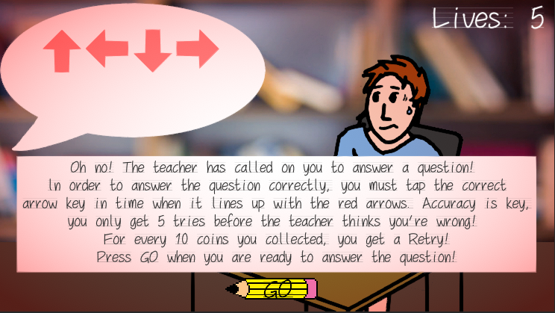

Boss Encounter

Pencil hazards, Bad Grade hazards

Pencil Hazard, Bad Grade Hazard

Coins scattered throughout the level

Coin

Cloud Platforms, Elevators, and Conveyors

Cloud Platform/Elevator/Conveyor

Bracket Teleporters

Bracket

Instructional data delivered via Post-It Notes

Post-It Note

One health pack on the level to heal the player

Lunch (Health Pickup)

One checkpoint

Checkpoint Flag

## Interface

## Three Cloud Health Icons in daydream main game

Three greyed-out Cloud Heath Icons behind the others

Five-strikes counter in Boss Encounter

Score Incrementor

Retry number based on coin collection number

Instructions delivered when relevant with Post-It Notes (moving, parachuting, dodging)

Escape Key Exit

## Art Style

## Most backgrounds will be designed to look like line paper/printer paper/book paper

Foreground would be detailed pixel art OR simplistic/cutesy poly-style art

Bad guys and enemies will have red eyes, coloration/look evil

Obstacles/platforms/interactable foreground will be darkened

## Audio

## Chill, cute music for main gameplay/menu

Intense, stressful music for the fast minigame

Specific audio sounds for relevant gameplay (Getting hit, checkpoint, collecting coins and health, etc.)

## Asset Database

**Audio**

Name File Type

|  |  |
| --- | --- |
| ArrowHit | .wav |
| Boss_Music | .mp3 |
| Coin_Collect | .mp3 |
| Game_Over | .mp3 |
| Health_Collect | .wav |
| Hurt | .wav |
| Tada | .mp3 |
| Main_Theme | .mp3 |

**Animations**

Name File Type

|  |  |
| --- | --- |
| Boss_Anim | .anim |
| Boss_Anim_Game_Over | .anim |
| Boss_Anim_Missed | .anim |
| Boss_Anim_Sweat | .anim |
| Boss_Anim_Still | .anim |
| Boss_Screen | .anim |
| Boss_Won_Anim | .anim |
| Boss_Won_Sleep | .anim |
| Player_IDLE_Anim | .anim |
| Player_WALK_Anim | .anim |
| Player_JUMPING_Anim | .anim |
| Player_PARACHUTE_Anim | .anim |
| Title_Screen | .anim |

## Materials

Name File Type

|  |  |
| --- | --- |
| Lights_OFF | .mat |
| Lights_ON | .mat |
| Cloud_Particle | .mat |

**Prefabs**

Name File Type

|  |  |
| --- | --- |
| Coin | .prefab |
| Death | .prefab |
| Elevator_Vertical | .prefab |
| UpDownHazard | .prefab |

**Scenes**

Name File Type

|  |  |
| --- | --- |
| Game_Start | .unity |
| Level_One | .unity |
| Level_One_BETA | .unity |
| Level_One_MIDTERM | .unity |
| Level_One_PROTOTYPE | .unity |
| Level_Boss | .unity |
| Level_Boss_Lost | .unity |
| Level_Boss_Won | .unity |

## Scripts

Name File Type

|  |  |
| --- | --- |
| ActivationTrigger | .cs |
| Anim | .cs |
| ArrowButton | .cs |
| ArrrowMove | .cs |
| ArrowTouched | .cs |
| BossTransition | .cs |
| Camera_Update | .cs |
| CheckPoint | .cs |
| Floater | .cs |
| GameController | .cs |
| Go | .cs |
| GravityActivationTrigger | .cs |
| Hazard | .cs |
| Ladder | .cs |
| LoadSceneOnClick | .cs |
| Level_Change | .cs |
| OnTriggerStay | .cs |
| Patrol | .cs |
| Patrol_Plus | .cs |
| Player_Health | .cs |
| Player_Move_Update | .cs |
| Retry_Boss | .cs |
| Started | .cs |
| PlaySound2D | .cs |
| Poof | .cs |
| Teleport | .cs |

**Sprites**

Name File Type

|  |  |
| --- | --- |
| Arrow | .png |
| Black_Arrow | .png |
| Border_01 | .png |
| Books_br | .png |
| Boss_Screen | .png |
| Boss_Screen_Lost | .png |
| Boss_Screen_Missed | .png |
| Boss_Screen_Sweat_1 | .png |
| Boss_Screen_Sweat_2 | .png |
| Boss_Screen_Won | .png |
| Brackets | .png |
| Cheat_Text | .png |
| Checkpoint_Flag | .png |
| Cloud_Particle | .png |
| Cloud_Platform | .png |
| Cloud_Text | .png |
| Coin | .png |
| Coin_Text | .png |
| Conveyor_Text | .png |
| Exam_Tmrw | .png |
| Exit_Door | .png |
| F_Paper | .png |
| Player_IDLE_64 | .png |
| Player_WALK_64 | .png |
| Player_JUMPING_64 | .png |
| Player_PARACHUTE_64 | .png |
| Grade_Text | .png |
| Health_Clouds | .png |
| Health_Segment | .png |
| Instructional_Text | .png |
| Ladder | .png |
| Level_Background | .png |
| Lunch | .png |
| Mushroom_Cloud | .png |
| Paper_S | .png |
| Parachute | .png |
| Parachute_Text | .png |
| Pencil | .png |
| Prototype_Level_Reduced | .png |
| Rotating_Plus | .png |
| RP_Background_512 | .png |
| RP_Block_256 | .png |
| RP_Ramp_256 | .png |
| Sticky_Note | .png |
| Study_Sets_Note | .png |
| Talk_Bubble | .png |
| Talk_Bubble_Missed | .png |
| Team_Splash | .png |
| Teleport_Text | .png |
| Title_Screen_1 | .png |
| Title_Screen_2 | .png |
| White_Arrow | .png |

## Fonts

## Puffy Dreamland Font: Puffy Dreamland font

PW School Script Font: PW School Script Font

Arial Font

## Development Roadmap

**Platform:** Unity Editor, Windows PC **Audience:** Everyone

**~~Milestone 1:~~** ~~09/09/20 GDD 1.0~~

**~~Milestone 2:~~** ~~9/30/20 PROTOTYPE~~

**~~Milestone 3:~~**  ~~10/14/20 MIDTERM~~

**~~Milestone 4:~~** ~~11/18/20 BETA~~

**~~Milestone 5:~~** ~~12/09/20 GDD FINAL~~

---------------------------

**Launch Day:** 12/09/20 GOLD MASTER

[1]

# References

|  |  |
| --- | --- |
| [1] | U. Health, "Student Isolation and Self-Quarantine," *COVID-19 Updates,* 2020. |