1. 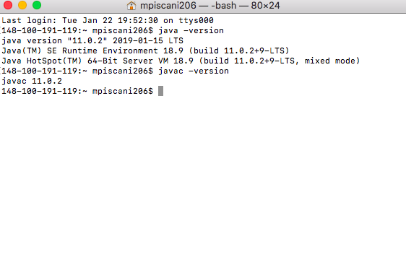Setup Java
2. Create an account on Kattis

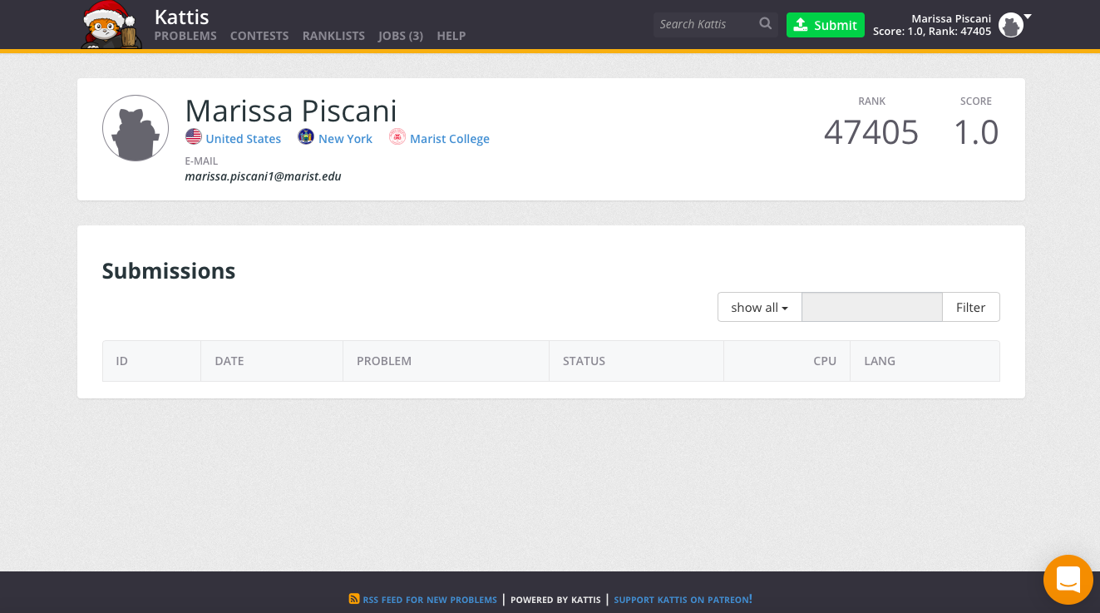

1. Create an account on GitHub

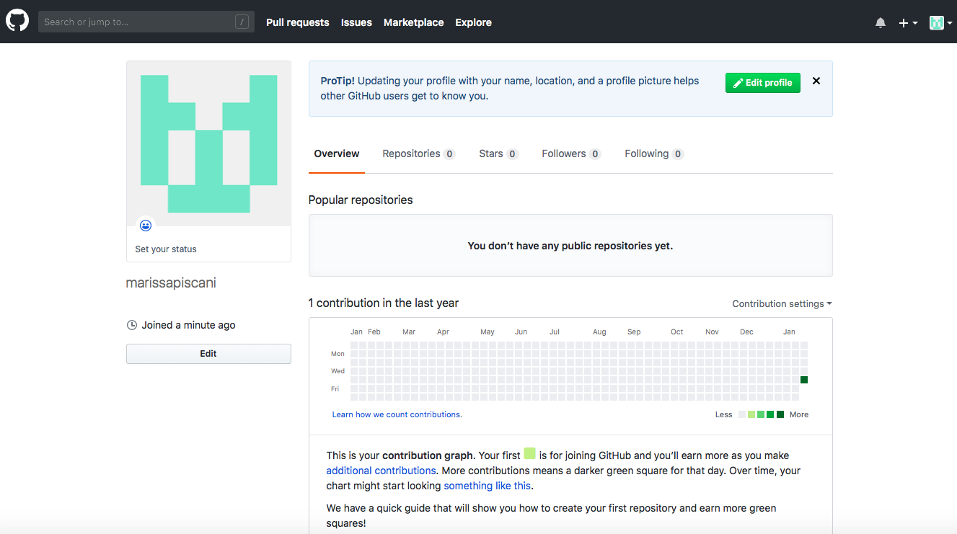

1. https://github.com/marissapiscani/cmpt220piscani.git