Activate Omeka account

Go to your Marist email and search for an email from the English 392 Administration titled “**Activate your account with the English 392 repository**”.

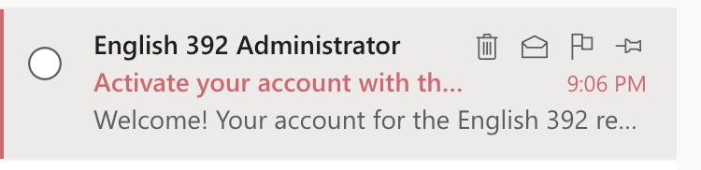

Click on the link inside the email.

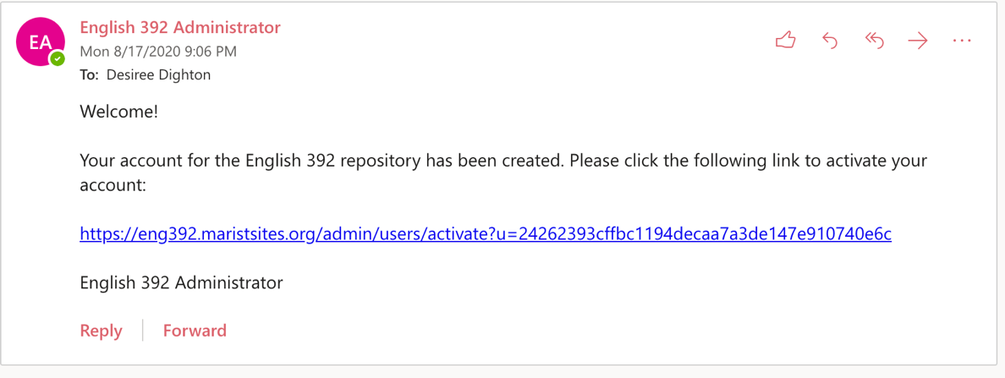

This will take you to a form where you can create your password for the site.

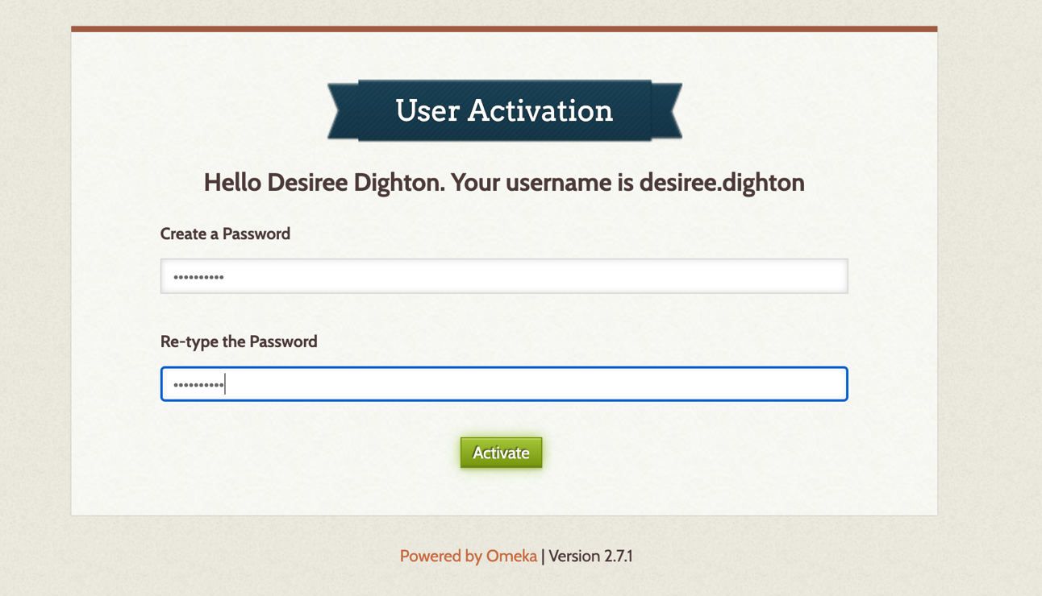

The User Activation screen above also contains your username. Your username will be firstname.lastname. After you create your password, you will be able to login to the site with your username and the password you just created. Click the **Remember Me?** box if you want the browser to store your username and password for future visits to the site.

