**MOBILE PROGRAMMING**

**FINAL PROJECT**

**Lagundino, Marithe Ygraine D.**  
BSCSSE – N22

Anthony Aquino  
*Professor*

S.Y. 2019-2020

1. **PROJECT DESCRIPTION**

The application named MAWYT is a user friendly to-do-list application that gives the users the assurance that certain tasks will be forgotten to do. This enables the user to manage or organize their task for the day or the next days and is useful for everyone especially people with short term memory. Topics such as notifications, alerts, toast, database, and etc. are all implemented in MAWYT.

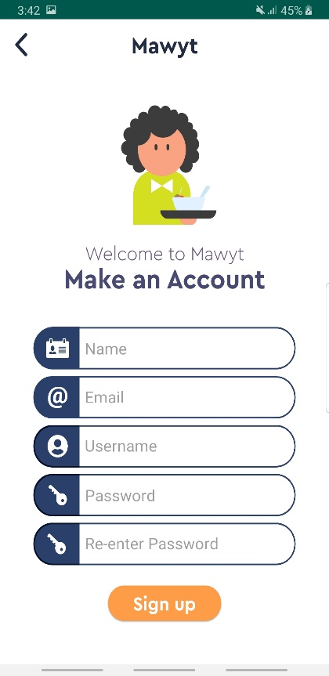**MAWYT APPLICATION**  
LOGIN/SIGNUP

**Sign Up** – Create an account

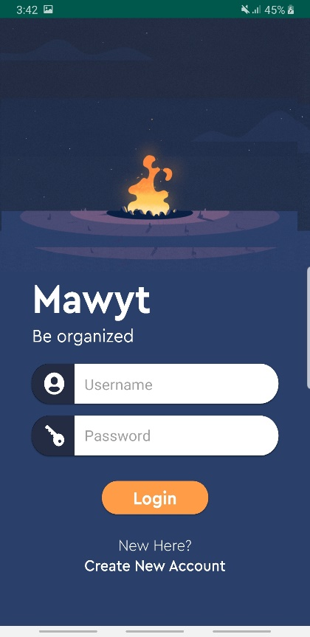

**Login** – consist of username and password. If user is not yet registered, he/she must sign up for an account first.

**Splash Screen** – consist of logo and application name

INSIDE THE APPLICATION

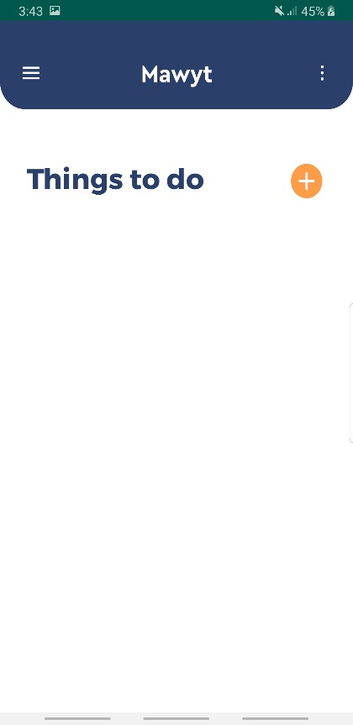

**MENU**

**OPTIONS MENU**

add new account,  
profile  
logout

settings, about, help

**ADD BUTTON**

**Main Screen** – what the user can see after signing in

used when you want to add task

ADDING TASK

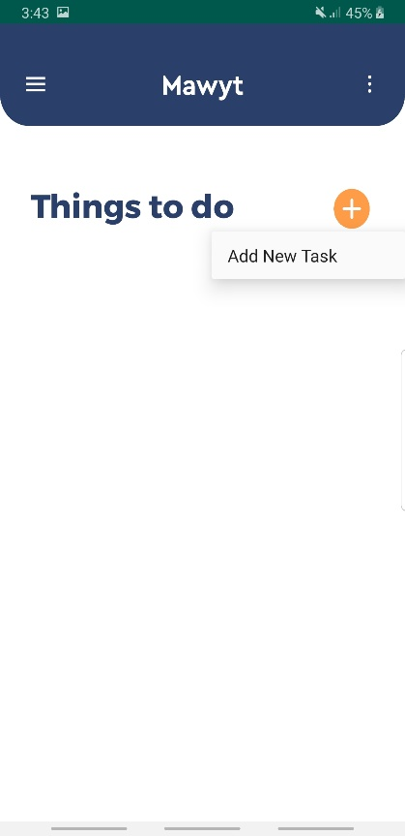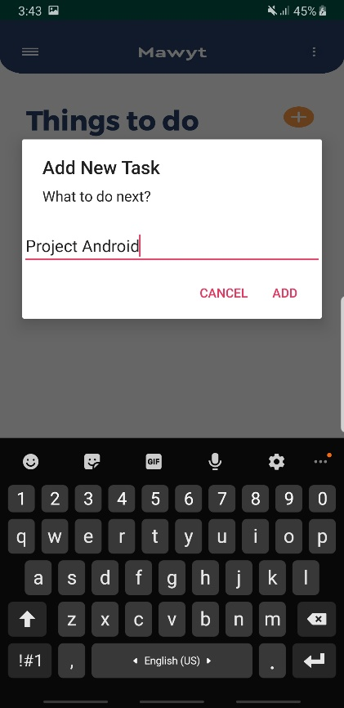

**CONFIRM BUTTON**

**TASK NAME**

Field where the user will enter the name of task

used when you want to add task

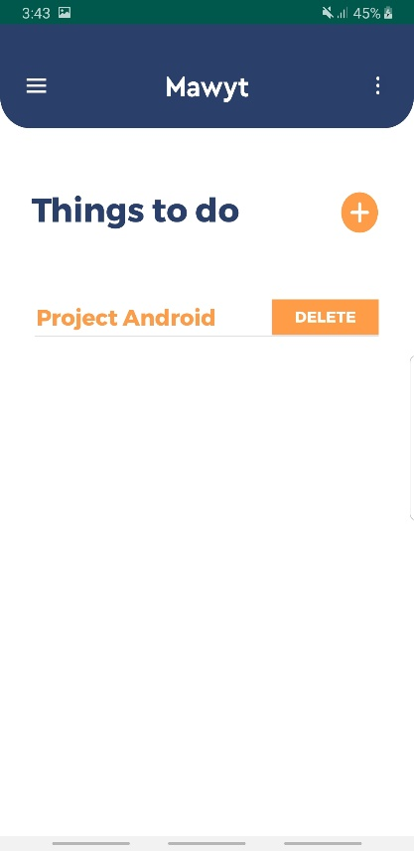

**TASK NAME**

**DELETE BUTTON**

Used when the user wants to delete the task

**What the user can see in the screen after adding a task**

OPTIONS MENU

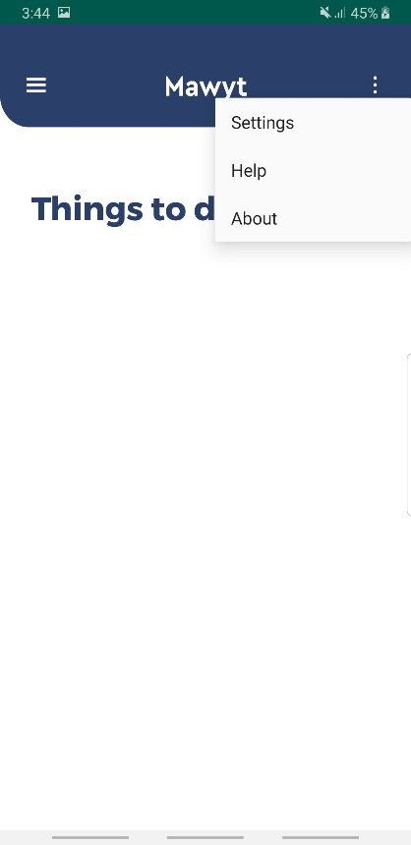

**INSTRUCTION**

**DELETION OF ACCOUNT**

**ABOUT THE APP**

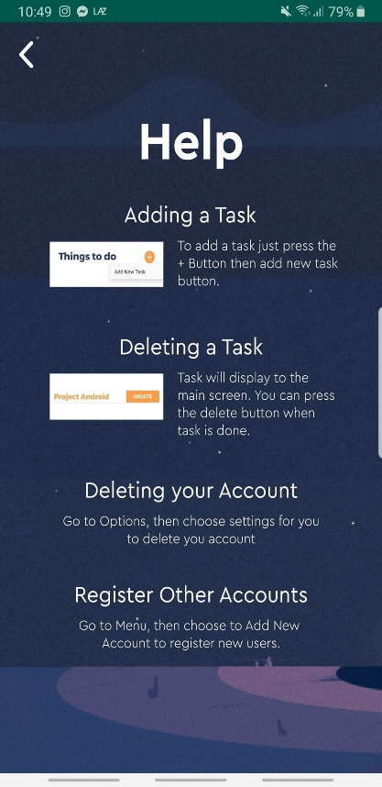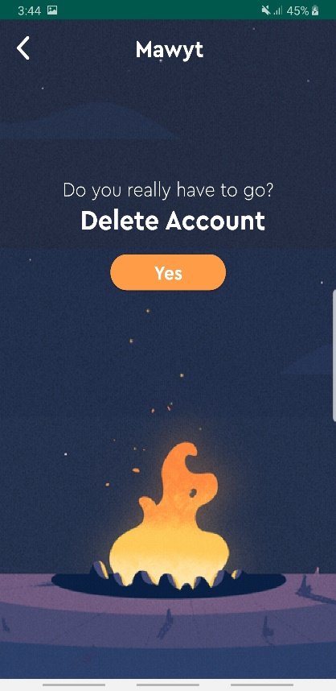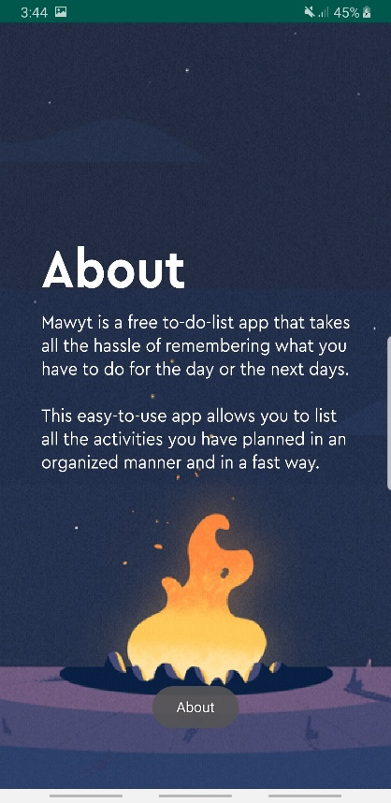

help

settings

about

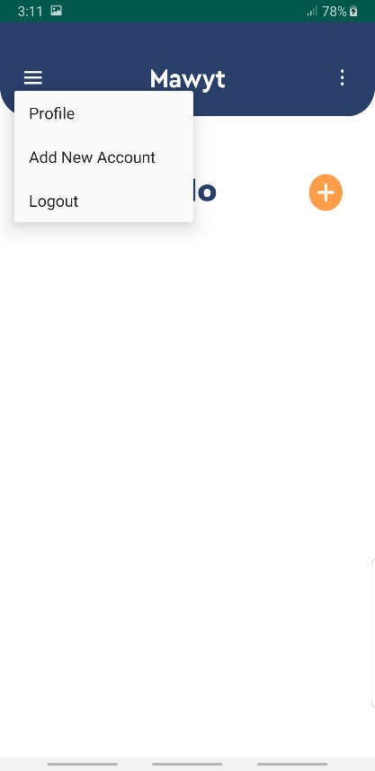MENU

**CREATE OTHER USER ACCOUNT**

**VIEW YOUR PROFILE**

**LOGOUT YOUR ACCOUNT**

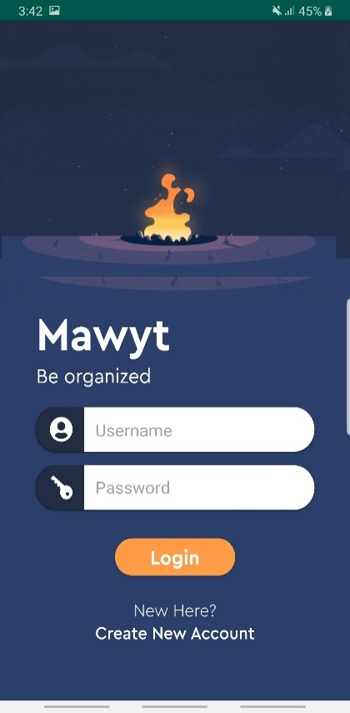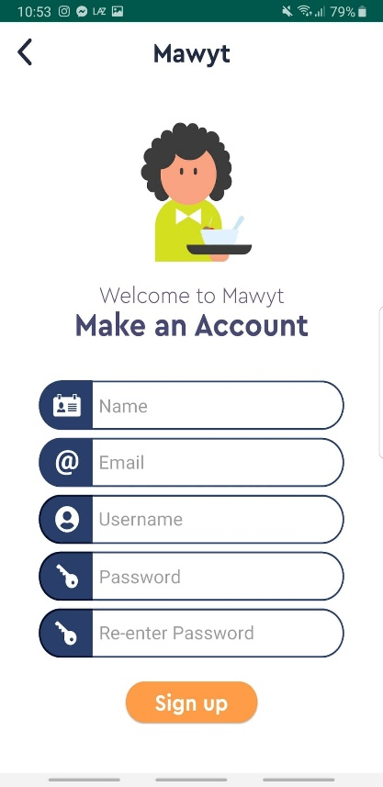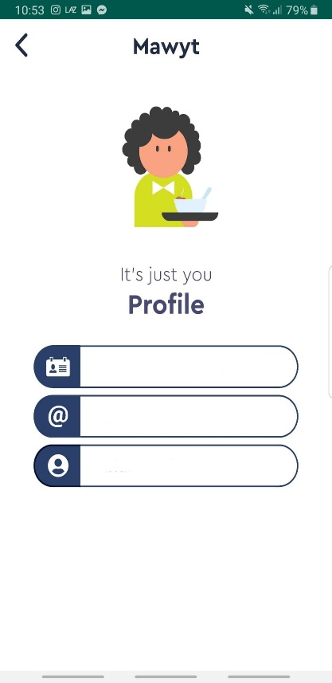

**Logout**  
Goes back to Login screen

Profile

Add New Account

1. **ALGORITHMS APPLIED**

* At first, the user needs to sign for an account then after successfully signing up. System will store all the input came from the user to the Database or SQLite.
* After signing up, the user may proceed to login. Login will be successful if and only if the username exists and matches the password that is inside the database.
* If the user successfully login, the system will redirect to the main screen. If not, it will not proceed to the main screen.
* In the main screen, the user may able to add tasks and delete it. Tasks will be saved to the database so that even when the user signed out, the task will remain inside that account.
* The user may also access the option menu which has setting to delete your account, the help button for the guide of the application, and the about which has the description about the application.
* The user may also access the menu which has the function to view your profile, then a signup option for registering other users, and lastly the logout button, which exits you from the main screen or application.