**CODE DOCUMENT**

1. **Packages and classes**

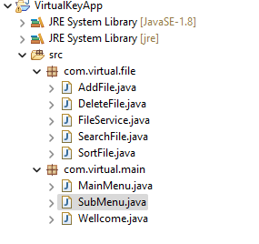

1. **Wellcome.java**

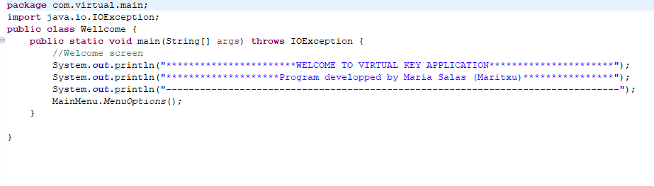

1. **MainMenu.java**

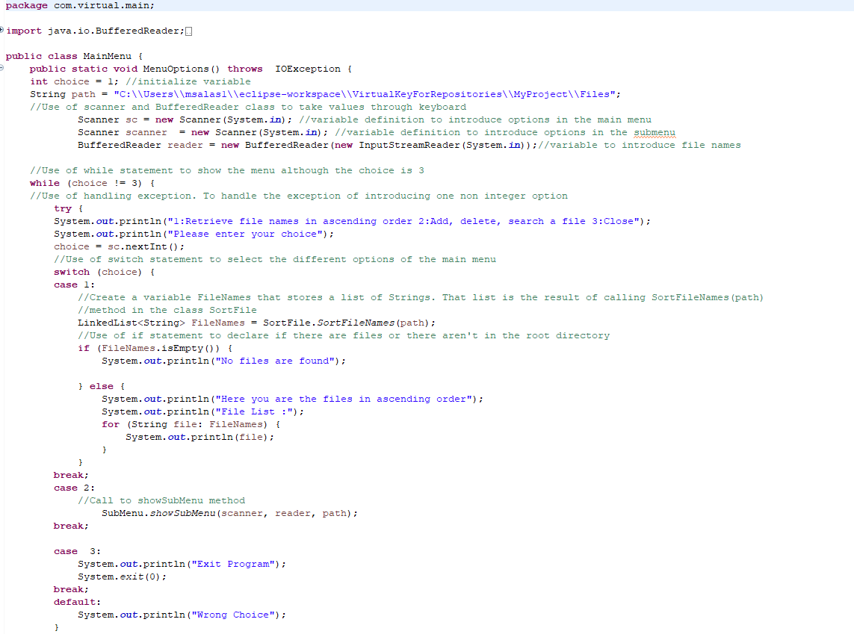

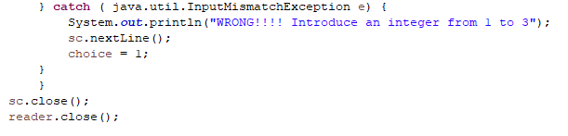

1. **SubMenu.java**

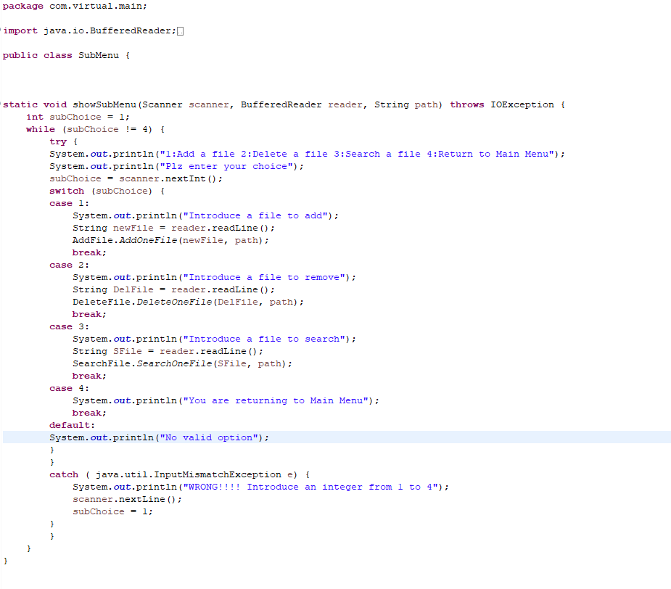

1. **FileService.java**

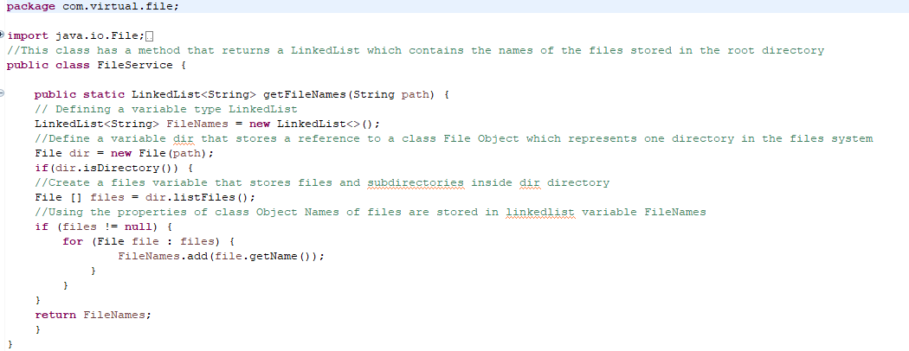

1. **SortFile.java**

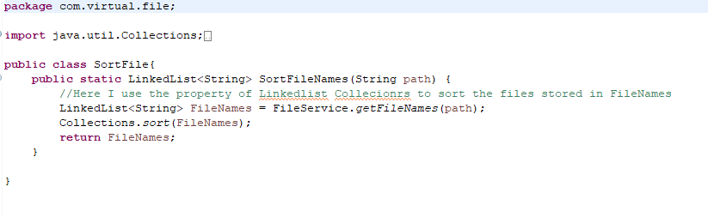

1. **AddFile.java**

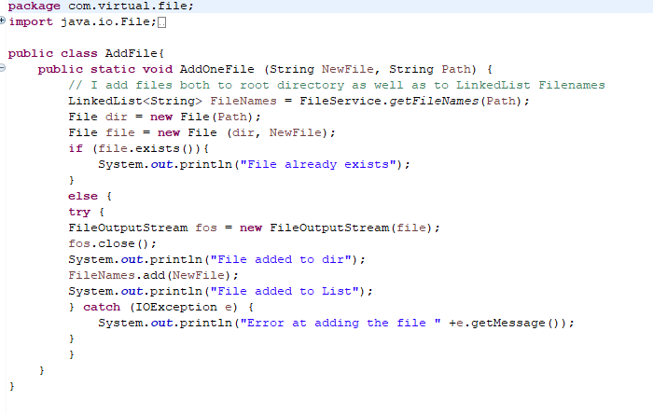

1. **DeleteFile.java**

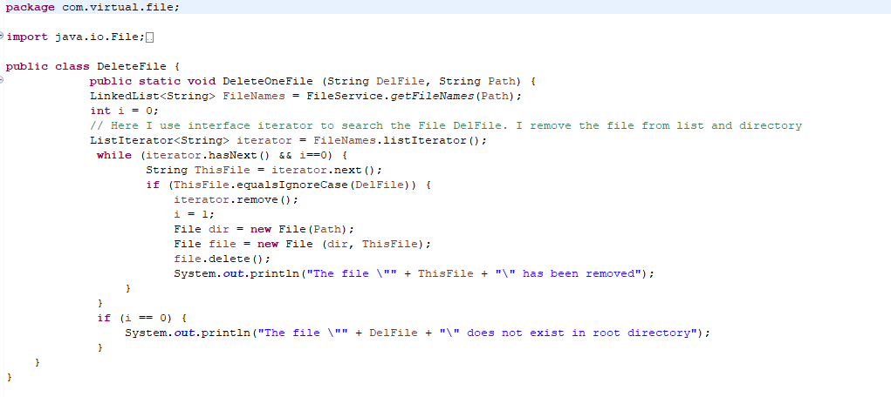

1. **SearchFile.java**

