**SCREEN SHOTS**

1. **Packages and classes**

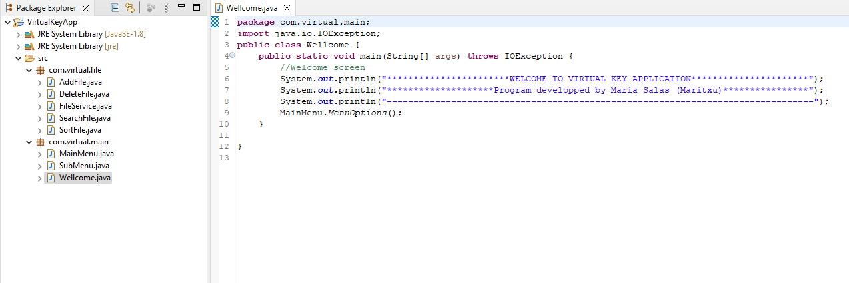

1. **Run Code**

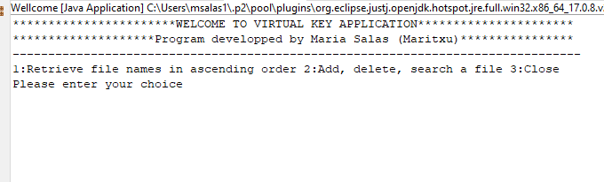

1. **Option 1 existing files in directory**

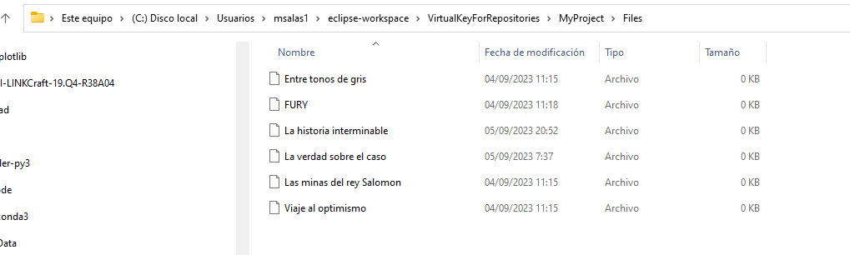

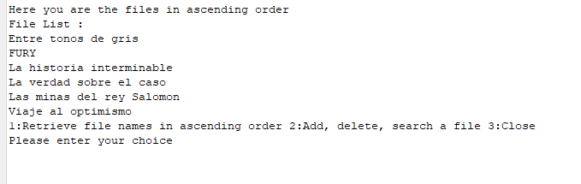

In my program always show the menu after each option but close

1. **Option1 but there are no files in the directory**

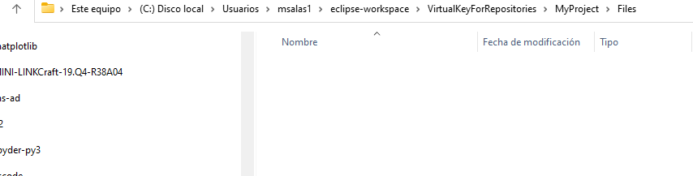

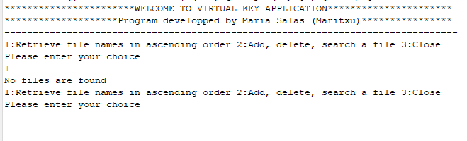

1. **Option 3. Close**

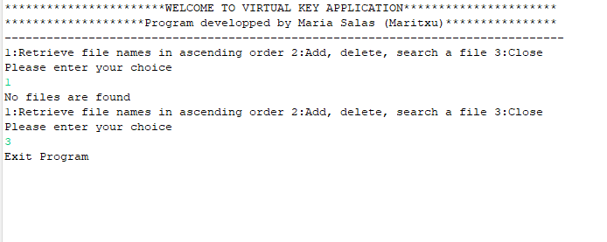

1. **I introduce a number different from 1 to 3**

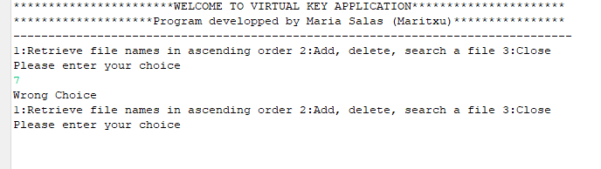

1. **Introduce some string instead of option**

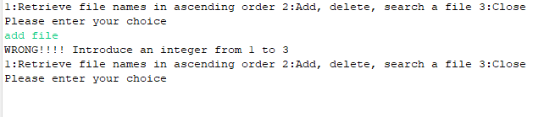

1. **Option 2. To submenu**

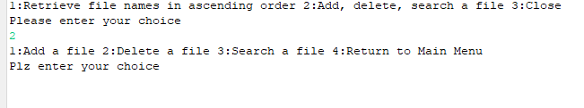

1. **Option 1. Add a file**

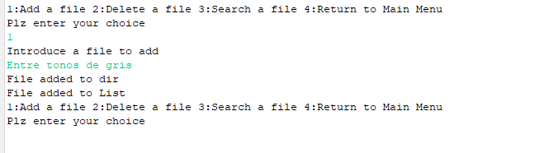

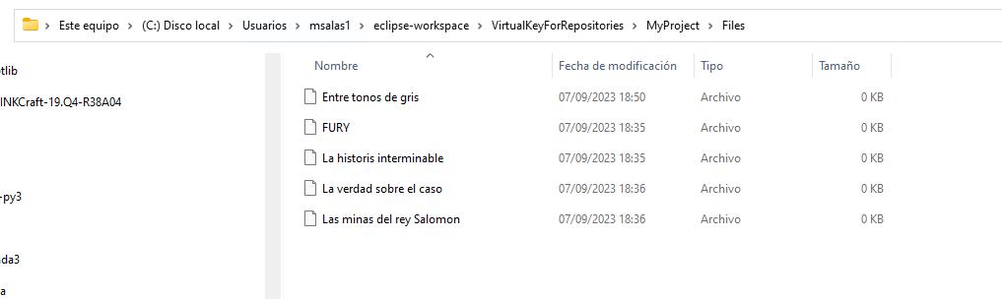

1. **Option 1. Add a file that already exists**

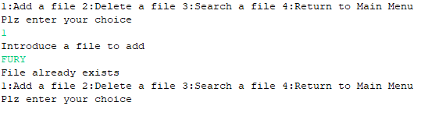

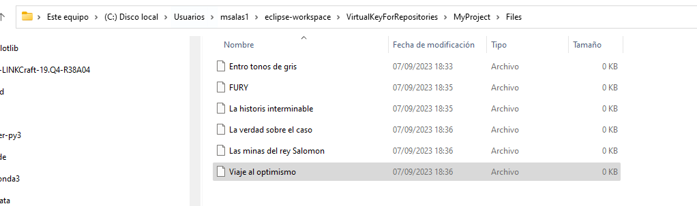

1. **Delete a file**

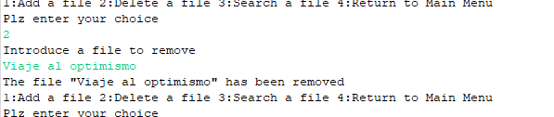

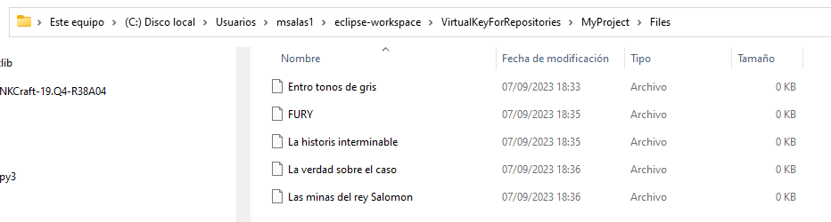

1. **Delete a file that doesn’t exist**

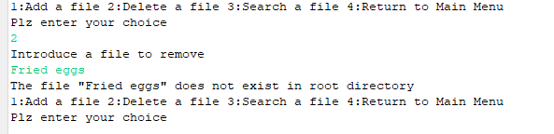

1. **Search a file**

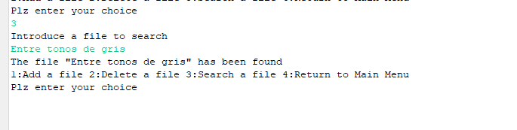

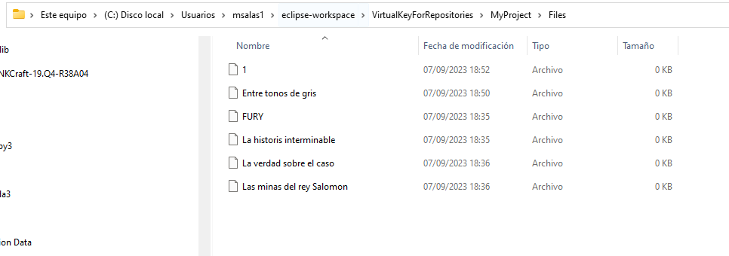

1. **Search a file that doesn’t exist**

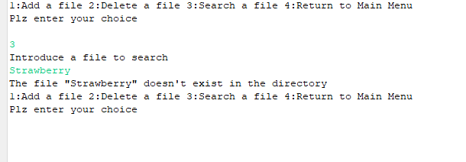

1. **Return to main menu**

