Homework 2 Exercise 2A
1. Explain regression > In detail, explain what regression is and provide an example
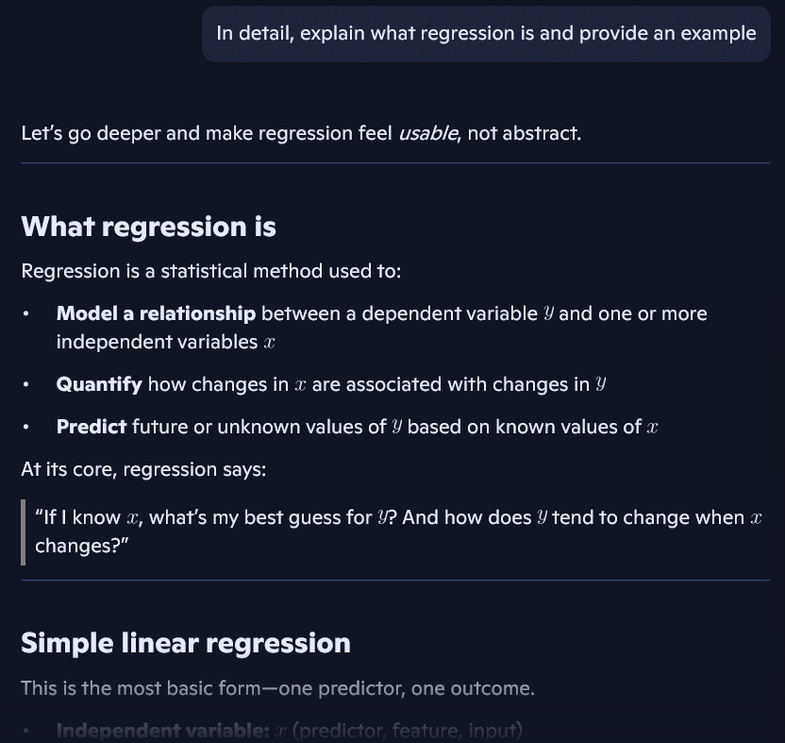

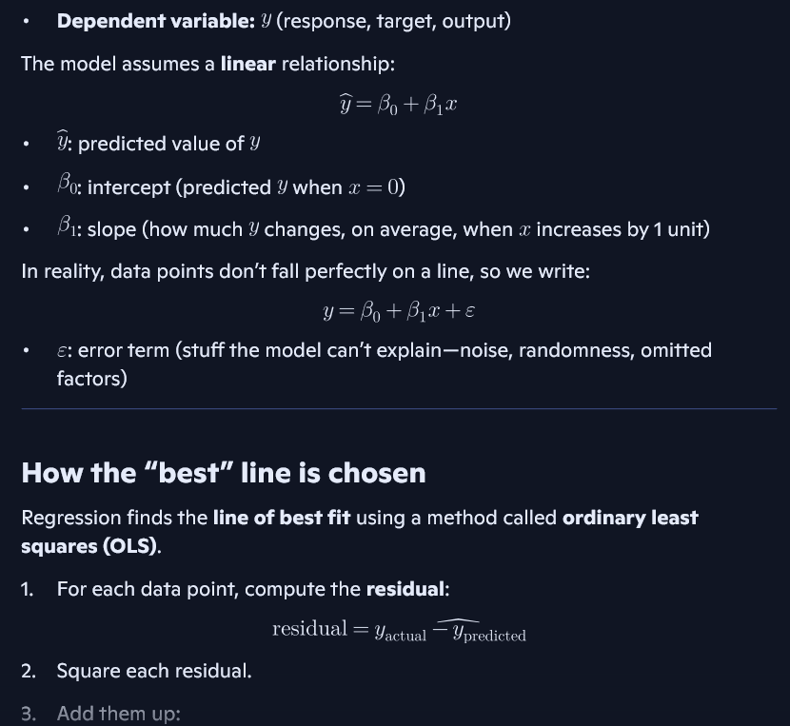

The second prompt had a better result because it was more specific. When I prompted “Explain regression” the answer stayed brief and general. When I prompted “In detail, explain what regression is and provide an example” I got a more in-depth answer and it provided an example, so the output was more thorough and structured.

2. Help me understand SQL > In simple terms explain what SQL is and provide an example
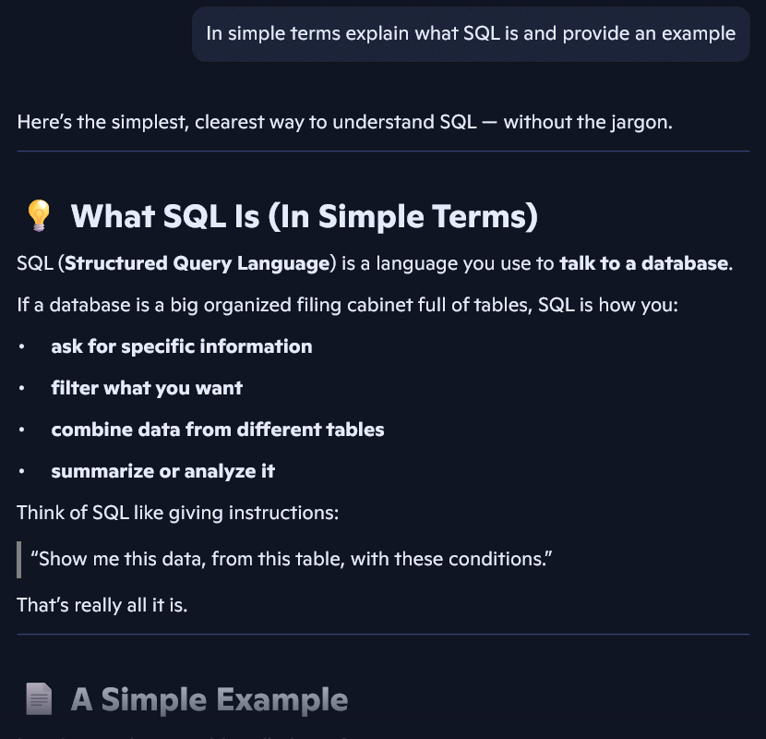
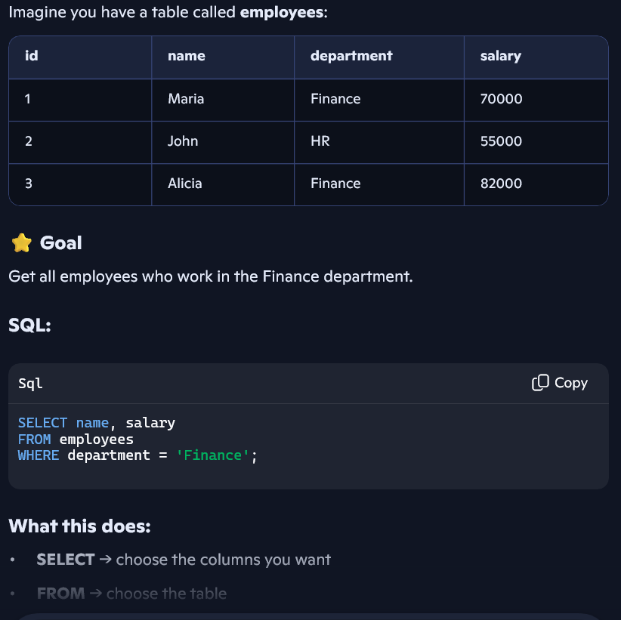
The first prompt was broad, so the answer was longer and more detailed. The revised prompt asked for simple terms and an example, which made the response clearer, shorter and more focused overall. It is a type of prompt you would need to enter to be able to understand SQL if you are a beginner or someone who is new to the concept.

3. Create a dataset > Create a dataset that includes information from grocery store inventory that contains items, prices, amounts, and item codes
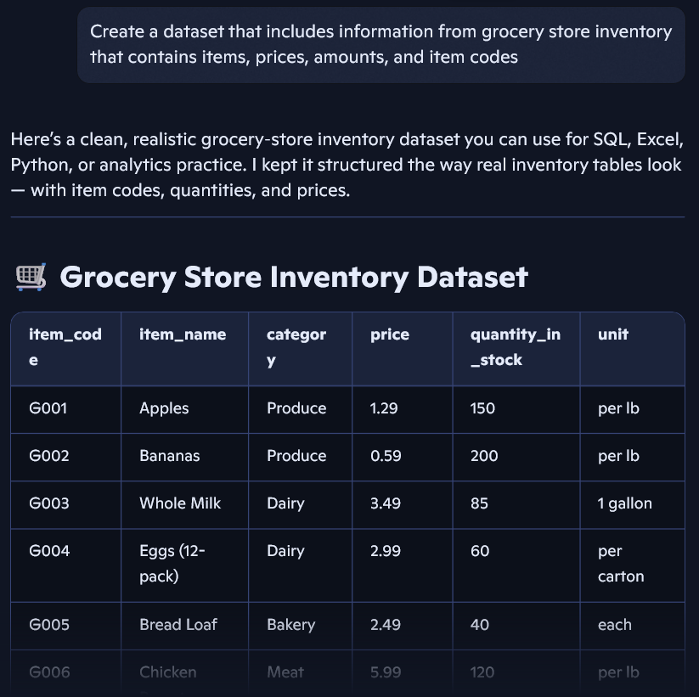
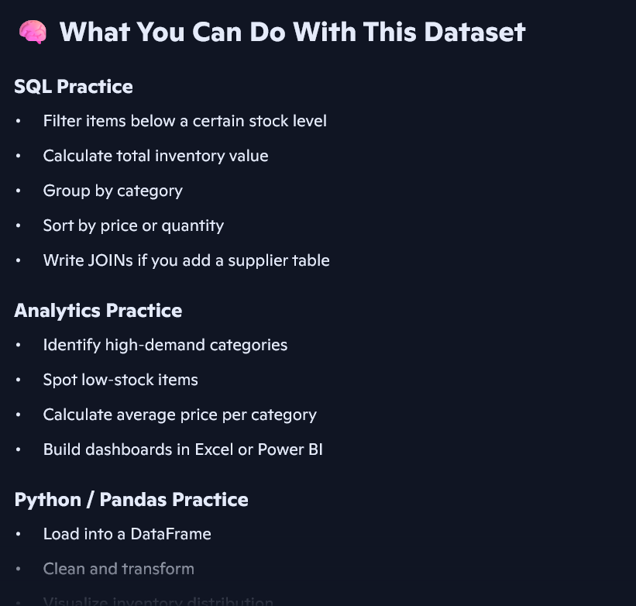

The first prompt didn’t specify to create a database about anything specific, it was vague, so the dataset was generic. The revised prompt listed exactly what I wanted (which was grocery items, prices, amounts, and item codes) so the results were clearer, more detailed and it outputted exactly what I asked for.

