Task no.1

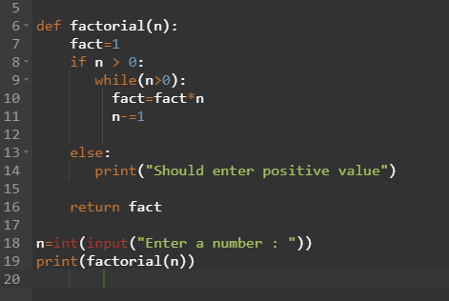

Output:

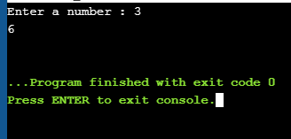

Task No.2

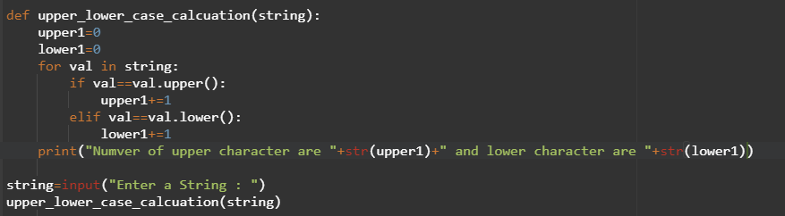

Output:

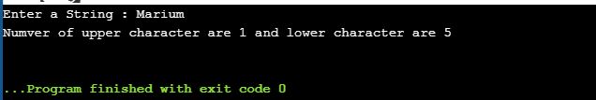

Task No.3:

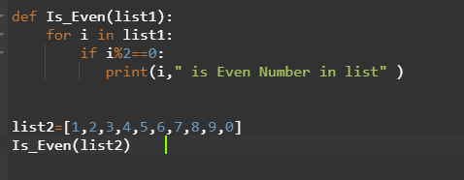

Output:

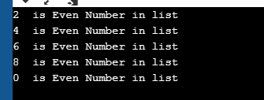

Task No.4:

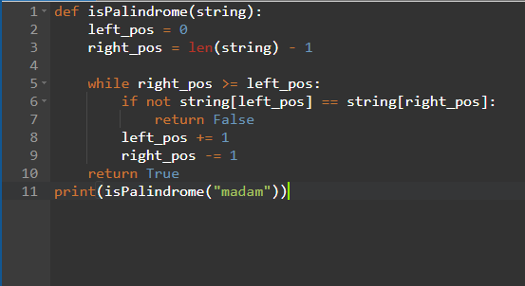

Output:

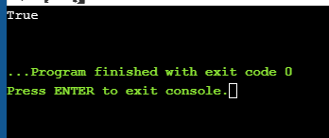

Task No.5:

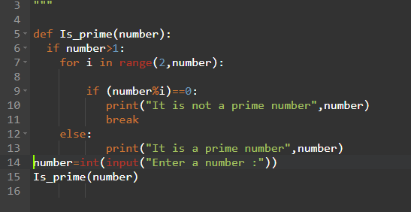

Output:

"""Suppose a customer is shopping in a market and you need to print all the items

which user bought from market.

Write a function which accepts the multiple arguments of user shopping list and

print all the items which user bought from market.

"""

def shopping(par):

# print("Following items you bought ")

for i in par:

print("items No is "+str(i))

#shopping("food","drink","zinger")

while True:

items=[]

print("---------------------\nMenu\n-------------------")

in1=int(input("Select Following\n1-add items\n2-view items\n0- exit : "))

if in1==1:

in2=input("Enter item ")

items.append(in2)

elif in1==2:

shopping(items)

elif in1==0:

print("You exit")

else:

print("Select valid option")