LAB # 2

SIMULATING Method

# Objective

To become familiar with the network simulator Packet Tracer

**CLASS ASSIGNMENTS**

**TOPOLOGY**

**Paste here picture of your topology which you make in class**

**CONFIGURATION**

**ROUTER:**

**Write here all commands….**

**Firstly complete your Class Assignment**

**HOME ASSIGNMENTS**

Q 1: Differentiate between three simulation methods.

A 1 Write answer here

Q 2: Perform these simulation method connecting more than 2 PC’s.

A 2 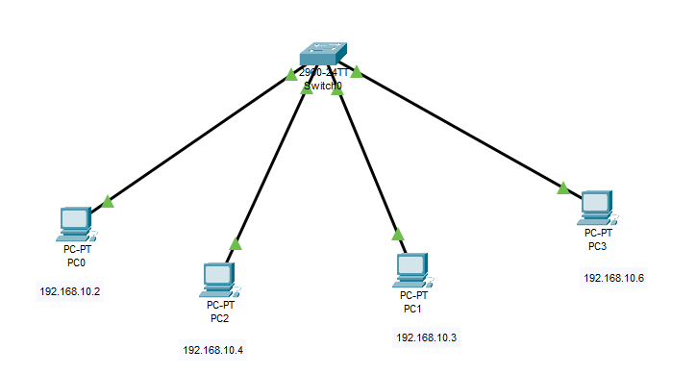

* **In Ping**

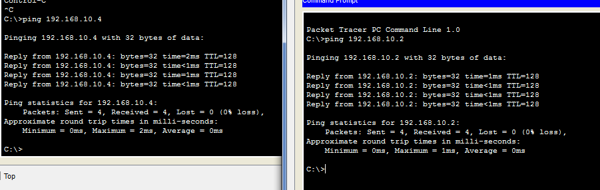

* **Real Time**

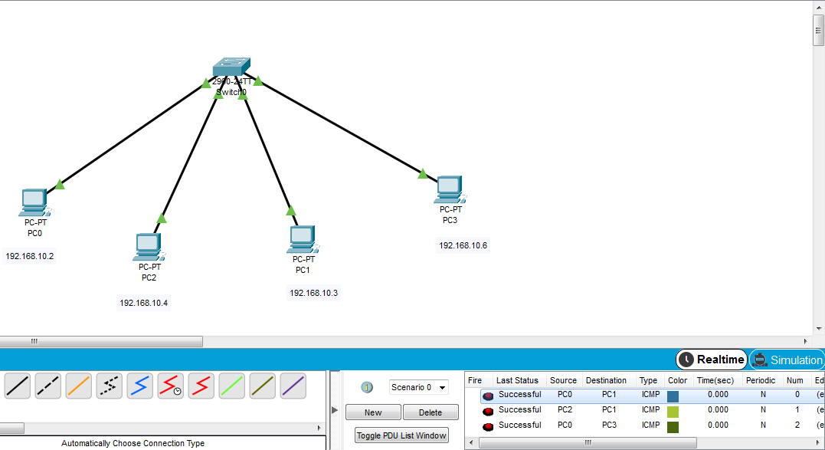

* **In Simulation**

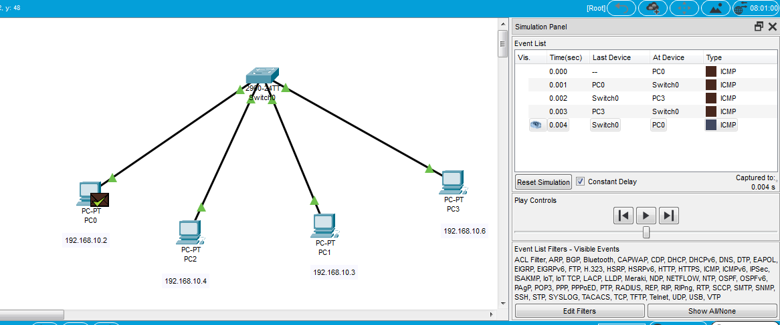

**CONCLUSION:**