LAB # 2

SIMULATING Method

# Objective

To become familiar with the network simulator Packet Tracer

**CLASS ASSIGNMENTS**

* **TOPOLOGY**

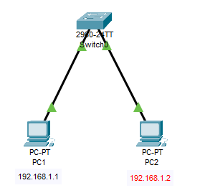

* **CONFIGURATION**

**PC1:**

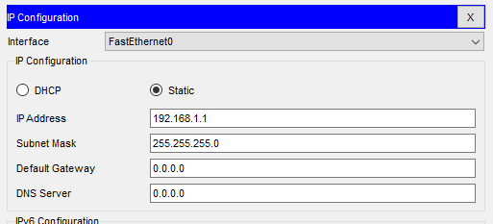

**PC2:**

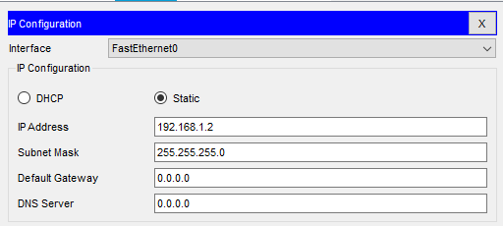

# Results:

Successful Ping by PC1 to PC2

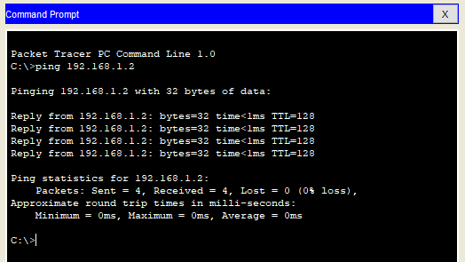

Successful Ping by PC2 to PC1

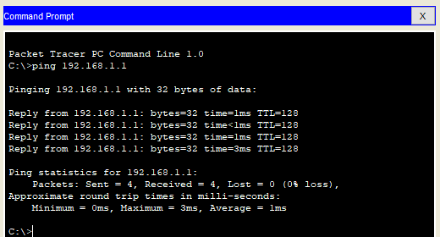

**HOME ASSIGNMENTS**

Q 1: Differentiate between three simulation methods.

A 1**: Real-time**: Real-time is typically considered to be at the time that the code is running or as the action is happening

**Simulation** :Simulation is a technique, a software program that models the behaviour of a network by calculating the interaction between the different network entities (routers, switches, nodes, access points, links etc.

**Ping** :Ping is a quick and easy utility to tell if the specified server is reachable and how long will it take to send and receive data from the server

Q 2: Perform these simulation method connecting more than 2 PC’s.

A 2 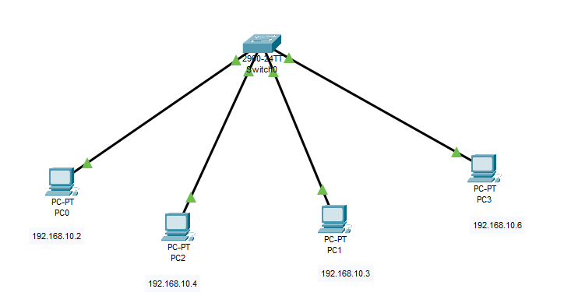

**In Ping**

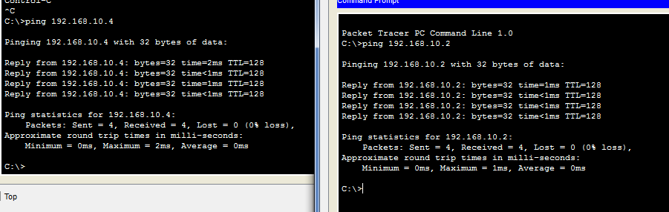

* **Real Time**

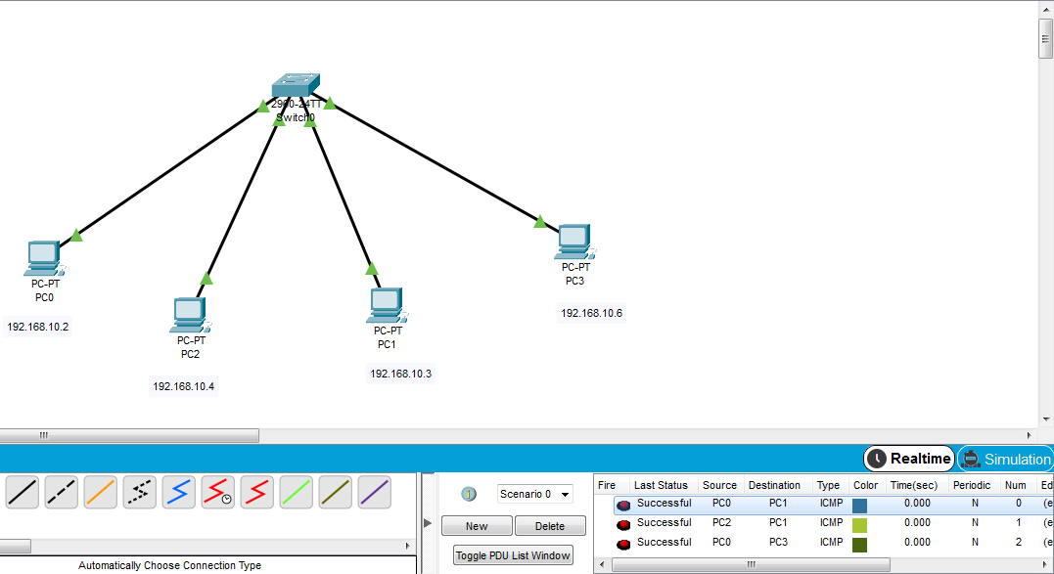

* **In Simulation**

