****LAB # 1****

INTRODUCTION TO NETWORK Devices

OBJECTIVE

# Introduction of network devices and basic terminologies.

**HOME ASSIGNMENTS**

Q1: Differentiate between manageable and unmanageable switches/bridges.

**Unmanaged switches** : These switches have no configuration interface or options. They are plug-and-play. They are typically the least expensive switches, found in home, SOHO, or small businesses. They can be desktop or rack mounted.

**Managed switches** : These switches have one or more ways, or interfaces, to modify the operation of the switch. Common management methods include: a serial console or Command Line Interface accessed via telnet or Secure Shell; an embedded Simple Network Management Protocol SNMP agent allowing management from a remote console or management station; a web interface for management from a web browser. Examples of configuration changes that one can do from a managed switch include: enable features such as Spanning Tree Protocol; set port speed; create or modify VLANs, etc.

Q2: Describe the different types of ports in manageable switches.

A2: It supports many management interfaces, like Web UI, CLI, or both. The configuration of VLAN is the common application for a managed switch. For this type, 10gbe switch, 40gbe switch and 100gbe switch are the common choices.

Q3: Difference between Layer 2 and Layer 3 switches.

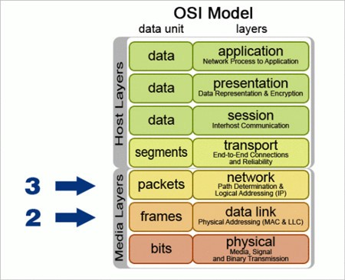

Layer 2 is Datalink layer, In datalink layer we mostly deal with frame ,MAC address. Layer 3 is Network layer ,In Network layer we mostly deal with IP address of source and destination

Q4: Difference between three modes of communication.

We have 3 types of transmission modes ;

1-Simplex mode,

2-Half duplex mode

3-Full duplex mode.

1. **SIMPLEX MODE:**  
   only Sender can send the data. In Simplex mode there is no receiver It is a unidirectional communication.
2. **HALF-DUPLEX MODE:**  
   Sender can send the data and receive data as well.It is two-way directional communication but one at a time.
3. **FULL DUPLEX MODE:**Sender and receiver both can send data simultaneously. It is two-way directional communication simultaneously.

CONCLUSION:

 Managed switches are far better than unmanaged because in organization we need customization and managed switches provides all the interface that needed. Every Mode of communications has its own role for instance Keyboard and traditional monitors for simplex duplex , Walkie- talkie  for half duplex ,Telephone Network  for Full duplex