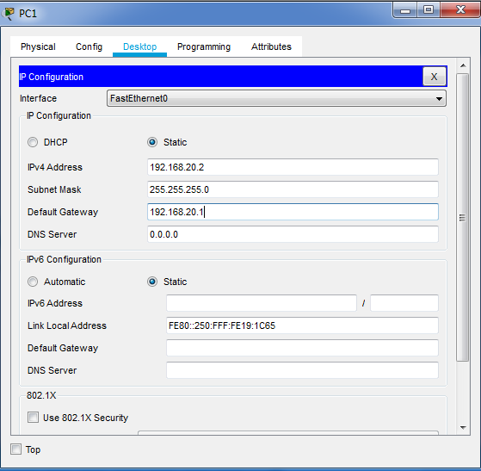

IP Configuration On PC0

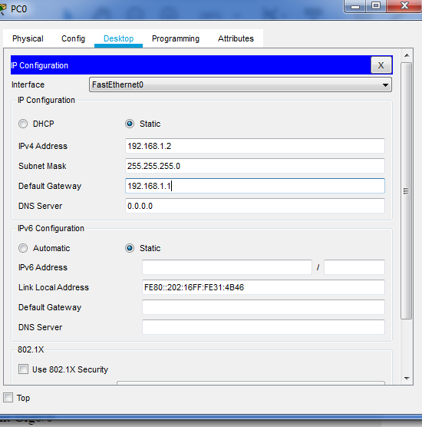

IP Configuration On PC1

**IP addresses on router interfaces**

Router 1:

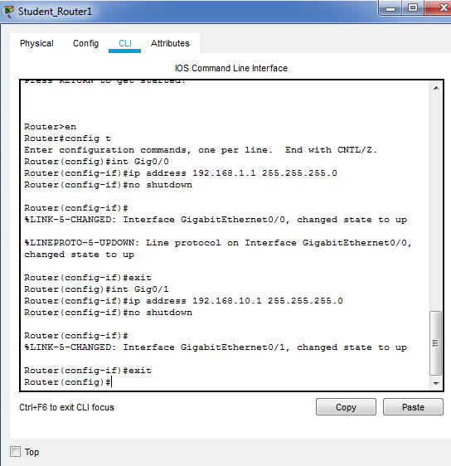

Router 2:

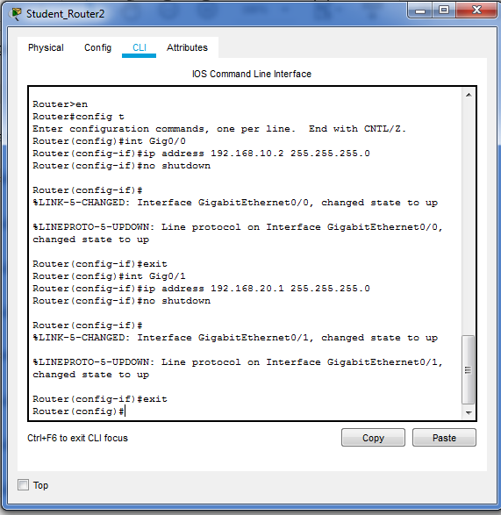

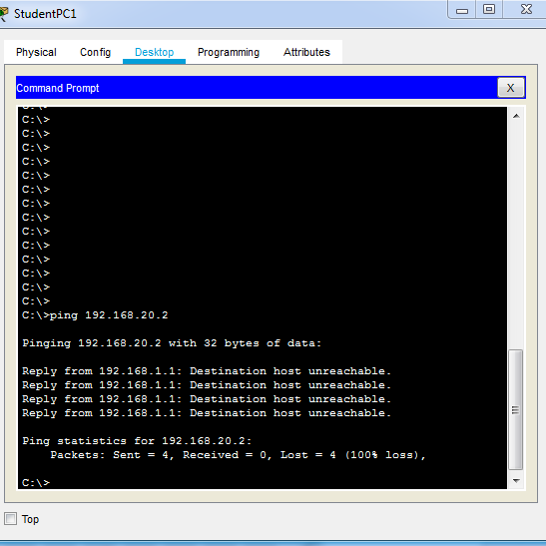No routing Protocol is configure that’s why ping command is not working, and pinging failed

Static Routing Procotol

On Router 1

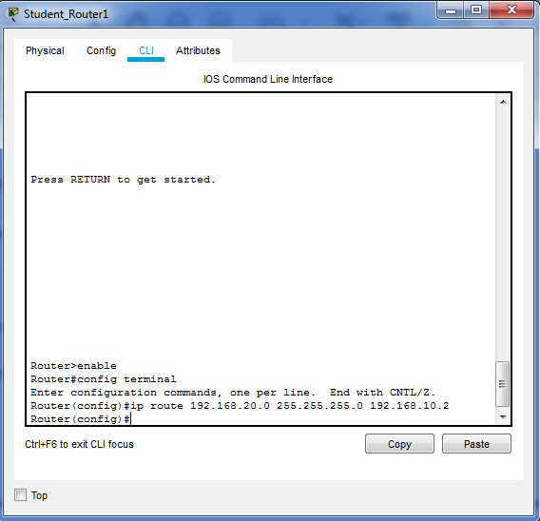

On Router 2

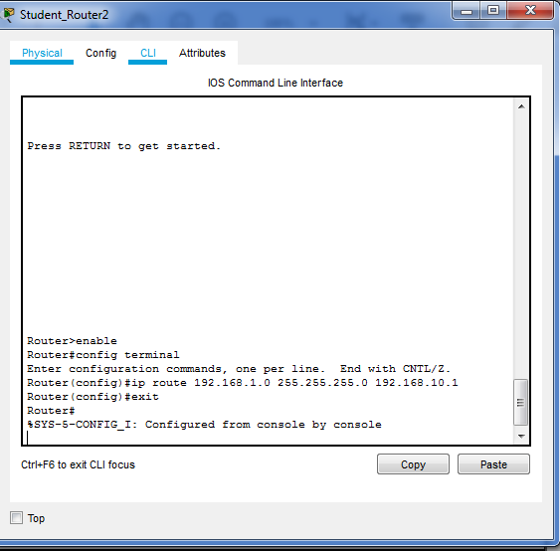

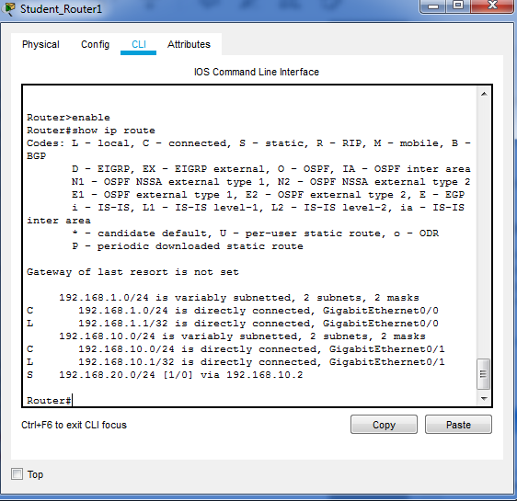

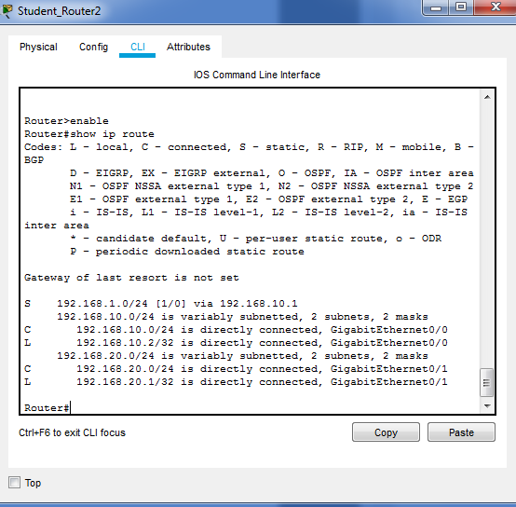

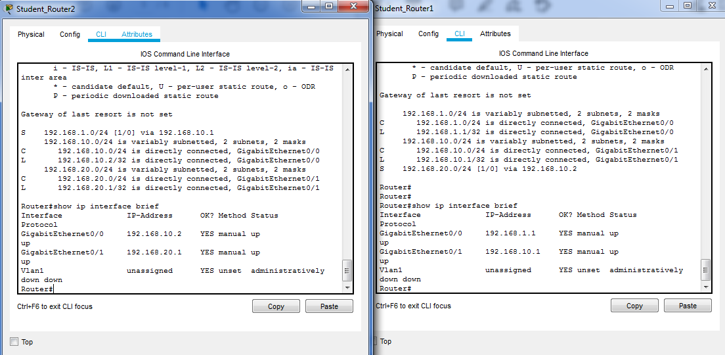

**Task**

**Question 1:**

**Commands:**

**configure static routing on Student_Router1. :**ip route 192.168.20.0 255.255.255.0 192.168.10.2

**enable password : #** enable password Ansar

**running-config:** #show running-config

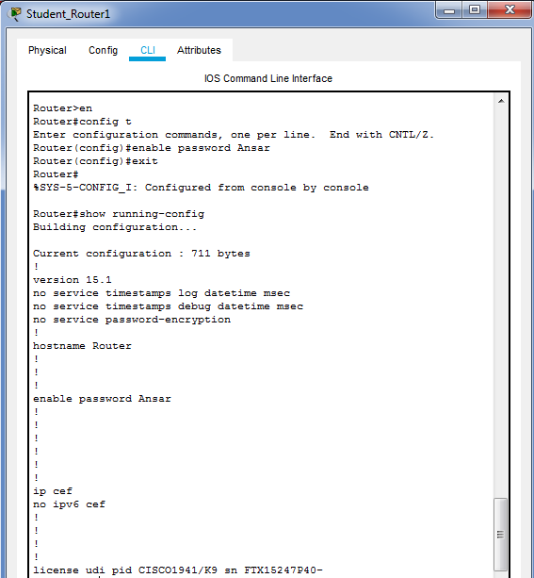

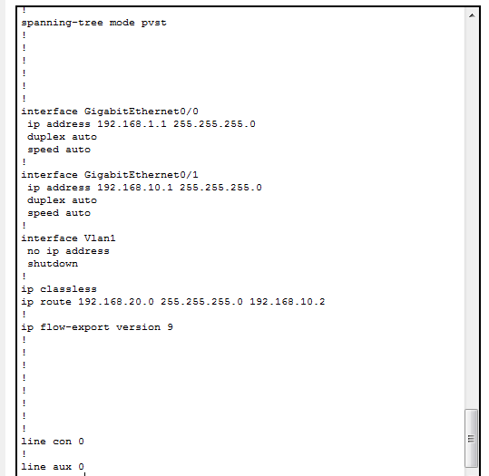

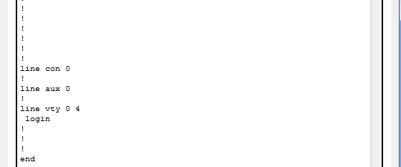

**Question 2:**

**Commands:**

**configure static routing on Student_Router1. :**ip route 192.168.1.0 255.255.255.0 192.168.10.1

**enable password : #** enable password Ansar

**running-config:** #show running-config

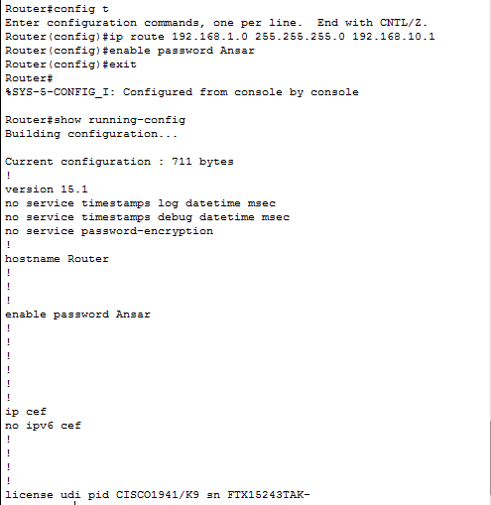

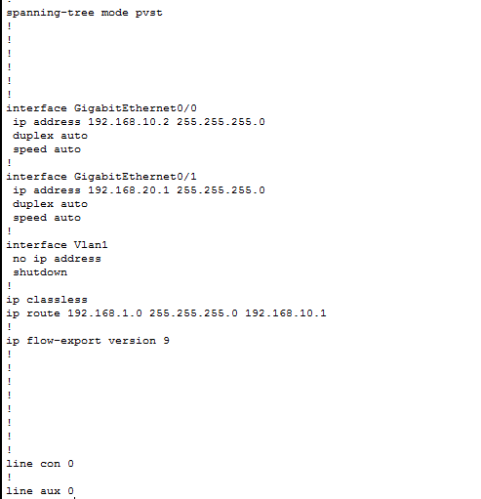

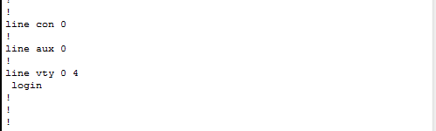

**Question No.3**

**Command:**

**Interface:show ip interface brief**

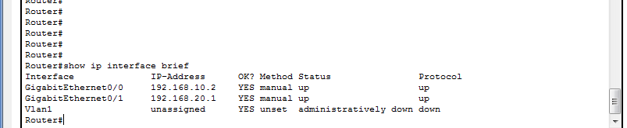

**Question 4:**

**Commands:**

**set hostname. :**hostname Ansar_Router1

**Display routing table : #** show ip route

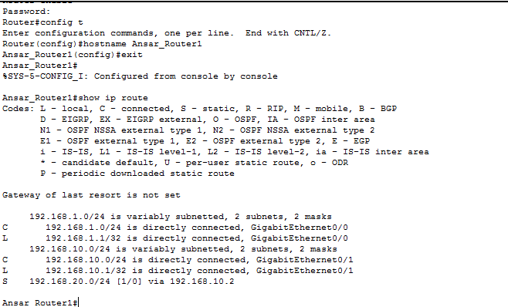

The “shw ip route” command is work to convey the router's routing table. This is the record of every networks packets and its interfaces . For example host 192.168.10.2 is using static routing protocol from network 192.168.20.0

**Question 5**

**Commands:**

**set hostname. :**hostname Ansar_Router2

**Display routing table : #** show ip route

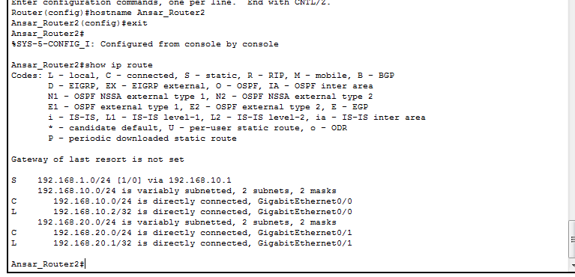

The “show ip route” command is work to convey the router's routing table. This is the record of every networks packets and its interfaces . For instance host 192.168.10.1 is using static routing protocol from network 192.168.1.0

**Question 6**

**Ping command can be used to check reachability of a system**

