There are several common external threats to networks:

* **Viruses, worms, and Trojan horses** - These contain malicious software or code running on a user device.
* **Spyware and adware** - These are types of software which are installed on a user’s device. The software then secretly collects information about the user.
* **Zero-day attacks** - Also called zero-hour attacks, these occur on the first day that a vulnerability becomes known.
* **Threat actor attacks** - A malicious person attacks user devices or network resources.
* **Denial of service attacks** - These attacks slow or crash applications and processes on a network device.
* **Data interception and theft** - This attack captures private information from an organization’s network.
* **Identity theft** - This attack steals the login credentials of a user in order to access private data.

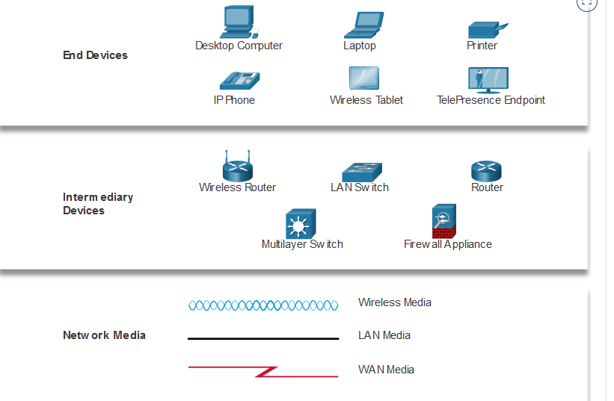

The services and protocols in the TCP/IP suite are defined by the Internet Engineering Task Force (IETF).

The TCP/IP standards are implemented in software and governed by the IETF.

The physical layer standards are implemented in hardware and are governed by many organizations including:

* ISO
* EIA/TIA
* ITU-T
* ANSI
* IEEE