# 

‘

]=-

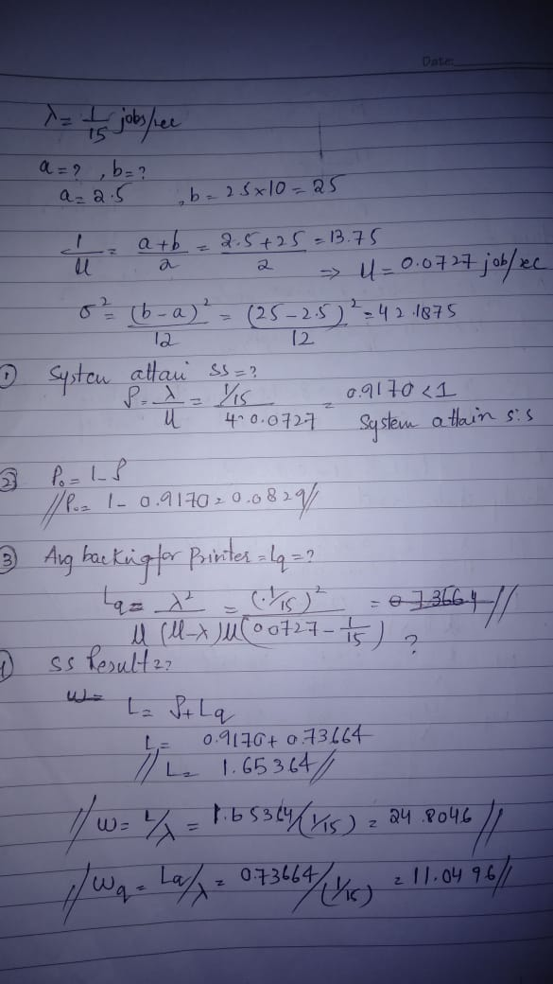



-

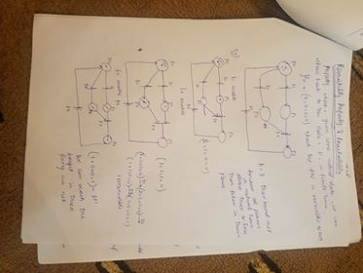



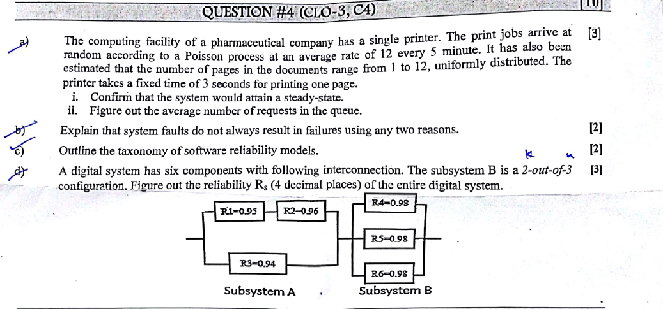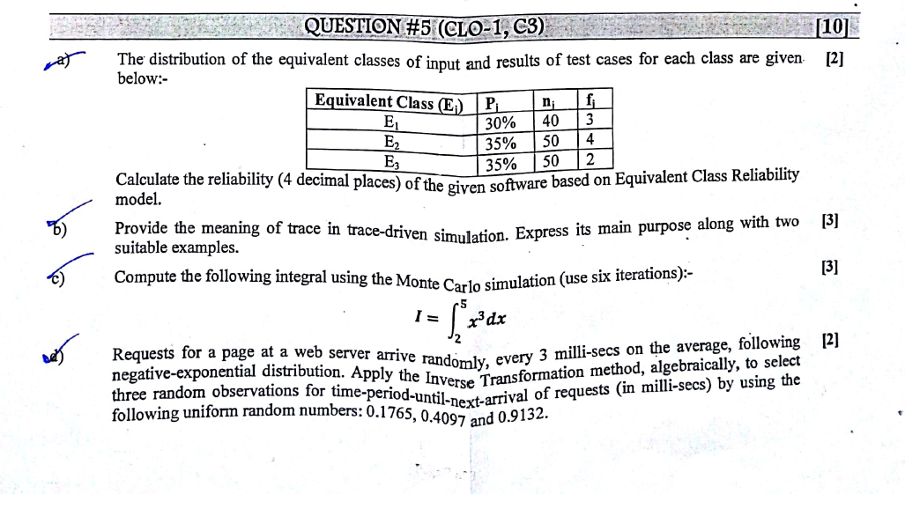



Determine why the failure rate is at its peak at the beginning of Infant Mortality phase and eventually decreases with time ?

# Consider the reliability block diagram in the figure attached. a) Derive the Reliability Expression. b) Assume homogeneous modules and value of R = your roll no/100, calculate the probability that overall system is reliable and data transmission is possible from point A to B.

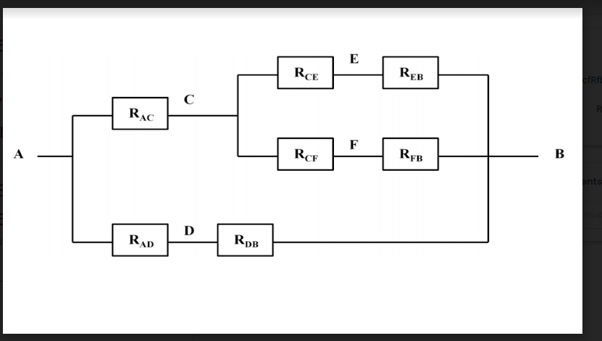

1-[1-RceReb][1-RcfRfb][Rac] R=19/100= 0.19 Put this value in above equation Ratob=0.8234

SECTION “B”

# An electrical supply system is subject to failure which causes loss of supply to the consumer. The mean time between such failures is known to be 398 hr and the meantime to repair the failures and restore the supply is known to be 2 hr. Compute the value of the availability of supply to the consumer?

A=MTTF/(MTTF+MTTR) A=398/(398 + 2)



3)Rsystem=1-[(1-[exp(−αt) * exp(−βt)] )* ( 1-[exp(−γt)*exp(−δt)] ) ]

2)rp=1-[(1-exp(−αt)) *( 1- exp(−βt))* (1-exp(−γt) *(1- exp(−δt)

# Provide at least two application areas of highly reliable systems.

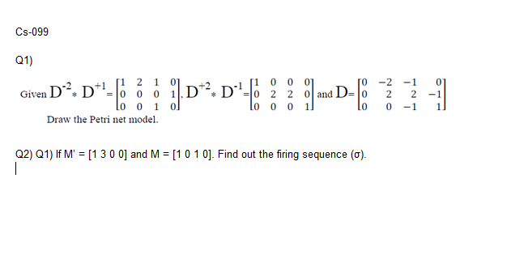 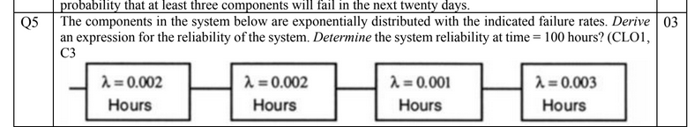

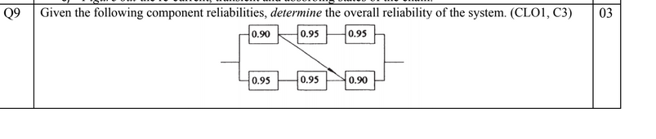

A system consists of four components. If more than two of the components fail, the system fails. If the

components have an exponential time-to-fail distribution with a failure rate of 0.000388, calculate the

reliability of the system at time = 300. Determine the overall system’s mean time to fail. (CLO1, C3)

