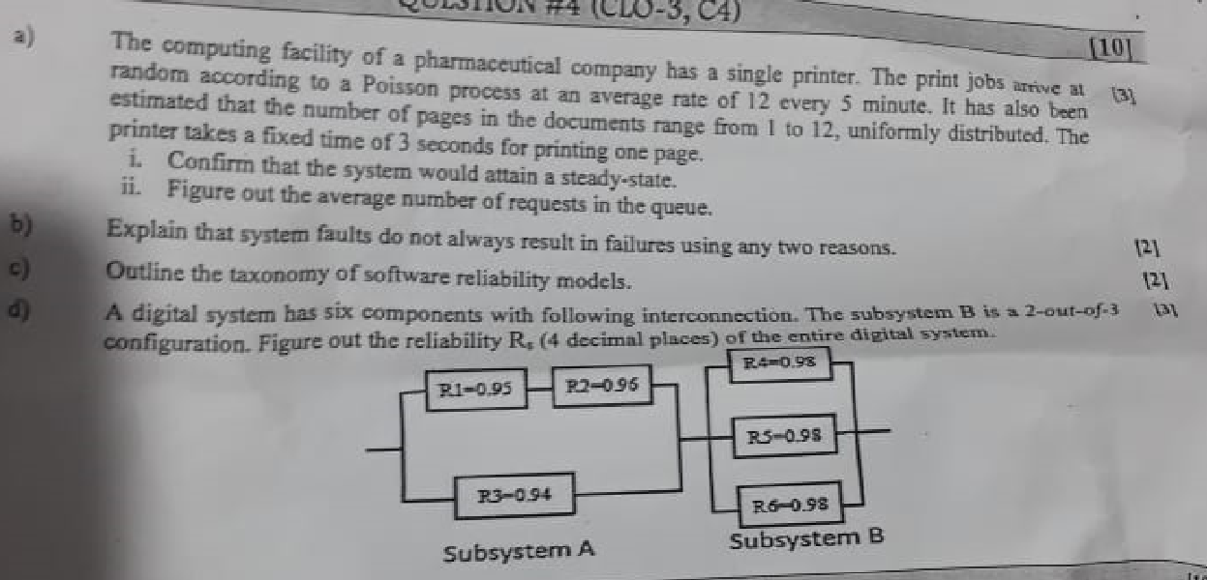



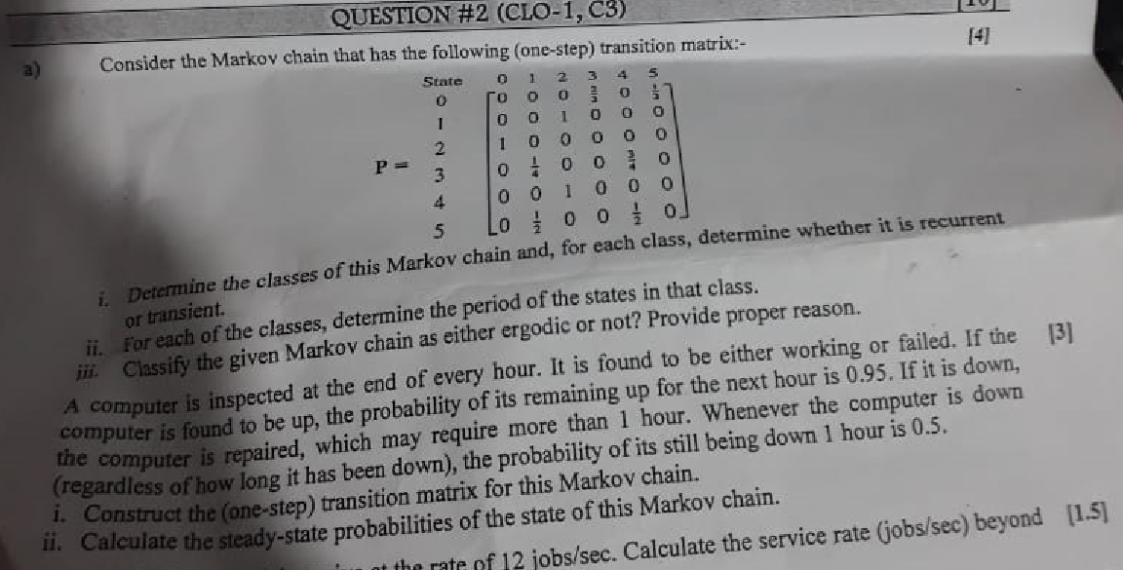





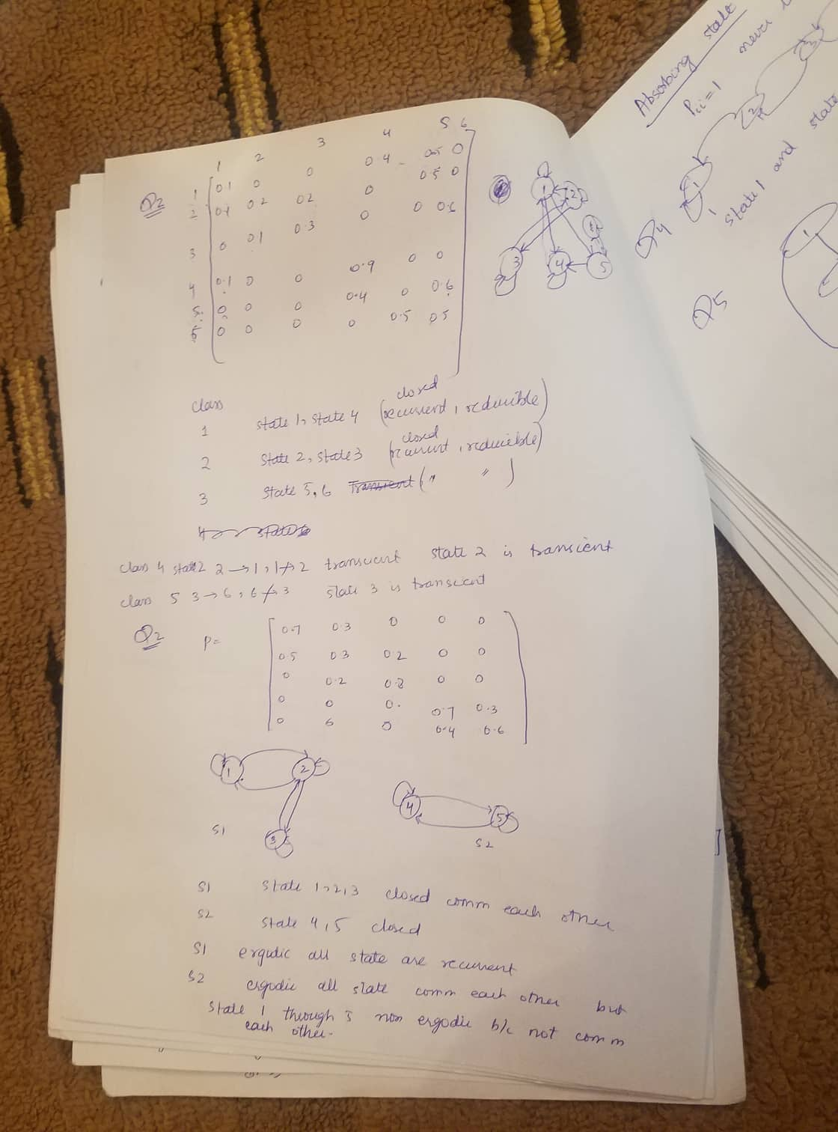

**Assignment2**

Roll No: CS-019

Complete all the tasks given in Lecture 6. Copy the question first and then provide the proposed solution.

**Task 1**

A newly developed compiler for C was found to be much slower than expected. After some preliminary investigation, it was suspected that the compiler was spending too much time manipulating the symbol table.

Show how the fraction of time used for symbol table manipulations, denoted *frac,* can be measured accurately using software monitoring*.*

**Solution:**

1.  Time spent for manipulating symbol table is depend upon the program being compiled, need set of randomly selected programs, or specifically selected set designed to be representative of actual workload.

2.  Use statistical techniques  to analyze data.

**Total time** = Time needed for computation

**Spent time** = Time spent in manipulating symbol table

**Fraction** = Spent Time / Total Time

**Task 2**

Consider the measurement of the relative frequency of instruction usage.

a)                     Discuss pure hardware monitoring and software monitoring solutions for the given problem.

b)                     Discuss the drawbacks (if any) of both of these methods.

**Solution (a):**

**Hardware Monitoring approach:**

1.  First we have to take out the instruction opcode from data bus when instruction is fetched.

2.  Secondly, use the user counter array and initialized it to zeros.

3.  Then increment count [f(opcode)].

4.  Lastly, Relative frequency = count[n] / sum of counts.

**Software Monitoring approach:**

1.  First counter array is in main memory and initialized it to zero.

2.  Then trap after every instruction

·         It is used in some machines

·         Turn off trapping

·         Increment counter [opcode]

·         Turn on trapping

·         Return

**Solution (b):**

Both approaches have some drawbacks:

**Drawback of** **Hardware Monitoring approach :**

1.  Hardware monitoring requires significant hardware.

2.  It is not flexible.

**Drawback of** **Software Monitoring approach:**

1.  Software  monitoring is not suitable because it is trap on every instruction.

2.  It has a large number of overhead.

**Assignment3:**

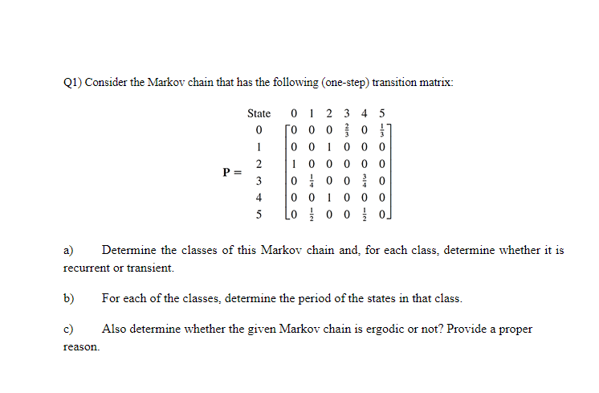

Q2) An engineering professor purchases a new computer every two years with preferences for three models: M1, M2 and M3. If the present model is M1, the next computer may be M2 with probability 0.2 or M3 with probability 0.15. If the present model is M2, the probabilities of switching to M1 and M3 are 0.6 and 0.25, respectively. And, if the present model is M3, then the probabilities of switching to M1 and M2 are 0.5 and 0.1, respectively. Represent the situation as a Markov chain. Also provide transition probability matrix.

Determine why the failure rate is at its peak at the beginning of Infant Mortality phase and eventually decreases with time ?

# Consider the reliability block diagram in the figure attached. a) Derive the Reliability Expression. b) Assume homogeneous modules and value of R = your roll no/100, calculate the probability that overall system is reliable and data transmission is possible from point A to B.

# 

1-[1-RceReb][1-RcfRfb][Rac] R=19/100= 0.19 Put this value in above equation Ratob=0.8234

SECTION “B”

# An electrical supply system is subject to failure which causes loss of supply to the consumer. The mean time between such failures is known to be 398 hr and the meantime to repair the failures and restore the supply is known to be 2 hr. Compute the value of the availability of supply to the consumer?

A=MTTF/(MTTF+MTTR) A=398/(398 + 2)

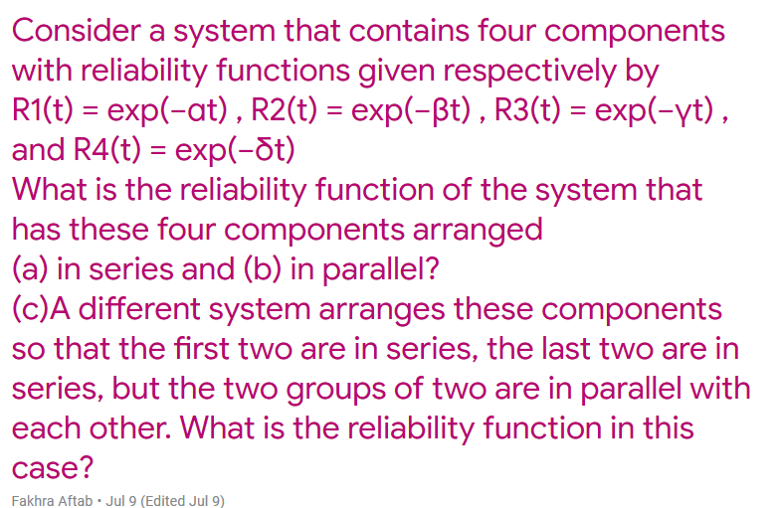

3)Rsystem=1-[(1-[exp(−αt) * exp(−βt)] )* ( 1-[exp(−γt)*exp(−δt)] ) ]

2)rp=1-[(1-exp(−αt)) *( 1- exp(−βt))* (1-exp(−γt) *(1- exp(−δt)

# Provide at least two application areas of highly reliable systems.

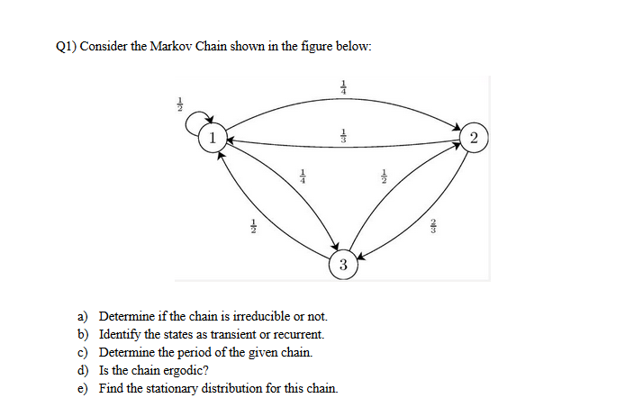

Q2) A wireless packet communication channel suffers from clustered errors. That is, whenever a packet has an error, the next packet will have an error with probability 0.9. Whenever a packet is error-free, the next packet is error-free with probability 0.99. Develop a (one-step) transition matrix for this chain.

Q1) A system executes an application program in 5.625s. The same application is executed by the competitor system in 4.375s. How much faster is the competitor system ?

(Hint: Relative Change)

**Solution:**

Relative change =(T1-T2)/T2

Where T1=5.625,T2=4.375s

So ,

                     Relative change= (5.625-4.375)/4.375

                     Relative change= 0.2875 Ans.

