Version Controlling🡪Change detect krta hai



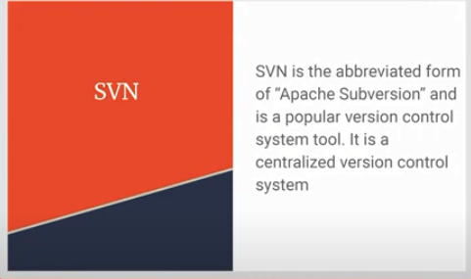

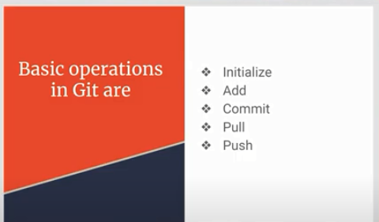

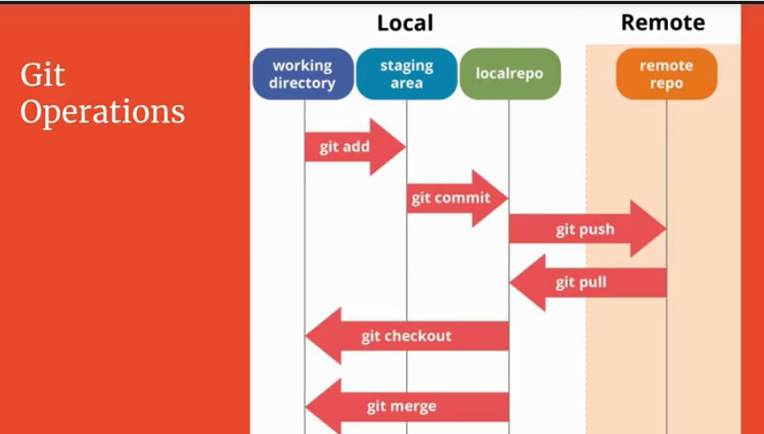

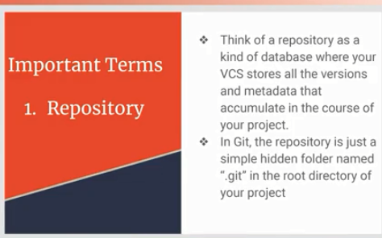

Database h kisne commit kia hai kse kia hai ktne files hai .git ki files m sab hota hai jab bhi git ki repsositiry banti hai toh sare ki sare chzein is m ajati hai

File Status: commit wager akrtey hai toh status update hota hai

Jse phle untracked hai phir add krtey hai toh wo file unmodified hota hai

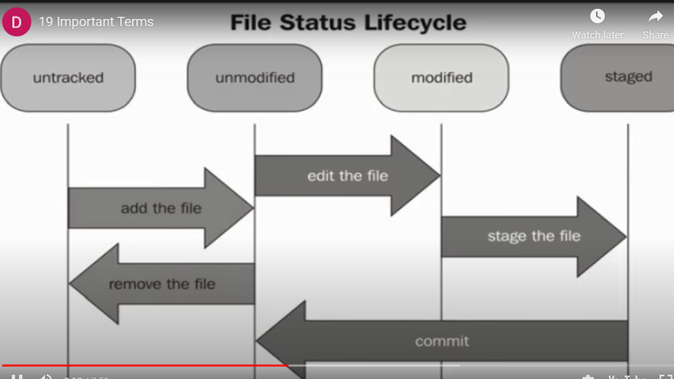

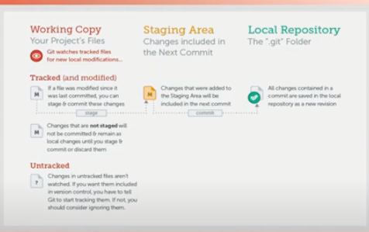

Git logs🡪Commits ki history aajeygi

Head

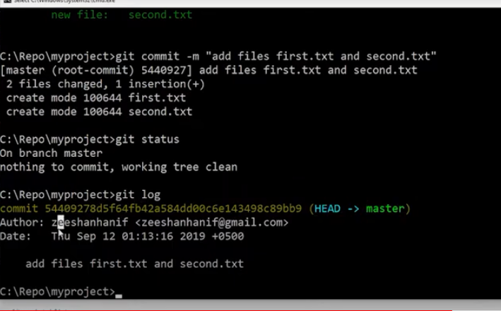

Head represent current node

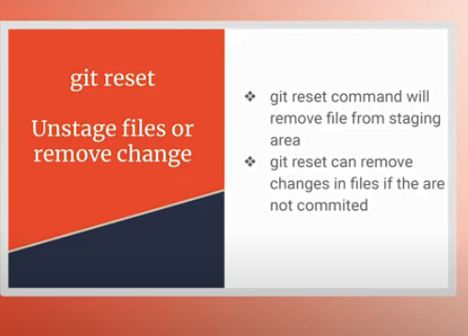

Commit nh kia sirf add kia hai toh git reset se stage files unstage m hojayegii changes remove nh hogi

Git reset –hard 🡪unstages+discard dono krta hai