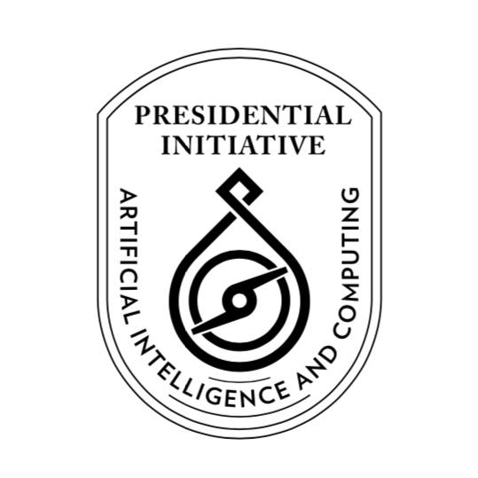

**Presidential Initiative for Artificial Intelligence and Computing (PIAIC)**

https://www.piaic.org

**Artificial Intelligence Specialist Program**

Course Syllabus

**Quarter I: AI-101 AI for Everyone and Fundamentals of Programming using Python**

Version 1.0.0 - 2020 (12 Weeks)

**Teaching Team: Inam Ul Haq, Dr. Noman Islam, Anees Ahmed, Nasir Hussain, Muhammad Qasim, Khurram Raheel, Waqas Ali Munawar, Muhammad Ali, Muhammad Hamza Khan, Aqsa Abdul Qadir, Fayyaz Farooq, Gulraeez Gulshan, Hafiz Muhammad Shahid, Jalees Ur Rehman Khan, Komal Aftab, Mansoor Hussain, Mohsin Iqbal, Muhammad Ali, Muhammad Asadullah, Muhammad Hamza Khan, Muhammad Haseeb Amjad, Muhammad Shahzad Ahsan, Muhammad Sohaib, Muhammad Usman, Nehal Ahmed, Ramsha Munawarah Azeemi, Saqib Arfeen, Shafqat Soomro, Shifa-ur-Rehman Jamali, Syed Hamza, Syed Hamza Ali, Syed Muhammad Masab, Syed Wajahat Ali Naqvi, Umair Shahzad, Waqas Ali Munawar, Rauf ur Rahim, Faizan Amin, Tahir Bhatti, Adan Abid, and Arslan**

**Course Description: We will start this course by understand the fundamentals and use cases for AI.** Then, we'll learn about basic programming concepts using Python, such as lists, dictionaries, classes, functions and loops, and practice writing clean and readable code with exercises for each topic. We'll also learn how to make your programs interactive and how to test your code safely before adding it to a project. It is a fast-paced, thorough introduction to programming with Python 3.8 that will have you writing programs, solving problems, and making things that work in no time. In this quarter we will also learn Git, the distributed version control system. We will also review Git based GitHub services.

**Please bring a Laptop with you for the Classes (Required, but not mandatory)**

**Preparation for International Microsoft Python Certification:**

[Exam 98-381: Introduction to Programming Using Python by Microsoft](https://www.microsoft.com/en-us/learning/exam-98-381.aspx)

**Textbooks:**

1. [A Smarter Way to Learn Python: Learn it faster. Remember it longer by Mark Myers](https://www.amazon.com/Smarter-Way-Learn-Python-Remember-ebook/dp/B077Z55G3B/ref=sr_1_8)
2. [Learn Version Control with Git: A step-by-step course for the complete beginner by Tobias Günther](https://www.amazon.com/Learn-Version-Control-step-step-ebook/dp/B00K54OL8I/ref=sr_1_3)

**Homework Exercises:**

<http://www.asmarterwaytolearn.com/python/index-of-exercises.html>

**Reference books:**

1. [Python Crash Course: A Hands-On, Project-Based Introduction to Programming by Eric Matthes](https://www.amazon.com/Python-Crash-Course-Hands-Project-Based-ebook/dp/B018UXJ9RI/ref=sr_1_1)
2. [Git Essentials by Ferdinando Santacroce](https://www.amazon.com/Git-Essentials-Ferdinando-Santacroce-ebook/dp/B00WX1CWIC/ref=sr_1_3)

**Certification Exam Learning Material:**

<https://sites.google.com/a/nu.edu.pk/noman-islam/exam-98-381-introduction-to-programming-using-python>

**PIAIC Announcements Facebook Group:** <https://www.facebook.com/groups/piaic/>

**Course Facebook Group:** <https://www.facebook.com/groups/deep.learning.edu/>

**Portal for online and onsite students:**

<https://portal.piaic.org/>

**Chat on Telegram:**

Group Name: PIAIC-AI

https://t.me/piaic_ai

**Grading:**

Students will be graded based on Percentile

<https://en.wikipedia.org/wiki/Percentile>

<https://en.wikipedia.org/wiki/Percentile_rank>

A-Grade: 78- 99 Percentile

B-Grade: 41- 77 Percentile

C-Grade: 23- 40 Percentile

D-Grade: 1 - 22 Percentile

F-Grade: Anyone who doesn’t appear in two or more exams

Note: Anyone who receives a F-Grade will be removed from the program. Students who receive a D-Grade will be put on probation, and be required to earn a grade of C or above in the next quarter, to remain in the program. Anyone absent from an exam will be deemed to have received a score of zero.

**Important Note:**

If a PIAIC candidate doesn’t appear in a Quiz at the scheduled time announced by management 10% score will be deducted from the test score for every week of delay.

**Course Outline:**

1. **Introduction to Machine Learning, Data Science and AI** (Week 1, 2 and 3)

AI for Everyone

<https://www.coursera.org/learn/ai-for-everyone>

Note: All optional sections in AI for Everyone course are required sections in this course.

Homework: Please watch the above videos at least three times at home

Additional Homework Viewing:

<https://aischool.microsoft.com/en-us/business/learning-paths/introduction-to-ai-technology-for-business-leaders/explore-state-of-the-art-ai-technology/introduction-to-ai-technology>

**AI Career Pathways**

PIAIC AI Program is training developers for the role of Software Engineer -ML. They require the following skills:

1. Data Engineering
2. Modeling
3. Deployment
4. AI Infrastructure

<https://workera.ai/candidates/report/>

**AI for Everyone Quiz in Week 3**

Total Questions: 60, Total Time: 75 minutes

1. **Additional and Supplementary Material: Fundamentals of Version Control with Git**

(**Videos and reading material available on Student Portal to help students learn Git, this material will not be covered in class to save class time)**  
Chapters 1, 2, 3, and 4 Learn Version Control with Git: A step-by-step course for the complete beginner by Tobias Günther

We will also covers these readings:

<https://help.github.com/articles/markdown-basics/>

<http://stackoverflow.com/questions/5009600/difference-between-fork-and-branch-on-github>

<http://stackoverflow.com/questions/3329943/git-branch-fork-fetch-merge-rebase-and-clone-what-are-the-differences>

<https://git-scm.com/book/en/v2/Git-Branching-Rebasing>

<http://git-scm.com/book/en/v2/Git-Branching-Remote-Branches#Tracking-Branches>

For practice: <https://try.github.io/levels/1/challenges/1>

Homework:

<https://www.datacamp.com/courses/introduction-to-git-for-data-science>

**Git Quiz in Week 1 of Quarter 2**

Total Questions: 60, Total Time: 75 minutes

*Note: Git study material and videos are being made available in the first quarter so that students are able to use Git immediately. The Git Quiz will be conducted in the first week of the next quarter i.e. second quarter and not in this first quarter.*

1. **Python Programming Part 1** (Weeks 4B, 5, 6, and 7)  
   Chapters 1-40 of **A Smarter Way to Learn Python: Learn it faster. Remember it longer by Mark Myers**

Homework:

<http://www.asmarterwaytolearn.com/python/1.html>

**Programming Assignments will also be given.**

**Python Quiz 1 in Week 8**

1. **Python Programming Part 2** (Weeks 7 - 12)  
   Chapters 41-77 of **A Smarter Way to Learn Python: Learn it faster. Remember it longer by Mark Myers**

Homework:

<http://www.asmarterwaytolearn.com/python/41.html>

**Programming Assignments will also be given.**

**Python Quiz 2 in Week 13**