**APPROVAL SHEET**

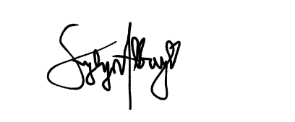 This Thesis entitled “**EDUCATORS’ LEADERSHIP STYLE AND WORK-BASED PERFORMANCE TOWARD WORK FULFILLMENT GUIDE**" prepared and submitted by **RODRIGO P. CALAPAN** in partial fulfillment of the requirements for the **Basic Education Program** has been examined and is recommended for Final Defense.

**KYLYN JOY B. ALBAY, LPT**

Research Project Adviser/Teacher

**APPROVED** in partial fulfillment of the requirements for the Basic Education Program by the Oral Examination Committee with the rating of.

**MR. ANDRO PHILIP G. BANAG**

Chairman

**Mr. MARK ANTHONY P. ILAGAN MR. RUBEN A. ALELUYA, LPT**

Member Member

**MRS. ROSALYN M. ESCUDERO**

Member

**ACCEPTED** and approved as partial fulfillment of the requirements for the Basic Education Program**.**

**ENGR. RODRIGO P. CALAPAN, MAED, LPT**

SHS Principal