**Problem: How do movie genres and release dates affect movie ratings?**

The movie database was quite small for an accurate study, however we utilized it to create insights for the available data. We compare the user’s rating to the ratings found on the IMDb and TMDb websites. We utilized the regular GET requests and the TMDb API to retrieve the ratings and genres of the movies in our list. Their ratings are based on a larger sample and professional movie critics which provide a more reliable rating score. We compare each users rating and the ratings retrieved and found that some users had largely different opinions about the movie on average. We can label these users as outlier and possibly omit their responses.

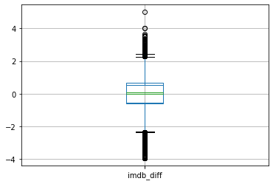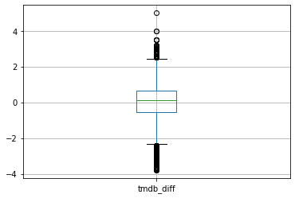

The release data did not have much of an effect on the movie rating. We found the two features were not linearly correlated acceding to the least square correlation coefficient. There may have been some bias when selecting older movies to watch by the users. Typically only better old movies may have been selected by the users to watch as the correlation coefficient was negative. We found that a higher degree polynomial had a better correlation with our data, however we should not attempt to use too high degree polynomial as over-fitting can occur.

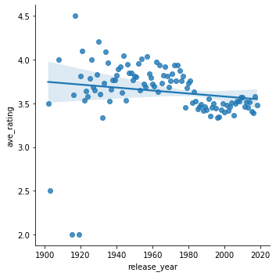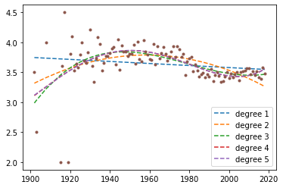

The average movie rating based on genres we were able to determine that horror films were on average the worst rated films while film-noir where the highest rated films according to the users in our database. Since this is still a small user-base, we should not take these results too strongly as the average rating based on genre only differed by less than 1 point.

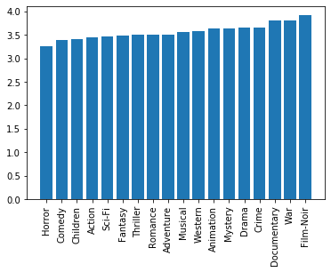Release can be found at: <https://github.com/marius-pop0/InterviewTest/releases/tag/1.0>