# Summary

I’ve been building iOS apps during the last five years, although I have written code for Android on a number of occasions in the past. I've been passionate about technology for as long as I can remember. I wrote my first commercial lines of code 10 years ago as a freelance web developer and transitioned to mobile apps along the way.

I am a practitioner of user-centric product development, I believe that running lean and agile is the way to create value for your users.

# Frameworks and tools

- AVFoundation, CoreAudio, CoreAnimation, CoreData, UIKit, MapKit, MapBox, Security

- Git, Xcode, Instruments, AppCode, Fastlane, Jenkins, Bots, Charles proxy, mitmproxy, Wireshark, Paw, Zeplin, Sketch, PaintCode, Dash

# Employment history

**Independent contractor  **

**iOS Developer, London, UK** *July 2016 - present*

While working with London based agency The App Business, I was part of an agile team that developed the official tourist guide of London. The app was written entirely in Swift 2, we employed an MVVM architecture, used Realm for persistence and TeamCity with fastlane tools for deploying builds to HockeyApp. During the same contract I worked on enhancing the security of an existing internal app for Unilever with assuring results coming from independent penetration testing.

** **

**iOS Developer, London, UK** *December 2014 - March 2016*

Composed is a classical music streaming app, a startup venture from Universal Music Group. Until the summer of 2015, it was hosted and managed by Made by Many, a product innovation studio based in London and New York, before integration back into Universal Music Group.  
I was in charge of developing and maintaining the iOS app. During my time there I’ve increased unit test coverage by 50%, replaced the audio engine in the app with an open-source implementation, added new UI in universal storyboards with auto-layout and written all new code in Swift.  
Additionally, at Composed we worked as a cross functional team and were all also involved in product-related tasks such as analytics review, user interviews, product steering sessions or feature sketch sessions.

  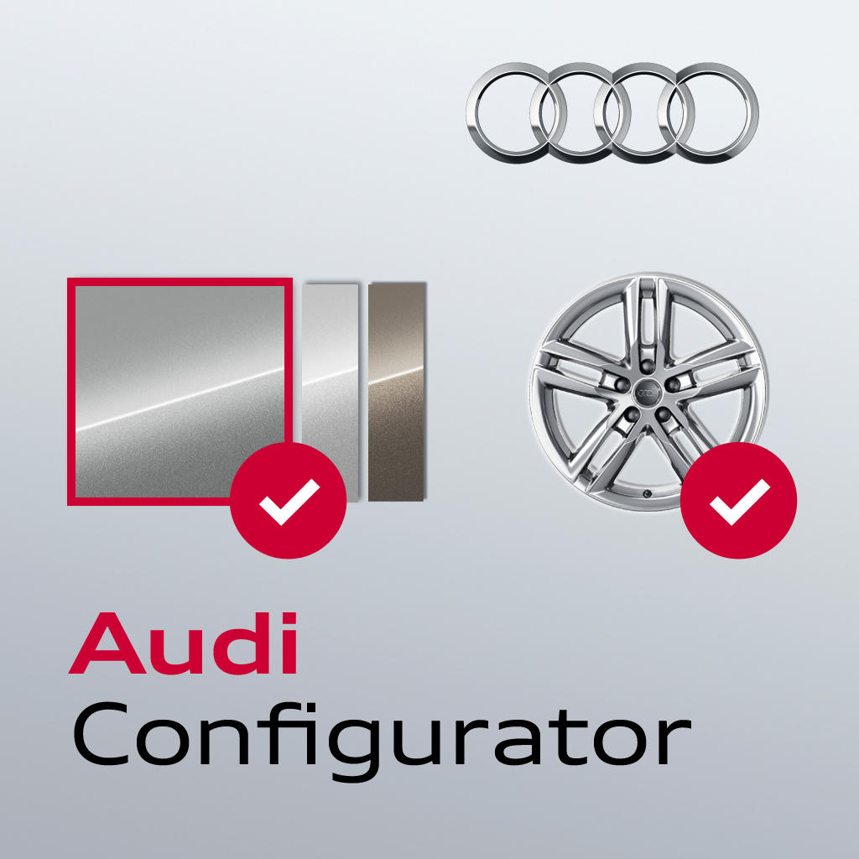  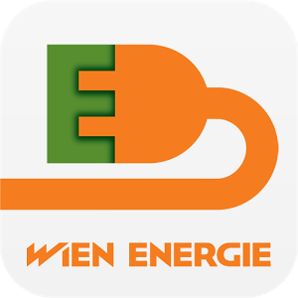  

**iOS Developer, Cluj-Napoca, Romania** *September 2012 - July 2014*

I was mainly involved in developing native apps for iPhone and iPad. I also performed code reviews for Audi AG, analyzing code bases of more than 20 internal and consumer iOS apps. Additionally I offered to help out on Android projects when needed.  
Here are some apps that I build from scratch:   
- Tanke: a location based mobile app that helps electric car owners in Vienna find charging stations around them.   
- mobiLEOS: product targeting the health sector in Germany. It helps health service providers manage appointments with patients and deal with paperwork involving treatment and payment.   
- De-Touro: product operating in the German health market. It enables cab drivers to bid on patient transport jobs offered by health insurance companies using their mobile devices.

**Small Footprint, Inc**.   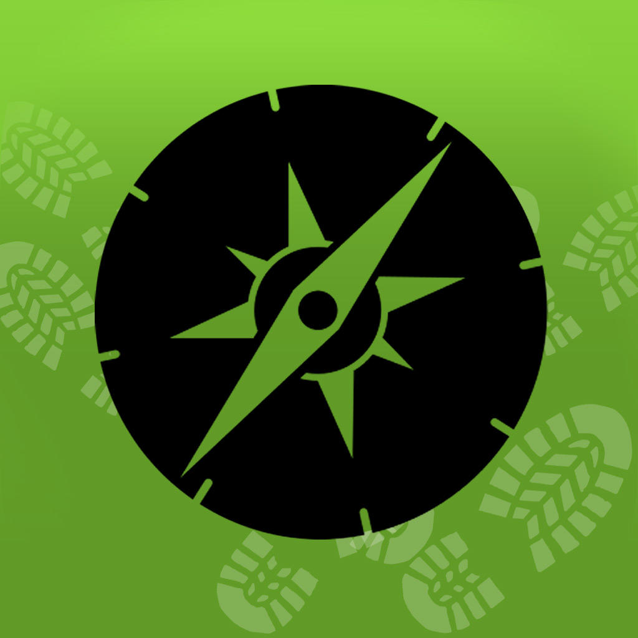

**Mobile App Developer, Cluj-Napoca, Romania** *November 2011 - August 2012*

Started out working on an app built with Titanium API but realized this technology was becoming a performance bottleneck. Then switched to native iOS development, learning along the way, I built two enterprise apps, one supporting iPhone and the other for iPad. My last project at this company was developing a simple 2D puzzle game for Android phones and tablets (Java) from scratch.

**OSF Global Services**

**JavaScript Developer, Cluj-Napoca, Romania** *October 2010 - August 2011*

I worked with Javascript both on the server-side and inside the browser (jQuery) while integrating custom e-commerce solutions based on the Demandware platform. I also worked on developing a few mobile applications for Android and Blackberry using the native APIs (Java) and Appcelerator’s Titanium API (Javascript).

**OgreCore.com - self employed**

**Web Developer, Cluj-Napoca, Romania** *April 2005 - August 2010*

Development of web applications using PHP/MySQL/HTML. Developed e-commerce websites, CMS, Wordpress customization, various front-end work.

# Education

**Bachelor’s degree – Electronics, Telecommunications and IT** *2006 – 2010*

**Technical University of Cluj Napoca**

Wrote my bachelor’s thesis at Vrije Universiteit Brussel as part of an Erasmus Programme. My project involved developing a sound-based localization method for determining the position of wireless sensor nodes. I developed an algorithm that would determine the position of a wireless sensor in a cartesian system of coordinates by using sound via on-board speakers and microphone. Wireless sensor nodes were running TinyOS, a real-time operating system and the code was written in nesC.

# Interests

- sports: basketball, tennis, golf, table-tennis

- I enjoy contributing to open source projects

- reading about computer science, software business, startups and design