Transport Break-even Engine
Blueprint Add-on: Webapp Process Map and Operating Model

Field | Value
Document type | Blueprint add-on documentation
Version | v1.0
Date | 7 May 2026
Project | Transport Break-even Engine
Scope | Business process, technical process, deployment process, ownership model and change-management rules

Purpose
This document extends the project blueprint with a practical process map for the web application. It explains how user inputs move through the frontend, shared calculation engine, backend API, database, saved history, export layer and deployment pipeline.

1. Executive Summary
The Transport Break-even Engine is not only a calculator. It is a controlled pricing workspace. It converts transport assumptions into operational, commercial and audit-ready outputs, while keeping the calculation path traceable from input to result.
The application should be managed through three connected processes:
- Business process: user assumptions become pricing and break-even decisions.
- Technical process: frontend, shared engine, backend and database cooperate to calculate, persist and export runs.
- Deployment process: code changes move through GitHub main and Render before live validation.
Layer | Role in the project
Frontend | User workspace for dashboard, company setup, fleet inputs, results, pricing, sensitivity and history.
Shared engine | Calculation truth for break-even, fleet aggregation, pricing scenarios and sensitivity logic.
Backend | API coordinator for reference data, preview calculation, saved runs, history, deletion, export and audit.
Database | Memory and audit layer for reference data, saved snapshots, results, pricing scenarios and logs.
GitHub | Source of truth for code and documentation.
Render | Live deployment layer for frontend and backend services.

2. Current Architecture Context
The repository is organised as a monorepo with frontend, backend and shared workspaces. This matters because business design, calculation logic, API behaviour and data persistence are separated into distinct responsibility areas.
transport-break-even-engine
|-- frontend React web application
|-- backend API, persistence, migrations, exports
|-- shared Blueprint calculation engine and tests

The root project scripts support frontend development, backend development, database migration, seed data, frontend build and tests. This means the project can be operated as a controlled engineering workflow rather than a set of isolated files.

3. Business Process Map
The business process starts when the user opens the webapp and ends when a calculation run is saved, reviewed, exported or used for pricing decisions.
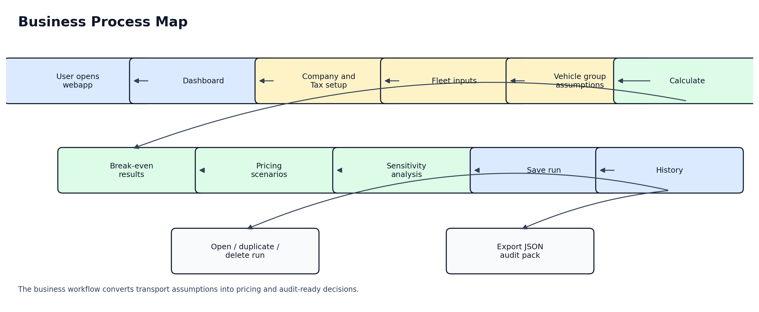
Business interpretation:
- The Dashboard gives the user a quick view of the current scenario.
- Company and Tax setup defines the commercial and jurisdictional modelling context.
- Fleet inputs define the operating assumptions for one or more vehicle groups.
- Calculation produces break-even, pricing and sensitivity outputs.
- History and export make the run reusable, auditable and suitable for later comparison.
Stage | User action | Business output
Dashboard | Open the webapp and inspect the scenario overview. | Initial orientation and status.
Company and Tax | Select country, company type, business model and VAT status. | Commercial modelling context.
Fleet Inputs | Enter fleet, vehicle group, load, cost and pricing assumptions. | Operational scenario definition.
Break-even | Calculate and review annual cost, loaded-km break-even and tonne-km break-even. | Core pricing floor.
Pricing | Review markup-based customer rates and profit impact. | Commercial price decision support.
Sensitivity | Stress key assumptions such as fuel, load factor, payload and markup. | Risk visibility.
History | Open, duplicate, delete or export saved runs. | Traceability and reuse.

4. Technical Process Map
The technical process describes how the frontend, backend, shared calculation engine and database cooperate during calculation and persistence.
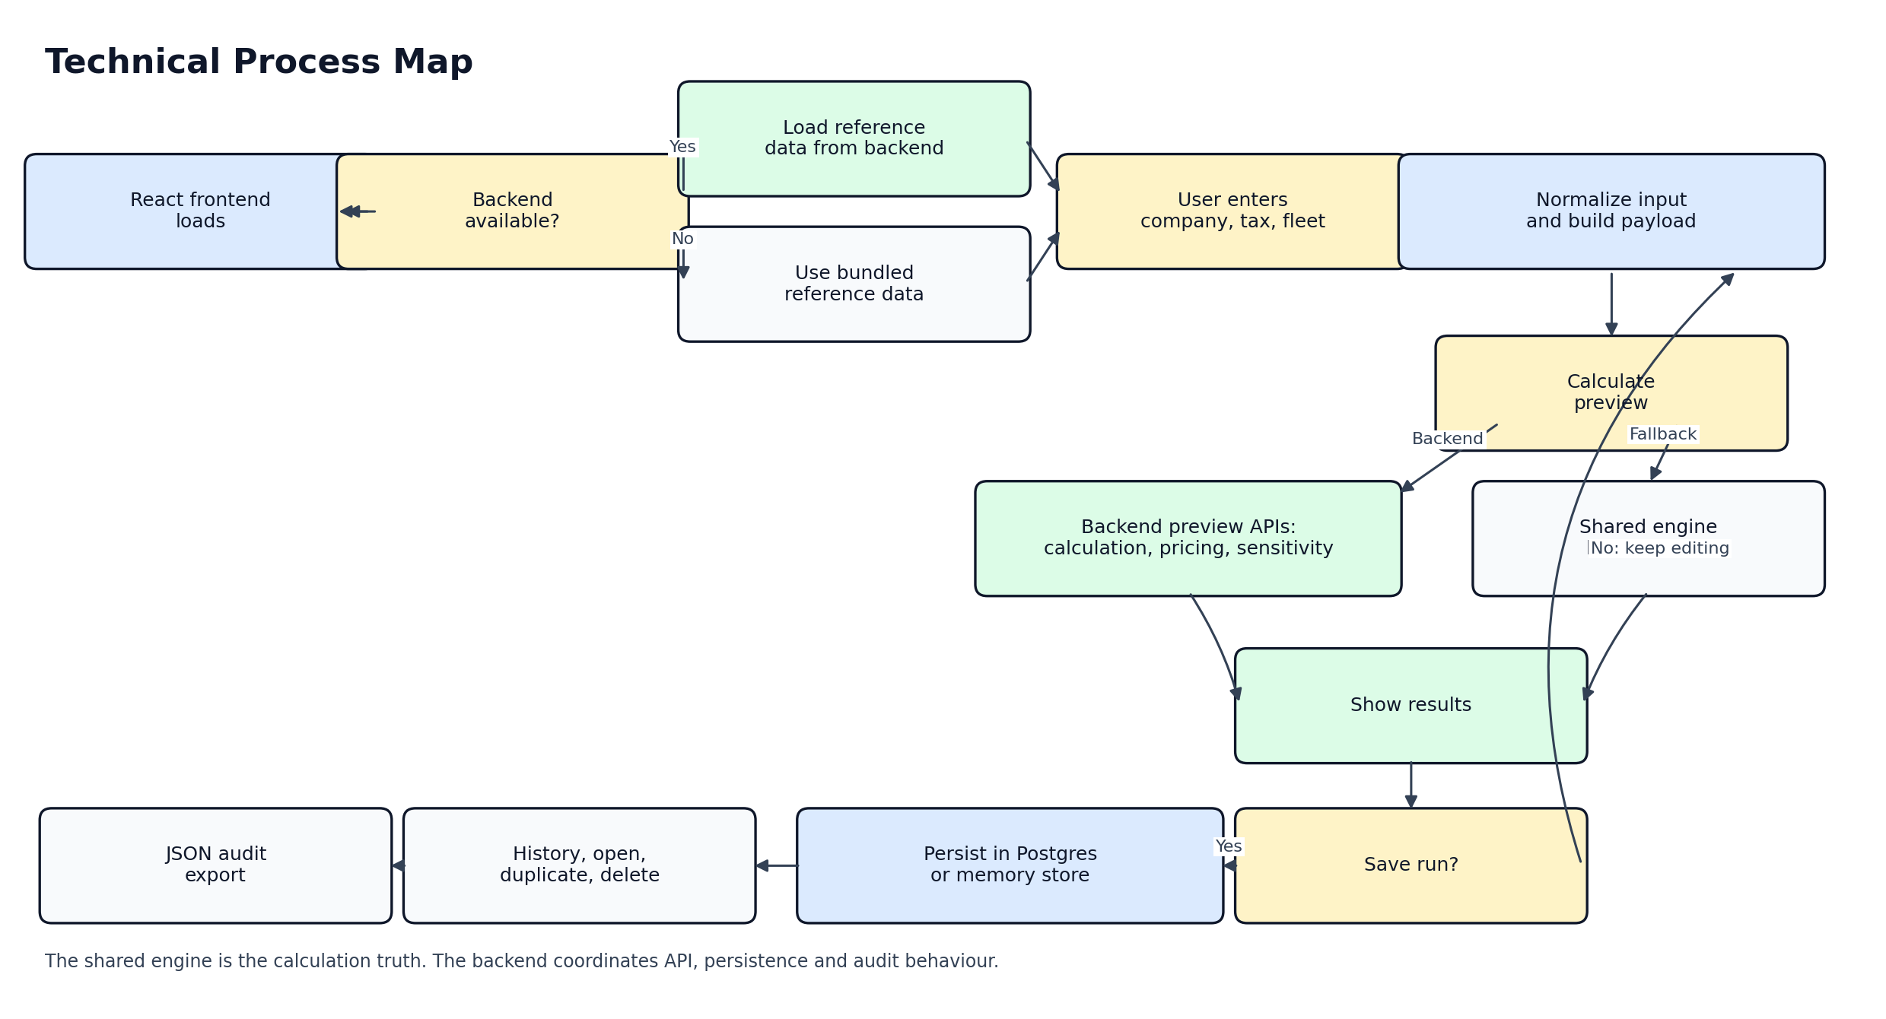
Technical interpretation:
- The frontend loads reference data from the backend when available.
- When the backend is not available, the frontend can still show a local preview through bundled reference data and the shared engine.
- Preview calculation can use backend APIs for calculation, pricing and sensitivity.
- Saved runs require backend support because they need persistence, history and export capability.
- When DATABASE_URL is configured, saved data persists in Postgres. Without it, local development can fall back to memory storage.
Technical step | Description | Risk if broken
Reference loading | The frontend requests reference, tax and vehicle data. | The user sees missing or outdated modelling choices.
Input normalisation | User inputs are converted into a calculation-ready payload. | Wrong units or empty values may distort results.
Preview calculation | The shared engine calculates break-even, pricing and sensitivity outputs. | The pricing decision becomes unreliable.
Save run | The backend persists input, tax, vehicle and result snapshots. | History, audit and comparison are lost.
History actions | Saved runs can be opened, duplicated, deleted and exported. | The user cannot reuse prior scenarios.
Export | A JSON audit pack can be generated for a saved run. | Traceability becomes weak for commercial review.

5. API Process Catalogue
The API should be understood as the process coordinator between frontend actions, calculation logic, database persistence and audit/export behaviour.
API group | Endpoint examples | Process role
Reference and tax cascade | GET /api/countries  GET /api/countries/:countryId/company-types  GET /api/business-models  GET /api/vehicle-classes  GET /api/tax-profile | Provides the modelling context required before calculation.
Calculation preview | POST /api/calculations/preview  POST /api/pricing-scenarios/preview  POST /api/sensitivity/preview | Generates non-persistent calculation, pricing and sensitivity previews.
Saved runs and history | POST /api/calculations  GET /api/calculations  GET /api/calculations/:id  DELETE /api/calculations/:id | Persists, retrieves and deletes calculation runs.
Audit and export | GET /api/audit-log  GET /api/exports/:calculationRunId/json | Supports traceability and export-ready documentation.

6. Data Persistence Process
The data layer must preserve the relationship between assumptions, formulas, results and commercial decisions. Saved runs should therefore be treated as immutable snapshots rather than temporary UI states.
Data area | Purpose
calculation_runs | Stores the saved run identity, name and input context.
calculation_results | Stores calculated result snapshots.
pricing_scenarios | Stores markup and customer-rate scenario outputs.
audit_log | Stores events that support traceability.

Database behaviour rule:
- Production and serious testing should use DATABASE_URL and Postgres.
- In-memory storage is acceptable only for local development and temporary testing.
- A saved commercial run should always be backed by persistent storage.

7. Deployment Process Map
The deployment process defines how a design, frontend, backend or database-related change becomes visible on the live webapp.
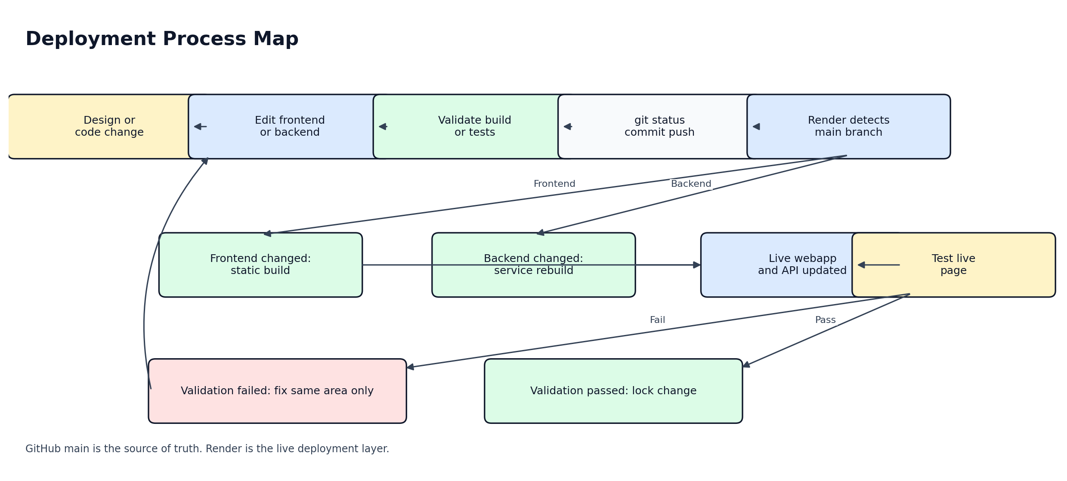
Step | Required action | Control point
1 | Identify whether the change affects frontend, backend, shared engine, database or deployment. | No blind changes.
2 | Implement the change in the smallest affected area. | Limit regression risk.
3 | Run build or relevant validation. | Confirm the app still compiles or tests pass.
4 | Run git status before commit. | Confirm changed files are intentional.
5 | Commit and push to main. | GitHub becomes the source of truth.
6 | Render deploys the affected service. | Frontend or backend becomes live.
7 | Test the live page or API. | Validate production behaviour, not only local behaviour.

8. Change Management Rule
Every change should follow the same controlled sequence:
request
-> identify affected process
-> identify affected file or component
-> implement only that change
-> run validation
-> git status
-> commit
-> push to main
-> test on Render
-> confirm result

No design, calculation, database or deployment change should be made without knowing which process it affects.

9. Process Ownership Model
Ownership area | Responsible for | Main risk
Frontend | Page layout, navigation, input forms, dashboard cards, result presentation, pricing tables, sensitivity tables, history view and user experience. | Breaking the user workflow or making calculation inputs unclear.
Shared engine | Calculation logic, formulas, fleet aggregation, pricing scenarios, sensitivity logic, precision rules and fallback local calculation. | Changing commercial results without traceability.
Backend | API endpoints, reference data loading, preview services, saved runs, history, delete logic, export generation, audit log and database connection. | The frontend looks correct, but save, history or export fail.
Database | Reference data, saved runs, calculation snapshots, pricing scenarios, audit records and future plan-vs-actual tables. | Loss of traceability between input, result and pricing decision.
Deployment | GitHub main branch, Render frontend deployment, Render backend deployment, environment variables and production validation. | Local version works, but live version fails.

10. Design Implementation Rule
A design change must be treated as a controlled frontend change. Design work should improve clarity, usability and visual hierarchy without silently modifying calculation logic.
Design step | Rule
Map target page | Identify whether the change affects Dashboard, Company and Tax, Inputs, Results, Pricing, Sensitivity, Vehicles or History.
Identify affected component | Change only the related component or stylesheet area.
Check logic impact | If calculation logic is affected, split it into a separate implementation task.
Validate visually | Check the page after deployment on Render.
Lock the change | Once the live result is correct, keep the design stable until a new request is defined.

11. Future Blueprint Extensions
The process map should later be extended with the annual planning layer and plan-vs-actual logic.
- Annual plan-vs-actual process
- Actual mileage update process
- Monthly forecast recalculation process
- Minimum, maximum and trend chart process
- Role-based user process
- Database audit process
- Commercial approval workflow

12. Final Architecture Statement
The Transport Break-even Engine should be managed as a workflow-based web application.
Frontend = user workspace
Shared engine = calculation truth
Backend = process coordinator
Database = memory and audit layer
Render = deployment layer
GitHub = source of truth

This add-on bridges the blueprint and implementation. It explains not only what the app does, but how changes should move safely through the system.

13. Source Notes
This documentation was generated from the current project analysis and the public repository structure available during the conversation. Source files reviewed include README.md, package.json and frontend/src/App.jsx from the GitHub repository mariusciobanunautilus/mariusciobanunautilus-transport-break-even-engine.
A FigJam version of the process map was also generated separately during the analysis workflow.

