Tourism in Norway

Marius R. Larsson

26 juli 2018

# Introduction

æøå This æ is ø an å example file and project for the course BED-2056. Use this as an inspiration for your own project. Feel free to steal ideas and use the code (but for your own sake, don’t copy/paste. Understand what it’s doing and why it was used.). In this example report we will look at the change in overnight stays at hotels in Norway from januar 1986 to september 2018.

# Overnight Stays Norway

The first plot shows a time series of the hotel overnight stays in Norway from January 1986 to May 2018. As we can se the activity is highly seasonal and seems to have a positive trend. We can observe that we have a small decrease in overnight stays following the 2008 financial crisis. On the other hand, it’s difficult to see whether or not the YTD 2018 is higher than YTD 2017. In addition, the plot is created with a static data frame. This is perfectly fine, but if we are to update this report every month (or every time new data is available), we should use the SSB API. Let’s change the way we plot the data and use the SSB API.

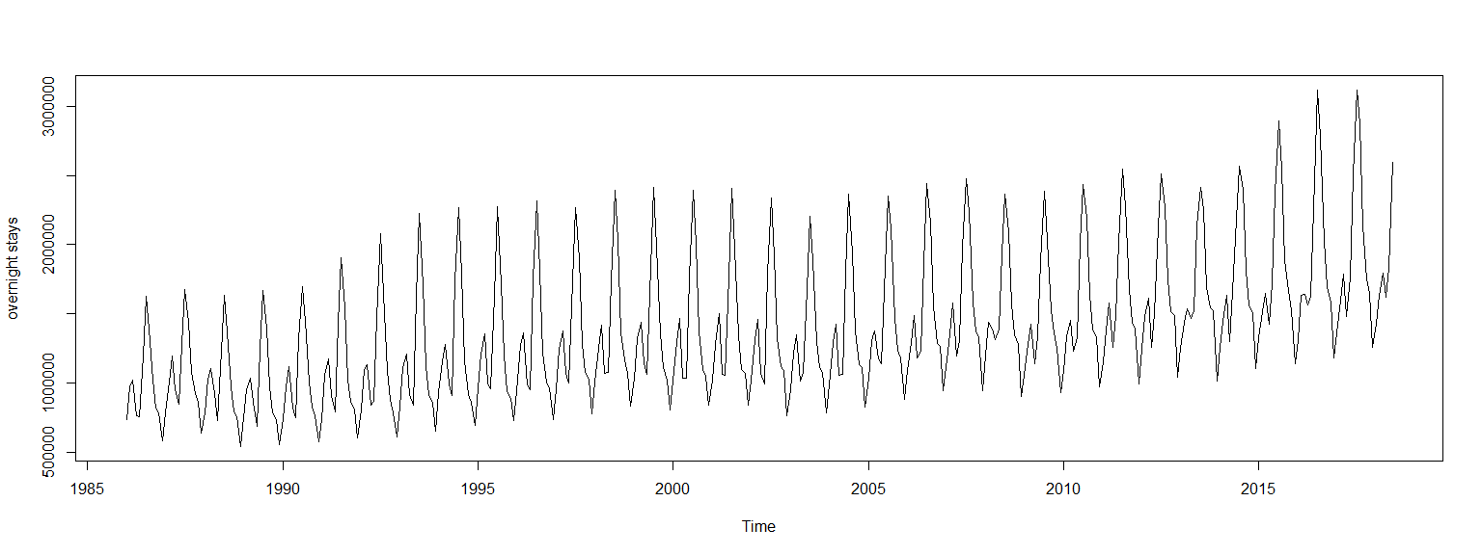

In the figure bellow we can se that for YTD, 2018 is currently the year with the most total overnight stays since 1986. This plot is created with a dynamic dataset which will automatically be updated every month when SSB updates their data. This is also true for the rest of this example report.

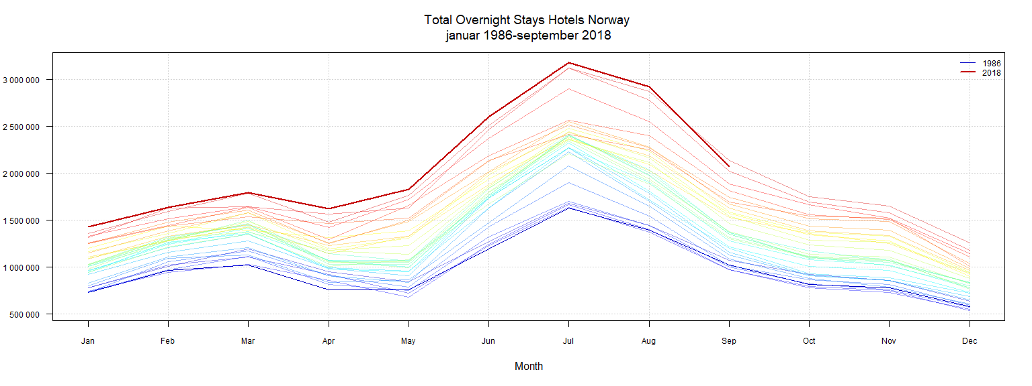

As we can se from the plot bellow, it’s the Ferie, fritid that accounts for most of the overnight stays during peak season in summer.

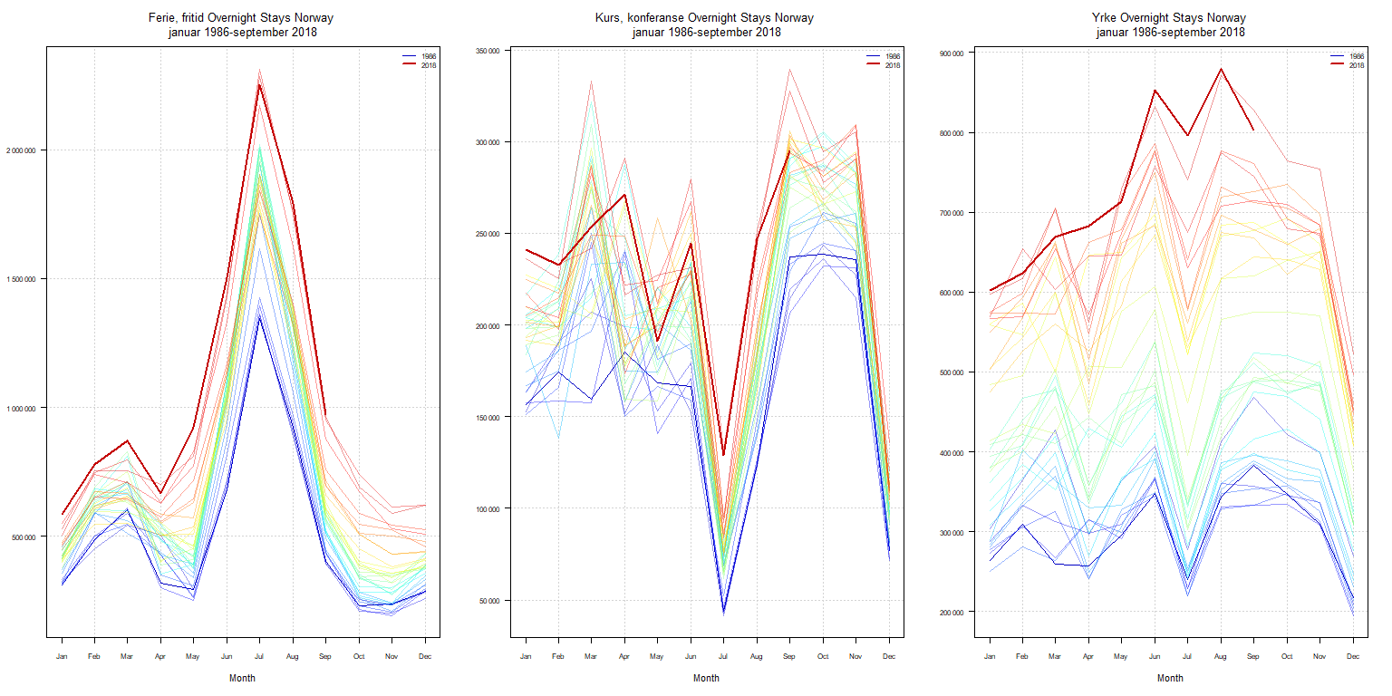

From the summary table bellow we can confirm that the month with the most overnight stays is highest for the Ferie, fritid category. The Kurs, konferanse category has the lowest. We can also see that the category Yrke has probably the least volatily as the range is quite low compared to the others. Both the plot and summary confirms this.

Summary Table 2017-2018

|  |  |  |  |
| --- | --- | --- | --- |
|  | Ferie, fritid | Kurs, konferanse | Yrke |
|  | Min. : 528721 | Min. : 92458 | Min. :522741 |
|  | 1st Qu.: 691982 | 1st Qu.:225233 | 1st Qu.:623856 |
|  | Median : 810618 | Median :240902 | Median :729580 |
|  | Mean :1058934 | Mean :236266 | Mean :721273 |
|  | 3rd Qu.:1444486 | 3rd Qu.:271401 | 3rd Qu.:803205 |
|  | Max. :2284651 | Max. :339637 | Max. :879381 |

Under we can observe the final 17 observations.

Observation 2017-2018

|  |  |  |  |
| --- | --- | --- | --- |
| month | Ferie, fritid | Kurs, konferanse | Yrke |
| jan 2017 | 528 721 | 236 117 | 597 049 |
| feb 2017 | 754 534 | 225 233 | 616 928 |
| mar 2017 | 752 397 | 332 851 | 704 227 |
| apr 2017 | 702 636 | 216 151 | 562 422 |
| mai 2017 | 810 618 | 227 345 | 729 580 |
| jun 2017 | 1 444 486 | 231 212 | 832 076 |
| jul 2017 | 2 284 651 | 92 458 | 740 667 |
| aug 2017 | 1 755 689 | 244 513 | 871 224 |
| sep 2017 | 964 518 | 339 637 | 828 404 |
| okt 2017 | 691 982 | 294 440 | 763 957 |
| nov 2017 | 588 455 | 305 309 | 753 812 |
| des 2017 | 621 509 | 111 498 | 522 741 |
| jan 2018 | 584 635 | 240 902 | 601 887 |
| feb 2018 | 778 897 | 232 519 | 623 856 |
| mar 2018 | 871 304 | 253 533 | 668 897 |
| apr 2018 | 666 009 | 271 401 | 683 074 |
| mai 2018 | 923 603 | 191 032 | 713 767 |
| jun 2018 | 1 501 250 | 244 444 | 853 360 |
| jul 2018 | 2 250 895 | 128 959 | 796 216 |
| aug 2018 | 1 790 005 | 246 834 | 879 381 |
| sep 2018 | 970 822 | 295 190 | 803 205 |

Finally, let’s look at all the counties in Norway

