**Intouch Games Web Developer Initial Test**

This aim of this task is to grab values from an existing JSON feed and render them to meet the specification below. You may choose how to retrieve and parse the JSON feed in order to render the data. Please make use of HTML, CSS, PHP and JavaScript accordingly.

Please make sure the page is fully responsive and is displayed exactly as the specification shows. Also make sure the code is correctly indented and documented where you feel it should be.

JSON Feed URL

<https://www.mfortune.co.uk/mk/jackpotservice>

Specification

* Maximum container width: 768px
* Content must be centred for all devices

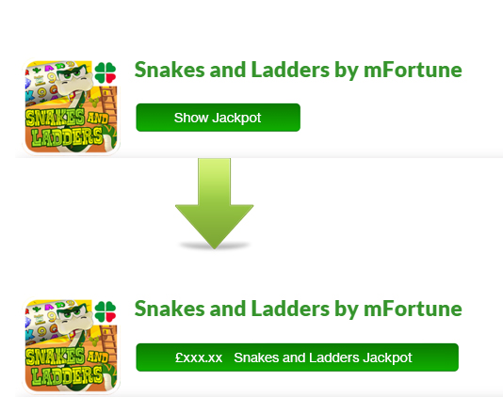

* By clicking “Show Jackpot” the jackpot value for that game needs to be displayed in place of the button for **5** seconds – after this time button should revert back to its original state.
* The game icon should be a hyperlink to the game page URL (found within JSON)
* Please use your own design skills to make the elements look good.