A1.5: Accounting Project – Reflection Paper

**Team 25**

Christine Drejer Jakobsen – 10817232

Marius Heje Mæhle – 9822577

DAT 5305 – Data Management & SQL Lecturer Names:

Prof. Luis Escamilla

April 1st, 2022



**1.0 Teamwork and Key Learning**

As we were able to pick pair ourselves for this assignment, we knew we would work well together. As we know each other well, we know where our strengths and weaknesses lie. Christine was better at understanding the business case and how to approach the problem. Christine’s SQL knowledge is strong, and Marius learned a lot from her coding skills. Marius was better at putting it all together and making useful insights from the data and results. Marius’ ways of connecting the views and understanding the connection tied it all together. It’s important to have open and honest feedback to improve the project, and our personal development. We both believe in having strong opinions, but that they are loosely held so that we can always improve the project, and ourselves.

The key SQL and technical learnings behind this challenge was how to apply our accounting knowledge in SQL by using coalesce. Then it is important to know how to join the tables together to create the needed stored procedures to create the P&L and B/S. To create the right accounting results, it is important that the relationships between the different tables in views are correct to improve integrity and reduce the redundancy. The stored procedure is also one important aspect to master, so it is easier to create different relations between tables and I the end get the right P&L and B/S.

If we would have done it all again, we would use less time to understand the views tables, and more time to understand how to create the stored procedures. We would probably also use more time on what is important to show for the P&L and the B/S. Overall, you learn by doing, and by reflecting after the work is done. This can help us for the next time we have to do something similar in SQL or in relation on how to store procedure.

Key learnings from this course have not only been enchasing our SQL skills, but it has also provided us a better understanding of how applications work in theoretical and in work-in-practice. In general, a company wouldn’t be dealing with relational databases, most of the data will be storage in for example in cloud storage, special media accounts to ecommerce applications.

The key learning in this assignment has been learning how to understand more complex ER diagrams and databases, narrow it down and identify essential elements that can be applied to provide a clear solution. Understanding the importance of the different variable types and connecting them together has been key to code our final code. The most important key learning-takeaway for us from this assignment is the continuous learning to develop our professional skills.

**2.0 SQL- P&L and B/S Output**

Balance sheet:

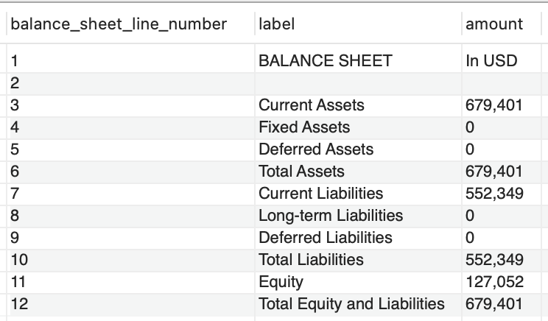

Profit & Loss:

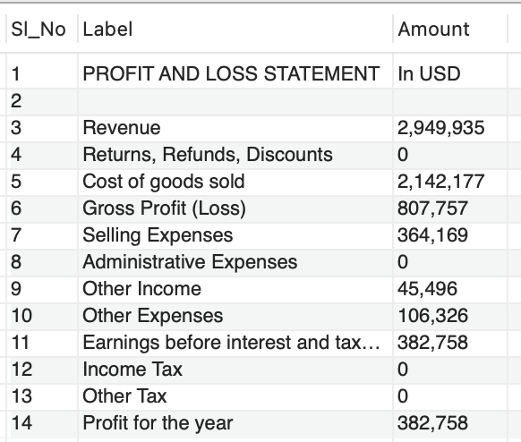

**3.0 SQL script**

Attached as an SQL file under assignment delivery or ‘Cjakobsen2020’