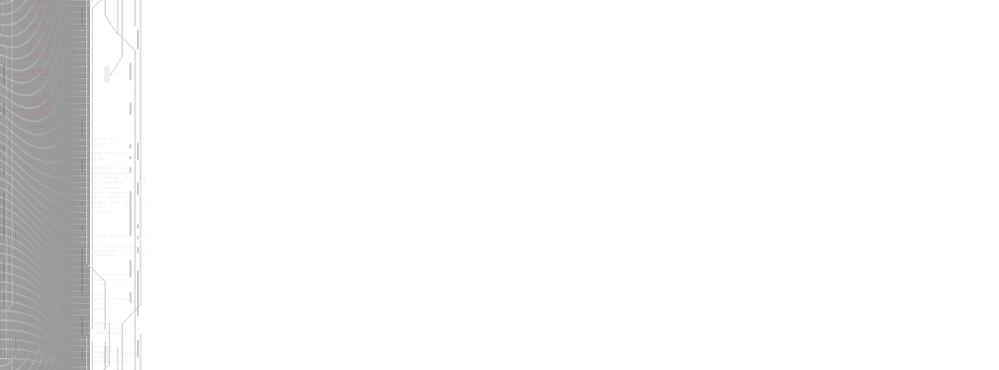

voidsoft
partner of your business evolution
for all your data access needs

TableMetadata - represents a database entity.
// Methods
public TableMetadata();
public virtual DatabaseField GetFieldByName(string fieldName);
public virtual DatabaseField GetPrimaryKeyField();
public virtual void SetFieldValue(int fieldIndex, object fieldValue);
public virtual void SetFieldValue(string fieldName, object fieldValue);

// Properties
public ArrayList Relations { get; }
public virtual DatabaseField[] TableFields { get; set; }
public virtual string TableName { get; set; }

// Fields
protected ArrayList alRelations;
protected DatabaseField[] fields;
protected string tableName;

Persistent Object - the business façade for a specific Table Metadata. Can be used
to read, create, update and delete data as well as specific business operation .
// Methods
public PersistentObject(EDatabase database, string connectionString, TableMetadata mainTable);
public void BeginTransaction();
public void BeginTransaction(IsolationLevel level);
public void Commit();
public virtual void Create(TableMetadata metaTable);
public virtual void Create(TableMetadata mainTable, params TableMetadata[] childTables);
public virtual void Delete(TableMetadata mainTable, bool deleteChildTables);
public virtual void Delete(TableMetadata mainTable, params TableMetadata[] secondaryTables);
public void Dispose();
protected override void Finalize();
public virtual DataSet GetData();
public virtual StringCollection GetFieldList(DatabaseField field);
public virtual DataSet GetFieldList(params DatabaseField[] fields);
public virtual StringDictionary GetFieldList(DatabaseField idField, DatabaseField descriptionField);
public virtual int GetRecordCount(DatabaseField field);
public DataSet GetRelationData(string relationName, object primaryKeyValue);
public virtual TableMetadata GetTableMetadata(object primaryKey);
public void GetTableMetadata(int rowIndex, DataTable table, TableMetadata mainTable);
private object GetValue(string fieldName, DataTable table, int rowIndex);
public void Rollback();
public virtual void Update(TableMetadata mainTable);
public virtual void Update(TableMetadata mainTable, params TableMetadata[] childTables);

// Properties
public DataSet Dataset { get; }
public int DatasetRecordCount { get; }

// Fields
protected string connectionString;
protected EDatabase database;
private bool disposed;
private DataSet ds;
protected IsolationLevel isolationLEvel;
protected bool isTransactionMode;
protected TableMetadata mainTable;
protected StringCollection scQueries;
protected StringCollection scUndoQueries;

