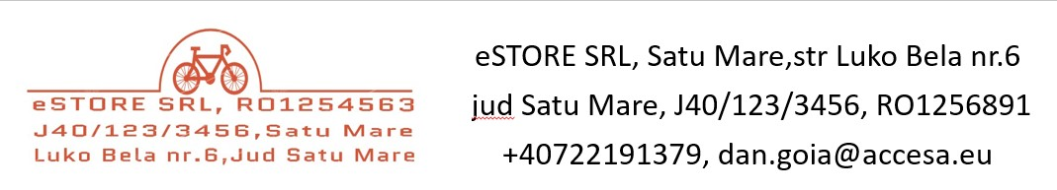

|  |  |  |  |
| --- | --- | --- | --- |
| **eStore SRL** |  | **Invoice NO.** | #InvoiceNum |
| Luko Bela, nr.6 |  | **Date** | 31-Mar-21 |
| Satu Mare, Satu Mare 440050 |  | **Terms** | Net 19 |
| Romania  +40722191379 |  |  |  |

|  |  |  |  |
| --- | --- | --- | --- |
| **BILL TO** |  |  | **SHIP TO** |
| #CompanyName |  |  | #ContactPerson |
| #CompanyAddress |  |  | #ShippingAddress |
| #CityStateZip |  |  | #CityStateZip |
| #Country |  |  | #Country |
| #Tel1 |  |  | #Tel2 |

|  |  |  |  |
| --- | --- | --- | --- |
| **DESCRIPTION** | **QTY** | **UNIT PRICE** | **TOTAL** |
|  |  |  | 0.00 |
|  |  | Subtotal | 0.00 |
|  |  | Tax Rate | 19% |
|  |  | Tax Total | 0.00 |
|  |  | Balance Due | RON 0.00 |

**Notes**

Thank you for your order!