Explain the process of borrowing an item

Make a POST request to the endpoint: {{borrow-host}}/api/borrows/create
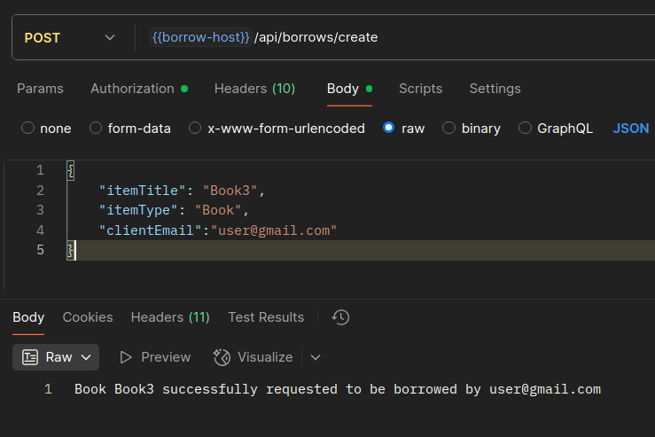
With the request body:
{
"itemTitle": "Book3",
"itemType": "Book",
"clientEmail":"user@gmail.com"
}
Containing the our info and the title and item type of the item
If the request will be successfully we will get the following message:

In the db, the status of the item gets changed

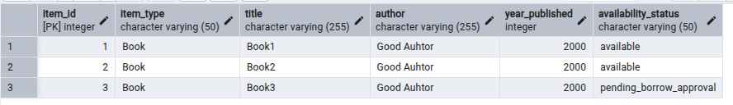

Also in the borrow_table a new borrow is added
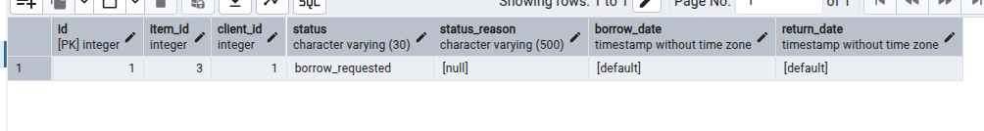
It’s status being still as a borrow_request
Now, is the librarian job to accept or decline the borrow

Making a POST request to: {{borrow-host}}/api/borrows/librarian/approveBorrow/1/3
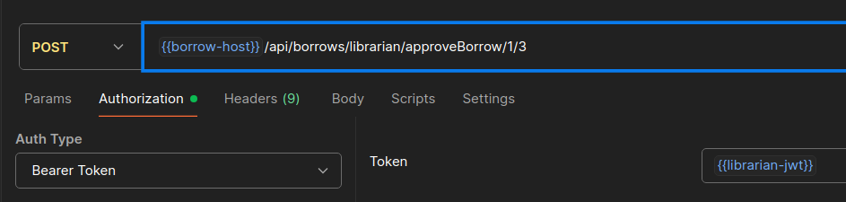
The first number being the id of the client, the second, the id of the item
Also the librarian jwt should be passed, because if a user will try to do this, the request will get rejected
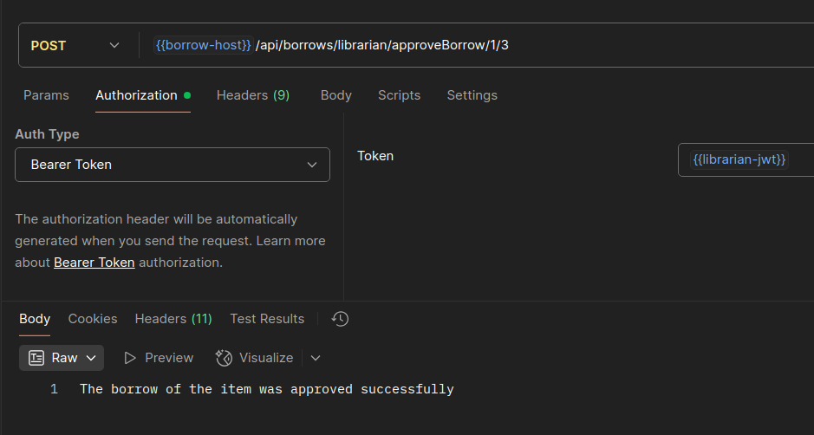

If everything is correct, the status will get updated to the item table and the borrow_table:
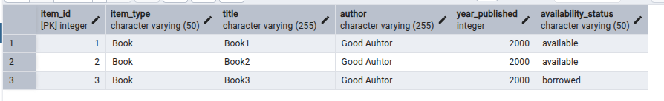
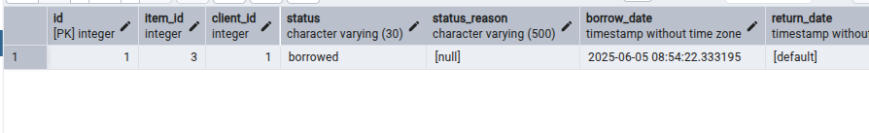
The status reason is null, but it can be set up by the librarian

