NOTES
Firebird Live CD based on Ubuntu applications demo (flamerobin + phpbb+ibwebadmin2.0+lazarus ) starting point will be
Version from september 2007 , you can still download it
http://flamerobin.blogspot.com/2007/09/creating-flamerobinfirebird-livecd-with.html
New Version updated to Hardy LTS
http://flamerobin.blogspot.com/2008/08/creating-flamerobinfirebird-livecd-with.html
Definition from debian live cd manual
http://alioth.debian.org/~lamby-guest/live-manual/html/meta.html
Live system
An operating system that can boot without installation to a hard drive. Live systems does not alter operating systems or files already installed on the computer hard drive unless instructed to do so. Live systems are typically booted from CD or DVD media as well as USB sticks and via netboot.

Minimal Ubuntu + LXDE Installation- Remove XFCE from live cd and install lxde

Only install the base system. Then, add our preceding repository, and do this:
Testing on qemu/kvm
In my case in have installed JEOS on an qemu virtual machine then i followed this tutorial
http://www.peopix.com/cai-gui-lxde-cho-ubuntu-server/
http://lxde.org/wiki/Ubuntu
I have added
$ sudo vi /etc/apt/sources.list.d/lxde.list
deb http://ppa.launchpad.net/lxde/ubuntu hardy main
deb-src http://ppa.launchpad.net/lxde/ubuntu hardy main
$ sudo apt-get install xorg
$ sudo apt-get install lxde
$ startx or
$ sudo /etc/init.d/gdm stop
Voila minimal deskop and space used is ~ 400M , it doesn even needs compression
I have installed flamerobin after that , but still i have an bug with window drawing , if i open an window
let's say flamerobin , it goes to the bottom of the screen slowly
Another option to start with is an minimal cd-image
https://help.ubuntu.com/community/Installation/MinimalCD
http://fullcirclemagazine.org/download-manager.php?id=93
Sometimes you want a bare-minimum LiveCD that you can use as a base for other projects. Creating one on Ubuntu is a rather big pain. GUI tools like ‘Reconstructor’ or ‘Ubuntu Customization Kit’ are meant to modify the existing install/Live CD’s, and don’t allow you to really strip down the CD to the bare minimum.
Debian has a project called live-helper which allows you to do just that with a debian distribution. This is also included in Ubuntu Hardy, but it doesn’t -quite- work out of the box. However, with the following small changes, you can make it work. I’ve just create a 77MB minimal hardy boot CD, and it works like a charm.

http://clemensfam.org/john/?p=39

udo lh_config -p xfce-desktop -a i386 -d hardy --mirror-bootstrap "http://us.archive.ubuntu.com/ubuntu" --mirror-bootstrap-security "http://security.ubuntu.com/ubuntu" --mirror-binary="http://us.archive.ubuntu.com/ubuntu" --sections "main restricted universe multiverse" --mirror-binary-security "http://security.ubuntu.com/ubuntu" --initramfs casper -k generic --linux-packages="linux-image" --packages flamerobin --apt-secure disabled --bootstrap cdebootstrap

I have done the bare minimum the only issue i had is with
parameters and some scripts modified

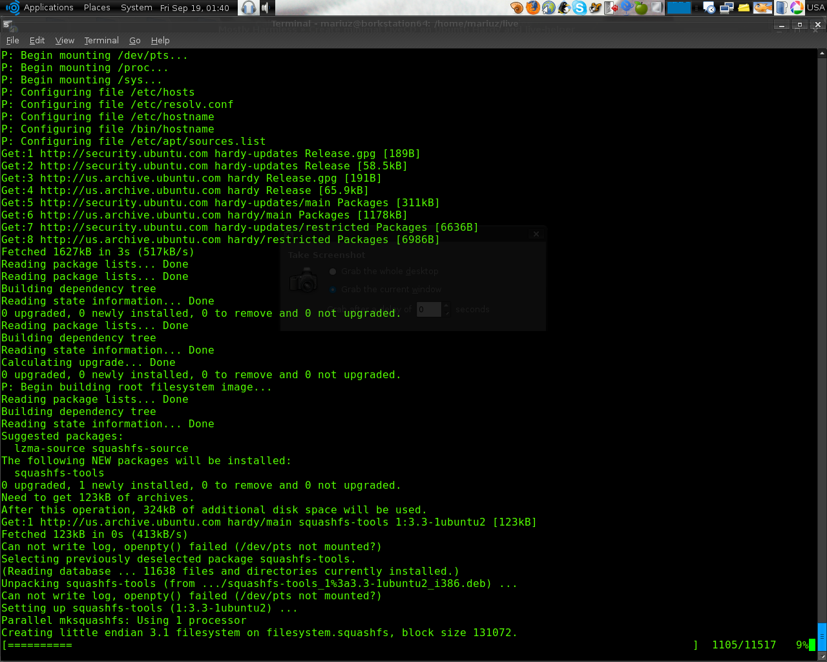

Debian Live Web Boot
Debian Live offers prebuilt images for CD/DVD discs, USB sticks (or any HD-media-like device), tarballs (for PXE netboot) as well as a bare squashfs image to boot from the web directly.
http://lists.alioth.debian.org/pipermail/debian-live-devel/2007-September/002133.html
http://blog.daniel-baumann.ch/2008/08/27#20080827_debian-live-lenny-beta1
Customize ubuntu without codecs with firebird logos http://www.gnewsense.org/Builder/HowToCreateYourOwnGNULinuxDistribution
Then i have added the gpg key id and the ubuntu/gnewsense mirrors from where to pull the sources
http://lists.gnu.org/archive/html/gnewsense-users/2008-06/msg00086.html
the only customization i did was
MIRROR=http://ftp.iasi.roedu.net/mirrors/ubuntulinux.org/releases/
SIGNINGKEY=EC475B46 - this is my new root generated gpg key id
REPOAPT=http://us.archive.gnewsense.org/gnewsense
and i get at the end
W: GPG error: http://us.archive.gnewsense.org deltah Release: The following signatures couldn't be W: GPG error: http://us.archive.gnewsense.org deltah Release: The following signatures couldn't be verified because the public key is not available: NO_PUBKEY 3FCB83DD91854607 verified because the public key is not available: NO_PUBKEY 3FCB83DD91854607
E: There are problems and -y was used without --force-yes
I guess i need to add the key on my hardy box
well i replaced --yes with --yes --force-yes in all the build script
$cd /srv/gnewsense/livecd/
$sudo mkisofs -o /tmp/gnewsense-livecd-deltah-2.1.iso -r -J -l -V 'gNewSense LiveCD 2.1' -b isolinux/isolinux.bin -c isolinux/boot.cat -no-emul-boot -boot-load-size 4 -boot-info-table cdroot/image
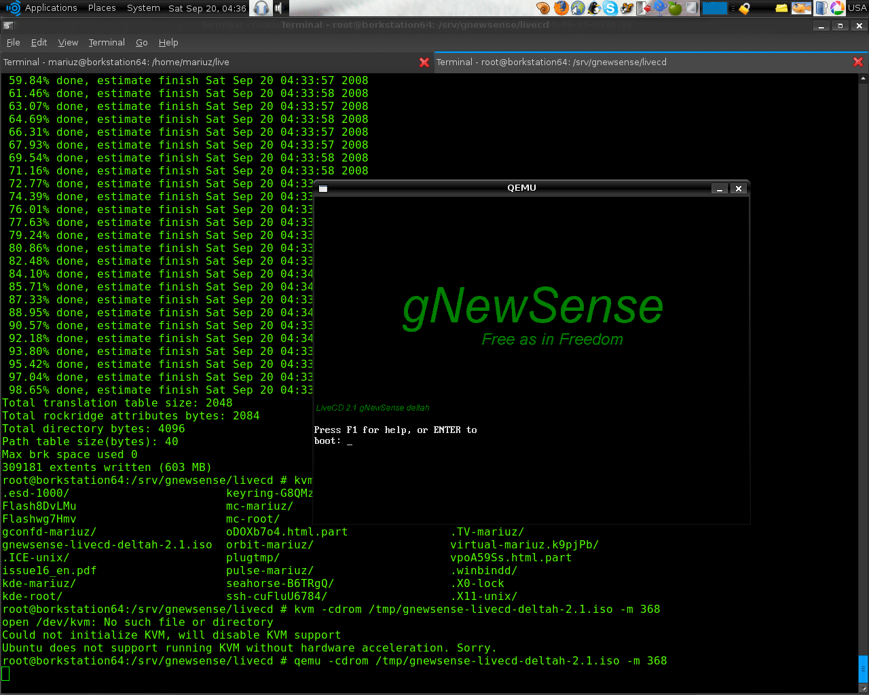
but xorg gave some error about edid not present
http://wiki.gnewsense.org/ForumMain/WeirdOnQemu
the problem is the cyrus card emulated doesn't return the correct info about resolutions and it crashes
So i had to choose safe mode with vesa
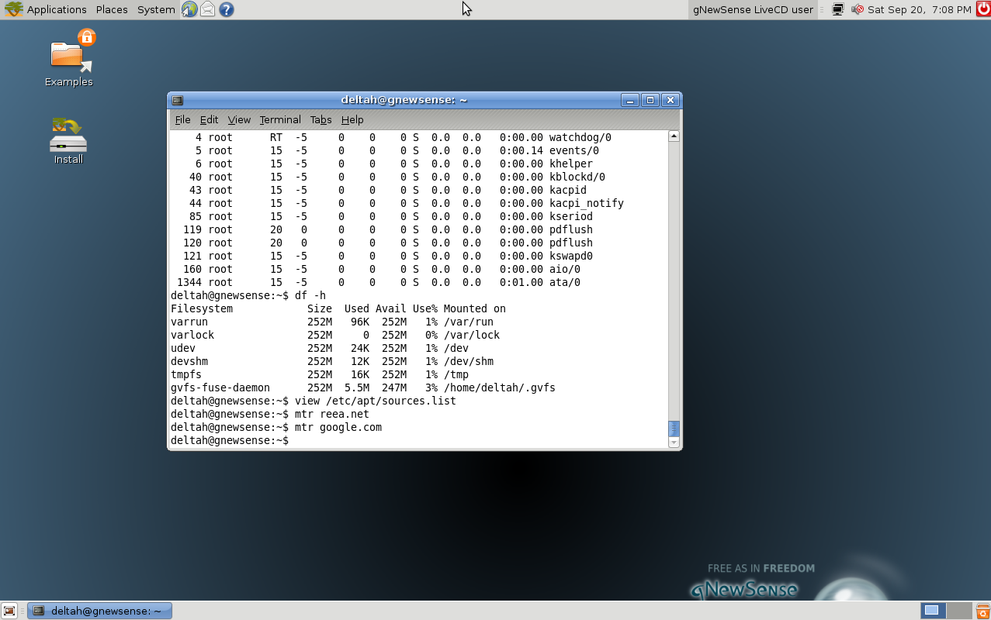
Test an debian live cd option
http://www.livedistro.org/resources/software/build-tools/live-helper
sems that is an new livecd for debian
http://lwn.net/Articles/295698/
$apt-cache search live-magic
live-magic - GUI frontend to create Debian LiveCDs, netboot images, etc.
$ sudo apt-get install live-magic
Next Next and the debian live iso is ready
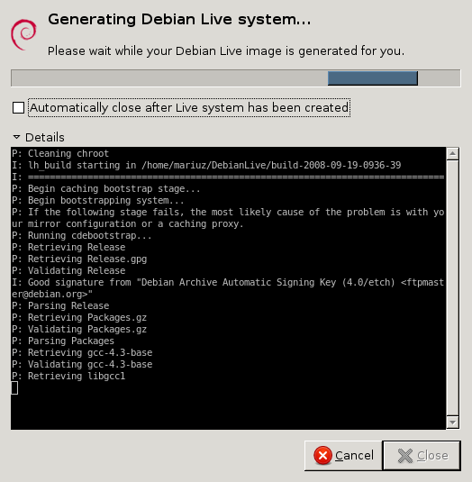
~/DebianLive/build-2008-09-19-1011-33$ kvm -cdrom binary.iso -m 1024
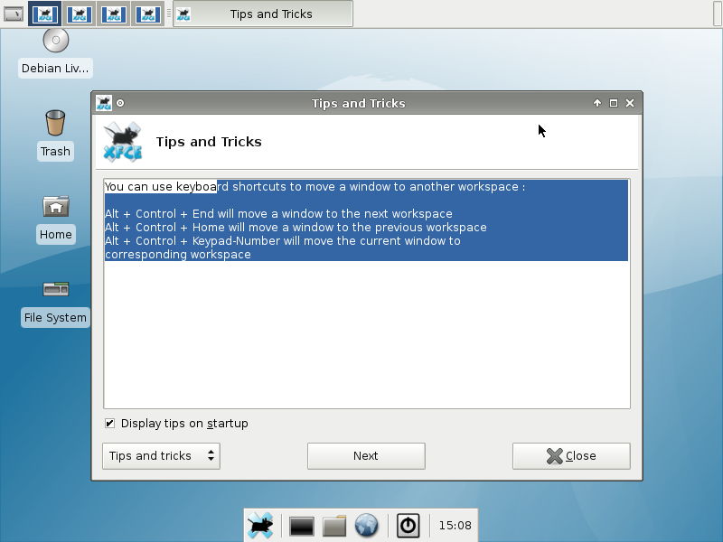
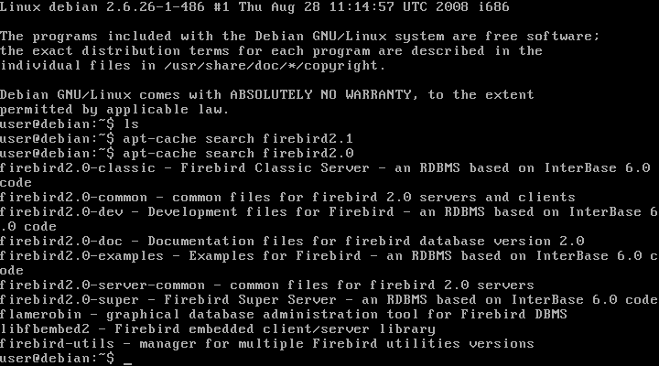
TO DO:
Will be Added phpbb3.0,jawscms,cakephp example
add qemu.exe on the cd and preview mode for windows
Create .bat file with qemu firebird.iso like in this example
http://www-128.ibm.com/developerworks/linux/library/l-scrnsave/
Remove all unused packeges
continue to aggressively trim down package list; run deborphan regularly to find unused libraries
Build usb :
http://edoceo.com/liber/ubuntu-live-usb
or use an php script for generating it
http://custom.nimblex.net/

