INSTRUCTIONS

How to run the SSMS script:
1. Open SQL Server Management Studio → connect to your local server → click New Query → open ITicketG2DBScript.sql file → then click Execute (F5).

Before proceeding to the backend ensure that:
1. You have pulled the latest FRONTEND commit from the repo: https://github.com/AlicaLynn17/iticket.git (MAIN BRANCH).
2. You have successfully run the database script I sent along this note in SSMS.
3. You have successfully pulled the C# base code from the repo: https://github.com/frankaong/ReactCsharp_Basecode.git (ITICKET BRANCH).

How to setup your backend in Visual Studio:
1. Open the .sln file in the files you just pulled. In the C# sln file look for the appsettings.json (This file is under ASI.Basecode.WebApp folder).
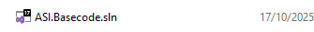
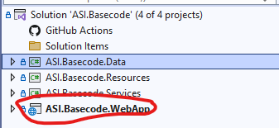
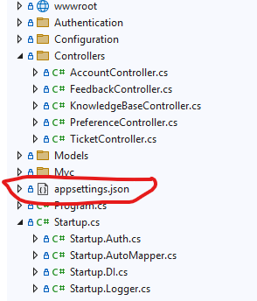

2. Look for this part:
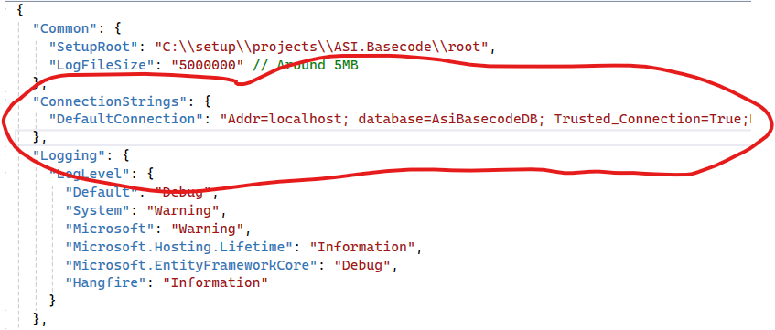
3. Change the localhost\\SQLEXPRESS in this part to the connection in your sql SMSS (This is usually named like DESKTOP-etc):
"ConnectionStrings": {
"DefaultConnection": "Server=localhost\\SQLEXPRESS;Database=ITicketG2DB;Trusted_Connection=True;MultipleActiveResultSets=true;TrustServerCertificate=True"
}

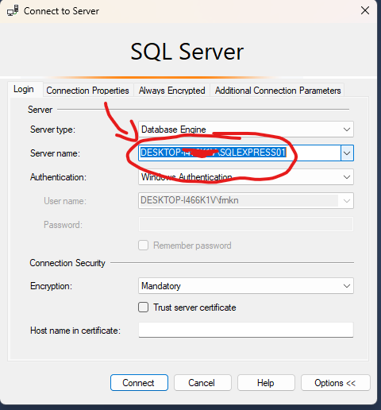
4. Build the file
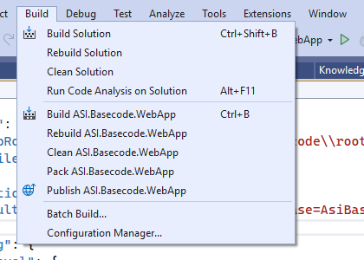
5. Select the WebApp project as startup. Then click the green button.
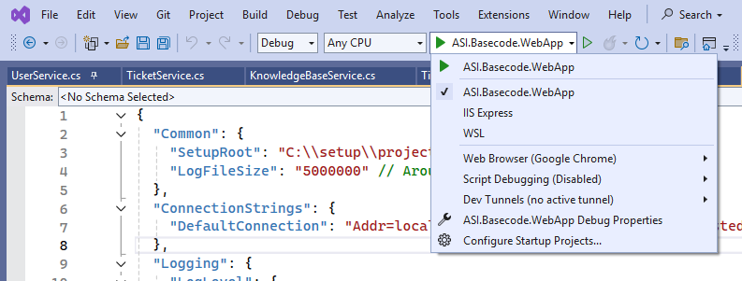

How to understand the file system:
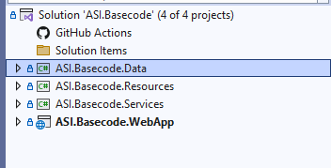
- There is are four files respectively (ASI.) what you really need to use and edit are just the .Data, .Services. and .WebApp
- .Data is the file that interacts with your sql SMSS. It contains the following folders:
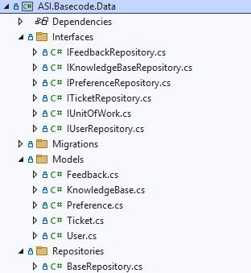
- In these folders, the important ones are Interfaces and Repositories. Check the Interfaces (IKnowledgeBaseRepository.cs) there you can see that this is the place where I listed my method names along with their parameters. Use the file to copy the methods accdg to your use (Create, Delete, etc…)
- In the Repositories (KnowledgeBase.cs) you can see that whatever I stated in the Interfaces are also called here, but this file interacts with the DbContext and is where it “saves” the changes. There are functions like AddAsync, Remove, Update, etc… and I save it by calling UnitofWork.
- You can also see I’m using await methods, do your own research to know whether to use sync or async (it depends with your usage) but I prefer using async since most of my methods are API calls
- .Services is what connects your controller and model
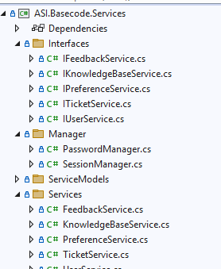
- Whatever you make in your .Data Interfaces, you need to copy it on the .Services Interfaces
- You also need to make changes in the .Services Services folder accdg to your methods interaction to that specific repository,
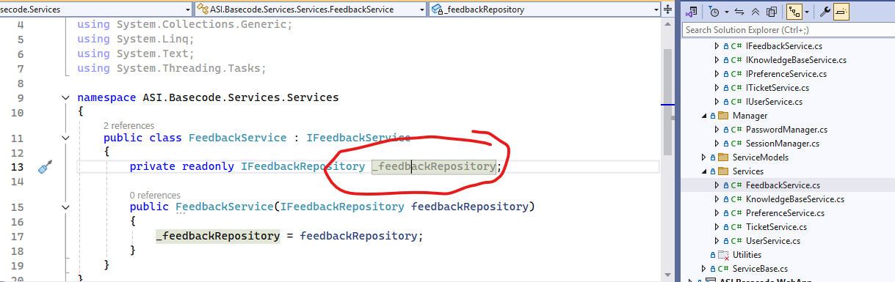
- If you notice, (use the other files with content as your reference BUT DO NOT CHANGE ANYTHING IN IT) the logic is just simple, it just interacts with your repository when your controller uses it. Basically siya ang palaman ni DB – Services – Controller. This is Java in its very core man and if you recall, sa Java nay encapsulation etc…
- You also notice nga wala siyay UnitofWork.save etc… kay trabaho mana ni .Data. Basically si .Service ray nagtawag sa .Data and that specific repo if nagamit siya then si .Data na ang mu interact directly sa DB
- In .WebApp, you really only need to touch the Controllers (BTW this is important: our localhost in the backend is https://localhost:5001 OR http://localhost:5000)
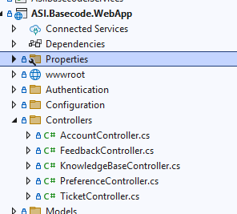

- Your controller files are where the logic comes in AND where you call the methods in your .Services Services. Make sure when you create functions here to never end it with Async, as this tells your backend to ignore it when called.
- If you notice in files with content (AGAIN USE AS REFERENCE BUT DO NOT TOUCH. USE THE CONTROLLER ACCDG TO YOUR TASK): [Route("api/[controller]/[action]")] This is how you will call it on your frontend REACT. Example for Knowledge Base in frontend GET (axios.get("https://localhost:5001/api/KnowledgeBase/GetArticles")
- To run, RUN your react with npm run start and C# using the green run button.
- To test I always recommend using Postman first, because if Postman -> C# backend works, its probably the frontend React that’s containing ur issue and vice versa.
- If you have error 404 in your frontend, its most likely ang issue is your url, make sure its using this [Route("api/[controller]/[action]")]
- To check if successful ba jud, go to the DB SSMS
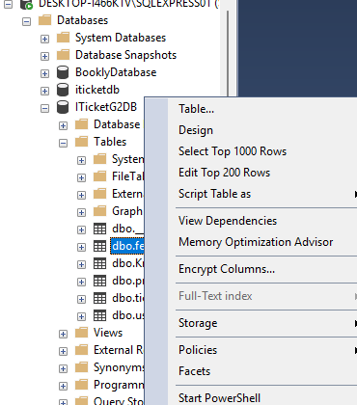
- Go to your database -> tables and right click that table u need and click “Select Top 1000 Rows”
- It will display the populated data (if successful man gai siya)
- Do not populate Id in your frontend or backend since auto generated nani siya sa DB SSMS
- For other bugs, please do your research

ADMIN ACCS FOR TESTING: EMAIL & PW
tarragon@iticket.comm
hellohellobaby

thumbellina@iticket.com
thumbellina

DESIGNATION OF TASKS:

franka
signup and login and create, update, delete, & display tickets and create, update, delete, & display users and create, update, delete & display articles.
alica & sy
create, update & display preferences and display dashboard

mary & glendell
create & display feedback and display reports

NOTE: If you don’t fulfill your task by Nov. 15, make sure to finish it by Nov. 22 since this is our final defense. Your part, your responsibility, your role to defend it. Don’t expect anyone else to do it for you because the designation of tasks in the first sem AND even for C# is obviously unfair already. PM ko yes, but STUDENT ko first, LIKE YOU. I’m aware that I’m responsible for the team’s overall output but the grading for this subject and the prev one is by contributions (for ur knowledge lahi2 tag grado sa Alliance even if team ta).

