**Course Outcome 1**

**Use different Python packages to perform numerical calculations, statistical computations and data visualization.**

**PROGRAM 1**

Program to review the fundamentals of Python.

**PROGRAM 2**

**AIM**

Program to perform arithmetic operations on a 2D Matrices.

**PROGRAM**

import numpy as np

a1 = np.array([[2, 2, 4], [7, 1, 2], [6, 7, 8]])

a2 = np.array([[1, 2, 3], [4, 5, 6], [2, 8, 4]])

print('Addition')

print(np.add(a1, a2))

print('Subtraction')

print(np.subtract(a1, a2))

print('Product')

print(np.multiply(a1, a2))

print('Division')

print(np.divide(a1, a2))

print('Transpose of matrix 1')

print(a1.T)

print('Transpose of matrix 2')

print(a2.T)

print('Sum of diagonal elements of matrix 1')

print(sum(np.diag(a1)))

print('Sum of diagonal elements of matrix 2')

print(sum(np.diag(a2)))

**OUTPUT**

Addition

[[ 3 4 7]

[11 6 8]

[ 8 15 12]]

Subtraction

[[ 1 0 1]

[ 3 -4 -4]

[ 4 -1 4]]

Product

[[ 2 4 12]

[28 5 12]

[12 56 32]]

Division

[[2. 1. 1.33333333]

[1.75 0.2 0.33333333]

[3. 0.875 2. ]]

Transpose of matrix 1

[[2 7 6]

[2 1 7]

[4 2 8]]

Transpose of matrix 2

[[1 4 2]

[2 5 8]

[3 6 4]]

Sum of diagonal elements of matrix 1

11

Sum of diagonal elements of matrix 2

10

**PROGRAM 3**

**AIM**

Program to find a given matrix's inverse, rank, determinant, and eigen values.

**PROGRAM**

import numpy as np

a1 = np.array([[1, 2, 3], [7, 3, 4], [9, 1, 10]])

a_inv=np.linalg.inv(a1)

a_rk = np.linalg.matrix_rank(a1)

a_det=np.linalg.det(a1)

a_eig=np.linalg.eig(a1)

print('Inverse = \n', a_inv)

print('\nRank = ', a_rk)

print('\nDeterminant = ', a_det)

print('\nEigenvalues = \n\n', a_eig)

**OUTPUT**

Inverse =

[[-0.25490196 0.16666667 0.00980392]

[ 0.33333333 0.16666667 -0.16666667]

[ 0.19607843 -0.16666667 0.10784314]]

Rank = 3

Determinant = -102.00000000000004

Eigenvalues =

EigResult(eigenvalues=array([13.59525451, -2.54418376, 2.94892925]),

eigenvectors=array([[-0.27489862, -0.69790968, -0.23772009],

[-0.49320516, 0.5516356, -0.87237232],

[-0.82533594, 0.45674965, 0.42714833]]))

**PROGRAM 4**

**AIM**

Program to create customized line plot for comparing the Age-wise annual salary variations for Python developers with JavaScript developers from the dataset of the average yearly salary of developers of various programming languages.

**PROGRAM**

import numpy as np

import pandas as pd

import matplotlib.pyplot as plt

df=pd.read_csv("https://raw.githubusercontent.com/CoreyMSchafer/code_snippets/master/Python/Matplotlib/10-Subplots/data.csv")

plt.figure(figsize=(8,6))

plt.title("Age-wise Salary Comparison of Python vs JavaScript Developers")

plt.plot(df["Python"],"k-*",label="Python Developers' Salary")

plt.plot(df["JavaScript"],"c--*",label="JS Developers' Salary")

plt.legend()

plt.xlabel("Age")

plt.ylabel("Salary in USD")

plt.grid(True)

plt.show()

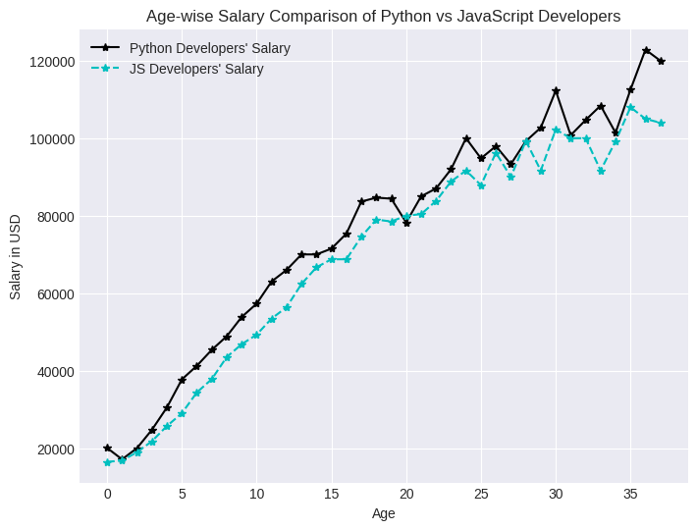**OUTPUT**

**PROGRAM 5**

**AIM**

Program to create a gender-wise count plot by using the values in the sex column dataset of tips taken on the total bill amount in restaurants.

**PROGRAM**

import pandas as pd

import numpy as np

import matplotlib.pyplot as plt

import seaborn as sns

tip_df=pd.read_csv("https://raw.githubusercontent.com/mariya-sherin/DSML/refs/heads/main/RestaurantTips.csv")

plt.figure(figsize=(7, 5))

plt.title("Gender-wise Count Plot")

sns.countplot(x='sex', data=tip_df, hue='sex')

plt.grid(True)

plt.show()

**OUTPUT**

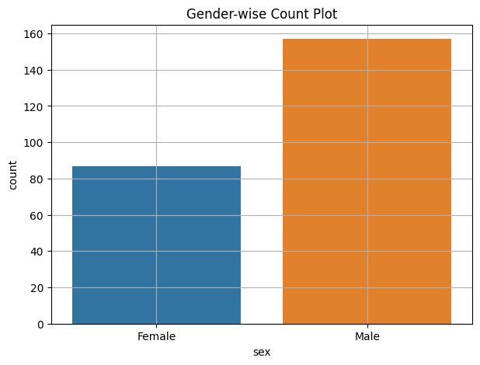

**PROGRAM 6**

**AIM**

Program to create a histogram of a list of random ages of 100 individuals in a range between 1 and 91.

**PROGRAM**

import matplotlib.pyplot as plt

import pandas as pd

age_list = [1,1,2,3,3,5,7,8,9,10,

     10,11,11,13,13,15,16,17,18,18,

     18,19,20,21,21,23,24,24,25,25,

     25,25,26,26,26,27,27,27,27,27,

     29,30,30,31,33,34,34,34,35,36,

     36,37,37,38,38,39,40,41,41,42,

     43,44,45,45,46,47,48,48,49,50,

     51,52,53,54,55,55,56,57,58,60,

     61,63,64,65,66,68,70,71,72,74,

     75,77,81,83,84,87,89,90,90,91]

plt.figure(figsize=(5, 4))

df = pd.DataFrame(age_list)

plt.title("Age Distribution")

plt.xlabel("Age")

plt.ylabel("Frequency")

plt.hist(age_list, bins=10, edgecolor='black')

plt.show()

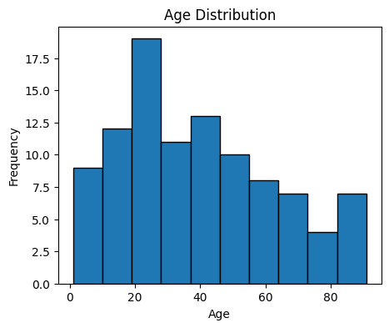**OUTPUT**

**PROGRAM 7**

**AIM**

Program to create a bar chart of the popularity of programming languages.

**PROGRAM**

import matplotlib.pyplot as plt

data = {'java': 22.2, 'python': 17.6, 'php': 8.8, 'javascript': 8, 'c#': 7.7, 'c++': 6.7}

languages = list(data.keys())

popularity = list(data.values())

plt.figure(figsize=(5, 4))

plt.bar(languages, popularity, color='red')

plt.xlabel('Languages')

plt.ylabel('Popularity (%)')

plt.title('Popularity of Programming Languages')

plt.grid(True)

plt.show()

**OUTPUT**

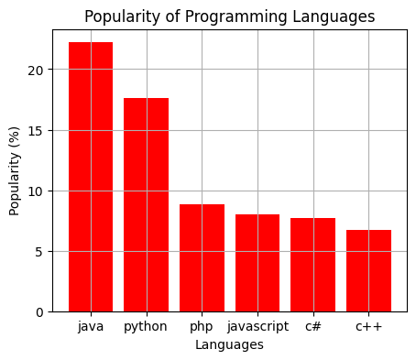

**PROGRAM 8**

**AIM**

Program to create a pie chart of the popularity of programming languages.

**PROGRAM**

import matplotlib.pyplot as plt

lang = ['java', 'python', 'php', 'javascript', 'c#', 'c++']

popularity = [22.2, 17.6, 8.8, 8, 7.7, 6.7]

plt.figure(figsize=(5, 5))

plt.pie(popularity, labels=lang, autopct='%1.1f%%')

plt.title('Popularity of Programming Languages')

plt.show()

**OUTPUT**

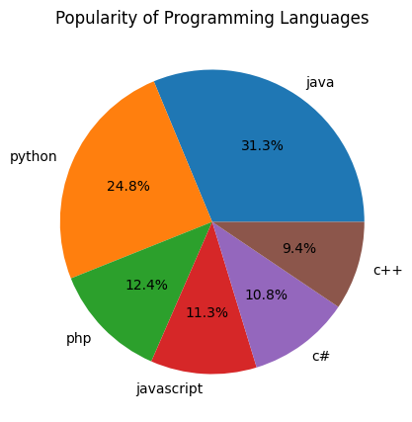

**PROGRAM 9**

**AIM**

Program to create a scatter plot between the 'Sepal Length' & 'Sepal Width' columns & Differentiate between the data points of different classes.

**PROGRAM**

import pandas as pd

import matplotlib.pyplot as plt

import seaborn as sns

df = pd.read_csv('https://raw.githubusercontent.com/mariya-sherin/DSML/main/Iris.csv')

plt.figure(figsize=(5, 5))

sns.scatterplot(data=df, x='SepalLengthCm', y='SepalWidthCm', hue='Species')

plt.title('Scatter Plot of Sepal Length vs Sepal Width')

plt.show()

**OUTPUT**

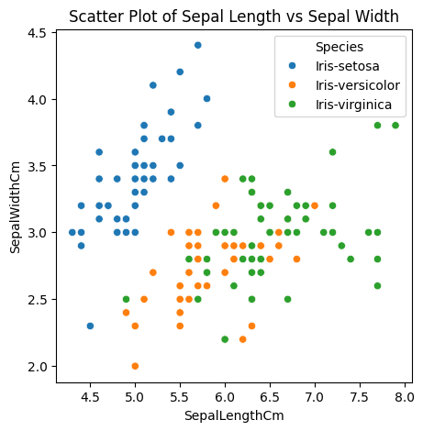

**Course Outcome 2**

**Use different packages and frameworks to implement regression and classification algorithms.**

**PROGRAM 10**

**AIM**

Program to implement KNN classification using any standard dataset available in the public domain and find the algorithm's accuracy.

**PROGRAM**