Тема 8

Домашно 3 – База от данни за училище

Изготвил: Мария Качаунова, ф.н. 71996

1. **E/R модел на данни**

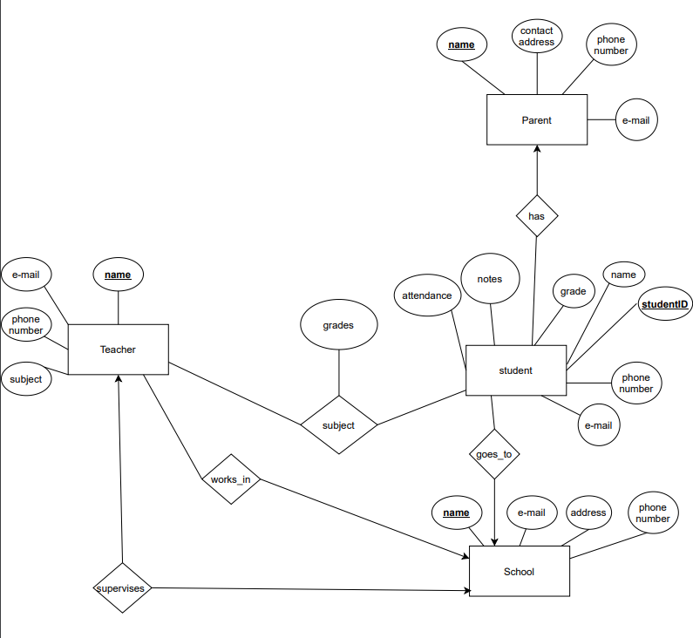

1. **Релационен модел на данни**

Първо преобразувам множествата от същности, след това връзките много-много и след това връзките много-един. Оптимизирам връзките много-един и връзките един-един.

Parent (name, e-mail, phone number, contact address)

Student (studentID, name, grade, notes, attendance, e-mail, phone number, schoolName, parentName)

School (name, e-mail, address, phone number, e-mail, principalName)

Teacher (name, subject, phone number, e-mail, schoolName)

subject (teacherName, studentID, grades)

*works_in (teacherName, schoolName) X*

*has (parentName, studentID) X*

*Supervises (schoolName, principalName) X*

*goes_to (schoolName, studentID) X*

И накрая получаваме :

Parent (name, e-mail, phone number, contact address)

Student (studentID, name, grade, notes, attendance, e-mail, phone number, schoolName, parentName)

School (name, e-mail, address, phone number, e-mail, principalName)

Teacher (name, subject, phone number, e-mail, schoolName)

subject (teacherName, studentID, grades)