**\*\*Update Loan Controller\*\***

As a admin user after I see valid search results on Loan details screen

I want to click on the Loan Number to navigate to Loan Update screen.

So that I can navigate to the page and see all the loan details and be able to update any of the following fields:

Loan/Lien information: Loan Amount, Loan term, Lien Id, Lien Type.

**Acceptance Criteria**

Given I am an authenticated user

And I send a request with the fields to be updated as mentioned above

Then the updated fields should be persisted in the database

and return back appropriate response status code & object

else return back appropriate response status code if API fails

Notes:

The REST API should update the database record with the new values.

Junit Test cases would need to be written

Scenario 1 : Update Successful

Request :

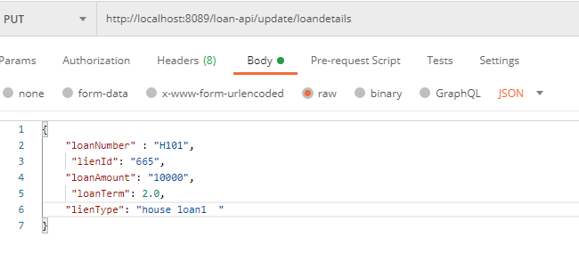

Response :

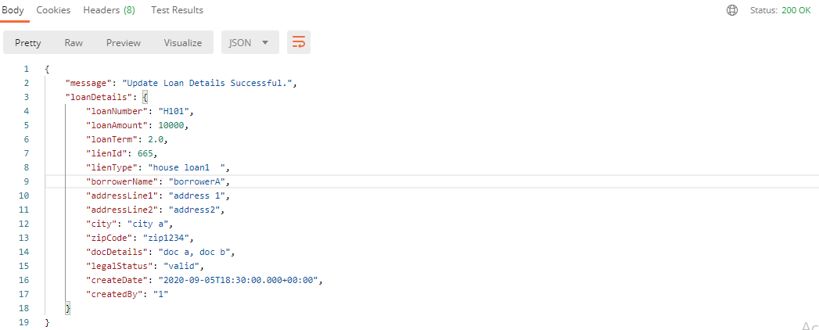

Scenario2 : The Loan Number is not given - Validation error message

Request :

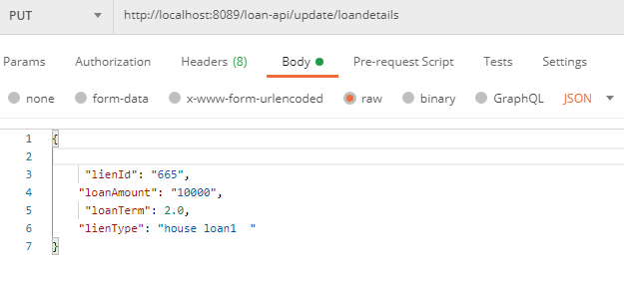

Response :

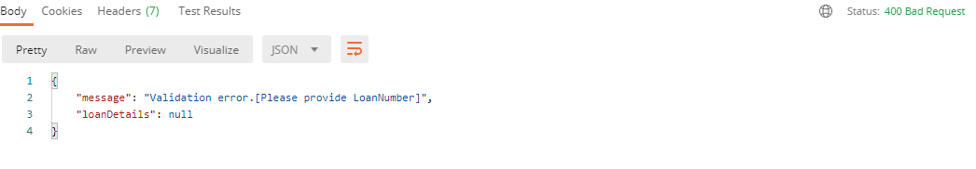

Scenario 3 : Loan number does not exists in database

Request :

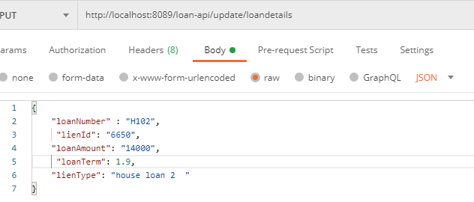

Response :

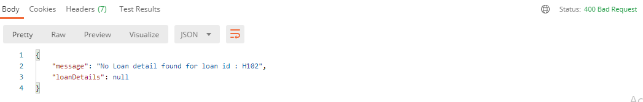

Scenario 4 : If authorization token is not provided

Request :

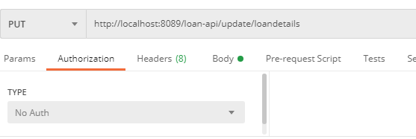

Response :

