The Fascinating World of Tulips

Introduction to Tulips

Tulips (Tulipa) are one of the most beloved flowers worldwide, admired for their vibrant colors and elegant shape. They belong to the Liliaceae family and are native to Central Asia, though they have found their most famous home in the Netherlands. Tulips are spring-blooming perennials that grow from bulbs and are known for their simple yet striking beauty. Their history, symbolism, and cultural significance make them a fascinating subject of study.

History and Cultural Significance

The journey of tulips from wildflowers in the mountains of Central Asia to the prized blooms of European gardens is rich and dramatic. Tulips were cultivated in the Ottoman Empire as early as the 10th century, where they symbolized wealth and prosperity. By the 16th century, they made their way to Europe, particularly the Netherlands, where they became a major trade commodity. The 17th-century "Tulip Mania" in the Dutch Golden Age saw tulip bulbs reaching prices higher than houses, showcasing their immense economic and cultural value. Today, tulips are an iconic symbol of the Netherlands, with vast fields blooming every spring, drawing millions of visitors.

Varieties and Colors
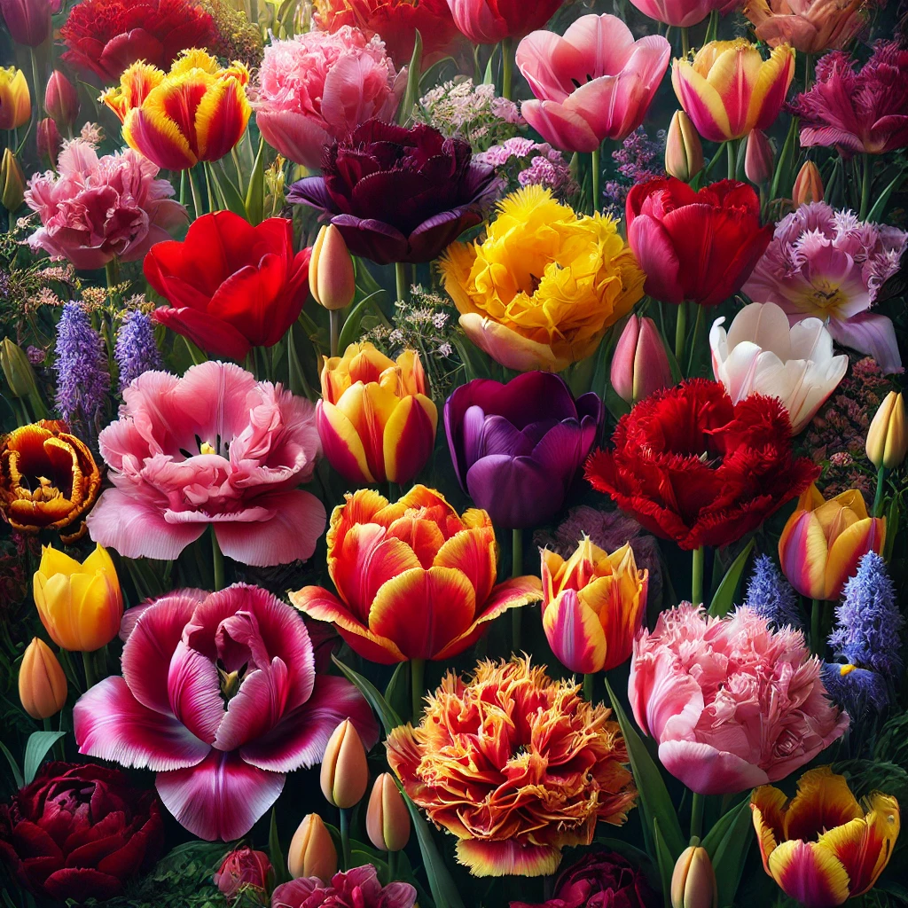
Tulips come in a dazzling array of colors and varieties, each with its own unique characteristics. There are over 3,000 registered varieties, classified into different groups such as single early, double late, fringed, parrot, and triumph tulips. Each color carries specific meanings: red tulips symbolize love, yellow tulips convey happiness, white tulips represent forgiveness, and purple tulips signify royalty. Some of the most famous varieties include the classic ‘Queen of Night,’ known for its deep purple hue, and the fringed ‘Lambada,’ with its ruffled edges.

Cultivation and Care
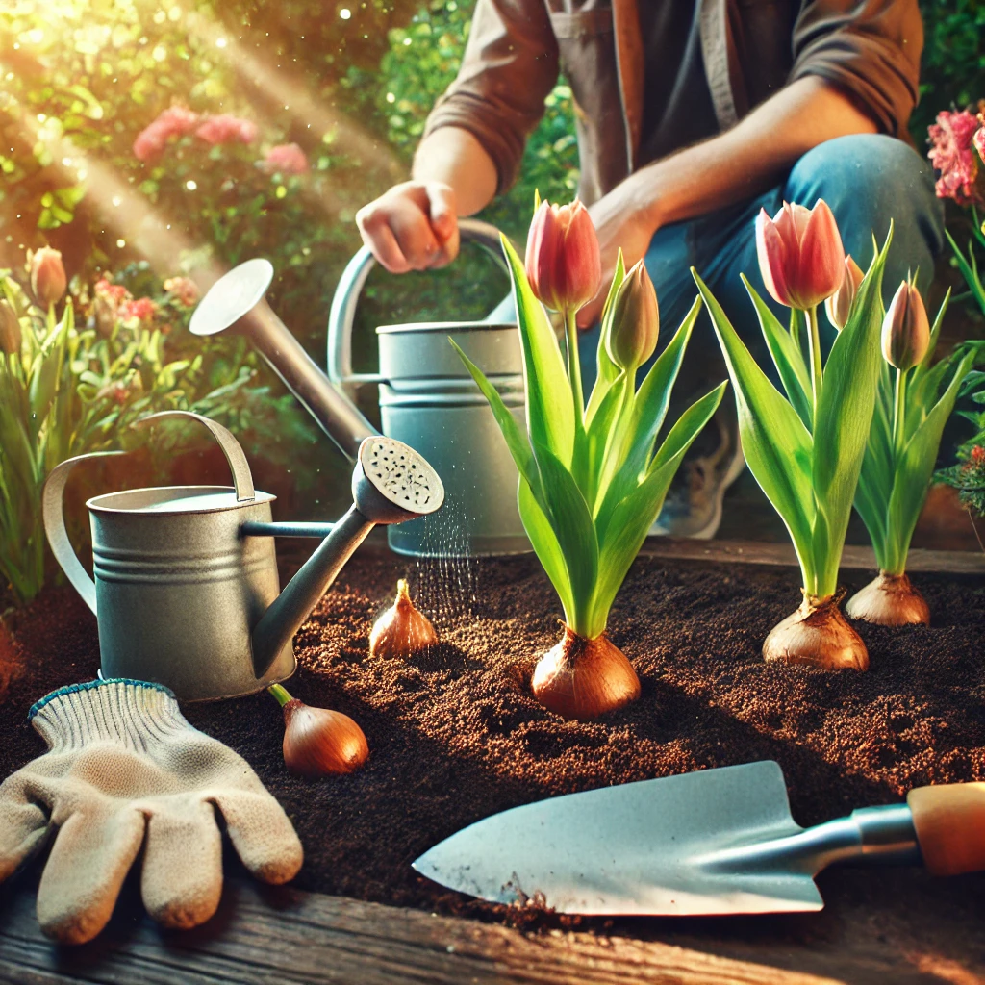
Growing tulips is relatively easy, making them a popular choice for gardens and floral arrangements. They thrive in well-drained soil with full sun exposure. The best time to plant tulip bulbs is in the fall, allowing them to establish roots before the winter frost. Proper care includes watering during dry spells, fertilizing in early spring, and removing spent flowers to encourage bulb energy storage. While tulips are perennials, some varieties may need to be replanted annually for the best bloom quality. With the right care, tulips provide a breathtaking burst of color that heralds the arrival of spring.
Tulips remain one of the most enchanting and cherished flowers in the world, continuing to captivate flower lovers with their timeless elegance and historical significance.

