**LIFE-SYNC**

**Table Design:**

1. **tbl_user**

**Primary Key:** user_id

|  |  |  |  |  |
| --- | --- | --- | --- | --- |
| **Sl. No** | **Field Name** | **Data Type** | **Key Constraints** | **Description** |
| 1 | user_id | INT | PRIMARY KEY | Unique ID for each user |
| 2 | username | VARCHAR (100) | NOT NULL | Username of the user |
| 3 | email | VARCHAR (150) | UNIQUE, NOT NULL | User's email address |
| 4 | password | VARCHAR (255) | NOT NULL | Hashed password |
| 5 | created_at | DATETIME | DEFAULT CURRENT_TIME | Account creation timestamp |
| 6 | role | ENUM('admin','free','premium') | NOT NULL | User role: admin, free, or premium |

1. **tbl_admin**

**Primary Key:** admin_id

**Foreign Key:** user_id REFERENCES tbl_user(user_id)

|  |  |  |  |  |
| --- | --- | --- | --- | --- |
| **Sl. No** | **Field Name** | **Data Type** | **Key Constraints** | **Description** |
| 1 | admin_id | INT | PRIMARY KEY | Unique ID for each admin |
| 2 | user_id | INT | FOREIGN KEY | References user_id in tbl_user |
| 3 | permissions | TEXT | NOT NULL | List of admin-specific permissions (view/delete free users, approve premium users) |

1. **tbl_todo**

**Primary Key:** todo_id **Foreign Key:** user_id REFERENCES tbl_user(user_id)

|  |  |  |  |  |
| --- | --- | --- | --- | --- |
| **Sl. No** | **Field Name** | **Data Type** | **Key Constraints** | **Description** |
| 1 | todo_id | INT | PRIMARY KEY | Unique ID for each to-do item |
| 2 | user_id | INT | FOREIGN KEY | References user_id in tbl_user |
| 3 | task | TEXT | NOT NULL | Task description |
| 4 | is_completed | BOOLEAN | DEFAULT FALSE | Task completion status |
| 5 | category | VARCHAR(50) | NULLABLE | Task category (optional for premium users) |

1. **tbl_expense**

**Primary Key:** expense_id  
**Foreign Key:** user_id REFERENCES tbl_user(user_id)

|  |  |  |  |  |
| --- | --- | --- | --- | --- |
| **Sl. No** | **Field Name** | **Data Type** | **Key Constraints** | **Description** |
| 1 | expense_id | INT | PRIMARY KEY | Unique ID for each expense |
| 2 | user_id | INT | FOREIGN KEY | References user_id in tbl_user |
| 3 | amount | DECIMAL(10,2) | NOT NULL | Expense amount |
| 4 | date | DATE | NOT NULL | Expense date |
| 5 | category | VARCHAR(50) | NULLABLE | Expense category |

1. **tbl_health**

**Primary Key**: health_id  
**Foreign Key**: user_id REFERENCES tbl_user(user_id)

|  |  |  |  |  |
| --- | --- | --- | --- | --- |
| **Sl. No** | **Field Name** | **Data Type** | **Key Constraints** | **Description** |
| 1 | health_id | INT | PRIMARY KEY | Unique ID for each health task |
| 2 | user_id | INT | FOREIGN KEY | References user_id in tbl_user |
| 3 | task | TEXT | NOT NULL | Health task description |
| 4 | is_completed | BOOLEAN | DEFAULT FALSE | Task completion status |

1. **tbl_calendar**

**Primary Key:** event_id **Foreign Key:** user_id REFERENCES tbl_user(user_id)

|  |  |  |  |  |
| --- | --- | --- | --- | --- |
| **Sl. No** | **Field Name** | **Data Type** | **Key Constraints** | **Description** |
| 1 | event_id | INT | PRIMARY KEY | Unique ID for each calendar event |
| 2 | user_id | INT | FOREIGN KEY | References user_id in tbl_user |
| 3 | title | VARCHAR(100) | NOT NULL | Event title |
| 4 | date | DATE | NOT NULL | Event date |

1. **tbl_notification**

**Primary Key:** notification_id **Foreign Key:** user_id REFERENCES tbl_user(user_id)  
 event_id REFERENCES tbl_calender(event_id)

|  |  |  |  |  |
| --- | --- | --- | --- | --- |
| **Sl. No** | **Field Name** | **Data Type** | **Key Constraints** | **Description** |
| 1 | notification_id | INT | PRIMARY KEY | Unique ID for each notification |
| 2 | user_id | INT | FOREIGN KEY | References user_id in tbl_user |
| 3 | message | TEXT | NOT NULL | Notification message |
| 4 | is_read | BOOLEAN | DEFAULT FALSE | Notification read status |
| 5 | event_id | INT | FOREIGN KEY | References event_id in tbl_calender |

1. **tbl_feedback**

**Primary Key:** feedback_id  
**Foreign Key**: user_id REFERENCES tbl_user(user_id)

|  |  |  |  |  |
| --- | --- | --- | --- | --- |
| Sl. No | Field Name | Data Type | Key Constraints | Description |
| 1 | feedback_id | INT | PRIMARY KEY | Unique ID for each feedback |
| 2 | user_id | INT | FOREIGN KEY | References user_id in tbl_user |
| 3 | feedback | TEXT | NOT NULL | User feedback |
| 4 | submitted_at | DATETIME | DEFAULT CURRENT_TIME | Feedback submission timestamp |

1. **tbl_payment**

**Primary Key:** payment_id **Foreign Key:** user_id REFERENCES tbl_user(user_id)

|  |  |  |  |  |
| --- | --- | --- | --- | --- |
| **Sl. No** | **Field Name** | **Data Type** | **Key Constraints** | **Description** |
| 1 | payment_id | INT | PRIMARY KEY | Unique ID for each payment |
| 2 | user_id | INT | FOREIGN KEY | References user_id in tbl_user |
| 3 | amount | DECIMAL(10,2) | NOT NULL | Payment amount |
| 4 | payment_date | DATETIME | DEFAULT CURRENT_TIME | Payment timestamp |

1. **tbl_userprofile**

**Primary Key:** profile_id  
**Foreign Key:** user_id REFERENCES tbl_user(user_id)

|  |  |  |  |  |
| --- | --- | --- | --- | --- |
| Sl. No | Field Name | Data Type | Key Constraints | Description |
| 1 | profile_id | INT | PRIMARY KEY | Unique ID for each profile |
| 2 | user_id | INT | FOREIGN KEY | References user_id in tbl_user |
| 3 | name | VARCHAR(100) | NOT NULL | User's full name |
| 4 | profile_picture | TEXT | NULLABLE | Path/URL to the user's profile picture |
| 5 | dob | DATE | NULLABLE | User's date of birth |
| 6 | email | VARCHAR(150) | UNIQUE, NOT NULL | User's email address |

**Class diagram:**

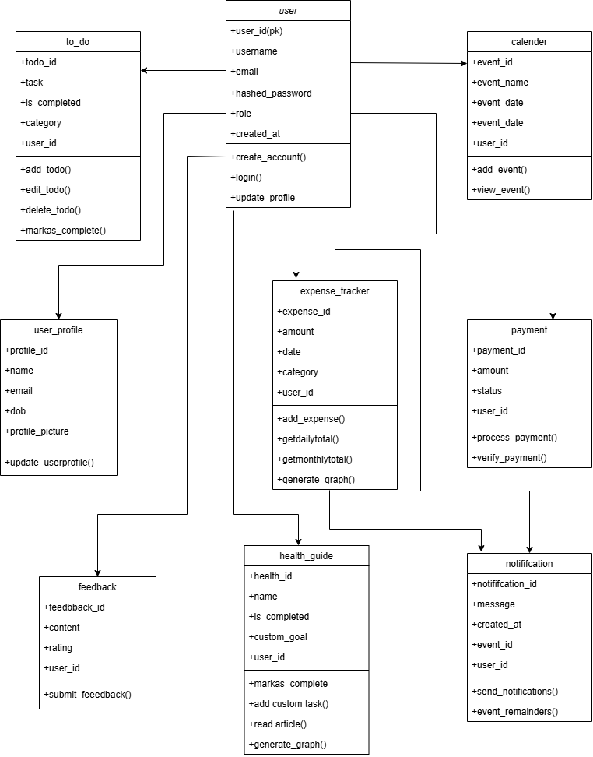

**Use Case Diagram:**

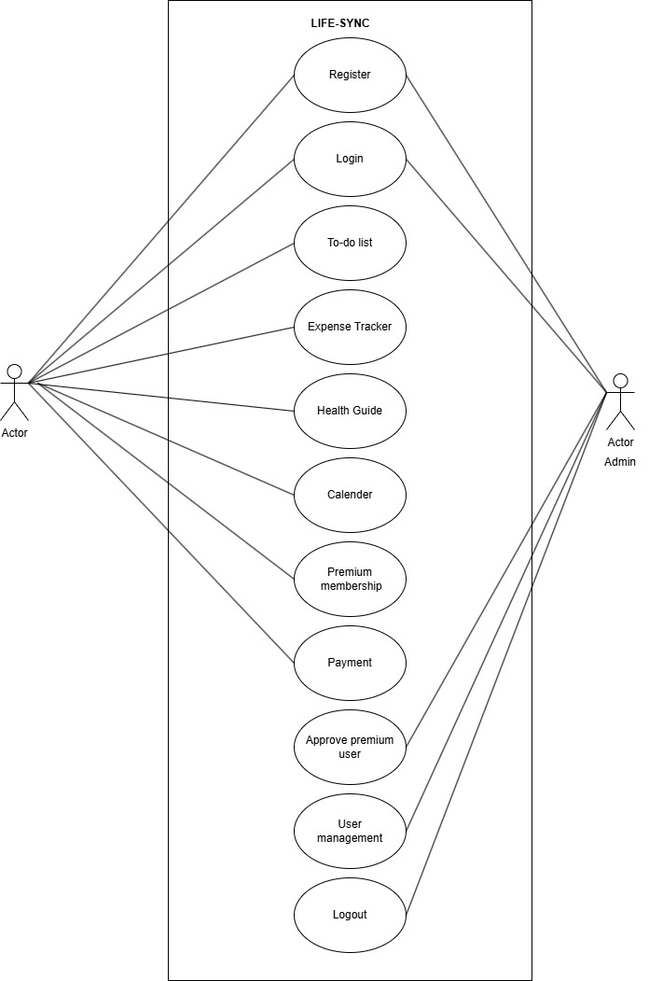

**Object diagram:**

**Deployment diagram:**

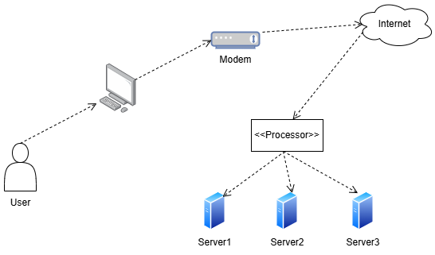

**Component diagram:**

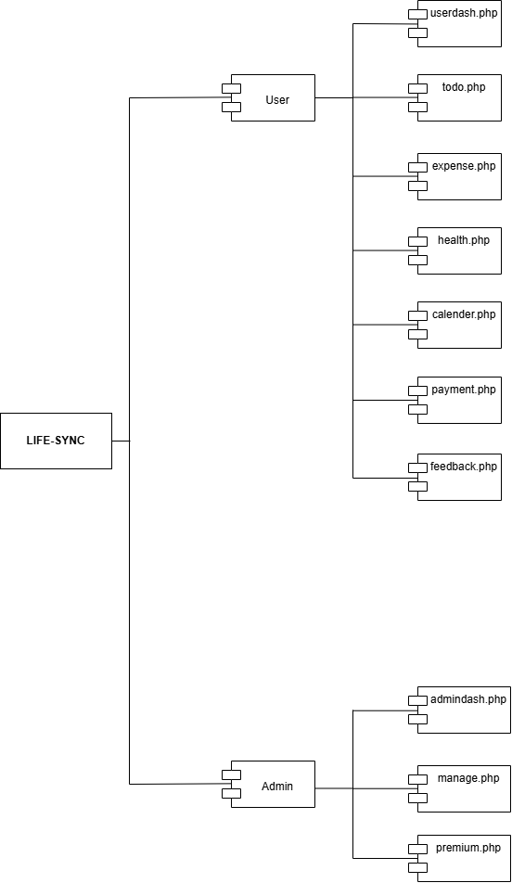

**Activity diagram:**

**Sequence diagram:**

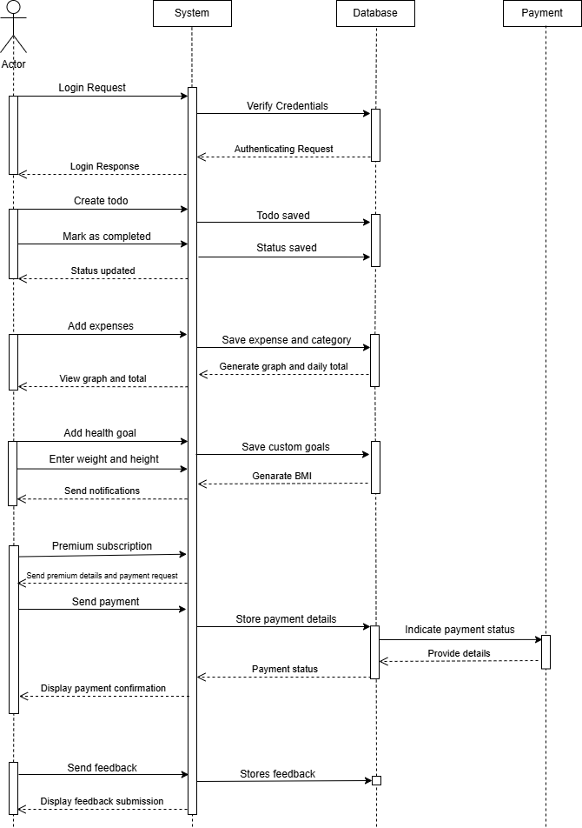

**State chart diagram:**

