

CSF 3133
REKA BENTUK ANTARA MUKA BERASASKAN WEB

NAME: NIK MARIYAH SOFEAH BINTI MOHD RIZAN
MATRIC NUMBER: S76237
GROUP: K4
LECTURER: PROF. MADYA TS DR. WAN NURAL JAWAHIR HJ WAN YUSSOF
DATE: 5/11/2025

SEMESTER I 2025/2026

- block.html
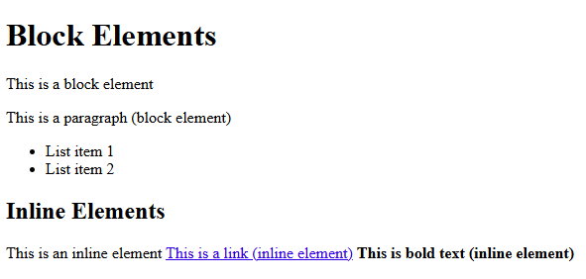

- div.html
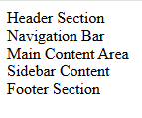

Using background-color
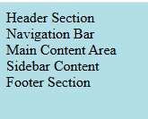

- entity.html
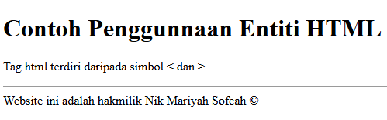

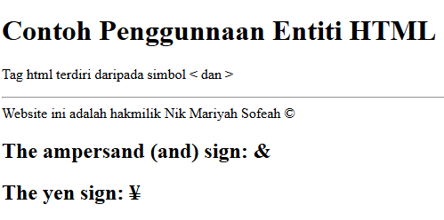

- intro5.html
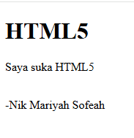

- input5.html
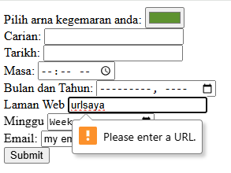

- inattribute5.html
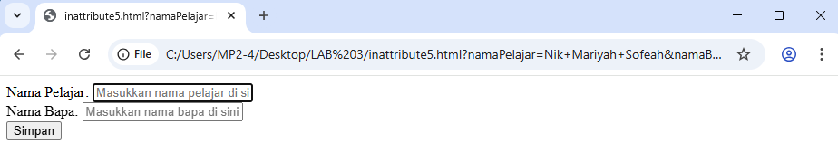
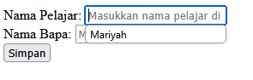
- output5.html
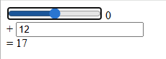
Lab Exercise
