

CSF 3133
REKA BENTUK ANTARA MUKA BERASASKAN WEB

NAME: NIK MARIYAH SOFEAH BINTI MOHD RIZAN
MATRIC NUMBER: S76237
GROUP: K4
LECTURER: PROF. MADYA TS DR. WAN NURAL JAWAHIR HJ WAN YUSSOF
DATE: 12/11/2025

SEMESTER I 2025/2026

- Page Structure Elements
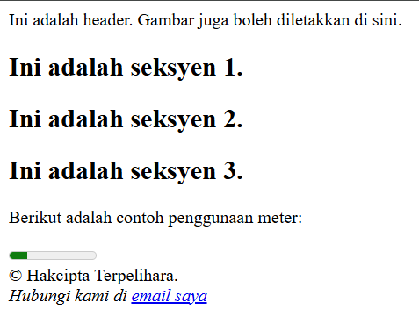

- Insert Video into HTML5 Document
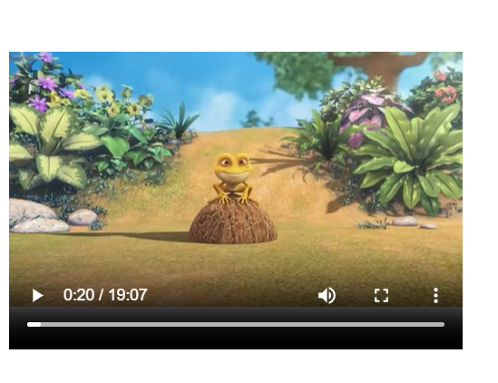

- Cascading Style Sheet

- Recognize ID and Selector Class

- Navigation Bar using CSS
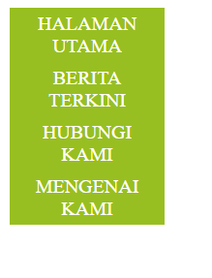

- Recognizing Text Decoration
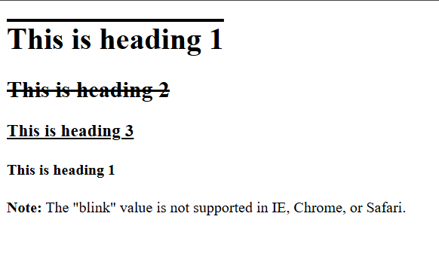

- Recognizing Styling Link
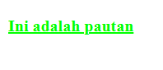
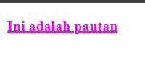
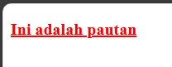
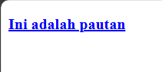

Lab Exercise
Source Code
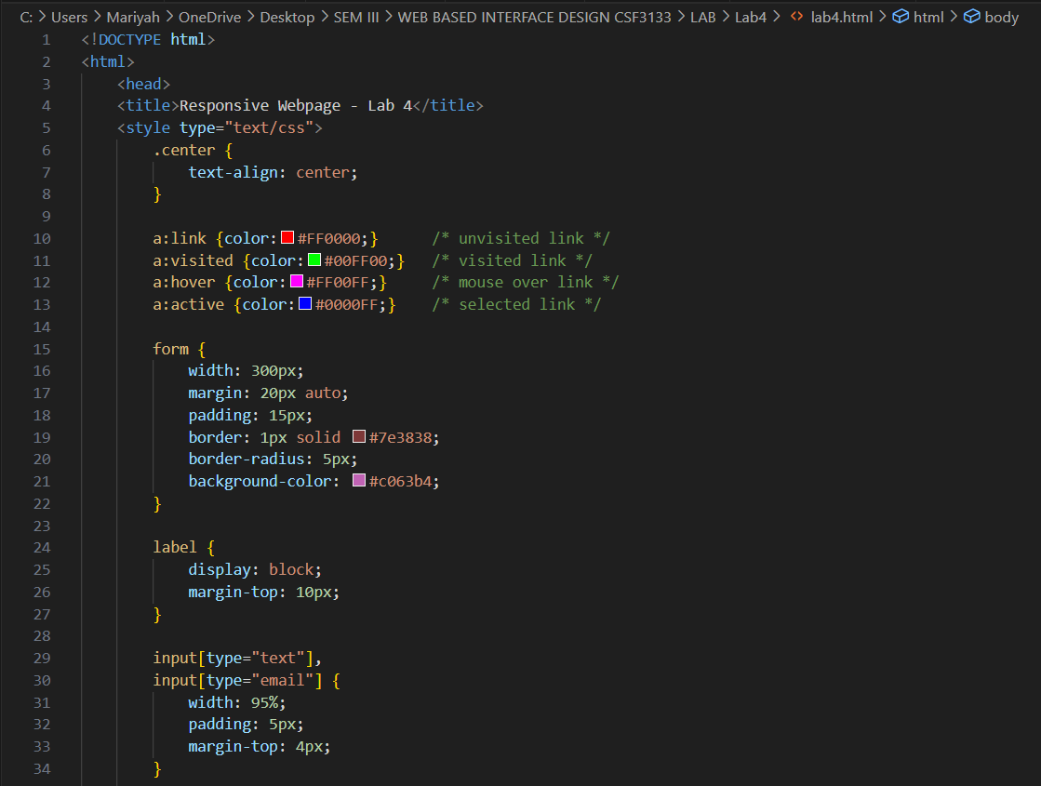
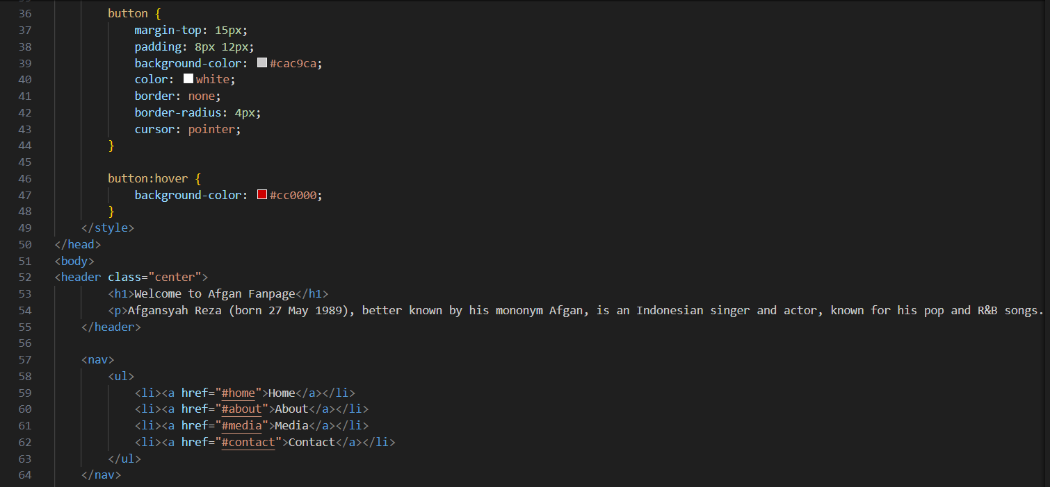
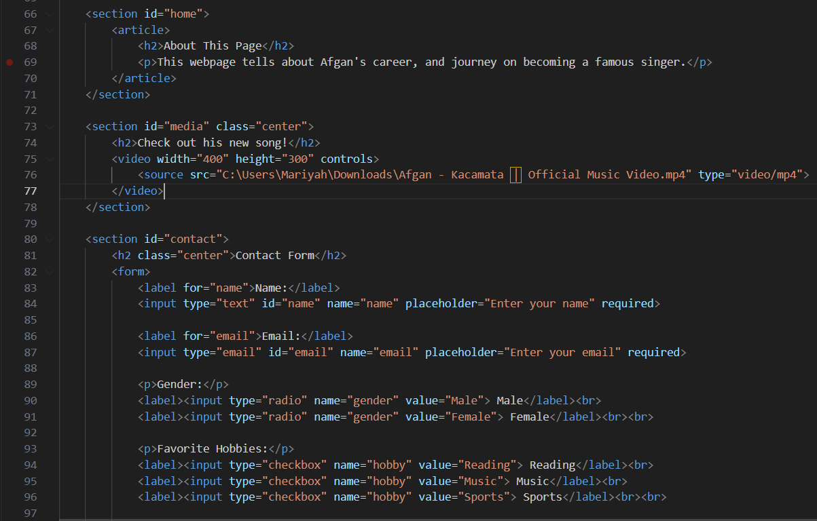
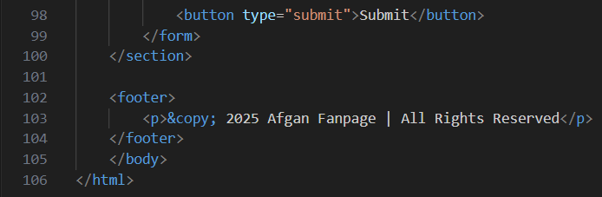

Output
