Employment determinants among Ukrainian refugees: a comparative analysis across European host countries

Table of contents

# Abstract

This paper analyzes the employment outcomes of Ukrainian refugees across six Central and Eastern European countries through a comparative, data-driven analysis. Using the 2023 Multi-Sectoral Needs Assessment (MSNA) data collected by UNHCR, it explores how demographic characteristics, previous work experience, access to social benefits, and perceived barriers, such as limited command of the language, lack of documentation, childcare, or health, influence job-seeking behavior. The study applies exploratory techniques with logistic regression modeling and machine learning methods to identify key predictors of employment status. Results reveal that previous employment and absence of barriers, consistently increase employment chances, while receiving certain social benefits or having caregiving responsibilities are associated with lower employment likelihood. While language proficiency is seen as an advantage, the analysis reveals that those reporting language barriers are more likely to be employed, likely because they tend to take up entry-level positions. Findings point to the importance of support policies that target specific employment barriers, enhance credential recognition, and offer accessible childcare and training opportunities to improve refugee labor market integration.

# Introduction and context

Since the start of the war in Ukraine, thousands of Ukrainians have been forced to leave the country and seek protection elsewhere. The inflow of more than 8 million Ukrainian refugees into Europe has introduced both challenges and opportunities for labour market outcomes. While it is hard to predict the intended length of stay of refugees in countries of the European Union, continued attacks made early returns very unpromising.

The Temporary Protection Status enacted by European host countries in 2022 allows people fleeing the war in Ukraine to live and work in the European Union for up to 3 years. Finding work that best matches refugees’ skills and education status is crucial in becoming financially stable and integrating into foreign society. Mastering their professional skills is also useful in reconstructing Ukraine in the future. Although the education and qualification levels of incoming Ukrainians are generally high, difficulties such as lack of language skills, childcare services and credential recognition processes pose significant barriers to employment. Instances of ethnic discrimination in the labor market have been reported, highlighting additional challenges in social and professional aspects (Londar et al., 2024). As the displacement persists, it is urgent to facilitate access to employment among refugees for long-term integration. The analysis is aimed at identifying key factors associated with successful job market outcomes to inform policy making and raise awareness on common obstacles, needs, and experiences faced by Ukrainians in European host countries.

# Data and Methods

This study employs Multi-Sectoral Needs Assessments (MSNA) of 2023, which provide data on Ukrainian refugees’ needs and priorities in Estonia, Slovakia, Poland, Romania, Moldova, and Czechia. The assessment employs both household-level and individual-level data collected through structured surveys in all the countries.

**Data Wrangling and Preparation**

To enable cross-regional comparisons, variables that were consistently present across all six national datasets were selected and merged into a single dataset. Questions allowing multiple responses, such as types of support received, reasons for unemployment, barriers to accessing services, were transformed using one-hot encoding into a series of binary indicator variables (1 = selected, 0 = not selected) to show each of the possible response categories in disaggregated form. Where categorical responses varied slightly across countries due to differences in wording or coding, the values were recoded into a uniform format for comparison.

For the convenience of exploratory data analysis (EDA) and model building, the outcome variable (employment status) was defined as follows:

* Respondents were classified as employed (1) if they reported any form of employment.
* All others (unemployed, in education, retired, or not working due to other factors) were classified as unemployed (0).

This two-category outcome variable, Employed, was used as the dependent variable for all the following regression and classification models.

Based on the proportions of missing data and their impact on model performance, non-available observations were excluded or imputed. Individual aggregated dataframes were created so that the distribution of binary-coded multi-response variables could be visualized and country-level comparisons could be made.

**Statistical Modeling**

Logistic regression and random forest classification were applied in an attempt to identify influential factors concerning employment among Ukrainian refugees:

* Random Forest Classifier

A random forest model was trained to account for potential non-linearities and interactions between variables. The model was trained using predictors selected based on feature importance scores. Its performance was evaluated using classification measures such as accuracy, precision, recall, and area under the ROC curve (AUC). Random forest allowed for selection of the most significant predictors of job-finding based on mean decrease in impurity and permutation importance.

* Logistic Regression

Binary logistic regression analysis was used to estimate the probability of employment (Employed = 1). Independent variables included demographic and socio-economic ones such as age, education level, country of residence, language skills, consumption of social services, icnome sources, among others. Odds ratios were estimated to define direction and strength of associations.

# Pooled Analysis Across Six Countries

## Exploratory Data Analysis

**Demographics**

The bar chart displays the distribution of survey respondents by age group (18–34, 35–59, 60+) across six Central and Eastern European countries. Across all countries, the 35–59 age group consistently has the highest number of respondents, followed by the 18–34 group, with the 60+ group being the least represented. Estonia shows a more balanced distribution between the younger and middle-aged groups, though the same pattern persists.

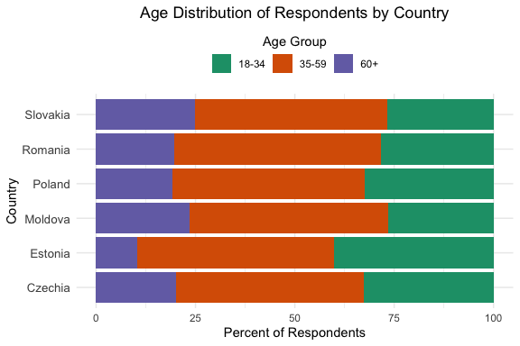

The variety of educational backgrounds of Ukrainians underscore the wide range of fields they are able to contribute to. Based on the data used in the analysis, most refugees possess at least secondary education (Figure 1). Across all six countries, the proportion of individuals holding a Bachelor’s degree ranges from 12% to 19% and Master’s degrees from 9% to as high as 40%, with particularly high shares observed in Slovakia and Romania. Although few hold PhDs, their presence is most visible in Slovakia and Czechia. Notably, technical and vocational training is the most frequent, suggesting that many displaced people were skilled laborers. This trend could indicate a reliance on skilled labor or informal employment in certain areas.

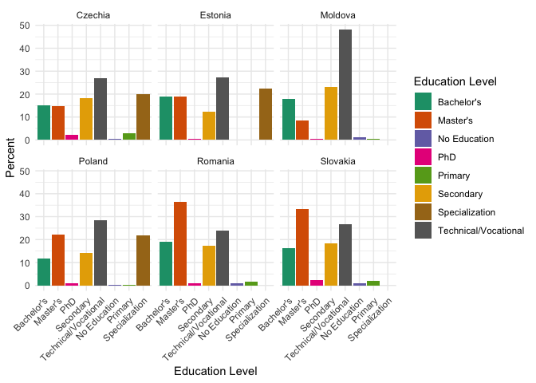

**Economic capacity and Aid**

The faceted bar chart indicates the sources of declared income. The most apparent trend is the dominant role of “employment in the host country” as the principal source of income in most countries, especially in Czechia, Estonia, and Slovakia, where it accounts for over 40–50%. Romania has a more balanced split, with employment percentages, other sources, and maintained employment from Ukraine all being similar, however, it also has the highest number of people with no income. Remote work and remittances in Romania and Poland respectively also arise more than anywhere else. Across all countries, rates like “no answer”, and “no income” are low but present.

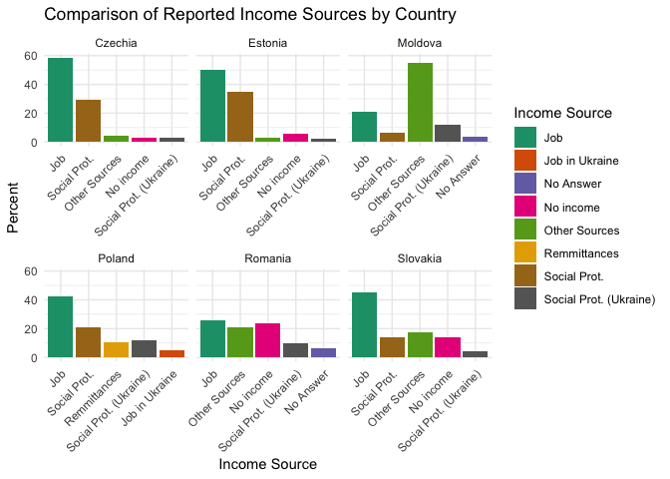

There is also some barriers people faced when looking for employment. For instance, Estonia stands out with a high incidence of the “Language barrier” (around 37%). Across all countries, language barriers and the fact that many are “Not looking for work” are consistently among the top reasons cited, though to varying degrees. “Lack of skills” and “Lack of recognition” are less frequently mentioned, typically below 10%. Moldova, Romania, and Poland also report relatively high percentages for “Not looking for work” and “Insufficient opportunities,” indicating structural and motivational challenges. In contrast, in Moldova and Slovakia, over 40% of respondents indicated no difficulties.

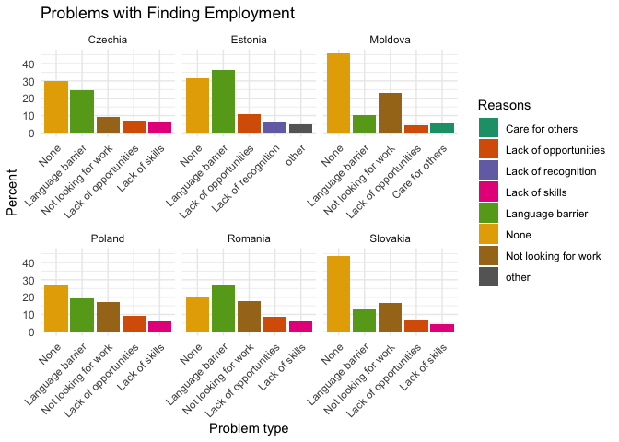

In Ukraine, the vast majority of refugees across all countries were employed, with employment rates ranging from approximately 60% to over 70%. Housekeeping and retirement were the next most common categories, but far less prevalent. In contrast, in host countries, employment drops significantly, while unemployment, studying, and housekeeping rise sharply. For example, in Moldova, Romania, and Slovakia, more than half of refugees are now unemployed. Studying categories also grow considerably, particularly in Romania, Czechia and Moldova. This shift indicates a major transition for many refugees, from stable employment in Ukraine to navigating unemployment or reskilling opportunities in their new environments.

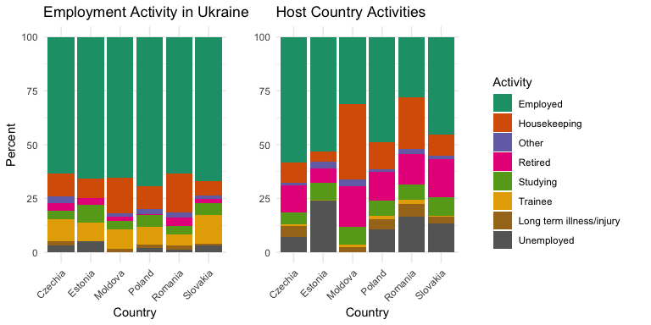

In most countries, especially Czechia, Moldova, Romania, and Slovakia, cash benefits are the dominant form of support, reaching around 80–90% in some cases. Poland stands out as the only country where the majority (over 80%) report receiving family grants instead of cash benefits. Estonia also presents a more balanced distribution, with both cash benefits and family grants being common, and a notable share receiving unemployment grants or reporting “Other Source.” Across all countries, disability and unemployment grants remain minor components. Overall, the data suggest that cash-based support remains the primary mechanism, though the specific type of aid can vary by host country.

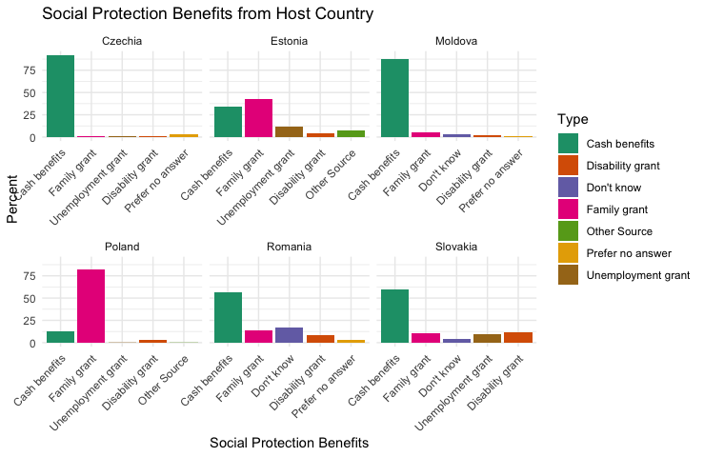

The data on socioeconomic needs of refugees is reported for four countries only: Estonia, Moldova, Romania, and Slovakia. In Estonia, Ukrainians select employment, accommodation, and education as the most important type of need. In Moldova, Romania, and Slovakia, a number of people consider humanitarian assistance, government assistance, and healthcare as their primary needs.

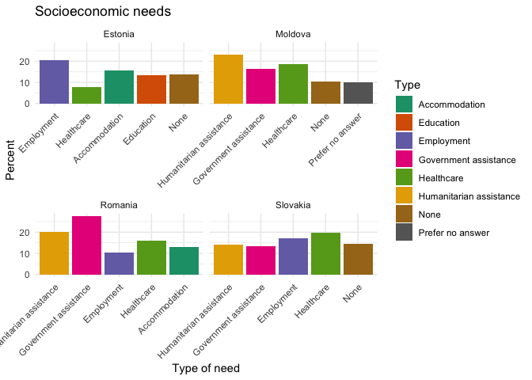

**Safety and Social Cohesion**

According to data, a majority of respondents reported no incidents of aggression or discrimination across all countries. Moldova (~80%) and Slovakia (~75%) report the highest rates of “No Incidents”. Verbal aggression and discriminatory behavior are the most common types of hostility experienced after “No Incidents”. Romania, Poland, and Slovakia show moderate levels of verbal aggression and discriminatory behavior, likely reflecting higher public tension. Romania shows physical attack in its top five, and even there, the percentage is minimal, so physical safety, therefore, seems relatively high across the surveyed countries.

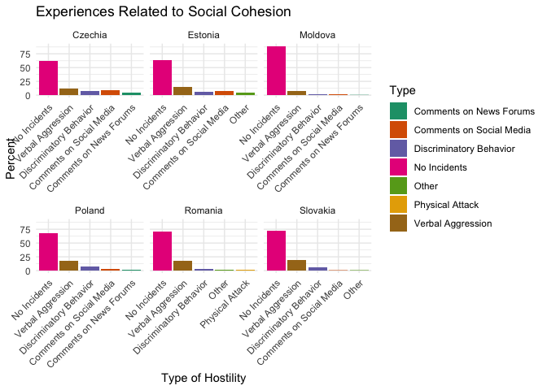

## Logistic Regression (Pooled Model)

### Random forest

To identify the most important predictors of employment among Ukrainian refugees, a Random Forest (RF) classifier was applied using the randomForest package in R. The analysis included 23 theoretically relevant independent variables related to demographics, barriers to employment, social benefits, and hostile experiences (see variable list below).

set.seed(123)  
important_vars <- c(  
 "introduction_resp_age",  
 "demographics_educ_level_grouped",  
 "demographics_resp_activity",  
 "income_social_protection_host_govt",  
 "income_remmittances",  
 "income_social_protection_ukr_govt",  
 "diff_lack_of_lang",  
 "diff_lack_childcare",  
 "diff_lack_of_skills",  
 "diff_lack_of_education_skills",  
 "diff_lack_of_info",  
 "diff_none",  
 "diff_discrimination",  
 "diff_lack_of_documentation",  
 "needs_medical",  
 "needs_accommodation",  
 "needs_host_govt_assistance",  
 "benefits_cash_benefits",  
 "benefits_unemployment_grant",  
 "hostile_comments_social_media",  
 "hostile_verbal_aggression",  
 "hostile_discriminatory_behavior",  
 "hostile_none"  
)

Only respondents with non-missing values across all included variables were selected for the analysis. employed_binary was converted into a factor with two levels: “Yes” and “No”. A Random Forest model was fit with the following parameters:

* Number of trees (ntree): 500
* Number of variables randomly sampled at each split (mtry): 2
* Importance metric: Mean Decrease in Accuracy

model_data <- combined_data |>  
 select(employed_binary, all_of(important_vars)) |>  
 drop_na() |>  
 mutate(employed_binary = factor(employed_binary, levels = c(0, 1),   
 labels = c("No", "Yes")))  
  
rf_model <- randomForest(employed_binary ~ ., data = model_data,  
 ntree = 500, mtry = 2, importance = TRUE)

The top 15 variables were selected based on their Mean Decrease in Accuracy, which reflects the contribution of each variable to prediction performance. The variable importance plot (varImpPlot) was used to visually assess the relative influence of each predictor.

The selected variables were then retained for subsequent logistic regression modeling, to estimate the direction and significance of their effects.

imp <- importance(rf_model)  
top_vars <- rownames(imp)[order(imp[, "MeanDecreaseAccuracy"],   
 decreasing = TRUE)][1:15]  
varImpPlot(rf_model, main = "Variable Importance: Random Forest Model")

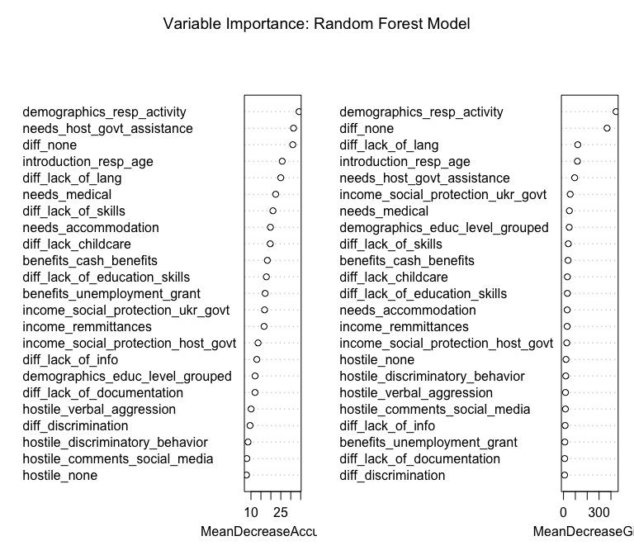

model_data_selected <- model_data[, c("employed_binary", top_vars)]  
model_data_selected$employed_binary <-   
 as.integer(model_data_selected$employed_binary == "Yes")

### Logistic Regression

A logistic regression model was fit to predict the binary employment outcome employed_binary, where 0 = Not Employed/1 = Employed, among Ukrainian refugees using selected explanatory variables identified as important in prior analysis.

Logistic regression analysis highlights several key factors shaping employment outcomes among Ukrainian refugees. Those reporting no difficulties are over seven times more likely to be employed than those facing challenges. In contrast, individuals previously engaged in housekeeping are 83% less likely to find work, and those with long-term illness or injury face an even steeper decline, with employment odds reduced by 96%. Older adults (60+) also struggle, with only a 16% likelihood of employment compared to younger groups. Additional barriers further limit employment prospects: lack of childcare reduces chances by 36%, and medical needs by 42%. Receiving unemployment grants is associated with a 77% drop in employment odds, while beneficiaries of Ukrainian social protection or general cash support face 34% and 46% lower chances of being employed, respectively. An unexpected result showed that reporting a lack of language skills was associated with a 218% increase in employment odds, suggesting underlying factors such as self-selection, possible skill mismatch, or employment in position with no language requirement.

logit_model <- glm(employed_binary ~ .,   
 data = model_data_selected, family = binomial)  
summary(logit_model)

Call:  
glm(formula = employed_binary ~ ., family = binomial, data = model_data_selected)  
  
Coefficients:  
 Estimate Std. Error z value  
(Intercept) 0.06838 0.05968 1.146  
demographics_resp_activityHousekeeping -1.77701 0.07683 -23.129  
demographics_resp_activityLong term illness/injury -3.14444 0.27829 -11.299  
demographics_resp_activityOther -0.68796 0.15579 -4.416  
demographics_resp_activityRetired -1.83316 0.16432 -11.156  
demographics_resp_activityStudying -0.91515 0.08130 -11.256  
demographics_resp_activityTrainee -0.64276 0.15695 -4.095  
demographics_resp_activityUnemployed -0.90545 0.14530 -6.232  
needs_host_govt_assistance -0.90319 0.06943 -13.008  
diff_none 2.12265 0.05848 36.300  
introduction_resp_age35-59 -0.02881 0.05097 -0.565  
introduction_resp_age60+ -0.96521 0.11838 -8.153  
diff_lack_of_lang 1.15577 0.05094 22.690  
needs_medical -0.54324 0.07345 -7.396  
diff_lack_of_skills 0.47595 0.06318 7.534  
needs_accommodation -0.22780 0.07952 -2.865  
diff_lack_childcare -0.44331 0.09888 -4.483  
benefits_cash_benefits -0.61771 0.08576 -7.202  
diff_lack_of_education_skills 0.55654 0.09308 5.979  
benefits_unemployment_grant -1.46624 0.27581 -5.316  
income_social_protection_ukr_govt -0.42288 0.06681 -6.330  
income_remmittances -0.58374 0.07257 -8.043  
income_social_protection_host_govt -0.12153 0.05645 -2.153  
 Pr(>|z|)   
(Intercept) 0.25191   
demographics_resp_activityHousekeeping < 2e-16 ***  
demographics_resp_activityLong term illness/injury < 2e-16 ***  
demographics_resp_activityOther 1.01e-05 ***  
demographics_resp_activityRetired < 2e-16 ***  
demographics_resp_activityStudying < 2e-16 ***  
demographics_resp_activityTrainee 4.22e-05 ***  
demographics_resp_activityUnemployed 4.61e-10 ***  
needs_host_govt_assistance < 2e-16 ***  
diff_none < 2e-16 ***  
introduction_resp_age35-59 0.57199   
introduction_resp_age60+ 3.54e-16 ***  
diff_lack_of_lang < 2e-16 ***  
needs_medical 1.40e-13 ***  
diff_lack_of_skills 4.93e-14 ***  
needs_accommodation 0.00417 **   
diff_lack_childcare 7.35e-06 ***  
benefits_cash_benefits 5.92e-13 ***  
diff_lack_of_education_skills 2.24e-09 ***  
benefits_unemployment_grant 1.06e-07 ***  
income_social_protection_ukr_govt 2.45e-10 ***  
income_remmittances 8.73e-16 ***  
income_social_protection_host_govt 0.03132 *   
---  
Signif. codes: 0 '***' 0.001 '**' 0.01 '*' 0.05 '.' 0.1 ' ' 1  
  
(Dispersion parameter for binomial family taken to be 1)  
  
 Null deviance: 17791 on 12889 degrees of freedom  
Residual deviance: 13047 on 12867 degrees of freedom  
AIC: 13093  
  
Number of Fisher Scoring iterations: 5

### Model Fit and Evaluation

The logistic regression model demonstrates a good overall fit to the data. McFadden’s pseudo-R² is approximately 0.267, indicating the model explains around 27% of the variance in employment outcomes, which reflects a moderate level of explanatory power for this type of social data. In terms of predictive performance, the model achieves a classification accuracy of about 75.1%, correctly predicting employment status for three out of four individuals. The confusion matrix reveals that the model more accurately identifies those who are employed (5,677 correctly classified) compared to those not employed (4,002 correctly classified), though there are some misclassifications in both groups. Additionally, the Area Under the Receiver Operating Characteristic Curve (AUC) is 0.828, signifying strong discriminatory ability to distinguish between employed and unemployed individuals. Together, these metrics suggest the model is both statistically sound and practically useful for understanding employment determinants among Ukrainian refugees.

pR2(logit_model)

fitting null model for pseudo-r2

llh llhNull G2 McFadden r2ML   
-6523.6443129 -8895.6827665 4744.0769072 0.2666505 0.3079127   
 r2CU   
 0.4113823

pred_probs <- predict(logit_model, type = "response")  
pred_class <- ifelse(pred_probs > 0.5, 1, 0)  
table(Predicted = pred_class, Actual = model_data_selected$employed_binary)

Actual  
Predicted 0 1  
 0 4002 1269  
 1 1942 5677

mean(pred_class == model_data_selected$employed_binary)

[1] 0.7508922

roc_obj <- roc(model_data_selected$employed_binary, pred_probs)  
plot(roc_obj)

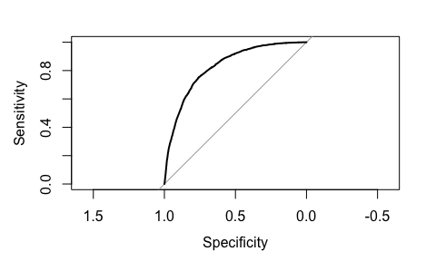

auc(roc_obj)

Area under the curve: 0.8279

# Country-Specific Analysis

A consistent analytical procedure was applied for each country included in the study to identify key factors associated with employment among Ukrainian refugees. Initially, exploratory data analysis was conducted by plotting relevant predictor variables against the binary employment outcome to visually assess differences between employed and unemployed groups. Variables showing notable group differences or supported by sufficient sample sizes were selected for further modeling. Multiple logistic regression models were then fit for each country, with statistically insignificant predictors being iteratively removed, in order to isolate the most influential variables affecting employment outcomes within each country. The significance alpha level for p-values was generally set at 0.05; however, in some cases, a more lenient threshold of 0.1 was used when exploratory data analysis (EDA) plots indicated meaningful differences. Additionally, the conditions for logistic regression were met, as the predictor variables included in the models were categorical. The following sections present regression results for each country, highlighting both common and unique factors influencing refugee employment.

## Poland

### Logistic regression

In Poland, multiple individual and structural factors were significantly associated with the likelihood of employment among Ukrainian refugees. Compared to respondents aged 18–34, those aged 60 and over had 69% lower odds of being employed, while the 35–59 group showed a marginal reduction in odds by 13%. Employment odds were also considerably lower for respondents engaged in housekeeping (80% lower), those with long-term illness or injury (96% lower), and retirees (80% lower), all highly significant. Studying and trainee statuses were associated with 53% and 42% lower odds of employment, respectively.

Income sources were also relevant: receiving social protection from the host government was associated with 16% lower odds of employment, remittances with 49% lower odds, and Ukrainian government benefits with 39% lower odds. Language barriers were a positive predictor: those citing lack of language skills as a difficulty had 134% higher odds of being employed. Lack of childcare decreased employment odds by 58%, while difficulties with age-related opportunities reduced them by 26%. In contrast, reporting “no difficulties” was associated with a 377% increase in the odds of being employed. Not actively looking for work had a strong negative effect, reducing odds by 84%. Finally, challenges related to lack of skills and lack of educational qualifications slightly increased employment odds by 29% and 78%, respectively, possibly due to their association with active job-seeking behaviors.

Call:  
glm(formula = employed_binary ~ ., family = binomial, data = poland_data)  
  
Coefficients:  
 Estimate Std. Error z value  
(Intercept) 0.78438 0.09423 8.324  
introduction_resp_age35-59 -0.14252 0.07556 -1.886  
introduction_resp_age60+ -1.17855 0.17723 -6.650  
demographics_resp_activityHousekeeping -1.61056 0.11261 -14.302  
demographics_resp_activityLong term illness/injury -3.22135 0.38360 -8.398  
demographics_resp_activityOther -1.19764 0.40752 -2.939  
demographics_resp_activityRetired -1.60703 0.22360 -7.187  
demographics_resp_activityStudying -0.76296 0.12028 -6.343  
demographics_resp_activityTrainee -0.53943 0.23431 -2.302  
demographics_resp_activityUnemployed -1.03238 0.21568 -4.787  
income_social_protection_host_govt -0.17779 0.06587 -2.699  
income_remmittances -0.66915 0.07867 -8.506  
income_social_protection_ukr_govt -0.49970 0.08566 -5.834  
diff_lack_of_lang 0.84912 0.07634 11.122  
diff_lack_childcare -0.85765 0.12434 -6.898  
diff_lack_of_skills 0.25544 0.08526 2.996  
diff_lack_of_education_skills 0.57518 0.11676 4.926  
diff_none 1.56400 0.09414 16.614  
diff_not_looking_for_work -1.84200 0.11139 -16.536  
diff_lack_of_age_opportunities -0.30076 0.11766 -2.556  
 Pr(>|z|)   
(Intercept) < 2e-16 ***  
introduction_resp_age35-59 0.05928 .   
introduction_resp_age60+ 2.94e-11 ***  
demographics_resp_activityHousekeeping < 2e-16 ***  
demographics_resp_activityLong term illness/injury < 2e-16 ***  
demographics_resp_activityOther 0.00329 **   
demographics_resp_activityRetired 6.63e-13 ***  
demographics_resp_activityStudying 2.25e-10 ***  
demographics_resp_activityTrainee 0.02132 *   
demographics_resp_activityUnemployed 1.70e-06 ***  
income_social_protection_host_govt 0.00696 **   
income_remmittances < 2e-16 ***  
income_social_protection_ukr_govt 5.42e-09 ***  
diff_lack_of_lang < 2e-16 ***  
diff_lack_childcare 5.29e-12 ***  
diff_lack_of_skills 0.00274 **   
diff_lack_of_education_skills 8.38e-07 ***  
diff_none < 2e-16 ***  
diff_not_looking_for_work < 2e-16 ***  
diff_lack_of_age_opportunities 0.01058 *   
---  
Signif. codes: 0 '***' 0.001 '**' 0.01 '*' 0.05 '.' 0.1 ' ' 1  
  
(Dispersion parameter for binomial family taken to be 1)  
  
 Null deviance: 9386.3 on 6909 degrees of freedom  
Residual deviance: 6369.8 on 6890 degrees of freedom  
AIC: 6409.8  
  
Number of Fisher Scoring iterations: 5

### Model performance

In terms of model performance, the McFadden pseudo R² was 0.321, indicating a substantial improvement in model fit compared to the null model, and suggesting that the selected predictors explain a meaningful portion of the variation in employment outcomes.In terms of predictive accuracy, the model correctly classified approximately 79.3% of cases. The confusion matrix showed 1886 true negatives and 3593 true positives, with relatively balanced false positives (993) and false negatives (438). The area under the ROC curve (AUC) was 0.848, reflecting strong discriminative ability and indicating that the model effectively distinguishes between employed and unemployed individuals based on the included variables.

fitting null model for pseudo-r2

llh llhNull G2 McFadden r2ML   
-3184.9182312 -4693.1693810 3016.5022996 0.3213716 0.3537324   
 r2CU   
 0.4761375

Actual  
Predicted 0 1  
 0 1886 438  
 1 993 3593

[1] 0.7929088

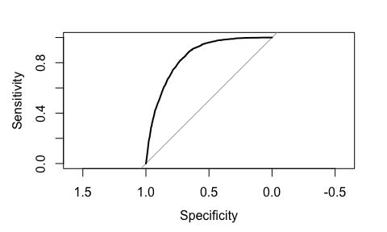

Area under the curve: 0.848

## Estonia

### Logistic regression

A logistic regression model was fit to assess the predictors of employment among Ukrainian refugees in Estonia. Compared to the reference group, respondents previously engaged in housekeeping, while living in Ukraine, had a 91% lower odds of employment, while those who were retired had a 97% lower odds. Individuals who were studying had a 92% lower odds, and those who were unemployed had a 66% lower odds of being employed.

Some barriers and support factors also had strong negative associations with employment. Reporting lack of documentation was associated with a 95% decrease in odds of employment, while receiving cash benefits or an unemployment grant was linked to an 88% and an 85% decrease in employment odds. Those who reported a need for employment support had an 85% lower odds of being employed.

Conversely, some variables were positively associated with employment. Surprisingly, those who reported language barriers had a 131% higher odds of employment. Experiencing hostile comments on social media was associated with a 540% increase in the odds of employment, and perceiving a loss of benefits was linked to a 1,668% increase in odds, though the latter should be interpreted cautiously due to wide error margins.

Call:  
glm(formula = employed_binary ~ ., family = binomial, data = estonia_data)  
  
Coefficients:  
 Estimate Std. Error z value Pr(>|z|)   
(Intercept) 1.2360 0.1988 6.217 5.06e-10 ***  
demographics_resp_activityHousekeeping -2.3784 0.4171 -5.702 1.18e-08 ***  
demographics_resp_activityOther -1.4186 0.6311 -2.248 0.024585 *   
demographics_resp_activityRetired -3.4393 0.6679 -5.149 2.61e-07 ***  
demographics_resp_activityStudying -2.5225 0.4597 -5.487 4.09e-08 ***  
demographics_resp_activityUnemployed -1.0777 0.4744 -2.272 0.023103 *   
diff_lack_of_lang 0.8389 0.2518 3.332 0.000862 ***  
diff_lack_of_documentation -2.9101 1.2807 -2.272 0.023070 *   
benefits_cash_benefits -2.1139 0.3006 -7.032 2.03e-12 ***  
benefits_unemployment_grant -1.9297 0.4701 -4.105 4.04e-05 ***  
hostile_comments_social_media 1.8576 0.4340 4.281 1.86e-05 ***  
diff_loss_benefits 2.8724 1.1600 2.476 0.013277 *   
needs_employment -1.8743 0.3113 -6.021 1.74e-09 ***  
---  
Signif. codes: 0 '***' 0.001 '**' 0.01 '*' 0.05 '.' 0.1 ' ' 1  
  
(Dispersion parameter for binomial family taken to be 1)  
  
 Null deviance: 768.45 on 555 degrees of freedom  
Residual deviance: 467.63 on 543 degrees of freedom  
AIC: 493.63  
  
Number of Fisher Scoring iterations: 6

### Model performance

The model predicting outcomes in Estonia demonstrated strong overall performance. The McFadden pseudo-R² was 0.39, indicating a good model fit relative to the null model. The classification accuracy was 80.0%, correctly predicting 250 out of 296 employed individuals and 195 out of 260 unemployed individuals. The confusion matrix showed a balance between sensitivity and specificity. The Area Under the Receiver Operating Characteristic Curve (AUC) was 0.884, suggesting high ability to distinguish between employed and unemployed groups.

fitting null model for pseudo-r2

llh llhNull G2 McFadden r2ML r2CU   
-233.8139308 -384.2235491 300.8192365 0.3914638 0.4178585 0.5579266

Actual  
Predicted 0 1  
 0 195 46  
 1 65 250

[1] 0.8003597

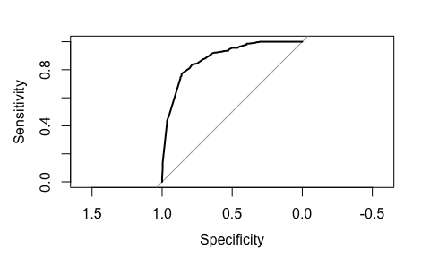

Area under the curve: 0.8842

## Czechia

### Logistic regression

In Czechia, respondents who were engaged in housekeeping were 73% less likely to be employed than those working. Those reporting a long-term illness or injury were 98% less likely to be employed, while retired individuals had 87% lower odds of being employed. Respondents who were studying had 70% lower odds of employment, and those who were unemployed at the time of the survey had 68% lower odds of being employed.

Access to social protection from the host government was negatively associated with employment: recipients were 78% less likely to be employed. On the other hand, individuals who reported no major difficulties integrating or accessing work were nearly 6.5 times more likely to be employed. Experiences of verbal aggression were positively associated with employment, with those experiencing it having 86% higher odds of being employed.

Difficulties such as lack of decent employment and lack of childcare were also significant: those who faced a lack of decent employment had 53% higher odds of being employed, whereas those who reported childcare difficulties had 47% lower odds of being employed. Finally, individuals who were not actively looking for work had 87% lower odds of being employed, indicating a strong behavioral link to employment outcomes.

Call:  
glm(formula = employed_binary ~ ., family = binomial, data = czechia_data)  
  
Coefficients:  
 Estimate Std. Error z value  
(Intercept) 1.3440 0.1974 6.808  
demographics_resp_activityHousekeeping -1.2947 0.2415 -5.361  
demographics_resp_activityLong term illness/injury -4.0272 0.7728 -5.212  
demographics_resp_activityOther -0.0595 0.4072 -0.146  
demographics_resp_activityRetired -2.0217 0.4088 -4.945  
demographics_resp_activityStudying -1.2062 0.2364 -5.102  
demographics_resp_activityTrainee -0.7219 0.4587 -1.574  
demographics_resp_activityUnemployed -1.1449 0.4022 -2.846  
income_social_protection_host_govt -1.5296 0.1579 -9.689  
diff_lack_of_lang 0.4990 0.1812 2.754  
diff_none 1.8667 0.2523 7.398  
hostile_verbal_aggression 0.6194 0.1941 3.191  
diff_lack_of_decent_employment 0.4282 0.1925 2.224  
diff_lack_childcare -0.6328 0.2586 -2.447  
diff_not_looking_for_work -2.0256 0.2688 -7.536  
 Pr(>|z|)   
(Intercept) 9.91e-12 ***  
demographics_resp_activityHousekeeping 8.29e-08 ***  
demographics_resp_activityLong term illness/injury 1.87e-07 ***  
demographics_resp_activityOther 0.88383   
demographics_resp_activityRetired 7.60e-07 ***  
demographics_resp_activityStudying 3.36e-07 ***  
demographics_resp_activityTrainee 0.11553   
demographics_resp_activityUnemployed 0.00442 **   
income_social_protection_host_govt < 2e-16 ***  
diff_lack_of_lang 0.00589 **   
diff_none 1.39e-13 ***  
hostile_verbal_aggression 0.00142 **   
diff_lack_of_decent_employment 0.02613 *   
diff_lack_childcare 0.01439 *   
diff_not_looking_for_work 4.84e-14 ***  
---  
Signif. codes: 0 '***' 0.001 '**' 0.01 '*' 0.05 '.' 0.1 ' ' 1  
  
(Dispersion parameter for binomial family taken to be 1)  
  
 Null deviance: 1860.0 on 1486 degrees of freedom  
Residual deviance: 1145.3 on 1472 degrees of freedom  
AIC: 1175.3  
  
Number of Fisher Scoring iterations: 6

### Model performance

The logistic regression model for Czechia demonstrated strong performance in predicting employment status among Ukrainian refugees. The McFadden pseudo-R² was 0.384, indicating a substantial improvement over the null model and suggesting that the predictors explained a meaningful portion of the variation in employment outcomes. The area under the ROC curve (AUC) was 0.878, which reflects excellent discriminatory ability of the model in distinguishing between employed and unemployed individuals. In terms of classification accuracy, the model correctly predicted 83.8% of all cases. Among the unemployed, it correctly classified 295 out of 358 individuals (82.4%), while for the employed group, it correctly predicted 951 out of 1,129 cases (84.2%).

fitting null model for pseudo-r2

llh llhNull G2 McFadden r2ML r2CU   
-572.6510292 -930.0016949 714.7013315 0.3842473 0.3816082 0.5346625

Actual  
Predicted 0 1  
 0 295 63  
 1 178 951

[1] 0.8379287

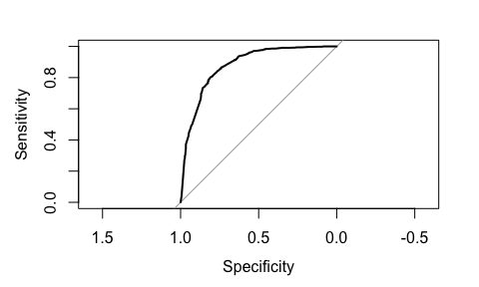

Area under the curve: 0.8782

## Slovakia

### Logistic regression

The logistic regression analysis for Slovakia identified that being aged 60 or older reduced the odds of employment by approximately 66%. Compared to other activity categories, engaging in housekeeping decreased the odds of employment by 80%, having a long-term illness or injury by 78%, being retired by 81%, studying by 70%, and being unemployed by 66%. Receipt of social protection benefits from the host government was associated with a 51% lower likelihood of employment. Not looking for work was linked to a 73% decrease in employment odds, while needing host government assistance or humanitarian assistance decreased the odds by 47% and 42%, respectively. Reporting no barriers to employment increased the odds by 401%, and surprisingly, reporting a lack of skills increased the odds by 78%. Finally, receiving cash benefits showed a marginal negative association, with odds of employment decreased by 52%.

Call:  
glm(formula = employed_binary ~ ., family = binomial, data = slovakia_data)  
  
Coefficients:  
 Estimate Std. Error z value  
(Intercept) 0.735414 0.210802 3.489  
introduction_resp_age35-59 0.121755 0.200053 0.609  
introduction_resp_age60+ -1.079908 0.390158 -2.768  
demographics_resp_activityHousekeeping -1.587135 0.337215 -4.707  
demographics_resp_activityLong term illness/injury -1.520569 0.756290 -2.011  
demographics_resp_activityOther -0.005407 0.566287 -0.010  
demographics_resp_activityRetired -1.684344 0.514602 -3.273  
demographics_resp_activityStudying -1.203479 0.267835 -4.493  
demographics_resp_activityTrainee -1.491922 0.783914 -1.903  
demographics_resp_activityUnemployed -1.086592 0.406088 -2.676  
income_social_protection_host_govt -0.704119 0.291831 -2.413  
diff_lack_of_skills 0.576793 0.281010 2.053  
diff_not_looking_for_work -1.323255 0.267911 -4.939  
needs_host_govt_assistance -0.626295 0.188424 -3.324  
needs_humanitarian_assistance -0.550940 0.189311 -2.910  
diff_none 1.610766 0.182710 8.816  
benefits_cash_benefits -0.743778 0.389486 -1.910  
 Pr(>|z|)   
(Intercept) 0.000485 ***  
introduction_resp_age35-59 0.542782   
introduction_resp_age60+ 0.005642 **   
demographics_resp_activityHousekeeping 2.52e-06 ***  
demographics_resp_activityLong term illness/injury 0.044372 *   
demographics_resp_activityOther 0.992382   
demographics_resp_activityRetired 0.001064 **   
demographics_resp_activityStudying 7.01e-06 ***  
demographics_resp_activityTrainee 0.057018 .   
demographics_resp_activityUnemployed 0.007456 **   
income_social_protection_host_govt 0.015832 *   
diff_lack_of_skills 0.040114 *   
diff_not_looking_for_work 7.85e-07 ***  
needs_host_govt_assistance 0.000888 ***  
needs_humanitarian_assistance 0.003612 **   
diff_none < 2e-16 ***  
benefits_cash_benefits 0.056180 .   
---  
Signif. codes: 0 '***' 0.001 '**' 0.01 '*' 0.05 '.' 0.1 ' ' 1  
  
(Dispersion parameter for binomial family taken to be 1)  
  
 Null deviance: 1425.3 on 1038 degrees of freedom  
Residual deviance: 1000.8 on 1022 degrees of freedom  
AIC: 1034.8  
  
Number of Fisher Scoring iterations: 5

### Model performance

The logistic regression model for Slovakia showed a moderate fit, with a McFadden’s pseudo-R² of approximately 0.298, indicating that about 29.8% of the variability in employment status is explained by the predictors. Classification accuracy was 77.2%, with the model correctly predicting employment status for the majority of cases. The area under the ROC curve (AUC) was 0.843, indicating good discrimination ability between employed and unemployed individuals.

fitting null model for pseudo-r2

llh llhNull G2 McFadden r2ML r2CU   
-500.3917968 -712.6424265 424.5012595 0.2978361 0.3353982 0.4493868

Actual  
Predicted 0 1  
 0 311 91  
 1 146 491

[1] 0.7718961

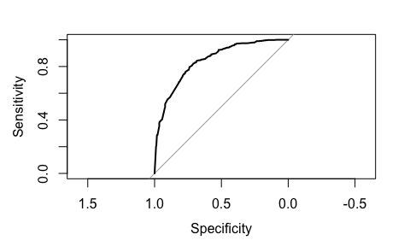

Area under the curve: 0.8431

## Moldova

### Logistic regression

The logistic regression model for Moldova revealed that engaging in housekeeping was associated with an 87% reduction in the odds of employment, while having a long-term illness or injury corresponded to a 93% decrease. Respondents who were studying had 63% lower odds, and those identified as trainees experienced a 79% reduction in employment likelihood.

In contrast, lacking language skills was linked to a 337% increase in employment odds, with a similar positive effect observed for those reporting a lack of skills, which raised the odds by 299%. Additionally, respondents reporting no difficulties had odds more than 9 times greater than those facing challenges. Medical needs and caregiving responsibilities negatively affected employment chances, reducing the odds by 50% and 83%, respectively.

Call:  
glm(formula = employed_binary ~ ., family = binomial, data = moldova_data)  
  
Coefficients:  
 Estimate Std. Error z value  
(Intercept) -0.9238 0.1816 -5.086  
demographics_resp_activityHousekeeping -2.0312 0.2670 -7.606  
demographics_resp_activityLong term illness/injury -2.6338 1.0575 -2.491  
demographics_resp_activityOther -1.0574 0.5173 -2.044  
demographics_resp_activityRetired -17.0998 519.7394 -0.033  
demographics_resp_activityStudying -0.9886 0.2598 -3.806  
demographics_resp_activityTrainee -1.5974 0.7071 -2.259  
diff_lack_of_lang 1.4743 0.2319 6.357  
diff_lack_of_skills 1.3115 0.3990 3.287  
diff_none 2.2347 0.1938 11.529  
needs_medical -0.6842 0.1576 -4.342  
diff_need_to_take_care_of_others -1.8068 0.5513 -3.277  
needs_humanitarian_assistance -0.2753 0.1511 -1.822  
 Pr(>|z|)   
(Intercept) 3.65e-07 ***  
demographics_resp_activityHousekeeping 2.82e-14 ***  
demographics_resp_activityLong term illness/injury 0.012748 *   
demographics_resp_activityOther 0.040946 *   
demographics_resp_activityRetired 0.973754   
demographics_resp_activityStudying 0.000141 ***  
demographics_resp_activityTrainee 0.023884 *   
diff_lack_of_lang 2.05e-10 ***  
diff_lack_of_skills 0.001013 **   
diff_none < 2e-16 ***  
needs_medical 1.41e-05 ***  
diff_need_to_take_care_of_others 0.001048 **   
needs_humanitarian_assistance 0.068401 .   
---  
Signif. codes: 0 '***' 0.001 '**' 0.01 '*' 0.05 '.' 0.1 ' ' 1  
  
(Dispersion parameter for binomial family taken to be 1)  
  
 Null deviance: 1497.3 on 1119 degrees of freedom  
Residual deviance: 1084.8 on 1107 degrees of freedom  
AIC: 1110.8  
  
Number of Fisher Scoring iterations: 16

### Model performance

The logistic regression model for Moldova demonstrated a reasonable fit, with a McFadden’s pseudo-R² of approximately 0.275, indicating that about 28.5% of the variation in employment status is explained by the model. The classification accuracy was 74.8%. Additionally, the model showed good discrimination ability with an area under the ROC curve (AUC) of 0.83, suggesting a strong capacity to distinguish between employed and unemployed respondents.

fitting null model for pseudo-r2

llh llhNull G2 McFadden r2ML r2CU   
-542.3926803 -748.6388062 412.4922520 0.2754948 0.3080881 0.4178432

Actual  
Predicted 0 1  
 0 514 112  
 1 170 324

[1] 0.7482143

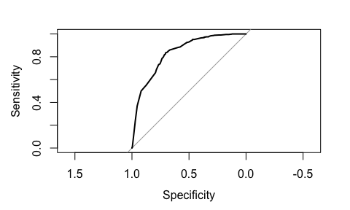

Area under the curve: 0.8349

## Romania

### Logistic regression

The logistic regression model for Romania reveals that being aged 60 or older reduces the odds of being employed by about 60%. Respondents engaged in housekeeping activities have approximately 82% lower odds of employment. Those with long-term illness or injury show a strong negative effect, with odds reduced by about 97%. Other activity categories such as “Other,” “Retired,” and “Studying” also significantly reduce employment odds by roughly 46%, 66%, and 54% respectively.

Lack of childcare decreases employment odds by about 66%, while lacking skills reduces odds by about 38%. Respondents needing to care for others have about 57% lower odds, and those not looking for work show a large negative association with employment, with 74% lower odds. Conversely, respondents reporting no barriers to employment have more than 4 times higher odds of being employed. Interestingly, needing host government assistance is associated with a 49% increase in employment odds, whereas income from other sources reduces employment odds by about 58%.

Call:  
glm(formula = employed_binary ~ ., family = binomial, data = romania_data)  
  
Coefficients:  
 Estimate Std. Error z value  
(Intercept) -0.3581 0.1969 -1.819  
introduction_resp_age35-59 -0.1837 0.1384 -1.328  
introduction_resp_age60+ -0.9131 0.3420 -2.670  
demographics_resp_activityHousekeeping -1.6896 0.2206 -7.661  
demographics_resp_activityLong term illness/injury -3.4553 1.0334 -3.344  
demographics_resp_activityOther -0.6077 0.2873 -2.115  
demographics_resp_activityRetired -1.0784 0.4908 -2.197  
demographics_resp_activityStudying -0.7808 0.2850 -2.740  
demographics_resp_activityTrainee -0.2453 0.3828 -0.641  
demographics_resp_activityUnemployed -0.7930 0.5770 -1.374  
diff_lack_of_decent_employment 0.2715 0.1541 1.762  
diff_lack_childcare -1.0849 0.3599 -3.015  
diff_none 1.5422 0.1599 9.647  
needs_host_govt_assistance 0.3998 0.1603 2.494  
income_other_sources -0.8606 0.1487 -5.787  
diff_lack_of_skills -0.4809 0.1729 -2.782  
diff_need_to_take_care_of_others -0.8419 0.2580 -3.264  
diff_not_looking_for_work -1.3312 0.2136 -6.232  
 Pr(>|z|)   
(Intercept) 0.068986 .   
introduction_resp_age35-59 0.184322   
introduction_resp_age60+ 0.007586 **   
demographics_resp_activityHousekeeping 1.85e-14 ***  
demographics_resp_activityLong term illness/injury 0.000827 ***  
demographics_resp_activityOther 0.034414 *   
demographics_resp_activityRetired 0.028008 *   
demographics_resp_activityStudying 0.006143 **   
demographics_resp_activityTrainee 0.521733   
demographics_resp_activityUnemployed 0.169320   
diff_lack_of_decent_employment 0.078151 .   
diff_lack_childcare 0.002573 **   
diff_none < 2e-16 ***  
needs_host_govt_assistance 0.012644 *   
income_other_sources 7.18e-09 ***  
diff_lack_of_skills 0.005410 **   
diff_need_to_take_care_of_others 0.001100 **   
diff_not_looking_for_work 4.62e-10 ***  
---  
Signif. codes: 0 '***' 0.001 '**' 0.01 '*' 0.05 '.' 0.1 ' ' 1  
  
(Dispersion parameter for binomial family taken to be 1)  
  
 Null deviance: 2255.5 on 1777 degrees of freedom  
Residual deviance: 1726.4 on 1760 degrees of freedom  
AIC: 1762.4  
  
Number of Fisher Scoring iterations: 6

### Model performance

The model shows a McFadden’s pseudo-R² of approximately 0.23, indicating a moderate fit. The likelihood ratio test statistic (G²) of 529.08 suggests the model fits significantly better than the null model. Classification accuracy is around 77.2%, with an area under the ROC curve (AUC) of 0.81, indicating good discrimination ability between employed and unemployed respondents.

fitting null model for pseudo-r2

llh llhNull G2 McFadden r2ML   
 -863.2127389 -1127.7536564 529.0818350 0.2345733 0.2573804   
 r2CU   
 0.3580870

Actual  
Predicted 0 1  
 0 1078 292  
 1 113 295

[1] 0.772216

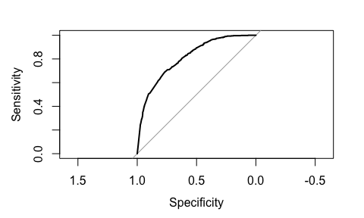

Area under the curve: 0.8102

# Discussion: Policy Lessons from Diverging Outcomes

Based on the statistical modeling of factors related to job-seeking behavior of Ukrainian refugees, it appears that there are common challenges, such as lack of decent age opportunities, language barriers, insufficient medical and childcare support, and skill mismatches, across six countries. However, the magnitude and relevance of these indicators varies on a country to country basis, requiring both context-sensitive and evidence-based responses.

In a number of countries, where employment rates grow steadily, digital job-matching tools are available to streamline the hiring process, connect refugees with suitable employers, and help overcome language or credential recognition barriers. For instance, Praca w Polsce (“Work in Poland”) is an online platform, where refugees provide information on their education, experience, and skills to find employment. Estonian Unemployment Insurance Fund manages an online page, where Ukrainians can contact employers, or receive additional employment support. While benefits are numerous, there are also risks associated with precarious employment, as Ukrainian refugees may be pushed into informal or illegal work due to limited opportunities, language barriers, or lack of recognized qualifications. To reduce the risk of potential violations of employment law, the Czech Republic, for instance, enhanced the capacity of its labor inspection system (ELA, 2022). However, even though many Ukrainian refugees have high levels of education, they struggle with transferring their skills due to lack of opportunities in their field, inability to get formal recognition, or low level of local language knowledge. According to OECD report, recognized credentials like the European or UNESCO Qualifications Passport, which assesses education, professional experience, and language skills through documentation review and interview can streamline the process of integrating refugees into host country labor markets by providing credible proof of qualifications in a timely manner (2023). Therefore, the focus on eliminating the most common challenges people face when looking for jobs have the potential to align refugee skills with the needs of local labor markets, facilitating smoother integration and improved employment outcomes.

While one might expect language barriers to hinder labor market integration, the regression results reveal a counterintuitive association: reporting a lack of language skills is associated with higher employment odds. This suggests the presence of underlying factors, such as self-selection into certain jobs that do not require host-country language proficiency or more urgent financial necessity among those facing linguistic barriers. A particularly illustrative case is Moldova, where relatively few respondents report language difficulties. Yet, this group also has the highest proportion of individuals with a technical education. Technical qualifications don’t necessarily require language proficiency, so it may help explain better labor market integration. Refugees in Slavic-language countries such as Poland and Slovakia reported fewer language-related difficulties, possibly due to linguistic proximity. Lack of professional skills follows a similar trend: those identifying it as a barrier to employment are more likely to find a job. It again implies the interplay of compensatory factors such as lower-skilled job availability or informal support systems. Consequently, although vacancies are present, only low-skill and entry-level positions are accessible to the majority of refugees. This complexity underscores the importance of looking beyond conventional assumptions in integration policy design.

Notably, receiving unemployment benefits or humanitarian assistance from either host or origin countries lowered employment odds. While such support provides an immediate safety valve for those still looking for stable employment, it may also inadvertently discourage labor market entry in the absence of complementary measures. In many instances, the need to take care of others was a significant factor impeding the possibility of employment. It indicates that broader support systems or family grants can be useful in helping those previously engaged in housekeeping. Therefore, the goal should be to apply a balanced approach combining initial financial support with training, mentorship, and childcare support, allowing for smooth adjustment and professional transition.

# Conclusion: Toward Durable Solutions

Individual motivation, prior experiences, and contextual factors are important considerations that shape professional trajectories of Ukrainian refugees in Central and Eastern Europe. European countries acted swiftly by providing work permits, integration language instruction and simplified recognition of qualifications. Despite multifaceted and timely support of those in need, some constraints such as childcare needs, health limitations, and reliance on social assistance still persist. Some outcomes also reveal the urgency of skill mismatch that needs to be addressed to support both the economic integration of Ukrainian refugees and the vitality of local labor markets. Country-specific upskilling programs and bridging courses remain essential and represent valuable investments in human capital development.

# References

* ELA (2022), Support for people fleeing Ukraine, https://www.ela.europa.eu/en/support-people-fleeing-ukraine
* Jirka, Luděk, et al. “High-Skilled Precarity: The Situation of Ukrainian Refugees in the Czech Republic and Poland.” Sociological Studios, no. 2(23), Lesya Ukrainka Volyn National University, Dec. 2023, pp. 41–48. Crossref, doi:10.29038/2306-3971-2023-02-24-24.
* Londar, S., et al. “Challenges for Ukrainian Refugees in the EU Labour Market: The Case of Poland and Germany.” Educational Analytics of Ukraine, no. 5, State Scientific Institution - Institute of Educational Analytics, 2024, pp. 5–16. Crossref, doi:10.32987/2617-8532-2024-5-5-16.
* OECD (2023), “What we know about the skills and early labour market outcomes of refugees from Ukraine”, OECD Policy Responses on the Impacts of the War in Ukraine, OECD Publishing, Paris, https://doi.org/10.1787/c7e694aa-en.
* SocioFactor, IOM, Impact-REACH, SHC, Sociofactor, TARKI Social Research Institute, Ipsos, UNHCR (2023). Poland, Slovak Republic, Hungary, Czech Republic, Moldova, Romania, Bulgaria: Multi-Sector Needs Assessment (MSNA) - 2023. Accessed from: https://microdata.unhcr.org
* UNHCR (2023). Estonia: Multi-Sector Needs Assessment (MSNA) - 2023. Accessed from: https://microdata.unhcr.org