CS-550 PA-2
Fatima Mariyam – A20527616
Design Document

Overview
This assignment is a client-server mode P2P file downloading system. It involves the creation of a client and server program. The server provides the list of all the peer nodes and the files they hold. The peer node could query the indexing server node to get the peer node lists that hold the requested file and then directly go to that node to request this file. The client node can send and receive files to/from other peer nodes.

Source Code
- IndexingServer.java - server logic for accepting client connections and sending download data.
- Peer.java - client logic for downloading files.
- LogUtility.java – utility class for logging.
- config.properties – properties file for project configurations
- Makefile
- Test.java – tester file for testing the basic operations of the system.
- scripts –
  - generate_files.sh – script to generate experiment data at the server location.
  - run_experiment_3.sh – script to run (3) of the problem statement.
  - run_experiment_4.sh – script to run (4) of the problem statement.
- Readme

Running Code
- compile code
make

- run server
- You can run the Peer program by using the makefile command “make run_server”. The server runs on
port 10000. The user doesn’t need to do anything for this port configuration.
make run_server

- run single client
make run_client

-clean class files
make clean

-clean data files
make clean_data

-clean downloaded files
make clean_downloaded_data

-clean logfiles
make clean_logfiles

Configurable parameters
Following are the parameters with their default values, that can be configured through the config.properties file according to usage and experiment requirement.
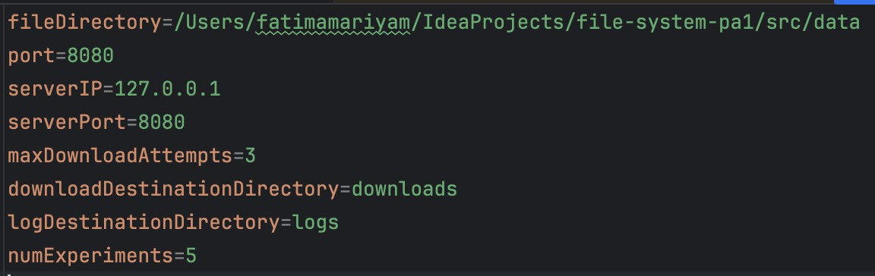

Indexing Server:
Run the Peer program using the makefile command 'make run_server'. The server operates on port 10000 automatically, requiring no additional configuration from the user. The Indexing Server functions independently, displaying messages that can be considered as logs, without needing user input.

Peer:
Initiate the Peer program with 'make run_peer', which starts two internal threads: Peer Client and Peer Server. The Peer Client connects to the Indexing Server on port 10000, while the Peer Server operates on port 20000.

Step-by-Step Execution:
- Execute 'make run_peer'.
- Console output:
- PEER CLIENT STARTED
- PEER SERVER STARTED
- Input prompts:
- Server Address: Input the IP address of the Indexing Server.
- Replication node query: Input Y if you wish to enable replication, requiring ample disk space.

Operational Choices:
1. Register files: Share files with the network via the Indexing Server.
2. Query files: Search for specific files within the network.
3. Unregister files: Cease sharing all files, removing them from the server's directory.
4. Download log: Review the log detailing file downloads from your node.
5. Exit: Terminate the program.

File Registration and Lookup:
- For file registration, specify the path(s) to the file(s).
- For file lookup, enter the complete filename to search on the server.

Download Options:
- Confirm download intent for located files.
- Choose to download or print the initial segment of text files.

Test Program Execution:
Run the Test program with 'make run_peer' to evaluate Lookup and Download operations, executed multiple times across multiple threads.

Testing Choices:
1. Lookup: Test the search function and measure response time.
2. Download: Evaluate file transfer speeds.
3. Exit: Close the test program.

