CS 550 – PA4
Fatima Mariyam – A20527616
Output File

Indexing Server and 5 Peers are started with Peers 1 and 4 having same files.

- Starting the Indexing Server: ./run_server.sh
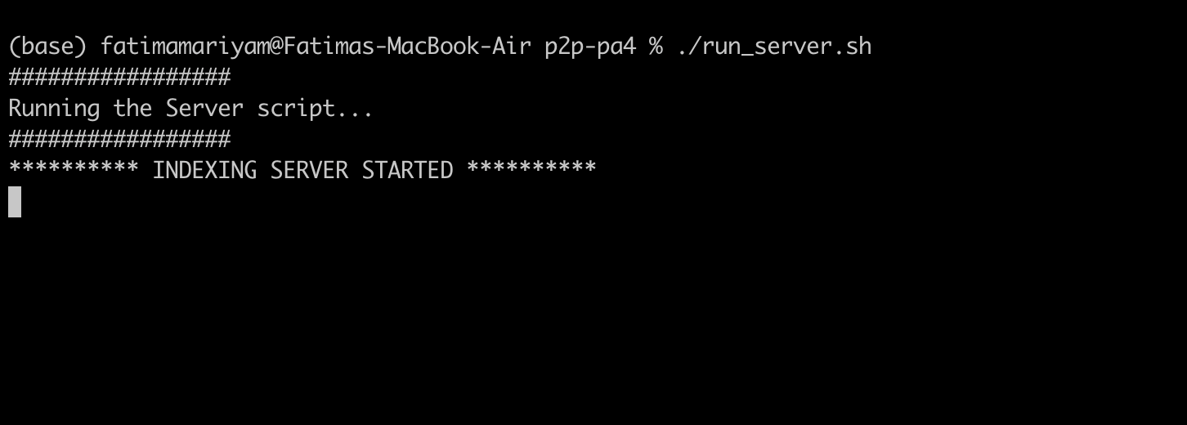

- Starting peer 1 ./run_peer.sh

(base) fatimamariyam@Fatimas-MacBook-Air p2p-pa4 % ./run_peer.sh
#################
Running the Peer script...
#################
Enter the port number for this peer
1001
Enter the directory path to register with the Indexing Server
/Users/fatimamariyam/Documents/HW/AOS/p2p-pa4/SHARED_DIR/Folder1
********** PEER CLIENT STARTED **********
1. Work
2. Work Parallel
2
Give a Peer ID to this Peer
1
Registering file file1_5 in Indexing Serverof size = 141312
Registering file file1_2 in Indexing Serverof size = 70656
Registering file file1_11 in Indexing Serverof size = 92160
Registering file file1_16 in Indexing Serverof size = 204800
Registering file file1_3 in Indexing Serverof size = 164864
Registering file file1_4 in Indexing Serverof size = 230400
Registering file file1_10 in Indexing Serverof size = 219136
Registering file file1_15 in Indexing Serverof size = 211968
Registering file file1_12 in Indexing Serverof size = 78848
Registering file file1_1 in Indexing Serverof size = 158720
Registering file file1_6 in Indexing Serverof size = 245760
Registering file file1_8 in Indexing Serverof size = 179200
Registering file file1_13 in Indexing Serverof size = 198656
Registering file file1_14 in Indexing Serverof size = 226304
Registering file file1_9 in Indexing Serverof size = 126976
Registering file file1_7 in Indexing Serverof size = 198656
Please make a choice
1. Query File
2. Un-register File
3. Exit

- Starting peer 2 ./run_peer.sh
#################
Running the Peer script...
#################
Enter the port number for this peer
1002
Enter the directory path to register with the Indexing Server
/Users/fatimamariyam/Documents/HW/AOS/p2p-pa4/SHARED_DIR/Folder1
********** PEER CLIENT STARTED **********
1. Work
2. Work Parallel
2
Give a Peer ID to this Peer
2
Registering file file1_5 in Indexing Serverof size = 141312
Registering file file1_2 in Indexing Serverof size = 70656
Registering file file1_11 in Indexing Serverof size = 92160
Registering file file1_16 in Indexing Serverof size = 204800
Registering file file1_3 in Indexing Serverof size = 164864
Registering file file1_4 in Indexing Serverof size = 230400
Registering file file1_10 in Indexing Serverof size = 219136
Registering file file1_15 in Indexing Serverof size = 211968
Registering file file1_12 in Indexing Serverof size = 78848
Registering file file1_1 in Indexing Serverof size = 158720
Registering file file1_6 in Indexing Serverof size = 245760
Registering file file1_8 in Indexing Serverof size = 179200
Registering file file1_13 in Indexing Serverof size = 198656
Registering file file1_14 in Indexing Serverof size = 226304
Registering file file1_9 in Indexing Serverof size = 126976
Registering file file1_7 in Indexing Serverof size = 198656
Please make a choice
1. Query File
2. Un-register File
3. Exit

- Starting peer 3 ./run_peer.sh
#################
Running the Peer script...
#################
Enter the port number for this peer
1003
Enter the directory path to register with the Indexing Server
/Users/fatimamariyam/Documents/HW/AOS/p2p-pa4/SHARED_DIR/Folder3
********** PEER CLIENT STARTED **********
1. Work
2. Work Parallel
2
Give a Peer ID to this Peer
3
Registering file file3_1 in Indexing Serverof size = 238592
Registering file file3_2 in Indexing Serverof size = 135168
Registering file file3_5 in Indexing Serverof size = 146432
Registering file file3_4 in Indexing Serverof size = 141312
Registering file file3_3 in Indexing Serverof size = 252928
Please make a choice
1. Query File
2. Un-register File
3. Exit

- Starting peer 4 ./run_peer.sh
#################
Running the Peer script...
#################
Enter the port number for this peer
1004
Enter the directory path to register with the Indexing Server
/Users/fatimamariyam/Documents/HW/AOS/p2p-pa4/SHARED_DIR/folder1
********** PEER CLIENT STARTED **********
1. Work
2. Work Parallel
2
Give a Peer ID to this Peer
4
Registering file file1_5 in Indexing Serverof size = 262144
Registering file file1_2 in Indexing Serverof size = 89088
Registering file file1_11 in Indexing Serverof size = 212992
Registering file file1_16 in Indexing Serverof size = 114688
Registering file file1_18 in Indexing Serverof size = 180224
Registering file file1_3 in Indexing Serverof size = 200704
Registering file file1_4 in Indexing Serverof size = 238592
Registering file file1_19 in Indexing Serverof size = 83968
Registering file file1_17 in Indexing Serverof size = 124928
Registering file file1_10 in Indexing Serverof size = 177152
Registering file file1_15 in Indexing Serverof size = 248832
Registering file file1_12 in Indexing Serverof size = 186368
Registering file file1_1 in Indexing Serverof size = 133120
Registering file file1_6 in Indexing Serverof size = 249856
Registering file file1_8 in Indexing Serverof size = 107520
Registering file file1_13 in Indexing Serverof size = 257024
Registering file file1_14 in Indexing Serverof size = 136192
Registering file file1_9 in Indexing Serverof size = 178176
Registering file file1_7 in Indexing Serverof size = 228352
Please make a choice
1. Query File
2. Un-register File
3. Exit

- Starting peer 5 ./run_peer.sh
#################
Running the Peer script...
#################
Enter the port number for this peer
1005
Enter the directory path to register with the Indexing Server
/Users/fatimamariyam/Documents/HW/AOS/p2p-pa4/SHARED_DIR/folder4
********** PEER CLIENT STARTED **********
1. Work
2. Work Parallel
2
Give a Peer ID to this Peer
5
Registering file file4_9 in Indexing Serverof size = 71680
Registering file file4_7 in Indexing Serverof size = 151552
Registering file file4_6 in Indexing Serverof size = 146432
Registering file file4_1 in Indexing Serverof size = 120832
Registering file file4_8 in Indexing Serverof size = 256000
Registering file file4_11 in Indexing Serverof size = 128000
Registering file file4_10 in Indexing Serverof size = 143360
Registering file file4_4 in Indexing Serverof size = 173056
Registering file file4_3 in Indexing Serverof size = 165888
Registering file file4_2 in Indexing Serverof size = 250880
Registering file file4_5 in Indexing Serverof size = 92160
Registering file file4_12 in Indexing Serverof size = 242688
Registering file file4_14 in Indexing Serverof size = 108544
Registering file file4_13 in Indexing Serverof size = 80896
Please make a choice
1. Query File
2. Un-register File
3. Exit

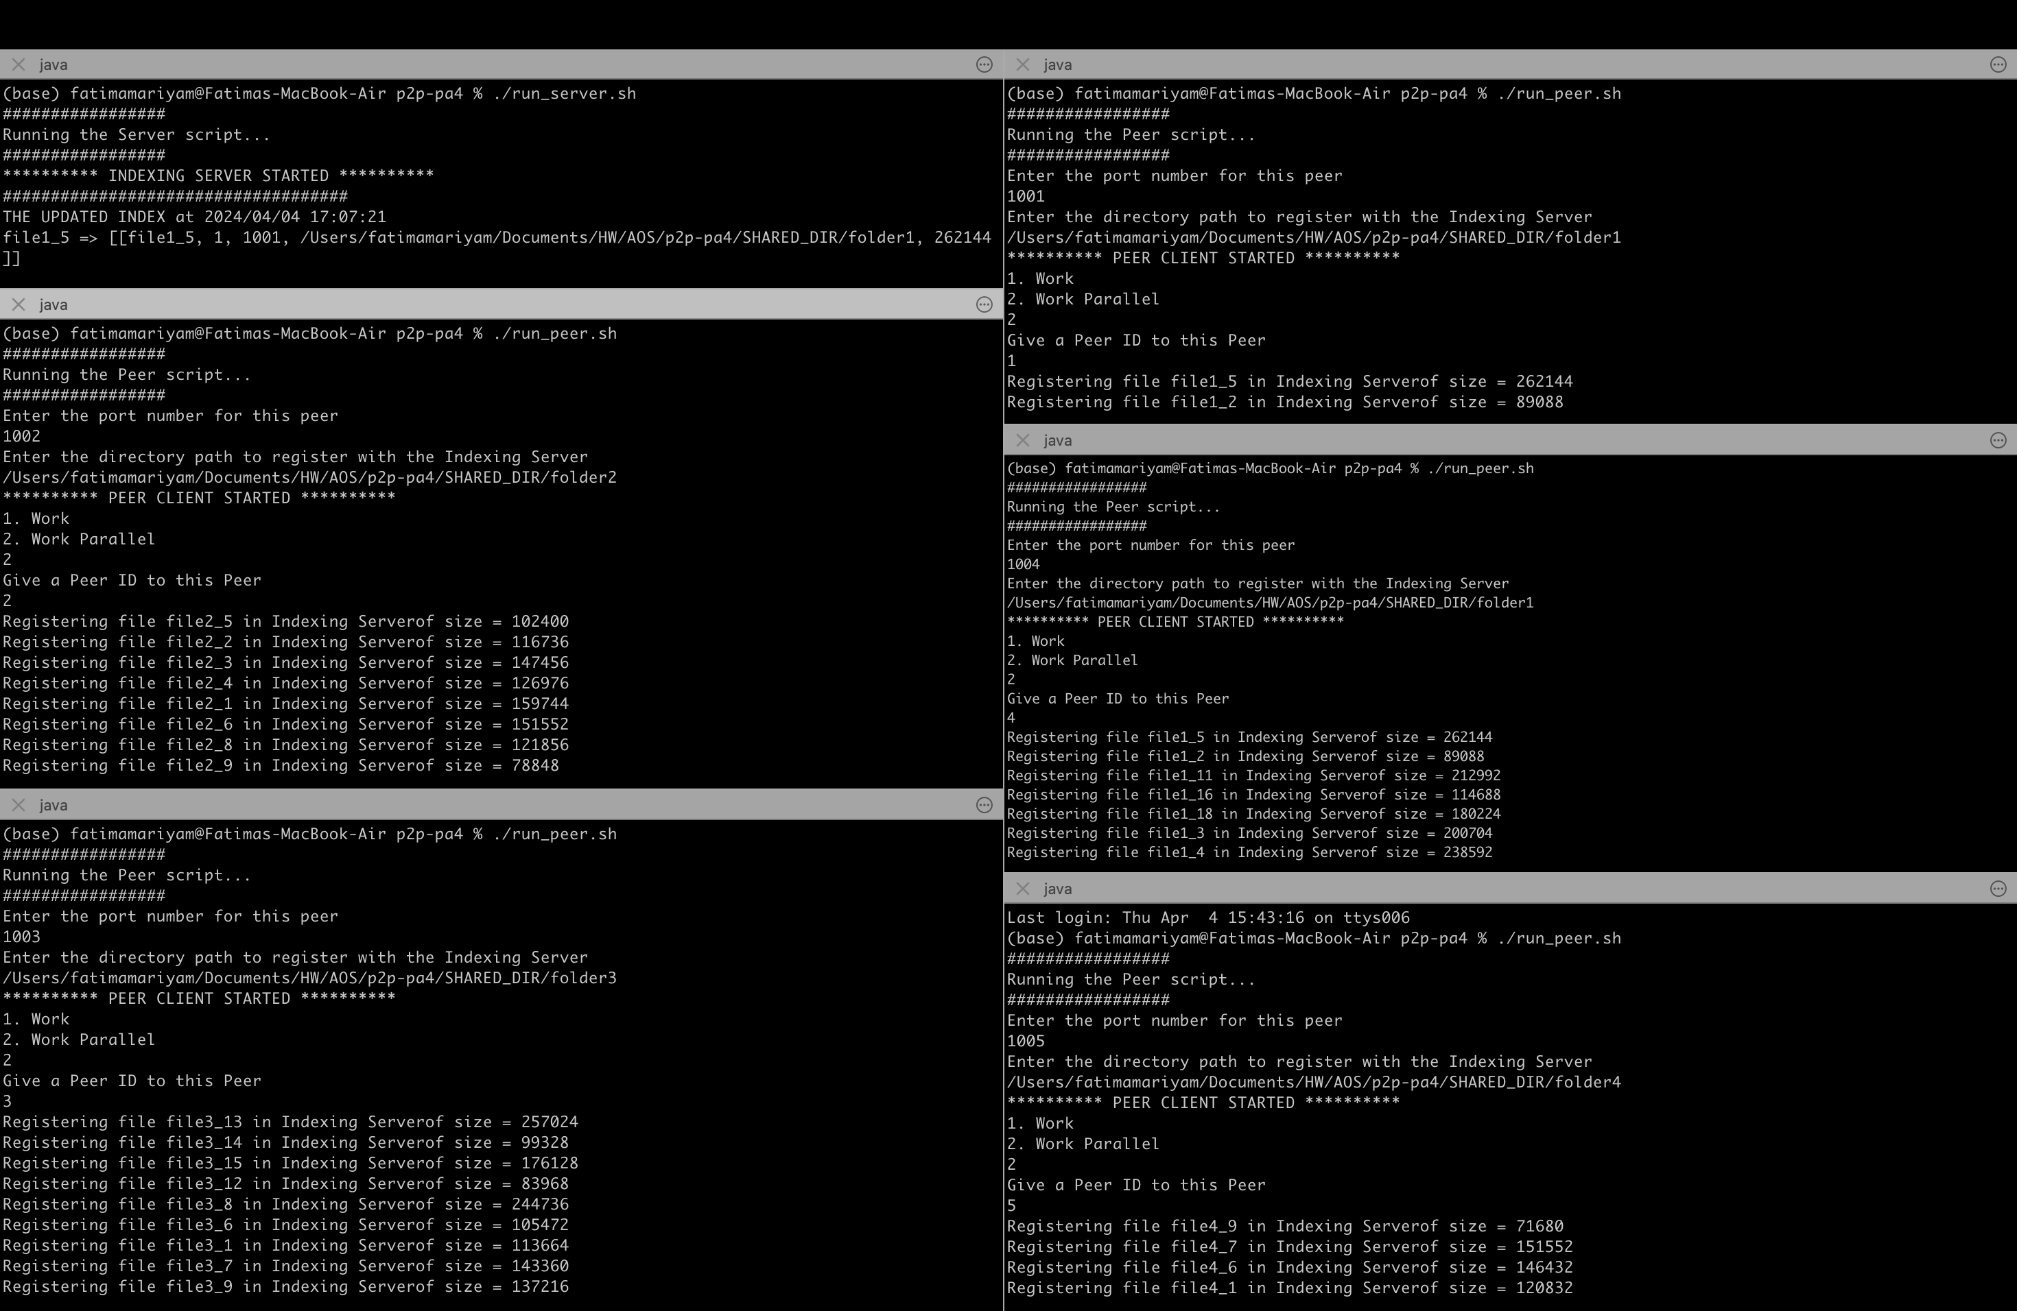

- Requesting “file1_11” from Peer 2 - present in Peer 1 and 4

Enter name of the file you want to look for at indexing server:
file1_11
List of peer IDs holding the requested file:
Peer-ID: 1
Peer-ID: 4
Number of chunks = 4
File download in process...
File download in process...
Chunk 1 downloaded successfully
Chunk 0 downloaded successfully
File download in process...
File download in process...
Chunk 2 downloaded successfully
Chunk 3 downloaded successfully
Chunk 0 downloaded successfully
Chunk 1 downloaded successfully
Chunk 2 downloaded successfully
Chunk 3 downloaded successfully
File downloaded successfully from multiple peers.
Integrity check passed: Downloaded file matches the original file.
1. Query File
2. Un-register File
3. Exit

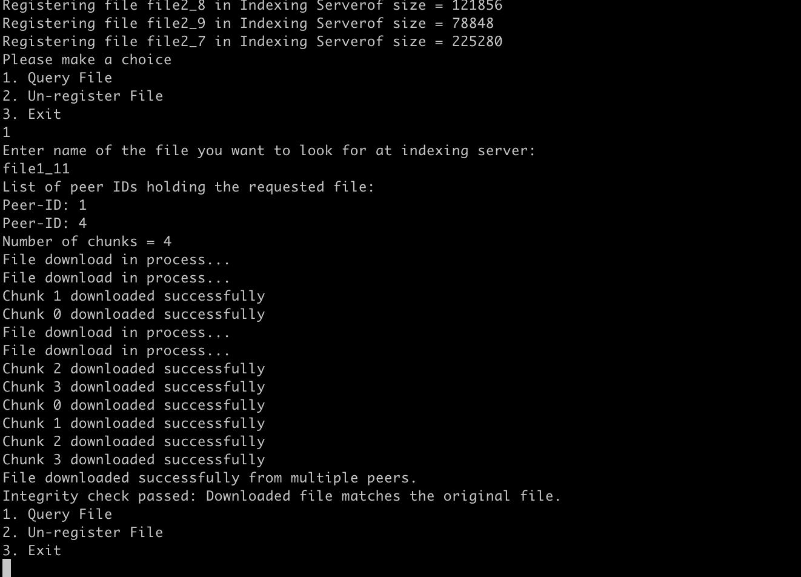

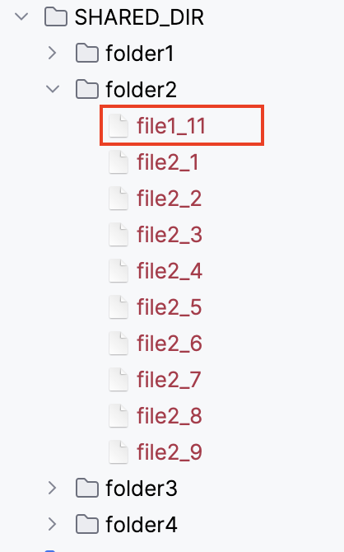

- Size of downloaded file in folder2 = size of original file in folder1
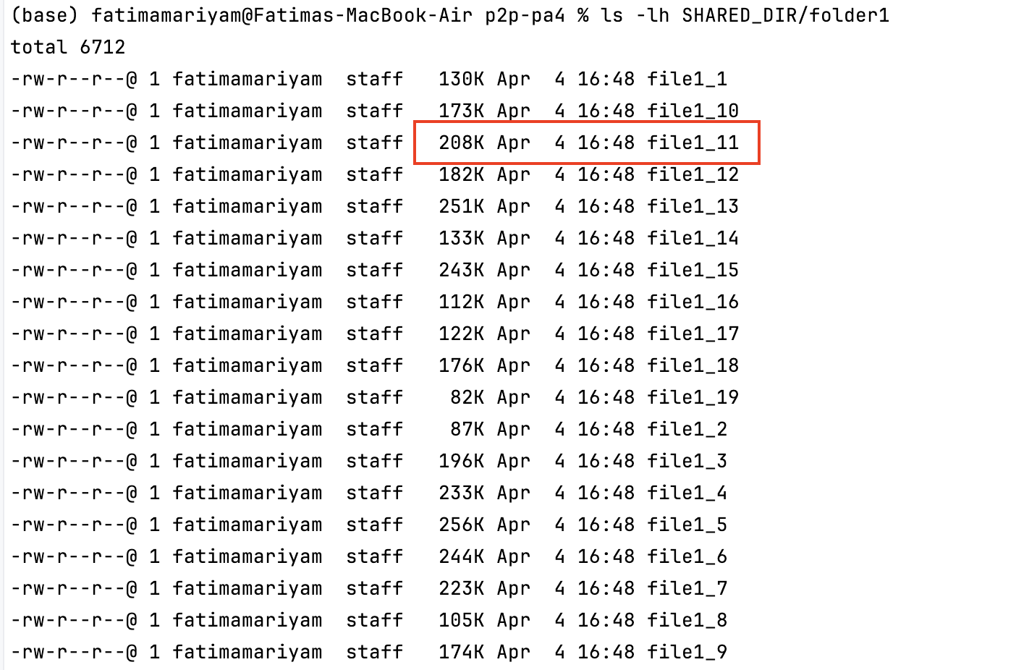
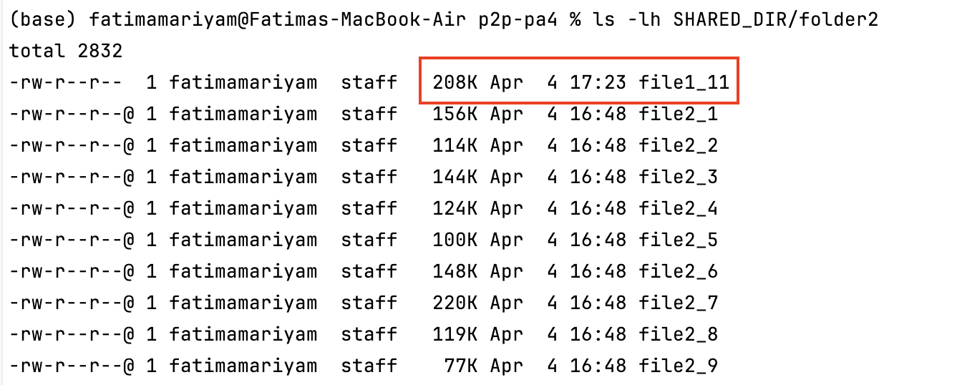

- Deleting file from Peer2
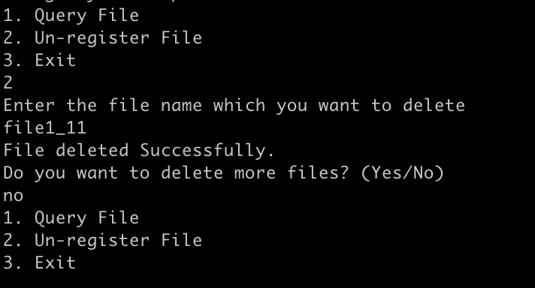

- Indexing server logging
