CS-550 PA-1
Fatima Mariyam – A20527616
Performance Evaluation

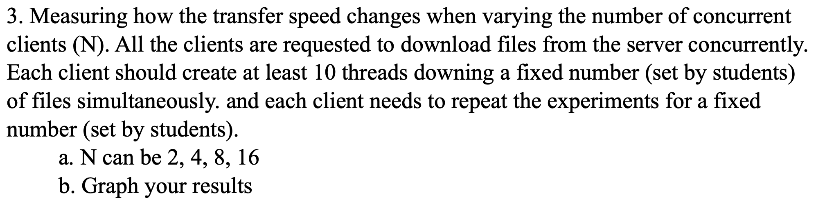

- Performance evaluation for problem 3:
- Number of clients connected concurrently = N
- Run for N = 2, 4, 8, 16
- Each client = 10 threads
- Download file size = 8kb (this can be changed through the script)
- Total number of experiments executed = 5 (can be configured using “numExperiments” in the config.properties file.)
- Results:
For N=2:
Client 1 | 2812.85 ns
Client 2 | 2718.23 ns
For N=4:
Client 1 | 6317.418
Client 2 | 6401.05
Client 3 | 6300.902
Client 4 | 6603.41
For N=8:
Client 1 | 7701.93 ns
Client 2 | 7766.33 ns
Client 3 | 7774.94 ns
Client 4 | 8292.83 ns
Client 5 | 2387.78 ns
Client 6 | 4468.60 ns
Client 7 | 3838.22 ns
Client 8 | 3622.58 ns
For N=16:

Client 1 | 6977.376 ns
Client 2 | 2851.434 ns
Client 3 | 2896.66 ns
Client 4 | 3808.208 ns
Client 5 | 32492.824 ns
Client 6 | 30998.1 ns
Client 7 | 3974 ns
Client 8 | 5128.81 ns
Client 9 | 4565.516 ns
Client 10 | 48272 ns
Client 11 | 60428.9 ns
Client 12 | 62671.292 ns
Client 13 | 16838.286 ns
Client 14 | 8034.35 ns
Client 15 | 8650.184 ns
Client 16 | 34755.794 ns

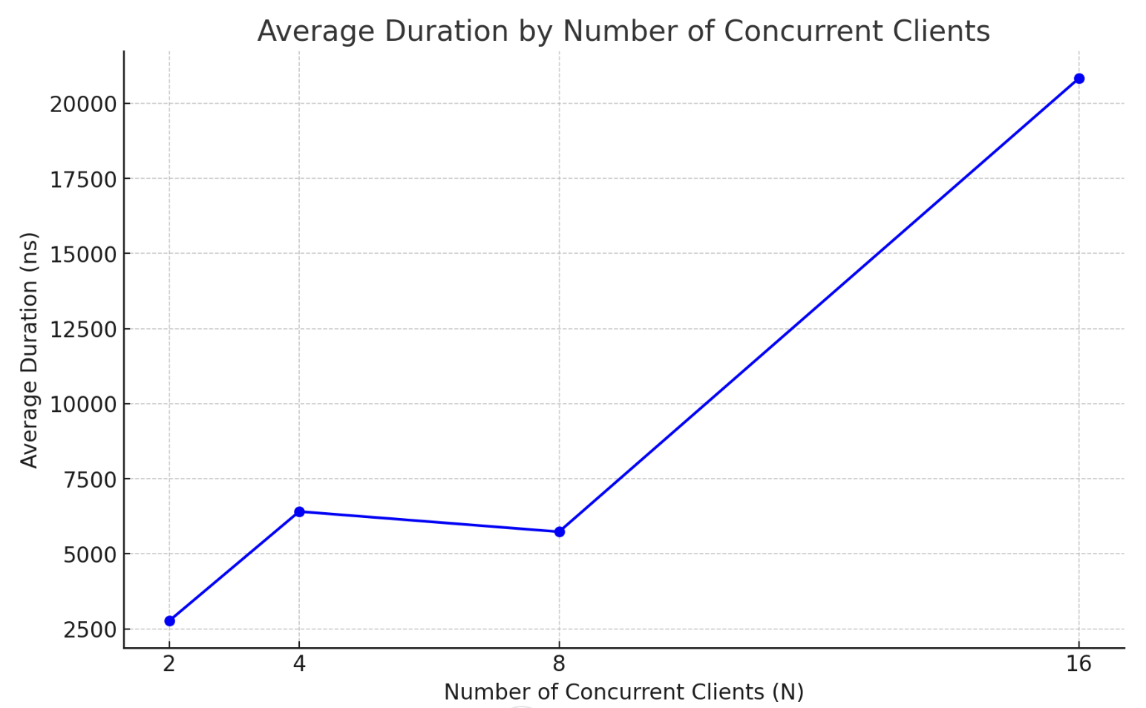

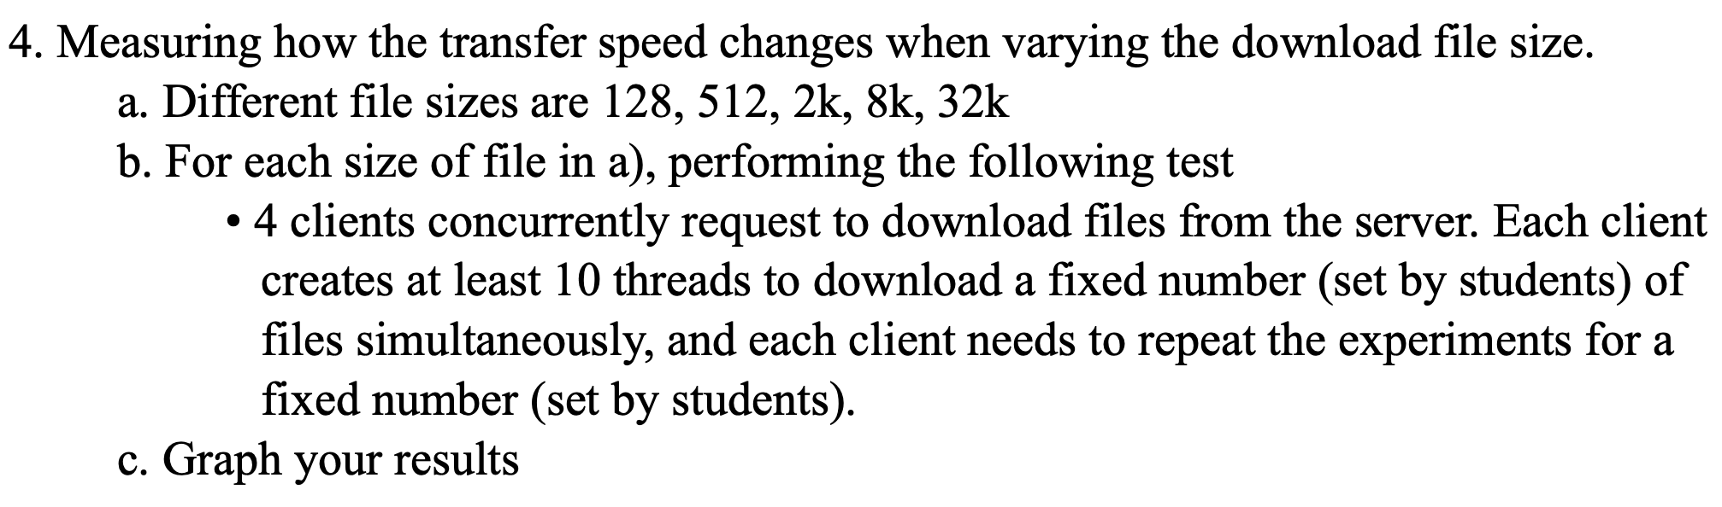

- Performance evaluation for problem 4
- Total number of clients = 4
- Each client = 10 threads
- Number of experiments = 5 (configurable through “numExperiments”)
- Following are the execution results of downloading each of the given file sizes:

